Worksheet 2

Student Name: Ayush Y UID: 25IMC13004
Branch:MCA (AI&ML) Section/Group:1/A
Semester:2nd Date of Performance:22/01/2026
Subject Name:- DBMS LAB Subject Code:

1. Aim of the Session

To implement and analyze SQL SELECT queries using filtering, sorting, grouping, and aggregation concepts in PostgreSQL for efficient data retrieval and analytical reporting.

2. Software Requirements
- PostgreSQL (Database Server)
- pgAdmin
- Windows Operating System

3. Objective of the Session

After completing this practical, the student will be able to:
- Retrieve specific data using filtering conditions
- Sort query results using single and multiple attributes
- Perform aggregation using grouping techniques
- Apply conditions on aggregated data using HAVING clause
- Understand real-world analytical queries commonly asked in placement interviews

4. Practical / Experiment Steps
- Create a sample table representing customer orders
- Insert realistic records into the table
- Retrieve filtered data using WHERE clause
- Sort query results using ORDER BY
- Group records and apply aggregate functions
- Apply conditions on grouped data using HAVING
- Analyze execution order of WHERE and HAVING clauses

5. Procedure of the Practical

(i) Start the system and log in to the computer.

(ii) Open PostgreSQL software.

iii) Create and select the database.

create database CompanyDB;

(iv) Create table using DDL command.

create table customer_orders(

order_id serial primary key,

customer_name varchar(20),

product varchar(20),

quantity int,

price numeric(10,2),

order_date date

);

(v) Insert records into the table.

insert into customer_orders(customer_name,product,quantity,price,order_date) values

('Amit', 'Laptop', 1, 55000, '2025-01-05'),

('Amit', 'Mouse', 2, 800, '2025-01-06'),

('Riya', 'Mobile', 1, 22000, '2025-01-10'),

('Riya', 'Headphones', 1, 2000, '2025-01-10'),

('Karan', 'Laptop', 1, 60000, '2025-02-02'),

('Karan', 'Keyboard', 1, 1500, '2025-02-05'),

('Neha', 'Mobile', 2, 21000, '2025-02-15'),

('Neha', 'Charger', 3, 900, '2025-02-18');

(vi) Display all records.

select * from customer_orders;

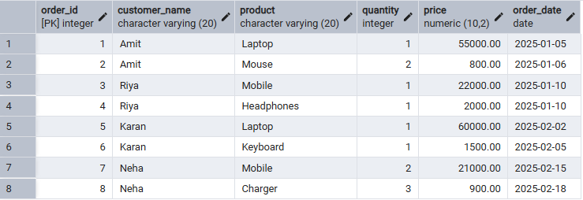

(vii) Filtering Data Using WHERE clause.

select order_id, customer_name, product, quantity, price

from customer_orders

where price > 20000;

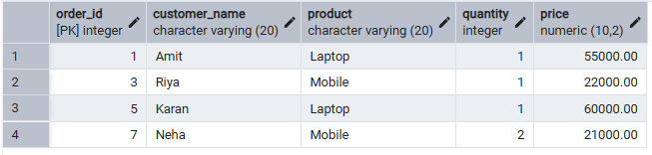

(viii) Sorting Query Results.
Ascending Order
select order_id, customer_name, product, quantity, price
from customer_orders
where price > 20000
order by price;
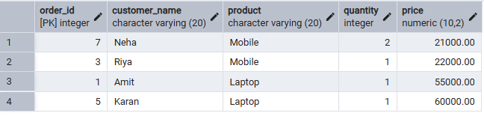
Descending Order
select order_id, customer_name, product, quantity, price
from customer_orders
where price > 20000
order by price desc;
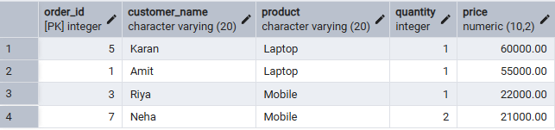

(ix) Grouping Data for Aggregation.
select product, count(*) as total_product_sale
from customer_orders
group by product;
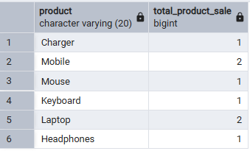
(x) Applying conditions on aggregated data (HAVING).
select product,
sum(quantity*price) as total_revenue
from customer_orders
group by product
having sum(quantity*price) > 50000;
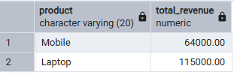

(xi) Using WHERE and HAVING together.
select product, sum(quantity*price) as total_revenue
from customer_orders
where order_date >= '2025-01-01'
group by product
having sum(quantity*price) > 50000;
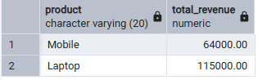

6. I/O Analysis (Input / Output)
Input:
- Customer order details
- Filtering, sorting, grouping, and aggregation queries
Output:
- Filtered customer records
- Sorted result sets
- Group-wise sales summary
- Aggregated revenue reports
(Screenshots of execution and output attached)

7. Learning Outcomes
- Students understand how data can be filtered to retrieve only relevant records.
- Students learn how sorting improves readability and usefulness of reports.
- Students gain the ability to group data for analytical purposes.
- Students clearly differentiate between WHERE and HAVING clauses.
- Students develop confidence in writing analytical SQL queries.
- Students are better prepared for SQL-based placement and interview questions.

