Worksheet 1.1

Student Name: Ayush Yadav UID: 25IMC13004
Branch: MCA (AI & ML) Section/Group: MAM-1 (A)
Semester: II Date of Performance: 10/01/26
Subject Name: Machine Learning Lab Subject Code: 25CAP-672

1. Aim/Overview of the practical:
Experiment-1:
- Implementation of Python Basic Libraries such as
- Math
- Numpy
- Matplotlib
- Seaborn
- Scipy

- Creation and loading different Datasets in Python using Jupyter Notebook

- Write a programs to implement Linear regression on Jupyter notebook
- Download different datasets from Kaggle or UCI ML repository
- Import all the necessary modules for the datasets.
- Find out the best fit line along with the MSE, RMSE

2. Coding:
PART-1
import math
import numpy as np
import seaborn as sns
import matplotlib.pyplot as plt

#MATH
print("Square root: ", math.sqrt(25))
print("Factorial: ", math.factorial(5))
print("Power: ", math.pow(2,3))
print("Ceiling: ", math.ceil(4.3))
print("Floor: ", math.floor(4.7))
print("Pie: ", math.pi)
print("Euler's Number: ", math.e)

#NUMPY
arr = np.array([1,2,3,4,5])

print("Array: ", arr)
print("Mean: ", np.mean(arr))
print("Sum: ", np.sum(arr))
print("Max: ", np.max(arr))

matrix = np.array([[2,4], [6,8]])
print("Matrix:\n", matrix)
print("Transpose:\n", matrix.T)

#MATPLOT LIBRARY
x = [1,2,3,4,5]
y= [10,20,30,40,50]
plt.plot(x,y)
plt.xlabel("X Axis")
plt.ylabel("Y Axis")
plt.title("Line Graph")
plt.show()

#SEABORN
data = [10,20,30,40,50]
sns.histplot(data)
plt.title("Seaborn Histogram")
plt.show()

#SCIPY LIBRARY
from scipy import stats
data = [10,20,30,40,50]
print("Mean: ", stats.tmean(data))
print("Median: ", stats.scoreatpercentile(data,50))
print("Mode: ", stats.mode(data))

OUTPUT:-
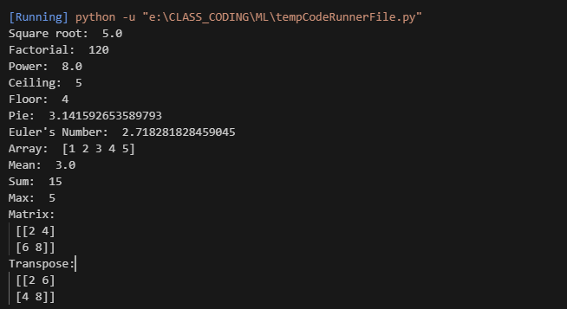
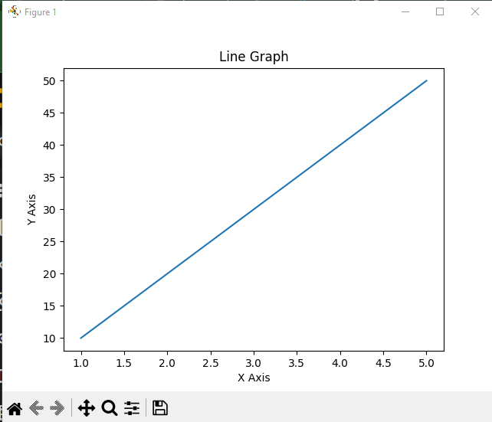

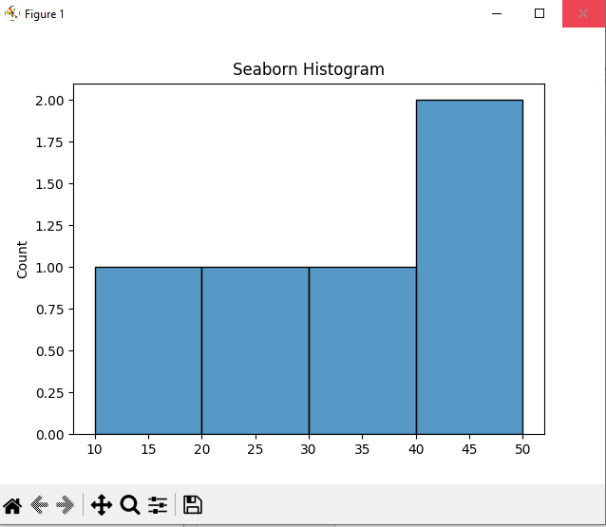

PART-2
import os
import numpy as np
import pandas as pd
import matplotlib as plt

data = {
'Name': ['Ayush', 'Yadav', 'Rao', 'Sahab'],
'Age' : [20,24,23,21],
'City': ['Delhi', 'Haryana', 'Chandigarh', 'Punjab']
}
df_show = pd.DataFrame(data)
print(df_show)

df_csv = pd.read_csv('E:\\Users\\Dell\\Downloads\\archive\\Sensitivity_Soil_Nutrient_Pools.csv')
print(df_csv)

df_excel = pd.read_excel('D:\\AYUSH\\RANDOM SHIT\\student_data.xlsx', engine='openpyxl')
print(df_excel)

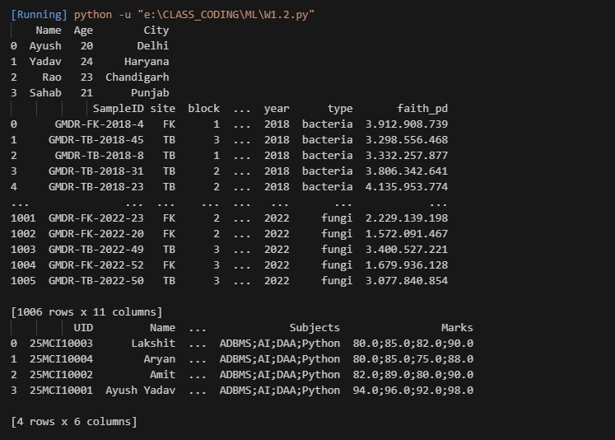

PART-3
import numpy as np
import pandas as pd
import seaborn as sns
import matplotlib.pyplot as plt
import seaborn as sns
from sklearn.model_selection import train_test_split
from sklearn.metrics import mean_squared_error
from sklearn.linear_model import LinearRegression

df = pd.read_excel('E:\\Users\\Dell\\Documents\\w1.xlsx')
X = df[['Distance']]
y = df['Time_Taken']
X_train, X_test, y_train, y_test = train_test_split(
X, y, test_size=0.2, random_state=42
)
model = LinearRegression()
model.fit(X_train, y_train)
y_pred = model.predict(X_test)
plt.scatter(X_test, y_test)
plt.plot(X_test, y_pred)
plt.xlabel("Distance")
plt.ylabel("Time Taken")
plt.title("Linear Regression: Distance vs Time Taken")
plt.show()
mse = mean_squared_error(y_test, y_pred)
rmse = np.sqrt(mse)
print("Mean Squared Error (MSE):", mse)
print("Root Mean Squared Error (RMSE):", rmse)

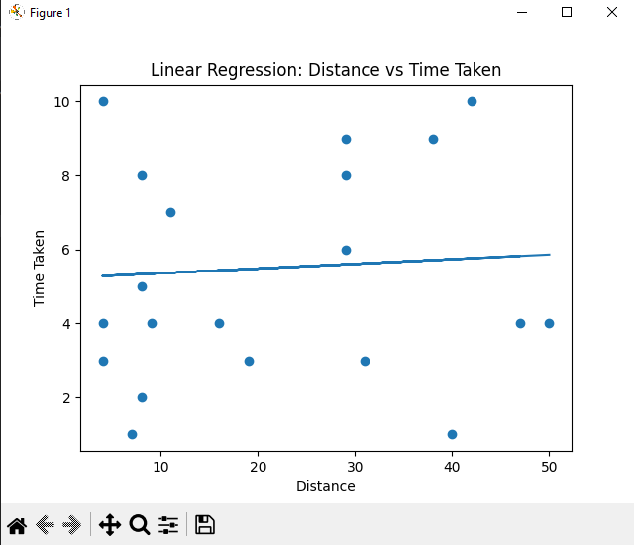

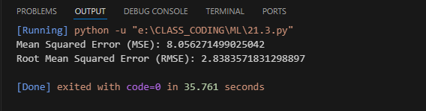

3. Learning outcomes (What I have learnt):
- Understand and use basic Python libraries such as Math, NumPy, Matplotlib, and Seaborn for numerical computation and visualization.
- Load, create, and explore datasets using Pandas in Jupyter Notebook.
- Understand the concept of Linear Regression and its role in predicting continuous values.
- Implement a Linear Regression model using real-world datasets.
- Visualize the best fit line to analyze the relationship between independent and dependent variables.
- Evaluate model performance using Mean Squared Error (MSE) and Root Mean Squared Error (RMSE).
- Interpret regression results and understand how prediction errors reflect model accuracy.

