Worksheet 2.2
Student Name: Ayush Yadav UID: 25IMC13004
Branch: MCA (AI & ML) Section/Group: MAM-1 (A)
Semester: II Date of Performance: 23/02/26 Subject Name: Advance Internet Programming Subject Code: 25CAP-656

- Aim/Overview of the practical: Convert and Deploy an Employee Management Application using Enterprise Java Components and Apply Validation Techniques

- Coding: Index.html file:
<!DOCTYPE html>
<html>
<head>
<title>Authentication</title>
<link href="https://cdn.jsdelivr.net/npm/bootstrap@5.3.2/dist/css/bootstrap.min.css" rel="stylesheet">
</head>
<body class="bg-light">

<div class="container mt-5">
<div class="card p-4 shadow">

<div class="text-center mb-4">
<button class="btn btn-primary me-2" onclick="showLogin()">Login</button>
<button class="btn btn-success" onclick="showSignup()">Signup</button>
</div>

<form id="loginForm" action="auth" method="post">
<input type="hidden" name="action" value="login">
<input class="form-control mb-3" type="text" name="username" placeholder="Username" required>
<input class="form-control mb-3" type="password" name="password" placeholder="Password" required>
<button class="btn btn-primary w-100">Login</button>
</form>

<form id="signupForm" action="auth" method="post" style="display:none;">
<input type="hidden" name="action" value="signup">
<input class="form-control mb-3" type="text" name="username" placeholder="Username" required>
<input class="form-control mb-3" type="email" name="email" placeholder="Email" required>

<input class="form-control mb-3" type="password" name="password" placeholder="Password" required>
<button class="btn btn-success w-100">Signup</button>
</form>

</div>
</div>

<script>
function showLogin(){ document.getElementById("loginForm").style.display = "block"; document.getElementById("signupForm").style.display = "none";
}
function showSignup(){ document.getElementById("loginForm").style.display = "none"; document.getElementById("signupForm").style.display = "block";
}
</script>

</body>
</html>

User.java file: to store the user data as json in tomcat directory
package model; public class User {

private String username; private String email; private String password;

public User() {}

public User(String username, String email, String password) { this.username = username;
this.email = email; this.password = password;
}
public String getUsername() { return username;
}
public void setUsername(String username) { this.username = username;
}
public String getEmail() { return email;

}
public void setEmail(String email) { this.email = email;
}
public String getPassword() { return password;
}
public void setPassword(String password) { this.password = password;
}
}

Auth.java file:
package controller; import model.User;
import com.google.gson.Gson;
import com.google.gson.reflect.TypeToken; import java.io.*;
import java.lang.reflect.Type; import java.nio.file.*;
import java.util.*;
import jakarta.servlet.annotation.WebServlet; import jakarta.servlet.http.*;

@WebServlet("/auth")
public class Auth extends HttpServlet {

protected void doPost(HttpServletRequest request, HttpServletResponse response) throws IOException {

String action = request.getParameter("action");
String username = request.getParameter("username"); String password = request.getParameter("password");
String filePath = getServletContext().getRealPath("/users.json"); Gson gson = new Gson();
List<User> userList = new ArrayList<>();
File file = new File(filePath); if(file.exists()){
String json = new String(Files.readAllBytes(Paths.get(filePath))); Type type = new TypeToken<List<User>>(){}.getType(); userList = gson.fromJson(json, type);

if(userList == null) userList = new ArrayList<>();
}
if("signup".equals(action)){
String email = request.getParameter("email"); for(User u : userList){
if(u.getUsername().equals(username)){ response.getWriter().println("<h3>User already exists</h3>"); return;
}
}

User newUser = new User(username, email, password); userList.add(newUser);
Files.write(Paths.get(filePath), gson.toJson(userList).getBytes());

response.getWriter().println("<h3>Signup Successful! Go back and Login.</h3>");

} else if("login".equals(action)){ for(User u : userList){
if(u.getUsername().equals(username) && u.getPassword().equals(password)){ response.sendRedirect("welcome.html"); return;
}
}
response.getWriter().println("<h3>Invalid Credentials</h3>");
}
}
}

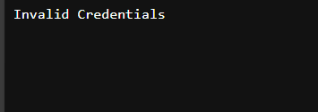
OUTPUT:

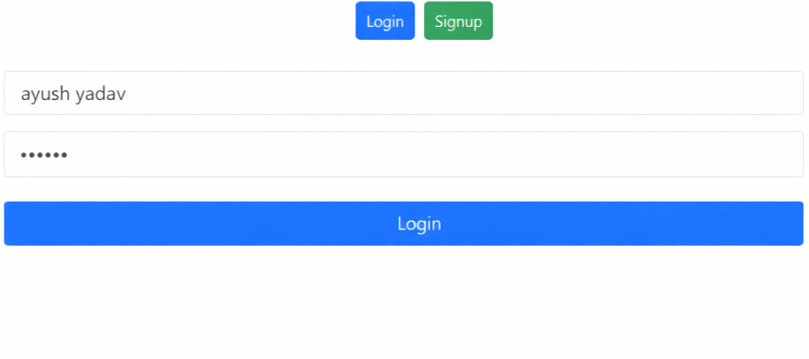

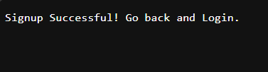

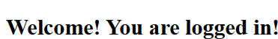

- Learning outcomes:

  - Understand client–server interaction in a web application.
  - Implement user authentication using Servlets.
  - Perform server-side form handling using HTTP POST requests.
  - Store and retrieve structured data using JSON files.
  - Apply MVC architecture using model and controller packages.
  - Implement basic input validation and duplicate user checking.

