Worksheet 1.1

Student Name: Ayush Yadav UID: 25IMC13004
Branch: MCA (AI & ML) Section/Group: MAM-1 (A)
Semester: I Date of Performance: 1/08/25
Subject Name: Artificial Intelligence Tools - I Subject Code: 25CAP-614

1. Aim/Overview of the practical:
Experiment-1:
Implementation of Breadth First Search

2. Coding:
import networkx as nx
import matplotlib.pyplot as plt
graph = {
'A': ['B', 'C', 'D'],
'B': ['A','G'],
'C': ['A','B'],
'D': ['A','E','F'],
'E': ['D','F','H'],
'F': ['D','E','H','I'],
'G': ['B','F','J'],
'H': ['E','F','I'],
'I': ['A','E','F'],
'J': ['G','K'],
'K': ['J','I'] }
G = nx.DiGraph(graph)
pos = nx.spring_layout(G)
nx.draw(G,pos,with_labels=True, node_color='red', node_size=3000, font_size=18, font_weight='bold', arrowsize=20)
plt.show()

OUTPUT:-
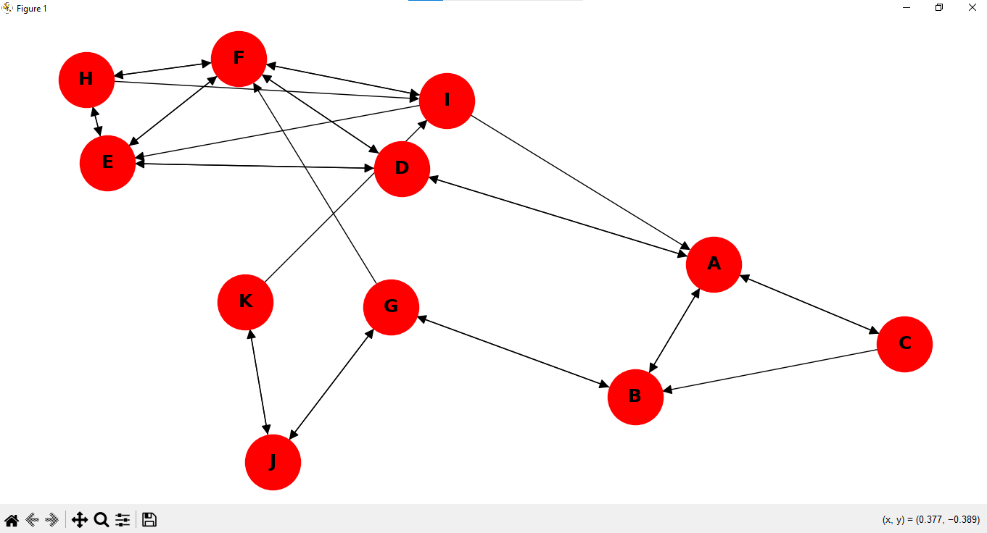

CODING:
from collections import deque
import networkx as nx
import matplotlib.pyplot as plt

def breadth_first_search_visualized(graph, start_node):
visited= set()
queue= deque([start_node])
visited.add(start_node)

G=nx.DiGraph(graph)

pos= nx.spring_layout(G)

visited_nodes=set()
visited_edges=set()

while queue:
vertex = queue.popleft()
visited_nodes.add(vertex)

node_colors = ['red' if node not in visited_nodes else 'green' for node in G.nodes()]
edge_colors= ['black' if edge not in visited_edges else 'blue' for edge in G.edges()]

plt.figure(figsize=(8,6))
nx.draw(G, pos, with_labels=True, node_color=node_colors, edge_color=edge_colors, node_size=3000, font_size=18, font_weight='bold', arrowsize=20)
plt.show()

for neighbor in graph[vertex]:
if neighbor not in visited:
queue.append(neighbor)
visited.add(neighbor)
visited_edges.add((vertex, neighbor))

if __name__ == '__main__':
graph = {
'A': ['B', 'C', 'D'],
'B': ['A','G'],
'C': ['A','B'],
'D': ['A','E','F'],
'E': ['D','F','H'],
'F': ['D','E','H','I'],
'G': ['B','F','J'],
'H': ['E','F','I'],
'I': ['A','E','F'],
'J': ['G','K'],
'K': ['J','I']
}

print("Breadth First Search Visualization Starting From Vertex 'E':")
breadth_first_search_visualized(graph, 'E')

OUTPUT:
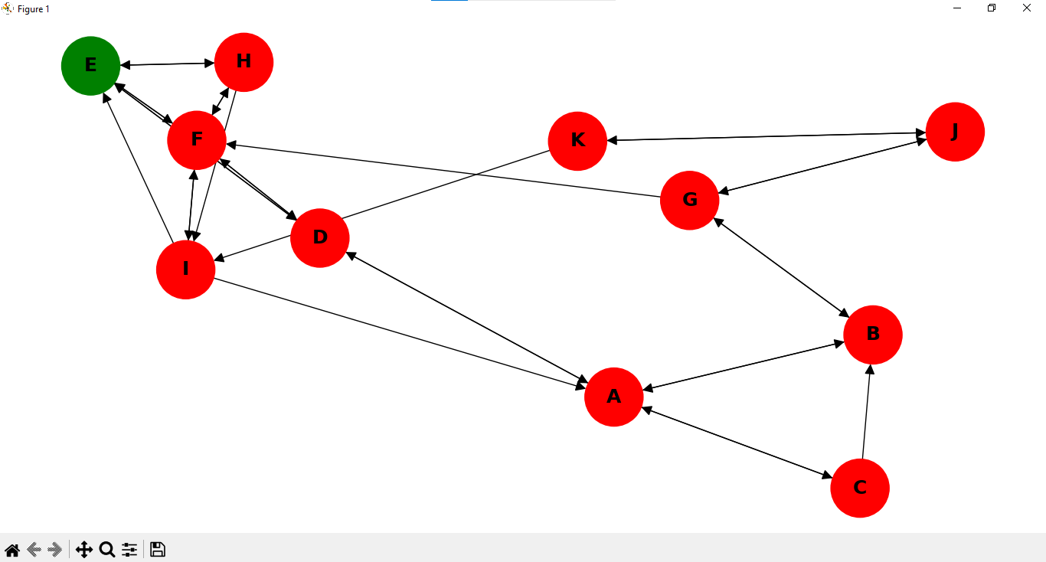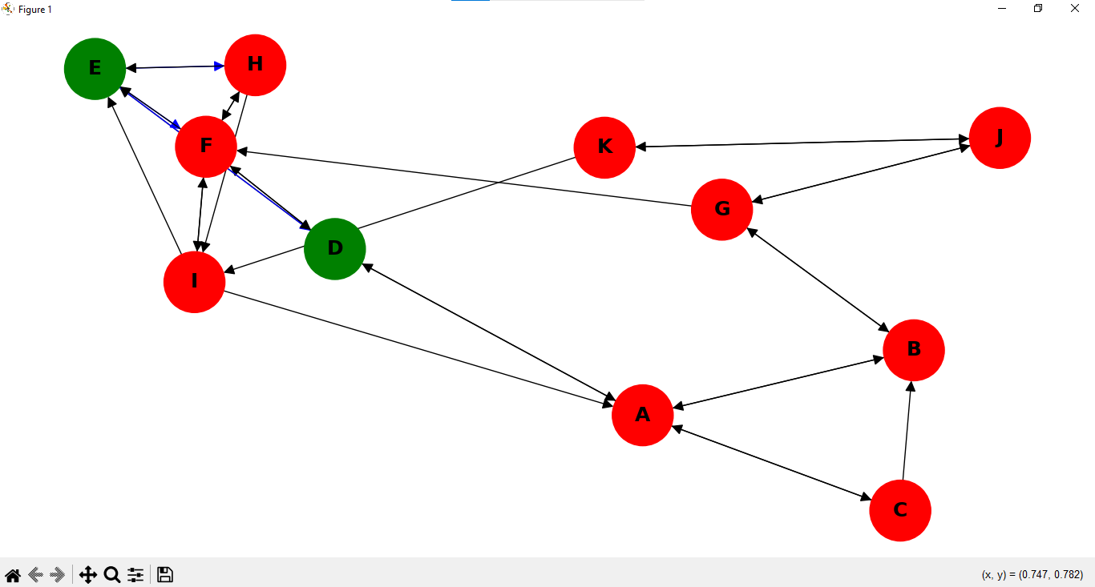
a. b.

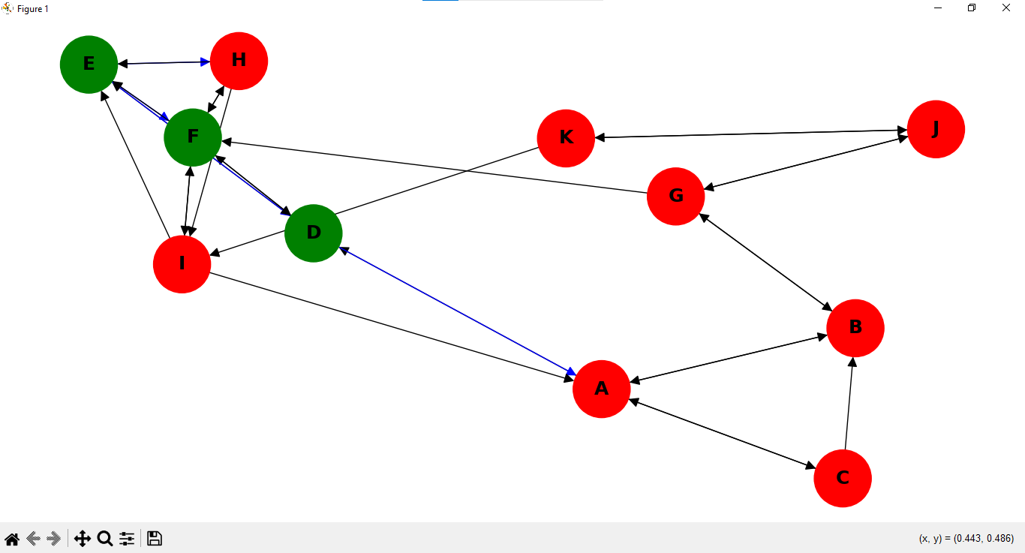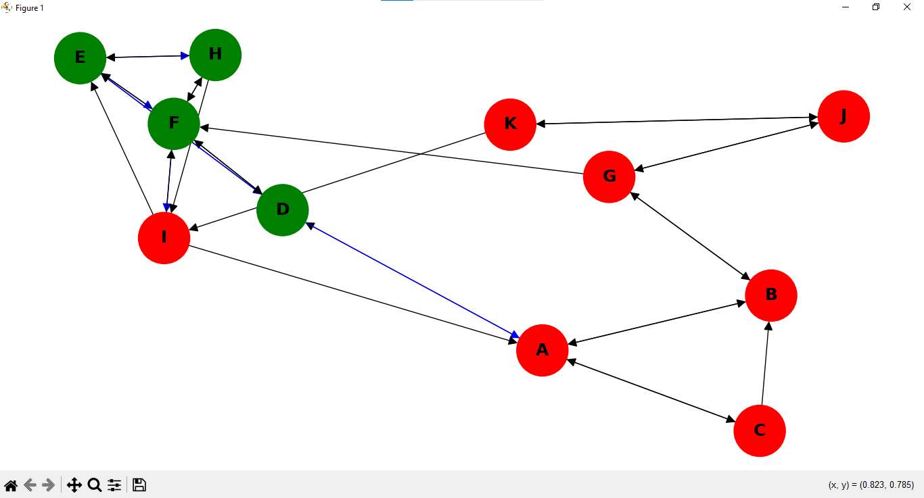
c. d.

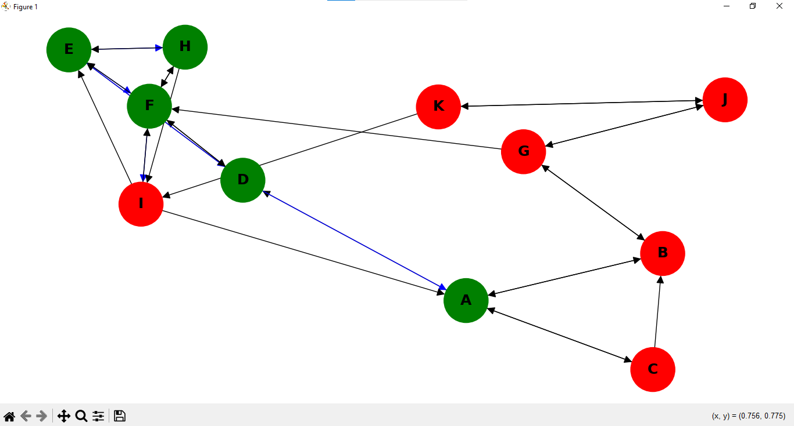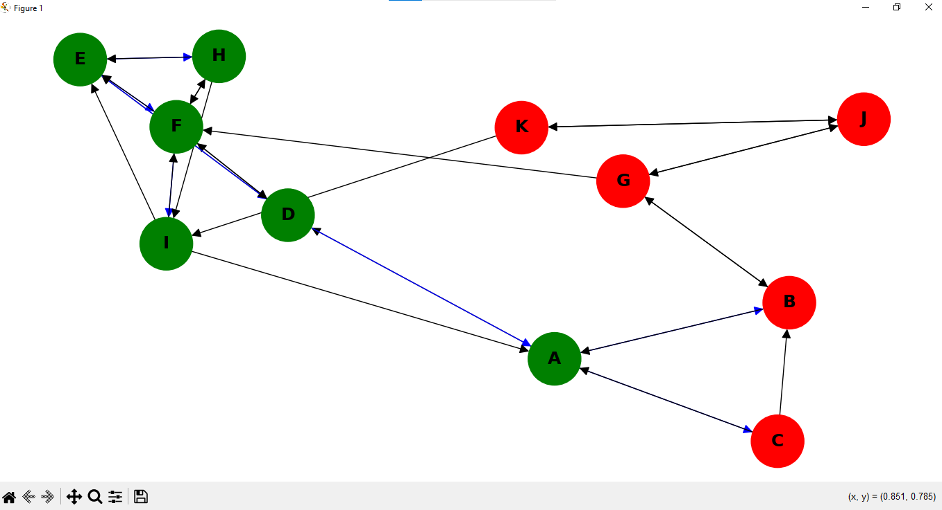
e. f.

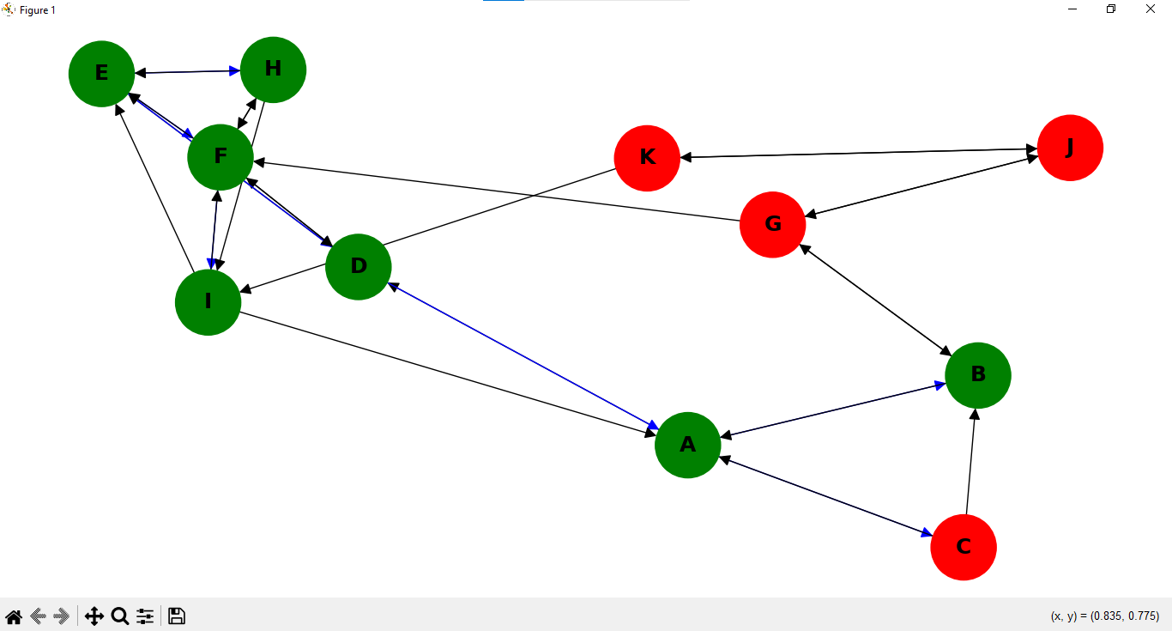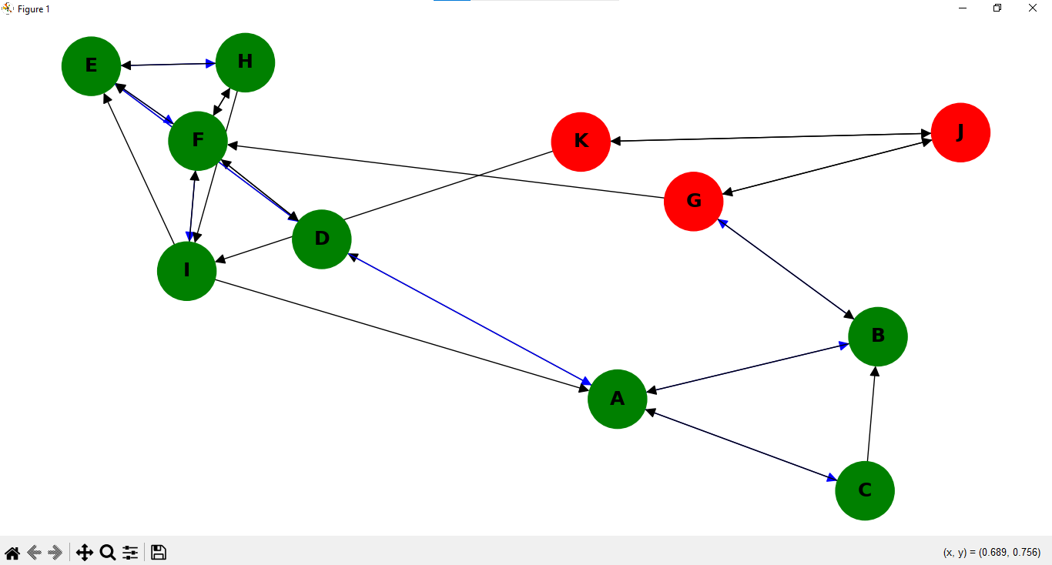
g. h.

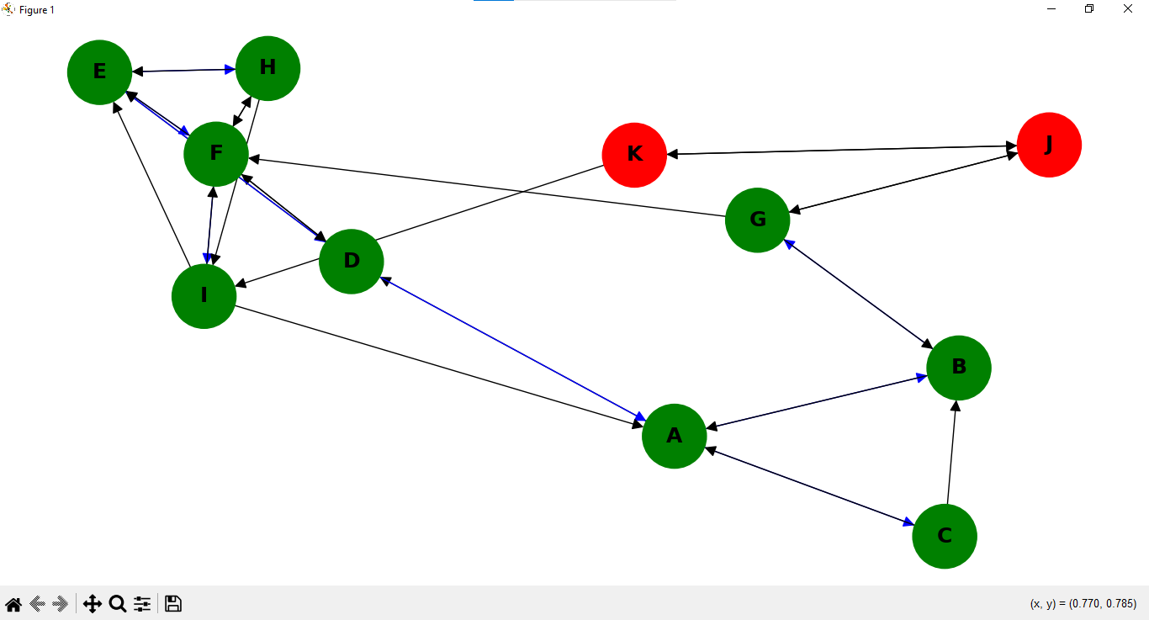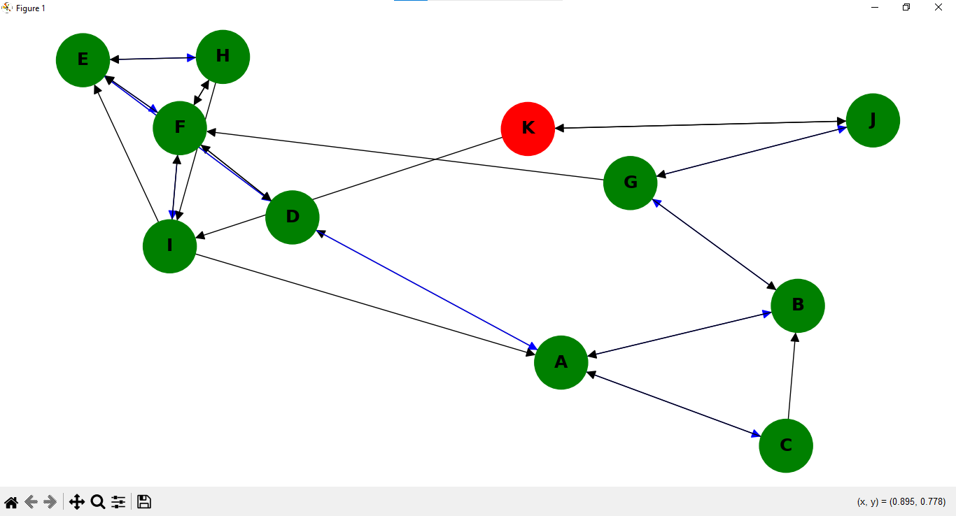
- j.

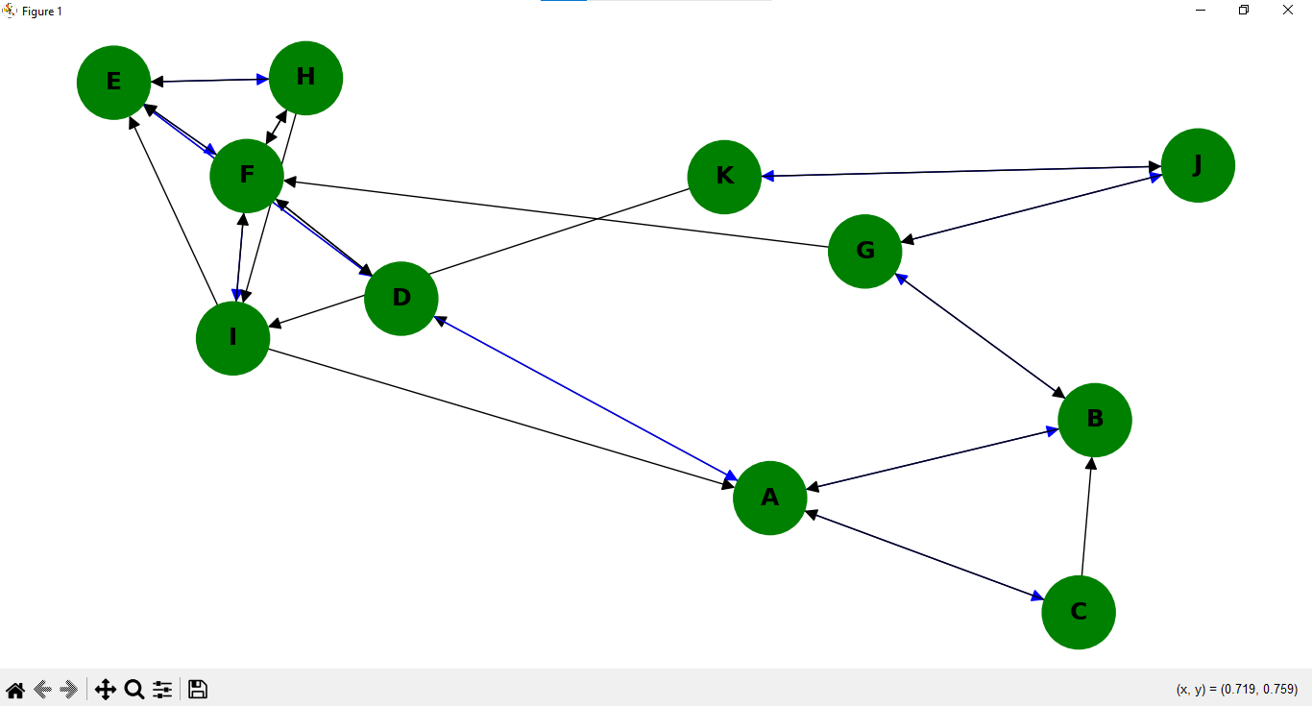
k.

4. Learning outcomes (What I have learnt):
- Understand the working principle of the Quick Sort algorithm
- Learn how to implement Quick Sort using recursion and partitioning.
- Analyze the time and space complexity of Quick Sort
- Compare Quick Sort with other sorting algorithms in terms of efficiency.
- Develop problem-solving skills using divide-and-conquer techniques.

