Worksheet 2.1

Student Name: Ayush Yadav UID: 25IMC13004
Branch: MCA (AI & ML) Section/Group: MAM-1 (A)
Semester: I Date of Performance: 15/09/25
Subject Name: Artificial Intelligence Tools - I Subject Code: 25CAP-614

1. Aim/Overview of the practical:
Experiment-2:
To implement the Best-First Search algorithm in Python using a priority queue and heuristics, in order to find the optimal path from a given start node to the goal node in a graph.

2. Coding:
EXAMPLE-1
import heapq
import networkx as nx
import matplotlib.pyplot as plt

def best_first_search(graph, start, goal, heuristic):
visited = set()
pq = []
heapq.heappush(pq, (heuristic[start], start))
parent = {start: None}

while pq:
cost, current_node = heapq.heappop(pq)

if current_node == goal:
path = []
while current_node is not None:
path.append(current_node)
current_node = parent[current_node]
return path[::-1]

if current_node not in visited:
visited.add(current_node)
for neighbour in graph[current_node]:
if neighbour not in visited:
parent[neighbour] = current_node
heapq.heappush(pq, (heuristic[neighbour], neighbour))

return None

# Graph definition
Graph = {
'A': ['B', 'C'],
'B': ['A', 'D', 'E'],
'C': ['A', 'F'],
'D': ['B'],
'E': ['B', 'F'],
'F': ['C', 'E']
}

heuristic = {
'A': 5,
'B': 4,
'C': 2,
'D': 6,
'E': 1,
'F': 0
}

# Run the search
path = best_first_search(Graph, 'A', 'F', heuristic)
print("Best First Search Path:", path)

# Visualize the graph
G = nx.Graph()
for node, neighbors in Graph.items():
for neighbor in neighbors:
G.add_edge(node, neighbor)

pos = nx.spring_layout(G, seed=42)
nx.draw(G, pos, with_labels=True, node_color='lightblue', node_size=1500,
font_size=12, font_weight='bold')
if path:
nx.draw_networkx_edges(G, pos,
edgelist=[(path[i], path[i+1]) for i in range(len(path)-1)],
edge_color='red', width=2)
plt.title("Graph Visualization with Best First Search Path")
plt.show()
OUTPUT:-
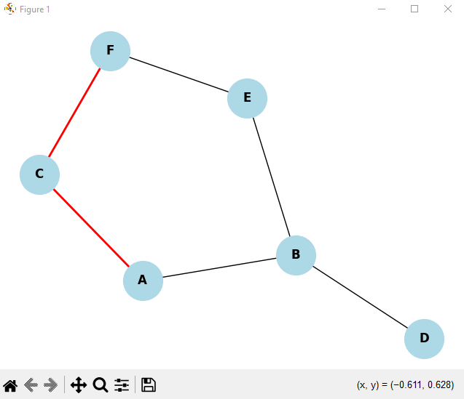

EXAMPLE-2
import heapq
import networkx as nx
import matplotlib.pyplot as plt

def best_first_search(graph, start, goal, heuristic):
visited = set()
pq = []
heapq.heappush(pq, (heuristic[start], start))
parent = {start: None}

while pq:
_, current = heapq.heappop(pq)

if current == goal:
path = []
while current:
path.append(current)
current = parent[current]
return path[::-1]

visited.add(current)

for neighbour in graph[current]:
if neighbour not in visited and neighbour not in parent:
parent[neighbour] = current
heapq.heappush(pq, (heuristic[neighbour], neighbour))

return None

# Graph definition
Graph = {
'X': ['Y', 'A', 'H'],
'Y': ['X', 'A', 'M', 'Z'],
'Z': ['Y', 'N'],
'A': ['X', 'Y', 'M'],
'M': ['Y', 'A', 'P'],
'N': ['Z', 'P'],
'H': ['X', 'O', 'R'],
'O': ['H', 'R'],
'P': ['M', 'N', 'R', 'S'],
'R': ['H', 'O', 'P', 'T', 'K'],
'S': ['P', 'K'],
'T': ['R', 'K', 'V'],
'V': ['T', 'K'],
'K': ['R', 'T', 'V', 'S']
}

# Heuristic values
heuristic = {
'X': 5,
'Y': 10,
'Z': 13,
'A': 4,
'M': 6,
'N': 9,
'H': 6,
'O': 7,
'R': 3,
'P': 8,
'S': 4,
'T': 7,
'V': 4,
'K': 0
}

# Run Best First Search
path = best_first_search(Graph, 'X', 'K', heuristic)
print("Best First Search Path:", path)

# Visualization
G = nx.Graph()
for node, neighbors in Graph.items():
for neighbor in neighbors:
G.add_edge(node, neighbor)

pos = nx.spring_layout(G, seed=42)

nx.draw(G, pos, with_labels=True, node_color='lightblue', node_size=800, font_size=10)

if path:
path_edges = list(zip(path, path[1:]))
nx.draw_networkx_nodes(G, pos, nodelist=path, node_color='orange')
nx.draw_networkx_edges(G, pos, edgelist=path_edges, edge_color='red', width=2)

plt.title("Best First Search Path from 'X' to 'K'")
plt.show()

(B). OUTPUT:
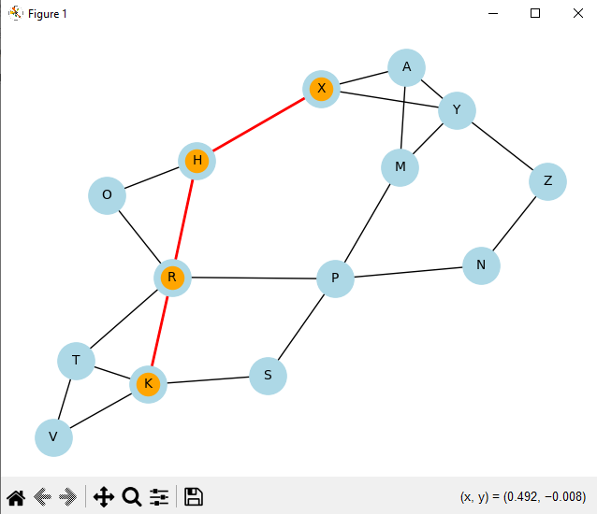

3. Learning outcomes (What I have learnt):
  - Successfully implemented the Best-First Search algorithm in Python using a priority queue.
  - Represented the given graph with 13 vertices and 12 edges using adjacency lists.
  - Applied heuristic values to guide the search process efficiently from the start node to the goal node.
  - Obtained the optimal path (X → … → U) between the start and goal nodes based on heuristics.
  - Understood how heuristic-based search reduces search space and improves efficiency compared to blind search methods like BFS or DFS.

