Worksheet 1.4

Student Name: Ayush Yadav UID: 25IMC13004
Branch: MCA (AI & ML) Section/Group: MAM-1 (A)
Semester: I Date of Performance: 23/09/25
Subject Name: Design and Analysis of Subject Code: 25CAP-612

Algorithms Lab

1. Aim/Overview of the practical:
Experiment-1:
To implement Dijkstra’s Algorithm in Python using a priority queue (min-heap) to find the shortest path from a given source node to all other nodes in a weighted, directed graph with non-negative edge weights.

2. Coding:
import heapq
def dijkstra(graph, start):
dist = {node: float("inf") for node in graph}
dist[start] = 0
pq = [(0, start)]
while pq:
curr_dist, u = heapq.heappop(pq)
if curr_dist > dist[u]:
continue
for v, weight in graph[u]:
if dist[v] > dist[u] + weight:
dist[v] = dist[u] + weight
heapq.heappush(pq, (dist[v], v))
return dist

# Example Graph (undirected, weighted):
graph = {
'P': [('Q', 4), ('R', 2), ('F', 9)],
'Q': [('P', 4), ('R', 5), ('S', 10)],
'R': [('P', 2), ('Q', 5), ('S', 3), ('E', 4)],
'S': [('Q', 10), ('R', 3), ('E', 1)],
'E': [('R', 4), ('S', 1)],
'F': [('P', 9)]
}
start_node = 'P'
distances = dijkstra(graph, start_node)
print("Shortest distances from node", start_node, ":")
for node, d in distances.items():
print(f"{start_node} → {node} = {d}")

OUTPUT:-
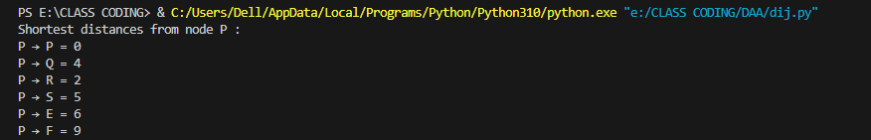

3. Learning outcomes (What I have learnt):
- Understand the concept of shortest path in a weighted graph
- Learn how Dijkstra’s Algorithm works step-by-step
- Implement priority queue using Python’s heapq module
- Represent graphs using adjacency lists (dictionary format)
- Apply logic to update and track minimum distances
- Strengthen Python coding and algorithmic thinking skills

