Worksheet 2.2

Student Name: Ayush Yadav UID: 25IMC13004
Branch: MCA (AI & ML) Section/Group: MAM-1 (A)
Semester: I Date of Performance: 26/09/25
Subject Name: Artificial Intelligence Tools - I Subject Code: 25CAP-614

1. Aim/Overview of the practical:
Experiment-2:
Implement A* Search Algorithm

2. Coding:
EXAMPLE-1
import networkx as nx
import matplotlib.pyplot as plt

def visualize_graph(graph, heuristic, path=None):
G = nx.Graph()
for node, neighbors in graph.items():
for neighbor, _ in neighbors:
G.add_edge(node, neighbor)

pos = nx.spring_layout(G, seed=42)

nx.draw(G, pos, with_labels=False, node_size=700, node_color="lightblue", font_weight="bold")

labels = {node: f"{node}({heuristic[node]})" for node in G.nodes()}
nx.draw_networkx_labels(G, pos, labels, font_size=10, font_weight="bold")

if path:
path_edges = list(zip(path, path[1:]))
nx.draw_networkx_edges(G, pos, edgelist=path_edges, edge_color="red", width=2.5)

plt.title("A* Search Path with Heuristics")
plt.show()

graph = {
'A': [('B', 1), ('C', 3)],
'B': [('A', 1), ('D', 1), ('E', 4)],
'C': [('A', 3), ('F', 2)],
'D': [('B', 1)],
'E': [('B', 4), ('F', 1)],
'F': [('C', 2), ('E', 1)]
}

heuristic = {
'A': 6,
'B': 5,
'C': 2,
'D': 6,
'E': 1,
'F': 0 # Goal node
}

visualize_graph(graph, heuristic, path=['A', 'C', 'F'])

# Function to visualize the graph
def visualize_graph(graph, heuristic, path=None):
G = nx.Graph()
for node, neighbors in graph.items():
for neighbor, cost in neighbors:
G.add_edge(node, neighbor, weight=cost)

pos = nx.spring_layout(G, seed=42)

nx.draw(G, pos, with_labels=False, node_size=700, node_color="lightblue", font_weight="bold")

labels = {node: f"{node}({heuristic[node]})" for node in G.nodes()}
nx.draw_networkx_labels(G, pos, labels, font_size=10, font_weight="bold")

edge_labels = nx.get_edge_attributes(G, 'weight')
nx.draw_networkx_edge_labels(G, pos, edge_labels=edge_labels)

if path:
path_edges = list(zip(path, path[1:]))
nx.draw_networkx_edges(G, pos, edgelist=path_edges, edge_color="red", width=2.5)

plt.title("A* Search Path with Heuristics")
plt.show()

def a_star_search(graph, start, goal, heuristic):
open_set = []
heapq.heappush(open_set, (heuristic[start], start))
came_from = {}

g_score = {node: float('inf') for node in graph}
g_score[start] = 0

f_score = {node: float('inf') for node in graph}
f_score[start] = heuristic[start]

closed_set = set()

while open_set:
_, current = heapq.heappop(open_set)

if current == goal:
path = []
while current in came_from:
path.append(current)
current = came_from[current]
path.append(start)
return path[::-1]

closed_set.add(current)

for neighbor, cost in graph[current]:
if neighbor in closed_set:
continue

tentative_g_score = g_score[current] + cost
if tentative_g_score < g_score[neighbor]:
came_from[neighbor] = current
g_score[neighbor] = tentative_g_score
f_score[neighbor] = tentative_g_score + heuristic[neighbor]

if not any(neighbor == item[1] for item in open_set):
heapq.heappush(open_set, (f_score[neighbor], neighbor))

return None

graph = {
'A': [('B', 1), ('C', 3)],
'B': [('A', 1), ('D', 1), ('E', 4)],
'C': [('A', 3), ('F', 2)],
'D': [('B', 1)],
'E': [('B', 4), ('F', 1)],
'F': [('C', 2), ('E', 1)]
}

heuristic = {
'A': 6,
'B': 5,
'C': 2,
'D': 6,
'E': 1,
'F': 0
}

visualize_graph(graph, heuristic)

path = a_star_search(graph, 'B', 'F', heuristic)
print("A* search path:", path)
visualize_graph(graph, heuristic, path)

OUTPUT:-
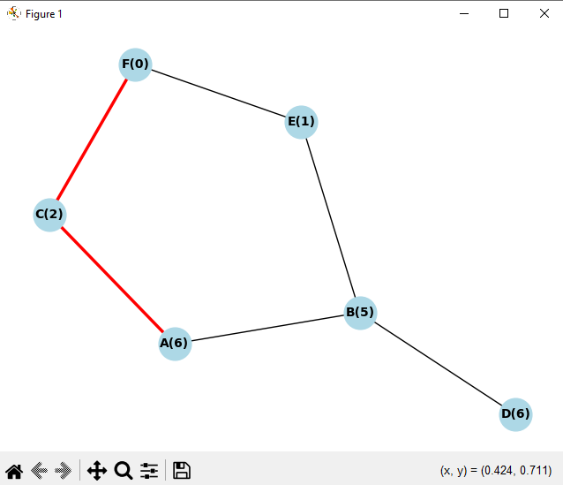

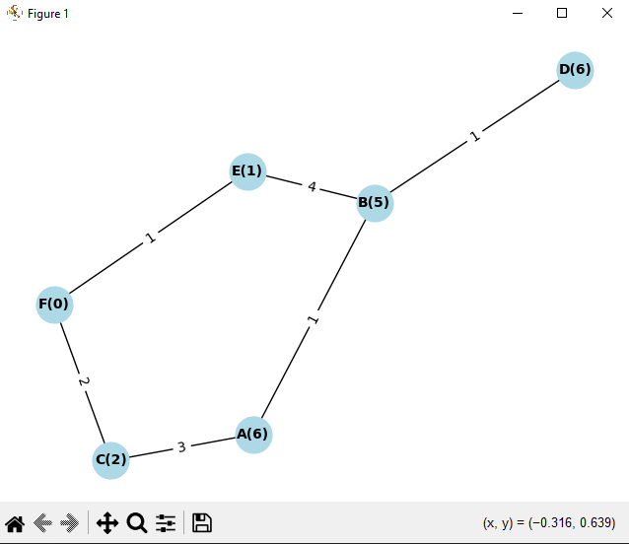
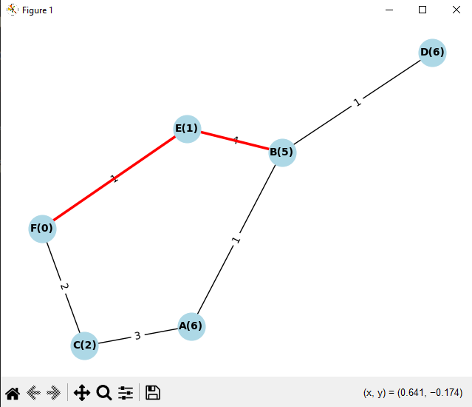

EXAMPLE-2
import heapq
import networkx as nx
import matplotlib.pyplot as plt

def visualize_graph(graph, heuristic, path=None):
G = nx.Graph()
for node, neighbors in graph.items():
for neighbor, cost in neighbors:
G.add_edge(node, neighbor, weight=cost)

pos = nx.spring_layout(G, seed=42)

nx.draw(G, pos, with_labels=False, node_size=700,
node_color="lightblue", font_weight="bold")

labels = {node: f"{node}({heuristic[node]})" for node in G.nodes()}
nx.draw_networkx_labels(G, pos, labels, font_size=10, font_weight="bold")

if path and len(path) > 1:
path_edges = list(zip(path, path[1:]))
nx.draw_networkx_edges(G, pos, edgelist=path_edges,
edge_color="red", width=2.5)

title = "Graph with Heuristics" if not path else "Graph with A* Path"
plt.title(title)
plt.show()

graph = {
'S': [('X', 3), ('Z', 4)],
'X': [('A2', 2), ('C', 3), ('Y', 9)],
'Y': [('A', 5), ('B', 2), ('X', 9), ('Z', 8)],
'Z': [('E', 1), ('Y', 8)],
'A': [('Y', 5), ('D', 2)],
'B': [('Y', 2), ('D', 4), ('E', 3)],
'C': [('X', 3), ('Y2', 9), ('F', 3), ('G', 4)],
'D': [('C', 9), ('A', 2), ('B', 4)],
'E': [('B', 3), ('Z', 1), ('H', 7), ('I1', 8)],
'F': [('C', 3), ('S2', 1), ('J', 2)],
'G': [('C', 4), ('J', 2), ('K1', 3)],
'H': [('E', 7), ('K1', 4)],
'I1': [('E', 8), ('K1', 9)],
'J': [('F', 2), ('G', 2), ('L', 7), ('H2', 5)],
'K1': [('I1', 9), ('H', 4), ('G', 3), ('L', 2)],
'L': [('J', 7), ('K1', 2)],
'A2': [('Y2', 3), ('X', 2)],
'Y2': [('A2', 3), ('U', 4), ('C', 9)],
'U': [('Y2', 4), ('S2', 3)],
'S2': [('U', 3), ('F', 1), ('H2', 2)],
'H2': [('S2', 2), ('J', 5)]
}

heuristic = {
'S': 1, 'X': 2, 'Y': 4, 'Z': 6,
'A': 4, 'B': 3, 'C': 7, 'D': 2,
'E': 5, 'F': 4, 'G': 5, 'H': 7,
'I1': 9, 'J': 3, 'K1': 7, 'L': 1,
'A2': 1, 'Y2': 2, 'U': 3, 'S2': 2, 'H2': 0 # H2 is goal
}

visualize_graph(graph, heuristic)

def a_star_search(graph, start, goal, heuristic):
open_set = []
heapq.heappush(open_set, (heuristic[start], start))

came_from = {}
g_score = {node: float('inf') for node in graph}
g_score[start] = 0

f_score = {node: float('inf') for node in graph}
f_score[start] = heuristic[start]

closed_set = set()

while open_set:
_, current = heapq.heappop(open_set)

if current == goal:
path = []
while current in came_from:
path.append(current)
current = came_from[current]
path.append(start)
return path[::-1]

closed_set.add(current)

for neighbor, cost in graph[current]:
if neighbor in closed_set:
continue

tentative_g_score = g_score[current] + cost
if tentative_g_score < g_score[neighbor]:
came_from[neighbor] = current
g_score[neighbor] = tentative_g_score
f_score[neighbor] = tentative_g_score + heuristic[neighbor]

if not any(neighbor == item[1] for item in open_set):
heapq.heappush(open_set, (f_score[neighbor], neighbor))

return None

visualize_graph(graph, heuristic)

path = a_star_search(graph, 'S', 'H2', heuristic)
print("A* search path:", path)

visualize_graph(graph, heuristic, path)

(B). OUTPUT:
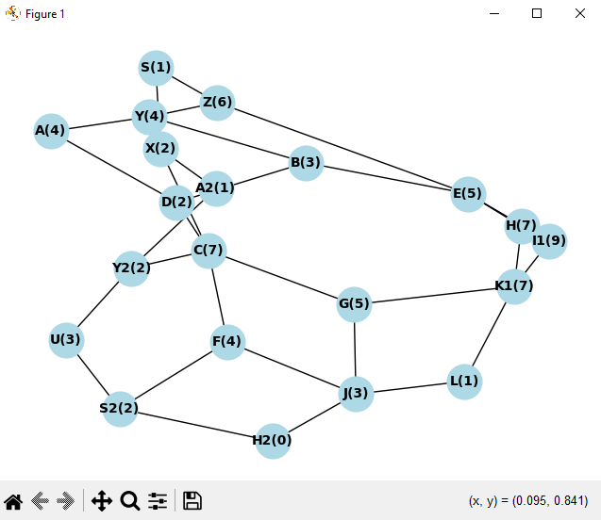
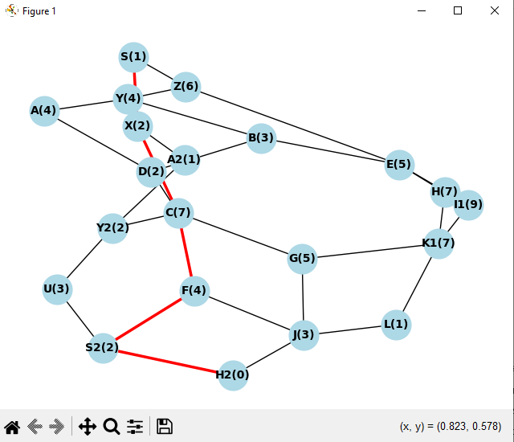

3. Learning outcomes (What I have learnt):
- Understand the concept of heuristic-based informed search and how it differs from uninformed search.
- Learn how A* combines actual path cost and estimated cost to efficiently find the shortest path.
- Gain experience in using priority queues and handling graphs in pathfinding problems.
- Be able to implement and visualize A* algorithm in practical applications like maps, robotics, and AI.
- Develop skills to analyze algorithm performance and verify correctness of paths found

