Worksheet 3.1

Student Name: Ayush Yadav UID: 25IMC13004
Branch: MCA (AI & ML) Section/Group: MAM-1 (A)
Semester: I Date of Performance: 27/10/25
Subject Name: Artificial Intelligence Tools - I Subject Code: 25CAP-614

1. Aim/Overview of the practical:
Experiment-1:
Implementing Hill Climbing Algorithm

2. Coding:
EXAMPLE-1
import matplotlib.pyplot as plt
import networkx as nx

def hill_climbing(graph, heuristic, start, goal):
path = [start]
current = start
while current != goal:
neighbors = graph[current]
if not neighbors:
print("No path found")
return path
next_node = min(neighbors, key=lambda x: heuristic[x])
if heuristic[next_node] >= heuristic[current]:
print("Local optimum reached or dead end.")
break
path.append(next_node)
current = next_node
return path

graph = {
'A': ['B', 'C'],
'B': ['D', 'E', 'G'],
'C': ['F'],
'D': [],
'E': ['G'],
'F': ['G'],
'G': []
}

heuristic = {
'A': 7,
'B': 6,
'C': 2,
'D': 3,
'E': 1,
'F': 1,
'G': 0
}

solution_path = hill_climbing(graph, heuristic, 'A', 'G')
print("Solution Path:", solution_path)

def visualize_graph(graph, heuristic, path):
G = nx.DiGraph()

for node, neighbors in graph.items():
for neighbor in neighbors:
G.add_edge(node, neighbor)

pos = nx.spring_layout(G, seed=42) # consistent layout

node_colors = []
for node in G.nodes():
if node in path:
node_colors.append("lightgreen")
else:
node_colors.append("lightcoral")

plt.figure(figsize=(8, 6))
nx.draw(
G, pos,
with_labels=True,
node_color=node_colors,
node_size=1500,
font_size=12,
font_weight="bold",
arrows=True,
arrowstyle="->",
arrowsize=20
)

labels = {n: f"{n}\n(h={heuristic[n]})" for n in G.nodes()}
nx.draw_networkx_labels(G, pos, labels=labels, font_size=10, font_color="black")

path_edges = list(zip(path, path[1:]))
nx.draw_networkx_edges(G, pos, edgelist=path_edges, edge_color="blue", width=2.5)

plt.title("Hill Climbing Algorithm Visualization", fontsize=14)
plt.show()
visualize_graph(graph, heuristic, solution_path)

OUTPUT:-
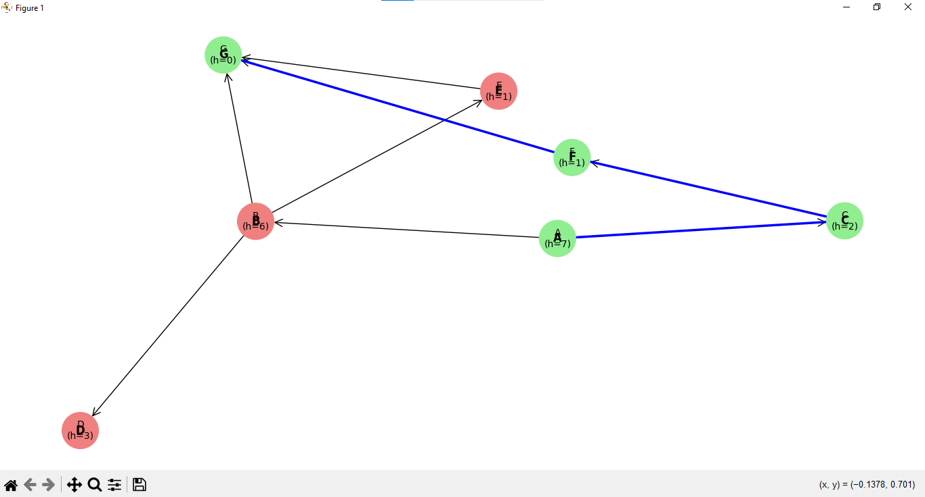

EXAMPLE-2
import random

def objective_function(x):
return -(x - 3) **2 + 9

def hill_climb(start_x, step_size=0.1, max_iteration=100):
current_x = start_x
current_value= objective_function(current_x)

for _ in range (max_iteration):
next_x = current_x + random.choice([-step_size, step_size])
next_value = objective_function(next_x)

if next_value > current_value:
current_x, current_value = next_x, next_value
else:
break

return current_x, current_value

start_x= random.uniform(0,6)
best_x, best_value = hill_climb(start_x)

print(f"Best x found: {best_x:2f}, Maximum value: {best_value:2f}")

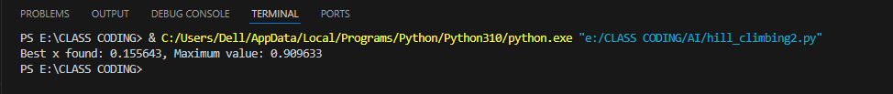

3. Learning outcomes (What I have learnt):
- Understand the concept of heuristic-based local search and how Hill Climbing uses heuristic values to iteratively move toward the goal state.
- Differentiate between Hill Climbing and uninformed search algorithms, recognizing its reliance on heuristics and lack of backtracking or path cost consideration.
- Learn how Hill Climbing selects the next state based on the best heuristic value and understand its limitations, such as getting stuck in local maxima, plateaus, or ridges.
- Gain hands-on experience in implementing and visualizing the Hill Climbing algorithm for optimization and pathfinding problems in areas like AI, game development, and robotics.
- Develop skills to analyze algorithm behavior and performance, including detecting local optima and verifying the effectiveness of heuristic functions.

