Worksheet 3.2

Student Name: Ayush Yadav UID: 25IMC13004
Branch: MCA (AI & ML) Section/Group: MAM-1 (A)
Semester: I Date of Performance: 02/11/25
Subject Name: Artificial Intelligence Tools - I Subject Code: 25CAP-614

1. Aim/Overview of the practical:
Experiment-1:
Implement Minimax Algorithm

2. Coding:
EXAMPLE-1
import networkx as nx
import matplotlib.pyplot as plt

class GameTree:
def __init__(self):
self.tree = {
'A': ['B', 'C'],
'B': ['D', 'E'],
'C': ['F', 'G'],
'D': [3, 5],
'E': [6, 1],
'F': [2, 9],
'G': [0, 4]
}

def minimax(self, node, is_max_turn=True):
"""Recursive Minimax algorithm with value return"""
if isinstance(self.tree[node][0], int): # leaf node
return max(self.tree[node]) if is_max_turn else min(self.tree[node])

child_values = {}
for child in self.tree[node]:
val = self.minimax(child, not is_max_turn)
child_values[child] = val

if is_max_turn:
best_child = max(child_values, key=child_values.get)
else:
best_child = min(child_values, key=child_values.get)

# Store best child for visualization
self.best_path[node] = best_child
return child_values[best_child]

def build_graph(self):
"""Builds a NetworkX graph from the tree structure"""
G = nx.DiGraph()
for parent, children in self.tree.items():
for child in children:
G.add_edge(parent, str(child))
return G

# --- Driver Code ---
game = GameTree()
game.best_path = {} # store best choices during minimax
optimal_value = game.minimax('A', True)

# Build graph
G = game.build_graph()

# Node positions for visualization
pos = nx.spring_layout(G, seed=42)

# Determine all edges and optimal path edges
all_edges = list(G.edges())
optimal_edges = []
node = 'A'
while node in game.best_path:
child = game.best_path[node]
optimal_edges.append((node, str(child)))
node = str(child)

# Draw all edges
nx.draw(G, pos, with_labels=True, node_size=2000, node_color="#87CEEB",
font_size=10, font_weight="bold", edgecolors="black")

# Highlight optimal path
nx.draw_networkx_edges(G, pos, edgelist=optimal_edges, edge_color="red", width=3)

# Show labels for leaf nodes (numeric values)
leaf_labels = {str(v): str(v) for k, vals in game.tree.items() if isinstance(vals[0], int) for v in vals}
nx.draw_networkx_labels(G, pos, labels=leaf_labels, font_color="black")

# Title
plt.title(f"Minimax Game Tree (Optimal Value at Root = {optimal_value})", fontsize=12, fontweight="bold")
plt.show()

OUTPUT:-
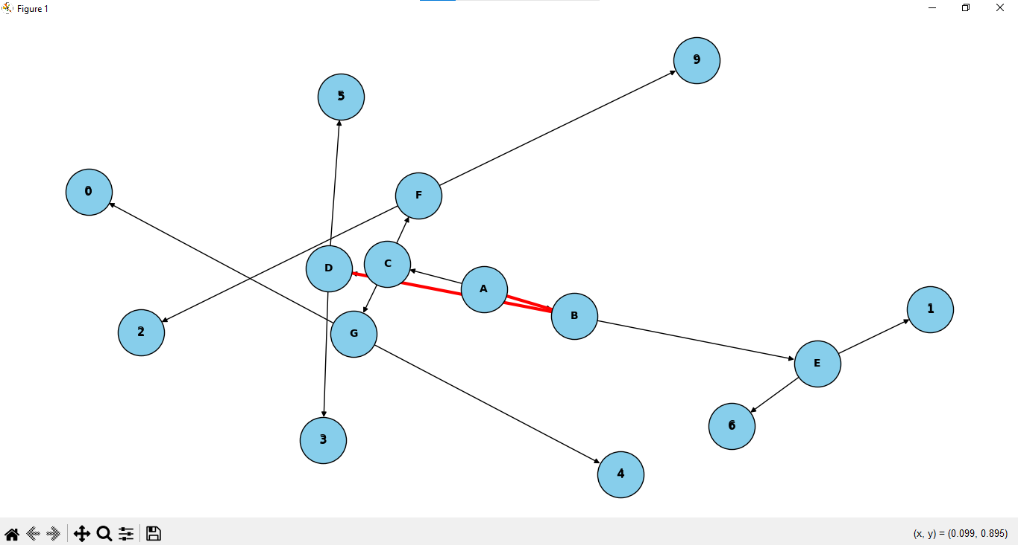

EXAMPLE-2
import networkx as nx
import matplotlib.pyplot as plt

class GameTree:
def __init__(self):
self.tree = {
'A': ['B', 'C'],
'B': ['D', 'E'],
'C': ['F', 'G'],
'D': [8, 2],
'E': [7, 5],
'F': [9, 1],
'G': [4, 6]
}

def minimax(self, node, is_max_turn=True):
"""Recursive Minimax algorithm"""
if isinstance(self.tree[node][0], int): # leaf node
return max(self.tree[node]) if is_max_turn else min(self.tree[node])

child_values = {}
for child in self.tree[node]:
val = self.minimax(child, not is_max_turn)
child_values[child] = val

if is_max_turn:
best_child = max(child_values, key=child_values.get)
else:
best_child = min(child_values, key=child_values.get)

# Store best child for visualization
self.best_path[node] = best_child
return child_values[best_child]

def build_graph(self):
"""Builds a NetworkX graph from the tree"""
G = nx.DiGraph()
for parent, children in self.tree.items():
for child in children:
G.add_edge(parent, str(child))
return G

# --- Driver Code ---
game = GameTree()
game.best_path = {}
optimal_value = game.minimax('A', True)

# Build graph
G = game.build_graph()

# Layered positions for a clean tree layout
pos = {
'A': (0, 3),
'B': (-2, 2), 'C': (2, 2),
'D': (-3, 1), 'E': (-1, 1), 'F': (1, 1), 'G': (3, 1),
'8': (-3.5, 0), '2': (-2.5, 0),
'7': (-1.5, 0), '5': (-0.5, 0),
'9': (0.5, 0), '1': (1.5, 0),
'4': (2.5, 0), '6': (3.5, 0)
}

# Determine edges
all_edges = list(G.edges())
optimal_edges = []
node = 'A'
while node in game.best_path:
child = game.best_path[node]
optimal_edges.append((node, str(child)))
node = str(child)

# Draw graph
nx.draw(G, pos, with_labels=True, node_size=2000, node_color="#90CAF9",
font_size=10, font_weight="bold", edgecolors="black")

# Highlight optimal path
nx.draw_networkx_edges(G, pos, edgelist=optimal_edges, edge_color="red", width=3)

# Show labels for leaf values
leaf_labels = {str(v): str(v) for k, vals in game.tree.items() if isinstance(vals[0], int) for v in vals}
nx.draw_networkx_labels(G, pos, labels=leaf_labels, font_color="black")

# Title
plt.title(f"Minimax Game Tree (Optimal Value at Root = {optimal_value})", fontsize=12, fontweight="bold")
plt.axis('off')
plt.show()

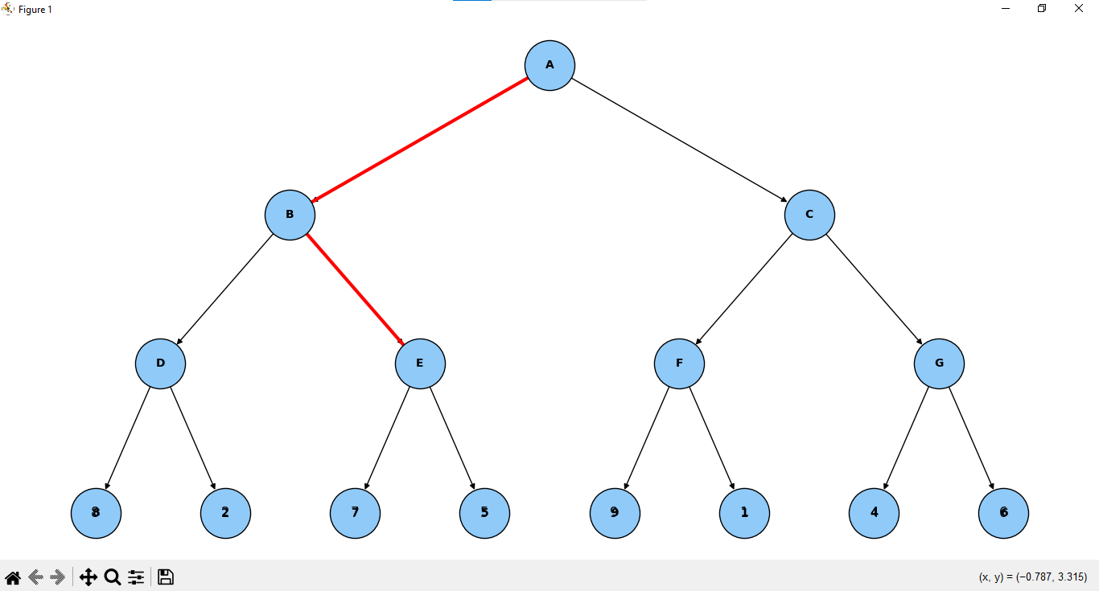
3. Learning outcomes (What I have learnt):
- Learners will be able to explain how the Minimax algorithm helps two-player (adversarial) games make optimal decisions by minimizing possible losses.
- Learners will understand the roles of maximizing and minimizing players and how they alternately choose the best or worst possible outcomes at each level.
- Learners will develop the ability to implement recursive logic to evaluate game trees, compute optimal values, and trace decision paths.
- Learners will be able to construct and visualize a game tree using Python libraries (like NetworkX and Matplotlib) and identify the optimal path visually.
- Learners will gain insight into the computational complexity of Minimax and understand why optimization techniques like Alpha-Beta Pruning are needed for larger trees.

