Worksheet 1.1

Student Name: Ayush Yadav UID: 25IMC13004
Branch: MCA (AI & ML) Section/Group: MAM-1 (A)
Semester: I Date of Performance: 20/08/25
Subject Name: Advanced Database Subject Code: 25CAP-602
Management System

1. Aim/Overview of the practical:
Experiment-1:

Write a program to implement quick sort using the divide-and-conquer method to efficiently sort an array in C.

2. Apparatus:
Supported Operating Systems:
- Windows 10 64-bit or later
- GCC (GNU Compiler Collection)
- Visual Studio Code
- C Standard Library (stdio.h, stdlib.h)

3. Coding :
#include <stdio.h>
void swap(int *a, int *b)
{
int t = *a;
*a = *b;
*b= t;
}
int partition (int arr[], int low, int high)
{
int pivot = arr[high];
int i = (low-1);

for( int j=low;j<= high-1; j++)
{
if (arr[j] <= pivot)
{
i++;
swap(&arr[i], &arr[j]);
}
}
swap (&arr[i+1], &arr[high]);
return (i+1);
}
void quickSort (int arr[], int low, int high) {
if (low<high) {
int pi=partition(arr, low, high);
quickSort(arr, low, pi-1);
quickSort(arr, pi+1, high);
}
}

void printarray(int arr[], int size)
{
for (int i=0; i<size; i++)
printf("%d", arr[i]);
printf("\n");
}
int main()
{
int arr[]= {1,7,8,9,5};
int n = sizeof(arr)/ sizeof(arr[0]);
printf("Original Array:");
printarray(arr,n);
quickSort(arr, 0, n-1);
printf("Sorted Array:");
printarray(arr,n);
return 0;
}

OUTPUT:-
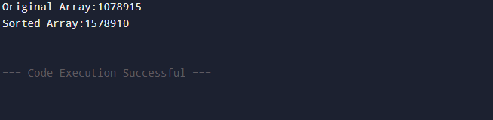

4. Learning outcomes (What I have learnt):
- Understand the working principle of the Quick Sort algorithm
- Learn how to implement Quick Sort using recursion and partitioning.
- Analyze the time and space complexity of Quick Sort
- Compare Quick Sort with other sorting algorithms in terms of efficiency.
- Develop problem-solving skills using divide-and-conquer techniques.

