Assignment – 1

• Install Power BI Desktop and share the final screenshot of the report view page which appears when power desktop starts.

Answer: 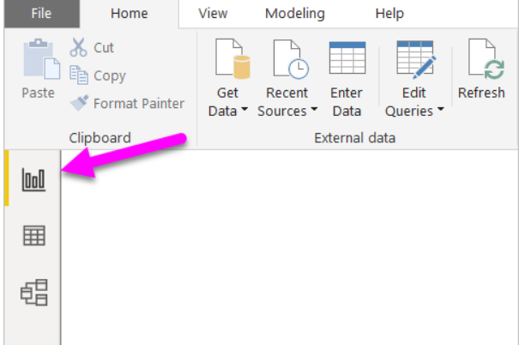

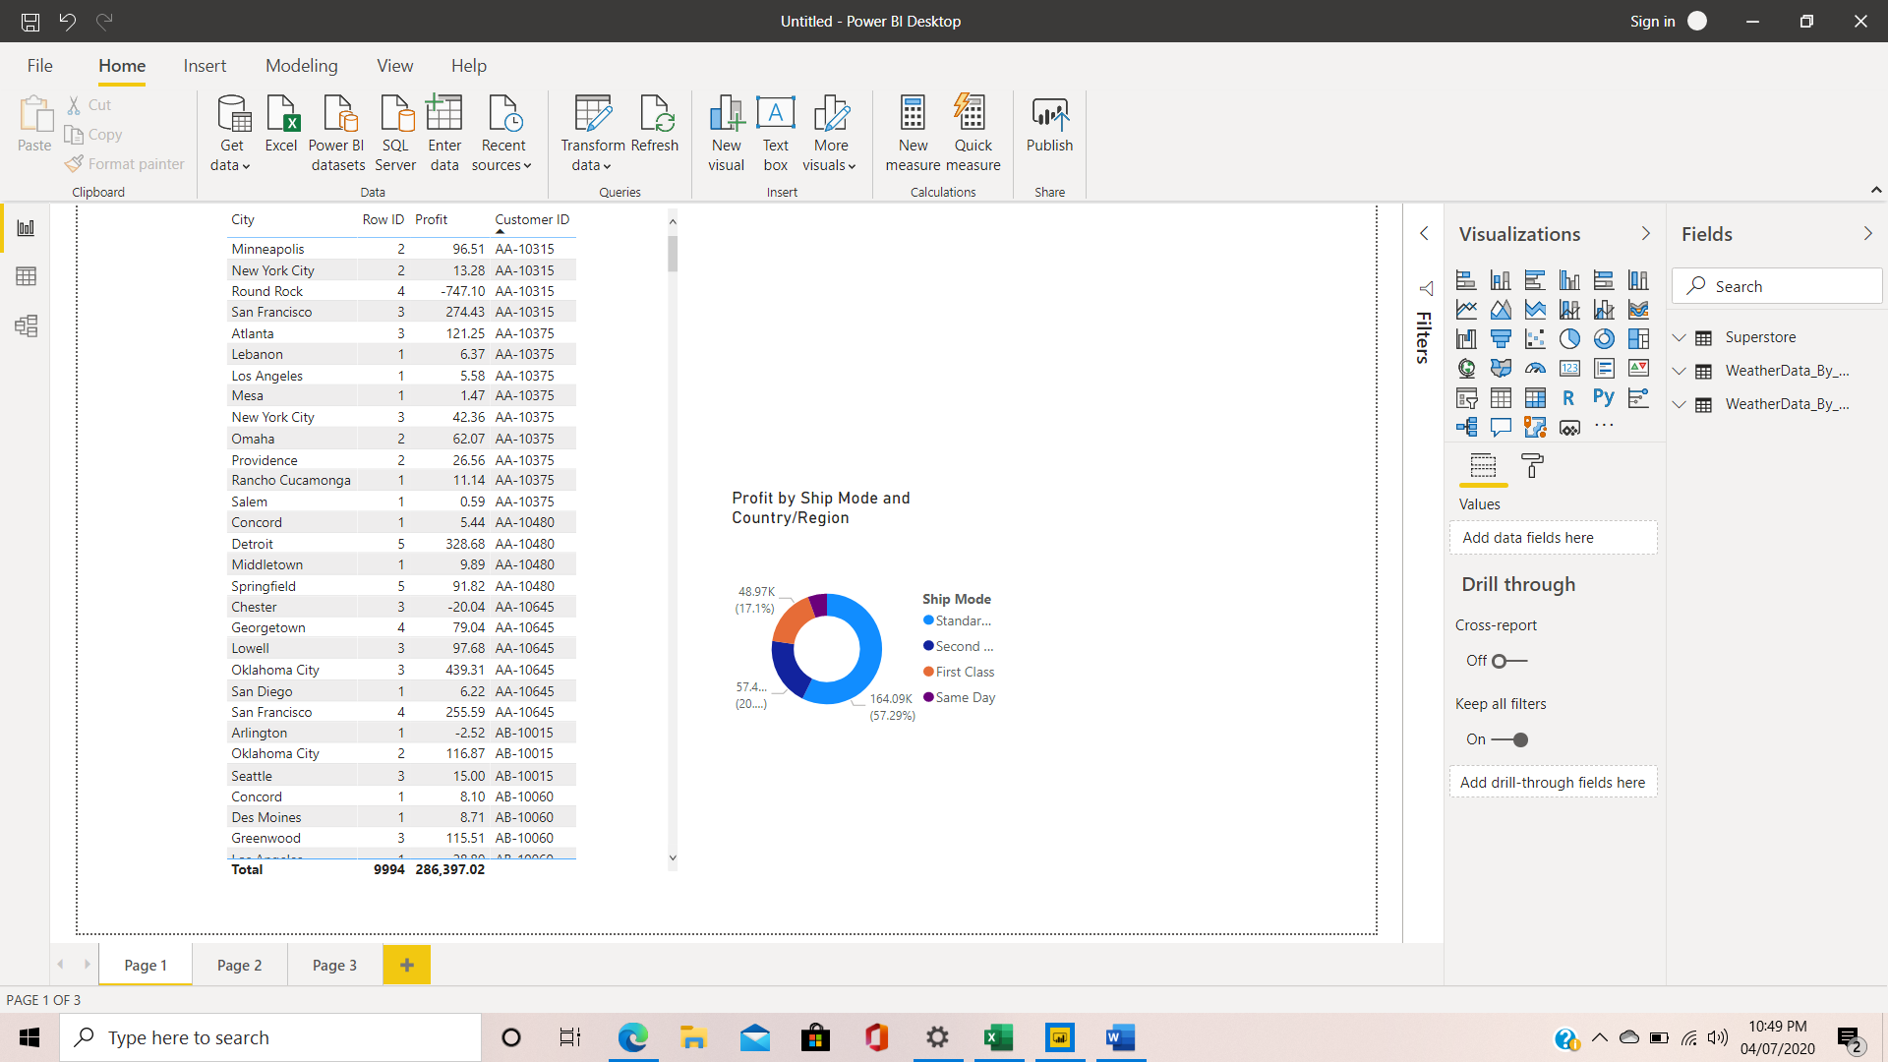

• Prepare a document and with the following screenshot

− Report View

− Data View

− Model View

− Power Query Editor

− Advance Editor

Answers:

Report view: 

Data view:

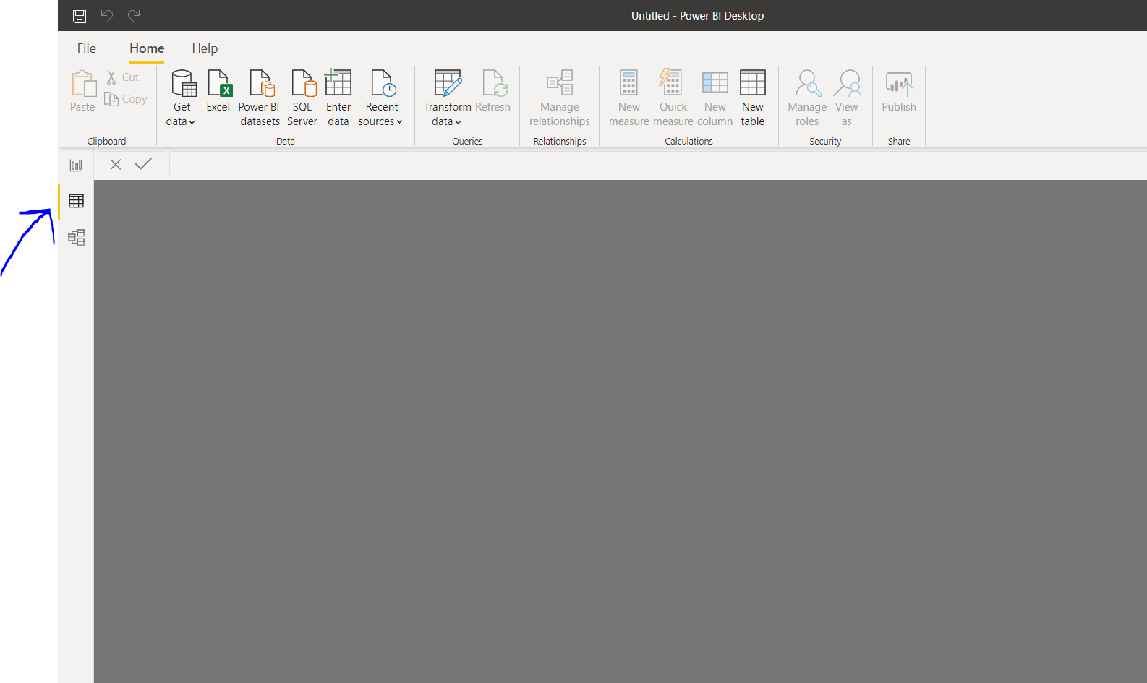

ModelView:

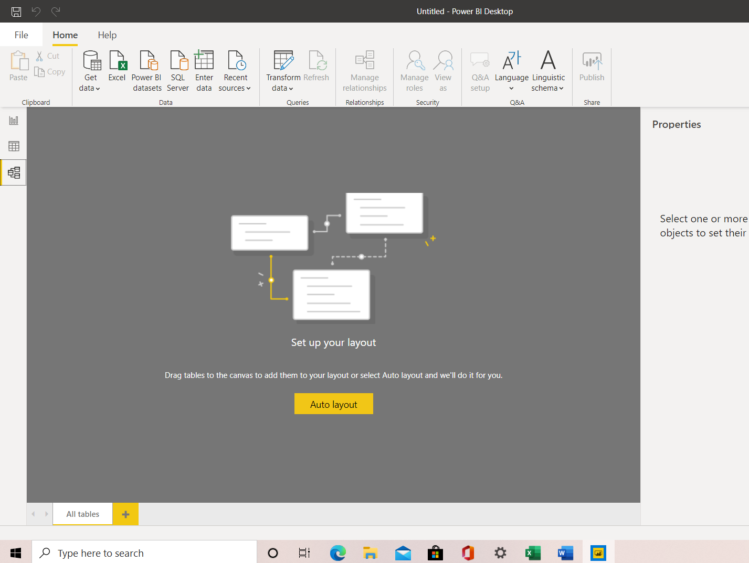

Power Query Editor:

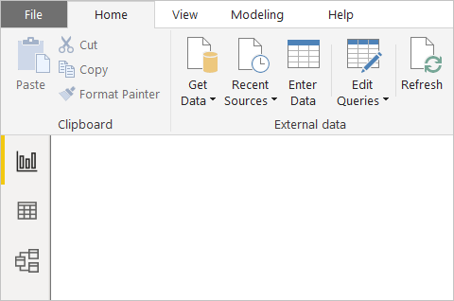

With no data connections, Power Query Editor appears as a blank pane, ready for data.

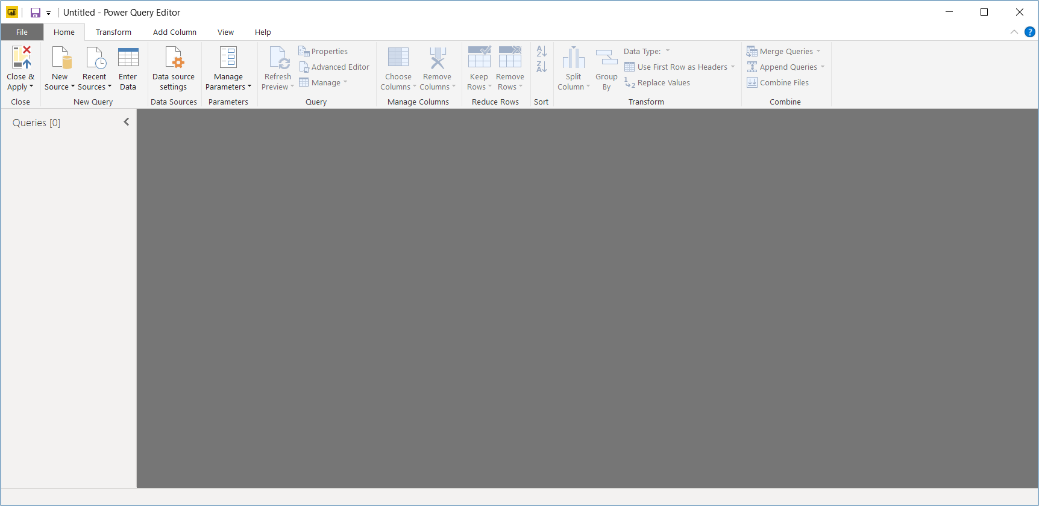

Advance Editor: The **Advanced Editor** lets you see the code that Power Query Editor is creating with each step. It also lets you create your own shaping code. To launch the advanced editor, select **View** from the ribbon, then select **Advanced Editor**. A window appears, showing the existing

query code.

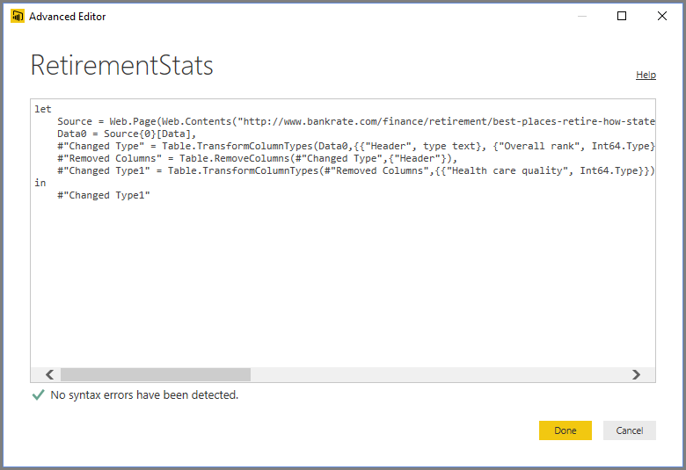

• Prepare a document with details of the following along with their price − Power BI Desktop − Power BI Pro − Power BI Premium.

Answer:

## Power BI Desktop: What is Power BI Desktop?

Power BI Desktop is basically the version of Power BI that you install on to your local system / computer to access the basic features of Power BI and act as a companion to the main, cloud based application. It is the ideal version to start with no matter your skill level Power BI Free enables you to connect to 70+ data sources, analyse data, publish to the web, export to excel and much more.

**Is power bi free?**

Yes, this particular version of Power BI is free to download and use while giving you all the basic features of Power BI.

**Who is Power BI Free for?**

Power BI free is for anybody and everybody that wants to glean meaningful insight from their data and apply it to their business. It is ideal for small business owners and individual professionals for whom large scale collaboration and integration is not always necessary.

Power BI PRO: Power BI Pro is the full version of Power BI, which means it comes complete with the ability to use Power BI for both building dashboards, reports and unlimited viewing, sharing and consumption of your created reports (and reports shared by others) which is not possible with Power BI Desktop.

The biggest difference of Power BI Pro vs. Free is the fact that with Pro you have the option and the ability to share the data, reports, and dashboards with a large number of other users that also have a Power BI Pro license while also being able to create an app based workspace. Furthermore, in Power BI Pro vs. Free you have a 10 GB per Pro user data storage limit.

## Who is Power BI Pro for?

Primarily, Power BI Pro vs. Free is licensed by individual users. This means that for you to use Power BI Pro in your organisations means each individual will receive their won Power BI Pro license and the collaborative use of which will allow every member of the organisation to integrate their workspace and therefore, their efforts. In other words, if your organisation has 10 people that need the full capabilities offered by Power BI Pro to create dashboards and reports, you require 10 licenses of Power BI Pro. If you have a much greater quantity of user, Power BI Premium would be a better idea considering the scale of operations as eventually, the cost will far exceed the benefits.

## Power BI Pro Cost

The Pro plan costs $9.99/user/month. It includes data collaboration, data governance, building dashboards with a 360-degree real-time view and the ability to publish reports anywhere. Users can try it a free trial for 60 days before purchasing the subscription.

Power BI Premium:

## What is Power BI Premium?

The Power BI Premium licence is not a per-user licence like a Free or Pro Licence. Instead, Power BI Premium licence provides a dedicated unit of capacity for all users in the organisation. This dedicated capacity (aka Premium Workspace) can be used to host large datasets up to 50GB while offering a total storage of 100TB in the cloud.

It enables your organization to use your own dedicated capacity and hardware rather than relying on Microsoft’s shared capacity. Although you will in fact need to determine said capacity accurately and ensure that it has the capabilities to handle your reporting and analysis needs. This allows for much larger scale and better performance if you size the capacity properly. Microsoft offers three sizes for Premium capacity and each come with a different number of v-cores and memory size.

## Who is Power BI Premium for?

Power BI Premium is for use in large organisations with a great number of users that need to collaborate in real time. The application is geared towards addressing the challenges of large enterprise deployments and workloads.

## Power BI Premium Cost

The Premium plan starts at $4,995 a month per dedicated cloud compute and storage resource. This does not include the cost of licensing for individual Pro and Free licenses required for each user in your organisation.