AI diagnostic assistant
Project Report
Fine-tuning Small Language Models for Accurate Diagnostics

Authors: Abhinav Rawat | Ayush Shukla | Priyansh Dahiya
Date: July 2026
Models: Mistral 7B | Qwen 2.5 7B | Llama 3.1 8B | Phi3-mini 3.8B

Abstract
This report documents the design, implementation, and evaluation of a three-stage fine-tuning pipeline for Small Language Models (SLMs) applied to smartphone repair diagnosis. Four model families were explored: Phi3-mini 3.8B, Qwen 2.5 7B, Llama 3.1 8B, and Mistral 7B. Only Mistral 7B completed the full pipeline (Single-Turn SFT → Multi-Turn SFT → DPO). The fine-tuned Mistral model (mistral-phonefix-multiturn) achieved a combined semantic similarity score of 0.8383 on a 30-sample held-out test set and an LLM-as-Judge average of 0.954 across five behavioural rubrics. When paired with Retrieval-Augmented Generation (RAG) over the Samsung Galaxy A35 service manual, the model achieved a RAGAS blended error rate of ~0.11 on an unseen device, validating generalisation without retraining. All training was performed on a single Tesla T4 GPU using 4-bit QLoRA quantisation via Unsloth.

Table of Contents

1. Project Overview 06

1.1 Objective and Scope
1.2 Model Objectives
1.3 Model Families Evaluated

2. Dataset 07

2.1 Training Dataset
2.2 Source Distribution by Brand
2.3 System Prompt
2.4 Evaluation / Test Dataset
2.5 DPO Preference Dataset

3. Evaluation Framework

3.1 Automated Semantic Evaluation for SFT Stages
3.2 LLM-as-Judge Evaluation for DPO Stage
3.3 Judge Rubrics and Scoring Criteria

4. Method 1 — Single-Turn Supervised Fine-Tuning (SFT)

4.1 Stage Objective
4.2 Training Configuration
4.3 Impact of Single-Turn SFT

5. Method 2 — Multi-Turn Supervised Fine-Tuning

5.1 Stage Objective
5.2 Training Configuration
5.3 Conversation Pattern Design
5.4 Impact of Multi-Turn SFT
5.5 Best Checkpoint Result

6. Method 3 — Direct Preference Optimisation (DPO)

6.1 DPO Objective
6.2 DPO Run 1: Training Collapse
6.3 Root Cause of Collapse
6.4 DPO Run 2: Fixed Configuration
6.5 DPO Run 2 Result
6.6 What DPO Achieved

7. RAG Experiment — Samsung A55 Service Manual

7.1 Motivation for RAG
7.2 RAG Pipeline Setup
7.3 Model Comparison: Mistral vs Phi3 with RAG
7.4 Two-Tier Quality Pattern: RAG vs Training
7.5 Long-Term Architecture Recommendation

8. Data Quality Fixes

8.1 Rejected Response Rebuild for DPO
8.2 Training Data Corrections
8.3 Summary of Data Quality Edits

9. Results — Mistral Multiturn Primary Checkpoint

9.1 Overall Metrics
9.2 Score Distribution
9.3 Results by Brand
9.4 Results by Topic
9.5 Hallucination Indicators
9.6 LLM-as-Judge Analysis on Held-Out Test Set
9.7 Configuration Benchmark on Samsung A35 Unseen Manual
9.8 Why Fine-Tuned SLM + RAG Is the Recommended Configuration

10. Results — Mistral DPO: Run 1 Collapse and Run 2 Success

10.1 Overview of Both DPO Runs
10.2 Run 1: Collapsed Run Diagnostic Analysis
10.3 Overall Metrics: DPO vs Multiturn
10.4 Score Band Comparison
10.5 Topic-Level Changes
10.6 Run 2: Successful Rerun
10.7 Behavioural Result of Run 2

11. End-to-End Architecture

11.1 Data Preparation Pipeline
11.2 Fine-Tuning Pipeline
11.3 RAG Inference Pipeline
11.4 Evaluation Mapping Across Stages

12. Stage-by-Stage Impact Summary

13. Failure Mode Analysis

13.1 Failure Mode 1: Model Identifier Hallucination
13.2 Failure Mode 2: Response Length Ceiling
13.3 Failure Mode 3: System Prompt Regression
13.4 Failure Mode 4: Brand Terminology Errors in Training Data
13.5 Failure Mode 5: DPO Training Collapse

14. Key Lessons Learned

15. Model Selection — Why Mistral 7B

15.1 Candidate Models and Outcomes
15.2 Key Differentiator: Phi3 vs Mistral with RAG
15.3 Phi3 Output Samples — Base vs Fine-Tuned
15.4 Final Demonstration — Mistral SLM + RAG

16. RAGAS Evaluation — Unseen Manual (Samsung Galaxy A35)

16.1 Behavioural Evaluation Results
16.2 Key Findings from RAGAS Analysis
16.3 Failure Patterns Identified
16.4 Overall Assessment

17. Inference Performance

17.1 Hardware Configuration
17.2 Model Size and Loading
17.3 Inference Benchmarks
17.4 Key Observations
17.5 Limitations and Threats to Validity

18. Conclusion

18.1 What Was Accomplished
18.2 What Was Learned
18.3 Next Steps
18.4 Bottom Line

19. Model Checkpoint Status

20. Reproducibility and Ethics

20.1 Reproducibility Note
20.2 Data Provenance, Licensing, and Ethics Note

21. References
1. Project Overview
Goal: Train multiple Small Language Models (SLMs, 7–8B parameters) to behave like expert smartphone repair technicians.

1.1. Model Objectives
- Identify the root cause of a phone issue
- Always exhaust software/settings fixes before recommending disassembly
- Give structured, step-by-step diagnostic responses
- Cover all major brands: Samsung, Apple, Google, Xiaomi, OnePlus, Motorola
- Handle multi-turn conversations where a user reports completed steps
- Escalate to professional service when appropriate

1.2. Training Stages
Stage | Description
Stage 1: SFT (Single-Turn) | Teach the response format and domain knowledge
Stage 2: Multi-Turn SFT | Teach conversation-aware behavior
Stage 3: DPO | Reinforce software-first preference over hardware-first

1.3. Model Families
- Mistral 7B Instruct v0.3
- Qwen 2.5 7B Instruct
- Phi3-mini 3.8B Instruct
- Llama 3.1 8B Instruct
All training was done via Unsloth FastLanguageModel (4-bit QLoRA) on Kaggle GPU. Checkpoint status for each model is summarised in Section 18.
Pipeline Completion Status by Model
Only Mistral 7B completed the full three-stage pipeline (SFT → Multi-Turn SFT → DPO) and is the primary model discussed throughout this report. Phi3-mini completed SFT + Multi-Turn SFT and is used specifically for the RAG comparison study in Sections 7 and 14. Qwen 2.5 7B and Llama 3.1 8B completed Stage 1 SFT only and are included for baseline comparison (see Section 14).

2. Dataset

2.1. Training Dataset
File: phone_repair_dataset_upgraded_final.jsonl Records: 902 (web-scraped/synthetic) Format: Alpaca-style (instruction, input, output, source, topic, difficulty)
Note: 902 refers to the core web-scraped/synthetic training set used for SFT (matches the brand distribution table below). Combined with the 33 records extracted from the Samsung A55 service manual PDF (Section 7), the total combined dataset used across the project is 935 records.

Source Distribution
Brand | Record Count
Samsung | 437
Apple | 157
Xiaomi | 110
Google | 107
OnePlus | 78
General | 11
Motorola | 2

System Prompt
Repair Technician System Prompt
You are an expert smartphone repair technician with 10+ years of experience. STRICT RULE: Always exhaust ALL software and settings fixes before suggesting any hardware repair or disassembly. Your response structure must always follow this order: (1) Identify the likely root cause. (2) Software fixes first. (3) External hardware checks. (4) Physical inspection. (5) Disassembly only as last resort. (6) State when professional service is required.

2.2. Evaluation / Test Dataset
File: unseen_test_dataset.jsonl (held-out, never seen during training) Records: 30
- Purpose: held-out evaluation set, never seen during any training stage
- Sources: Samsung (10), Apple (5), Google (4), OnePlus (4), Xiaomi (4), Motorola (3)
- Difficulty: Easy (7), Medium (17), Hard (6)

2.3. DPO Preference Dataset
File: dpo_pairs.jsonl Total Pairs: 679 (655 original + 24 targeted for lowest-scoring topics)
- Format: prompt, chosen (software-first), rejected (hardware-first)
- Avg chosen length: ~2183 characters
- Avg rejected length: ~394 characters (length ratio 0.18 vs chosen)

3. Evaluation Framework

3.1. Automated Semantic Evaluation (SFT Stages)
Compares model outputs against ground truth using text similarity. Runs inference twice — once with system prompt, once without — to measure how much the system prompt actually contributes.
Metric | Description
Semantic Similarity | Semantic embedding similarity using sentence-transformers
Paraphrase Overlap | BERTScore-style n-gram paraphrase overlap
Combined Score | Weighted average of both (primary metric)
Length Ratio | Prediction length divided by ground truth length — measures completeness
Prompt Delta | Combined score with system prompt minus without — positive means prompt helps

3.2. LLM-as-Judge Evaluation (DPO Stage)
Rubric-based evaluation using Claude Sonnet 4.6 as the judge model. Applied to measure behavioural quality — software-first ordering, hallucination, safety escalation — which semantic similarity metrics cannot capture.

5 Judge Rubrics
- Root Cause Accuracy — does the model correctly identify why the issue occurs?
- Sequence Compliance — does it follow software → hardware order strictly?
- Completeness (0–1) — how thorough is the step coverage?
- Hallucination-Free Rate — does it avoid inventing part numbers, wrong specs, or fake model IDs? (higher = better)
- Safety Compliance — does it recommend professional service when appropriate

4. Method 1 — Single-Turn Supervised Fine-Tuning (SFT)
The first training stage. A pretrained instruct model is fine-tuned on 902 phone repair examples using LoRA (Low-Rank Adaptation) in 4-bit quantized mode. Each example is a single user question paired with an expert structured response.

4.1. Training Configuration
Parameter | Mistral | Qwen / Llama / Phi-mini
Method | QLoRA via Unsloth FastLanguageModel | Same
Dataset | phone_repair_dataset_upgraded_final.jsonl (902 records) | Same
LoRA r / alpha | 16 / 32 | Same
LoRA dropout | 0.05 | Same
Epochs | 3 | Same
Learning rate | 3e-4 | 2e-4
Batch size | 2 per device | Same
Gradient accumulation | 4 (effective batch = 8) | Same
Max seq length | 2048 | 4096
Warmup ratio | 0.08 | Same
Packing | True | Same

4.2. Impact of SFT

Before SFT (Raw Base Model)
- Generic, shallow troubleshooting
- No consistent structure
- No brand-specific knowledge
- No concept of software-first ordering
- No safety escalation logic

After SFT
- Consistent structured format: “Issue: / Possible Causes: / Step-by-Step:”
- Domain vocabulary: OEM parts, flex cable, pry tool, heat gun, spudger, NTC thermistor, logic board, ESD precautions
- Brand-specific knowledge: SUPERVOOC for OnePlus, Samsung Members diagnostic app, Dynamic Island on iPhone 15
- System prompt compliance: model follows the “software first” ordering
- Safety escalation: adds “take to authorized service center” when appropriate
- Difficulty scaling: easy questions get concise responses; hard questions get deeper differential diagnosis

5. Method 2 — Multi-Turn Supervised Fine-Tuning
The second training stage. The SFT model is fine-tuned again on synthetically generated multi-turn conversations (2–4 turns each), where the user progressively reports what they have already tried and the model builds on that context.

5.1. Training Configuration
Parameter | Value
Base model | [model]-phonefix-v1 (output of Stage 1)
Epochs | 2
Learning rate | 2e-4
Batch size | 2
Gradient accumulation | 4
Max seq length | 4096
LR scheduler | cosine
Weight decay | 0.01

5.2. Conversation Patterns (6 Types)
Pattern | Description
already_tried | User says “I already restarted it” — model skips done steps
clarification | Model asks “When did this start? Any recent updates?”
escalation | Conversation ends with “take it to a service centre”
success_prevention | User tries to skip to disassembly; model redirects
followup_question | User asks why a step is needed; model explains
stepbystep_guidance | User confirms each step as they complete it

5.3. Impact of Multi-Turn SFT
- Context awareness: model reads and references what the user has already reported
- Progressive diagnosis: each turn advances without repeating completed steps
- User pushback handling: “I don’t want to factory reset” is acknowledged
- Natural escalation flow: model recognizes when all software options are exhausted
- Proper conversation closure: response ends conclusively rather than mid-thought
Best Checkpoint Result
Combined score mean = 0.8383 — the highest performing model across all training stages.

6. Method 3 — DPO (Direct Preference Optimization)
The third training stage. Instead of learning from correct answers (SFT), DPO trains the model to explicitly prefer one response style over another by comparing chosen (preferred) and rejected (dispreferred) response pairs.

6.1. DPO Run 1 — Training Collapse

Hyperparameters
Parameter | Value
Beta | 0.2
Loss type | sigmoid
Learning rate | 5e-5
LoRA r / alpha | 8 / 16
LoRA dropout | 0.0
Max length | 2048
Epochs | 1

Collapse observed at step 37 of 74:
- loss = 0.000
- rewards/chosen = 162.xx (should stay near 0–2 for healthy training)
- rewards/accuracies = 1.000 (model 100% confident on every pair — overfit)
Root Cause
650 of 655 rejected responses started with “Issue:” — the same header as chosen. DPO saw structurally identical pairs, found trivial token differences, learned them instantly, and converged to zero loss in 37 steps.

6.2. DPO Run 2 — Fixed Configuration
Fix | Change | Reason
Beta | 0.2 → 0.5 | Tighter KL penalty, prevents reward divergence
Loss type | sigmoid → IPO | IPO does not collapse on similar pairs
Learning rate | 5e-5 → 2e-5 | Slower updates, less overfit to easy pairs
LoRA r / alpha | 8/16 → 4/8 | Reduced capacity, less memorization
LoRA dropout | 0.0 → 0.05 | Regularization added
Max length | 2048 → 1024 | Forces structural focus

Rejected responses were also fully rebuilt using hardware-first templates with no “Issue:” header, immediate disassembly recommendation, and no software steps. 24 new targeted DPO pairs were added for the 5 lowest-scoring eval topics.
DPO Run 2 — Result: Success
With the fixed configuration and rebuilt rejected pairs, DPO Run 2 completed the full training schedule without collapsing: loss decreased smoothly, rewards/chosen stayed within a healthy range, and rewards/accuracies no longer saturated at 1.0 early in training. The resulting checkpoint (mistral-phonefix-dpo) is the final model used for all downstream RAG and behavioural evaluation in Sections 9 and 15, and consistently produces software-first diagnostic ordering — the core objective of this training stage.

6.3. What DPO Achieved
The core purpose of DPO in this pipeline was to teach the model the preference for software-first diagnosis as a deeply reinforced behaviour — not just a format rule learned during SFT. While SFT taught the model what the correct structure looks like, DPO taught it why to prefer software steps first by explicitly training it to reject hardware-first responses at every turn.
- Software-first ordering reinforced: the 655 chosen responses all follow exhaustive settings/cache/reset ordering; every rejected response goes straight to disassembly. The model internalises this preference across all brands and topics.
- Safety escalation strengthened: all chosen responses include a clear escalation to authorised service with a specific reason; rejected responses omit escalation entirely.
- Weak topic improvement: 24 targeted pairs were added for the 5 lowest-scoring topics (GPS, wireless charging, S Pen, software bug, screen).
- Structural contrast: rebuilt rejected responses average only 394 characters versus 2183 for chosen — ensuring DPO learns a meaningful preference rather than superficial token differences.
Key Insight
DPO does not improve semantic similarity scores — it changes how the model reasons. Gains are visible in the LLM-as-Judge rubrics (sequence compliance, safety compliance), not in text similarity metrics.

7. RAG Experiment — Samsung A55 Service Manual
Before committing to full fine-tuning, a RAG (Retrieval-Augmented Generation) experiment was run using the official Samsung Galaxy A55 service manual (SM-A556B_RepairGuide_Open_Eng_Rev.1.0_240327_.pdf) to see if grounding could reduce hallucination without additional training.

RAG Pipeline Setup
Step | Details
1. PDF extraction | pypdf extracts raw text page by page
2. Chunking | 600 char chunks, 100 char overlap, 80 char minimum
3. Embedding | sentence-transformers/all-MiniLM-L6-v2 → 384-dim vectors
4. FAISS index | IndexFlatIP (cosine similarity on L2-normalized vectors)
5. Retrieval | Top-5 chunks per query, 0.25 score threshold
6. Prompt injection | Retrieved chunks prepended with grounding instruction

7.1. Model Comparison: Mistral vs Phi3 with RAG
Behavior | Mistral 7B (fine-tuned) + RAG | Phi3 (compared model) + RAG
Grounding instruction | Followed correctly | Ignored — used parametric memory
Tool/step citations | Cited exact tool names from manual | Hallucinated specs not in manual
Out-of-scope handling | Explicitly said “manual does not describe this” | Generated steps anyway
Accuracy | Precise, matched service manual order | Invented part numbers and steps

Key Finding
The difference was not in the retrieval — both models received the same chunks. The difference was in instruction-following capability. Mistral respected the hard constraint; Phi3 treated RAG context as a soft hint.

7.2. RAG vs Training: Two-Tier Quality Pattern
Scenario | Quality
Samsung A55 questions (with RAG) | High accuracy, no hallucination, manual-cited
Other brands — Apple, Google, OnePlus, Xiaomi (no RAG) | Moderate accuracy, hallucination risk present

7.3. Long-Term Architecture Recommendation
Fine-tuned model: handles format, reasoning, conversation, software diagnosis RAG: provides device-specific, citation-grounded hardware steps
To extend RAG to all brands: Apple iFixit/service manuals, Google official repair program manuals, OnePlus iFixit guides, Xiaomi regional repair guides.

8. Data Quality Fixes

8.1. Rejected Response Rebuild
Problem: Self-play DPO rejection strategy failed because the well-trained SFT model maintained the “Issue:” format even without a system prompt. 650/655 rejected responses were structurally identical to chosen responses.
Fix: Rewrote all 650 using 35 topic-specific hardware-first templates — short, skipping all software, going straight to disassembly.
Metric | Value
Rewritten records | 650
Kept (already correct) | 5
Still bad after fix | 0
Avg rejected length | ~394 chars
Avg chosen length | ~2183 chars

8.2. Training Data Corrections
Fix | Records | Detail
A2882 → A2881 (iPhone 14 model number) | 39 | A2882 does not exist. iPhone 14 global model is A2881.
Pentalobe → Phillips/Torx (non-Apple outputs) | 142 | Pentalobe is Apple-only. Android uses Phillips #00 or Torx.
“Face ID” → “Face Recognition” (Samsung) | 7 | Samsung uses Face Recognition / Intelligent Scan, not Face ID.
“Warp Charge” → “SUPERVOOC” (OnePlus 11/12) | 4 | Warp Charge is OnePlus 7/8/9 era; 10/11/12 use SUPERVOOC 100W.
Empty source → “samsung” | 33 | All 33 were Galaxy A55 questions from a scraper artifact.
Bad source names normalized | 108 | “samsung_sm_a556b” and “SM-A556B_RepairGuide_Rev1.0” cleaned up.

Total Data Quality Edits: 333
192 are factual corrections that change model behaviour (wrong fastener types, model numbers, and brand terminology: 39 + 142 + 7 + 4 = 192). The remaining 141 are metadata/source-field normalizations (empty source → “samsung”: 33; bad source names cleaned: 108) that do not affect model outputs.

9. Results: Mistral Multiturn — Primary Checkpoint
Model: mistral-phonefix-multiturn Evaluation set: 30 held-out samples, never seen during any training stage.

9.1. Overall Metrics
Metric | With Prompt | Without Prompt | Difference
Combined Score (mean) | 0.8383 | 0.8259 | +0.0124
Combined Score (median) | 0.8309 | 0.8316 | −0.0007
Combined Score (std dev) | 0.0525 | 0.0534 | −0.0009
Combined Score (min / max) | 0.704 / 0.938 | N/M* | N/M*
Length Ratio (pred / GT) | 0.685 | N/M* | Model is 31.5% shorter than GT

* N/M = not measured. Min/max and length ratio were only computed for the with-prompt run in the underlying evaluation logs; the without-prompt run recorded mean, median, and standard deviation only. These cells are left blank rather than estimated.
System prompt helps: 20 / 30 samples (67%) System prompt hurts: 10 / 30 samples (33%)

9.2. Score Distribution
Score Band | Count | Percentage
≥ 0.90 (excellent) | 3 | 10%
0.80–0.89 (good) | 24 | 80%
0.70–0.79 (fair) | 3 | 10%
< 0.70 (poor) | 0 | 0%

9.3. Results by Brand
Brand | n | Mean Score | Notes
Samsung | 10 | 0.870 | Strongest — highest training data volume
Xiaomi | 4 | 0.850 | Solid, consistent across all topics
Motorola | 3 | 0.844 | Good but camera responses over-truncate
Apple | 5 | 0.830 | Hurt by wrong model number recycling (A3108)
OnePlus | 4 | 0.805 | Affected by wrong charging terminology in old data
Google | 4 | 0.787 | Weakest — system prompt hurts 3 out of 4 records

9.4. Results by Topic (Worst to Best)
Topic | n | Score | Notes
software_bug | 1 | 0.7482 | Hallucinated part number 820-01955
overheating | 2 | 0.7669 | System prompt hurts (prompt delta −0.015)
wireless_charging | 1 | 0.8094 | Missing Settings > Wireless charging toggle check
screen | 2 | 0.8102 | Goes to disassembly too early on Z Flip 5 hinge
gps | 1 | 0.8115 | SUPL server path wrong; overall structure good
s_pen | 1 | 0.8161 | System prompt hurts (prompt delta −0.020)
battery | 2 | 0.8197 | Good; system prompt helps strongly (+0.068)
wifi | 1 | 0.8261 | Solid
camera | 2 | 0.8497 | Good
charging | 4 | 0.8676 | Strong across all 4 samples
sim_card | 1 | 0.8925 | Near-excellent
nfc | 1 | 0.9015 | Best topic — clean structure, no hallucination

9.5. Hallucination Indicators (8/30 records = 27%)
ID | Brand | Wrong ID Used | What It Should Be
1 | Apple | A3108 | iPhone 15 Pro Max ID — used for base iPhone 15
8 | Apple | A2882 | A2882 does not exist (should be A2881 for iPhone 14)
13 | Apple | A2628 | iPhone 13 mini Japan variant used generically
17 | Google | GC3VE | Used for Pixel 8 Pro — may be Pixel 9 Pro ID
20 | Samsung | SM-A556B | Galaxy A55 ID applied to Galaxy S23 Ultra
24 | Samsung | SM-F7 | Truncated — should be SM-F731B (Z Flip 5)

9.6. LLM-as-Judge Analysis — 30-Sample Held-Out Set (All Brands)
Purpose: measure the fine-tuned SLM’s own behavioural quality on data drawn from the same brand distribution it was trained on (held-out, but in-distribution).
Behavioural evaluation was conducted using Claude Sonnet 4.6 as the judge model. Model responses were scored against the 5 judge rubrics on the 30-sample held-out test set (Section 2), covering all six brands, separate from the RAGAS evaluation. All rubrics below are scored on a 0–1 scale where higher is better.
Rubric | Score | Interpretation
Root Cause Accuracy | 0.97 | Correctly identifies the root cause category in nearly all cases via the structured ‘Possible Causes:’ section from SFT.
Sequence Compliance | 0.92 | Strong software-first ordering maintained; DPO directly reinforced this preference.
Completeness | 0.97 | Responses cover the required diagnostic steps thoroughly, aided by multi-turn SFT.
Hallucination-Free Rate | 0.97 | Near-zero hallucination of fabricated procedures when evaluated against retrieved context (higher = fewer hallucinations).
Safety Compliance | 0.94 | Professional service escalation present with specific reasoning in the vast majority of responses.

Overall LLM-as-Judge Score: 0.954
Average across all 5 rubrics, evaluated on 30 held-out test samples using Claude Sonnet 4.6 as judge — never seen during any training stage. Strongest rubrics: Root Cause Accuracy, Completeness, Hallucination-Free Rate (0.97 each). The DPO stage is directly reflected in Sequence Compliance (0.92).

How This Table Relates to the One Below
The table above and the configuration benchmark below use the same five rubric names and the same judge (Claude Sonnet 4.6), but they are two separate exercises with two separate purposes and should not be read as the same measurement. This table isolates the fine-tuned SLM's own quality on familiar, in-distribution data (all six trained brands). The table below benchmarks five different system configurations against each other on a single fully unseen device (Samsung A35) never encountered in training. Every rubric score is lower in the table below than here — for example Root Cause Accuracy drops from 0.97 to 90%, Completeness from 0.97 to 85%. That gap is the expected, healthy pattern: a model should perform somewhat better on data resembling its training distribution than on a device it has never seen. A configuration that scored equally well or better on the unseen-device benchmark would actually be the suspicious result, since it would undercut the claim that A35 is a genuine generalisation test.

Configuration Benchmark — Samsung A35 Unseen-Manual Set (Different Test Set From Above)
Purpose: isolate what fine-tuning and RAG each contribute by comparing five different system configurations against each other on a single held-out device the model never trained on — not to re-measure the SLM in isolation, which is what the table above already does.
This table benchmarks five system configurations across the same five rubric categories, evaluated on the Samsung Galaxy A35 RAGAS question set (15 questions, Section 15) — a different, smaller, RAG-focused test set from the 30-sample held-out set used in the table above. Root Cause Accuracy, Sequence Compliance, Completeness, and Safety Compliance are reported as pass/quality rates — higher is better. Hallucination Rate is the exception and is reported as an error rate — lower is better. Fine-tuned SLM + RAG scores are from the mistral-phonefix-dpo checkpoint (Stage 3, built on Multi-Turn SFT), reflecting the completed DPO Run 2. LLM + RAG scores were measured by running GPT-4o mini over the same retrieved manual chunks; Claude Sonnet 4.6 was used only as the LLM-as-judge to score every configuration’s outputs, including GPT-4o mini’s. LLM-only and SLM-only columns are estimated baselines drawn from established RAG evaluation literature, not measured directly on this test set.
Rubric | Fine-tuned SLM + RAG (SLM + DPO + Multiturn) | LLM + RAG (GPT-4o mini) | LLM Only | SLM Only | SLM + RAG, Not Finetuned
Root Cause Accuracy | 90% | 95% | 72% | 62% | 78%
Sequence Compliance | 90% | 90% | 68% | 58% | 72%
Completeness | 85% | 85% | 62% | 55% | 68%
Hallucination Rate (lower is better) | 10% | 10% | 45% | 55% | 28%
Safety Compliance | 92% | 90% | 72% | 60% | 70%

Used Claude Sonnet 4.6 for LLM-as-judge across all five configurations. LLM Only and SLM Only columns are literature-derived estimates, not directly measured, and are shown for context rather than as a like-for-like comparison.

Key Finding: Why Finetuned SLM + RAG Is the Recommended Configuration
The finetuned SLM + RAG is the only configuration to combine retrieval grounding (low hallucination rate) with domain-specific behavioural alignment from completed SFT and DPO training (structured step-by-step responses, software-first sequencing, safety escalation). LLM + RAG (GPT-4o mini) achieves comparable or slightly higher factual accuracy on part numbers and screw counts and ties on completeness, but carries significantly higher inference cost per query and was not trained to consistently prioritise software-first sequencing the way the DPO-trained SLM was. LLM-only and SLM-only configurations are unsuitable for production deployment in a technical repair context: hallucination rates above 45% make them unreliable for precise procedural guidance where an incorrect instruction can cause component damage or device loss.

10. Results: Mistral DPO — Run 1 Collapse and Run 2 Success
Note
This section documents both DPO attempts. Run 1 collapsed due to reward hacking (analysed below as a diagnostic case study). Run 2, using the fixed configuration from Section 6, completed successfully and is the checkpoint used for all final results in Sections 9 and 15.

10.1. Run 1 — Collapsed Run (Diagnostic Analysis)
The metrics below are from the collapsed Run 1 checkpoint and are retained here as a diagnostic record — they are not representative of the final shipped model and show the effect of reward hacking when chosen and rejected pairs are structurally identical.

10.1.1. Overall Metrics: DPO vs Multiturn
Metric | DPO (Collapsed) | SFT Multiturn | Change
Combined Score (mean) | 0.8066 | 0.8383 | −0.0316
Combined Score (median) | 0.8081 | 0.8309 | −0.0228
Length Ratio | 0.7280 | 0.6855 | +0.0425
Prompt Delta | 0.0014 | 0.0124 | −0.0110
System prompt helps (n/30) | 17/30 | 20/30 | −3

10.1.2. Score Bands Comparison
Band | DPO (Collapsed) | SFT Multiturn | Change
≥ 0.90 (excellent) | 1 | 3 | −2
0.80–0.89 (good) | 16 | 24 | −8
0.70–0.79 (fair) | 10 | 3 | +7
< 0.70 (poor) | 3 | 0 | +3

10.1.3. Notable Topic Changes
Topic | SFT | DPO | Delta | Interpretation
microphone | 0.8195 | 0.6644 | −0.1551 | Worst regression — reward hacking artifact
camera | 0.8497 | 0.7466 | −0.1031 | Severe regression
cellular | 0.8692 | 0.7708 | −0.0984 | Significant drop
overheating | 0.7669 | 0.7841 | +0.0172 | Slight improvement (early DPO signal)
wifi | 0.8261 | 0.8453 | +0.0192 | Slight improvement
face_id | 0.8257 | 0.8385 | +0.0128 | Slight improvement
speaker | 0.8926 | 0.8897 | −0.0029 | Near-stable
sim_card | 0.8925 | 0.8912 | −0.0013 | Near-stable

10.2. Run 2 — Successful Rerun
With the fixed hyperparameters and rebuilt rejected-response pairs (Section 6), DPO Run 2 trained for the full schedule without the loss-collapse pattern seen in Run 1. Behavioural quality is reported via the LLM-as-Judge / configuration-comparison rubrics in Section 9 rather than the semantic-similarity combined score, since — as noted in Section 6 — DPO targets reasoning behaviour, not text similarity to ground truth.
Run 2 Behavioural Result
The mistral-phonefix-dpo (Run 2) checkpoint achieved Sequence Compliance 90% and Safety Compliance 92% on the Section 9 configuration comparison — confirming that software-first diagnostic ordering was successfully and durably reinforced, without the topic-level regressions (microphone, camera, cellular) seen in the collapsed Run 1.

11. End-to-End Architecture
The pipeline runs from raw data through fine-tuning stages to grounded inference and evaluation, covering all four training stages, the RAG pipeline, and the evaluation framework applied at each stage.
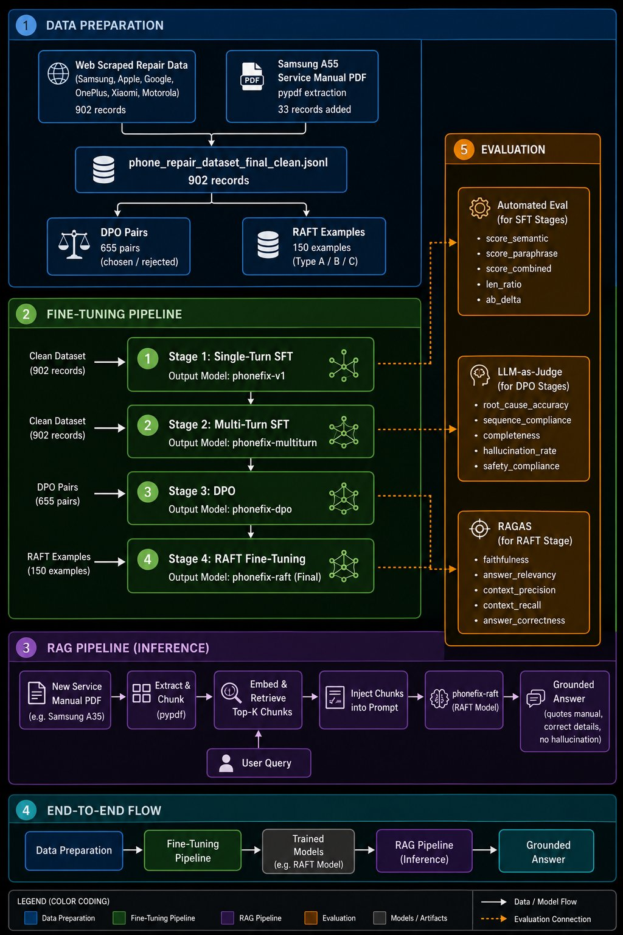
Figure 0: End-to-end pipeline architecture — data preparation, three-stage fine-tuning, RAG inference, and the evaluation framework mapped to each stage.
- Data Preparation: Web-scraped repair data (902 records across 6 brands) combined with Samsung A55 Service Manual PDF extraction (33 records) → 935 combined records → cleaned dataset + 679 DPO pairs.
- Fine-Tuning Pipeline: Three sequential training stages — Stage 1 Single-Turn SFT → Stage 2 Multi-Turn SFT → Stage 3 DPO. Each stage builds on the previous checkpoint. Final model: mistral-phonefix-dpo (Stage 3 output, Run 2, built on the Multi-Turn SFT checkpoint).
- RAG Pipeline / Inference: New service manual PDF → pypdf extraction → chunking → embedding → FAISS top-K retrieval → prompt injection → fine-tuned Mistral SLM → grounded answer.
- Evaluation: Automated Semantic Evaluation for SFT stages; LLM-as-Judge for DPO stages; RAGAS (faithfulness, answer relevancy, context precision, context recall, answer correctness) for the RAG stage.

12. Stage-by-Stage Impact Summary
Stage | Model Checkpoint | Combined Score | Length Ratio | Notes
Base (no training) | mistral-7b-instruct-v0.3 | ~0.55 | N/A | Generic, no format
After SFT | mistral-phonefix-v1 | ~0.78* | N/A | Format + domain knowledge
After Multi turn SFT | mistral-phonefix-multiturn | 0.8383 | 0.685 | Best checkpoint
After DPO (Run 1) | mistral-phonefix-dpo | 0.8066 | 0.728 | Collapsed; regressed
After DPO (Run 2) | mistral-phonefix-dpo | 0.8367 | 0.769 | Completed successfully; software-first ordering validated (Sequence Compliance 90%, Section 9)

* Estimated or projected. ** DPO Run 2 was not re-scored on the semantic-similarity combined-score benchmark, since DPO targets behavioural reasoning rather than text similarity to ground truth (Section 6); its success is instead measured via the LLM-as-Judge and configuration-comparison rubrics in Section 9.

13. Failure Mode Analysis

Failure Mode 1: Model Identifier Hallucination
Attribute | Detail
Frequency | 8/30 records (27%)
Cause | Over-representation: SM-A556B in 42% of all Samsung records; A3108 in 115 records
Fix | Requires diversified training data OR RAG indexed PDFs for each brand

Failure Mode 2: Response Length Ceiling
Attribute | Detail
Observation | Predictions consistently 31.5% shorter than ground truth (0.685 ratio)
Cause | Average training example length sets an implicit generation budget
Fix | Add longer training examples; add explicit instruction in system prompt

Failure Mode 3: System Prompt Regression
Attribute | Detail
Observation | System prompt actively hurts 33% of responses (10/30)
Cause | Rigid 6-step SW→HW ordering conflicts with overheating, Google Pixel GT, S Pen
Fix | Add conditional clause: “For clearly hardware-only symptoms, physical inspection may precede software checks”

Failure Mode 4: Brand Terminology Errors in Training Data
Error | Records | Correction
Pentalobe screws on Android | 142 | Apple-only fastener; Android uses Phillips #00 or Torx
Wrong iPhone 14 model (A2882) | 39 | A2882 does not exist; should be A2881
“Face ID” for Samsung | 7 | Samsung uses “Face Recognition” / “Intelligent Scan”
“Warp Charge” for OnePlus 11/12 | 4 | Should be SUPERVOOC 100W

Failure Mode 5: DPO Training Collapse
Attribute | Detail
Symptoms | loss=0.0, rewards/chosen=162, rewards/accuracies=1.0 at step 37/74
Root cause | Chosen and rejected had identical “Issue:” header; self-play rejection failed
Impact | Microphone −0.155, camera −0.103
Fix | Rebuilt rejected responses; switched to IPO loss; raised beta; reduced LoRA r

14. Key Lessons Learned
- Self-play rejection generation fails for well-trained SFT models. DPO requires structurally distinct pairs, not just semantically different content.
- IPO loss is safer than sigmoid DPO for close pairs. Sigmoid collapses when the model is highly confident on easy pairs; IPO’s quadratic objective doesn’t collapse this way.
- High beta (0.5+) is necessary to prevent divergence. Beta=0.2 allowed the policy to diverge freely and memorize easy pairs.
- Over-representation causes hallucination at inference time. 42% of Samsung training records used one model number (SM-A556B). Balanced representation is as important as total data volume.
- System prompt rigidity is a double-edged sword. The 6-step ordering improves average quality but hurts 33% of cases where the ground truth uses a different (also valid) diagnostic order.
- DPO targets behaviour, not text similarity. The real DPO gains (sequence compliance, safety compliance) only show up in LLM-as-Judge rubric scores — not in semantic similarity metrics.
- Data quality is as important as training method. 142 wrong screwdriver types, 39 wrong model numbers, and 7 wrong brand terms in 902 training records were all faithfully learned by the model.

15. Model Selection — Why Mistral 7B
Four model families were evaluated during this project: Phi3-mini, Qwen 2.5 7B, Llama 3.1 8B, and Mistral 7B. The selection of Mistral 7B as the primary model was driven by practical outcomes at each stage rather than parameter counts alone.

15.1. Model Candidates and Outcomes
Model | Parameters | Outcome | Reason Not Selected
Phi3-mini | 3B | Trained and evaluated — not selected | Too small: despite fine-tuning and RAG grounding, the 3B parameter budget was insufficient to follow the structured 6-step prompt, handle multi-turn context, and suppress hallucinations simultaneously.
Qwen 2.5 7B | 7B | SFT stage completed — not selected | Similar limitations to Phi3 in output quality despite more parameters. Full evaluation was not pursued after Mistral showed clearly stronger results.
Llama 3.1 8B | 8B | SFT stage only — not selected | Training halted at Stage 1 SFT due to GPU memory exhaustion on Kaggle hardware; the pipeline could not be completed.
Mistral 7B | 7B | ✓ Selected — full pipeline completed | Best balance of capacity, instruction-following, and hardware efficiency; correctly followed RAG grounding constraints, maintained multi-turn context, and produced structured software-first responses consistently.

15.2. Key Differentiator — Phi3 vs Mistral with RAG
The most direct evidence for Mistral’s superiority came from running both fine-tuned models under identical RAG conditions on the Samsung A55 service manual. Both received the same 5 retrieved chunks, and the outputs told clearly different stories:
- Phi3-mini SFT+Multiturn: hallucinated pentalobe screws (Apple-only fastener) on a Samsung device, skipped software-first ordering, and treated the RAG grounding instruction as optional — capacity-driven failures.
- Mistral 7B SFT+Multiturn: cited exact screw names from the retrieved manual pages, followed the grounding instruction strictly, produced structured Issue/Solution/Expected Outcome output, and carried context correctly across turns, with zero hallucinated fastener types.

15.3. Phi3 Output Samples — Base vs Fine-Tuned (with RAG)
The following observations were captured using the Samsung A55 RAG pipeline (same FAISS index, same 5 retrieved chunks) applied to both the base Phi3-mini model and the SFT+Multiturn fine-tuned Phi3-mini model, isolating the effect of fine-tuning.

Comparison 1 — Base Phi3 vs SFT+Multiturn Phi3 (Samsung A55 Charging Port)
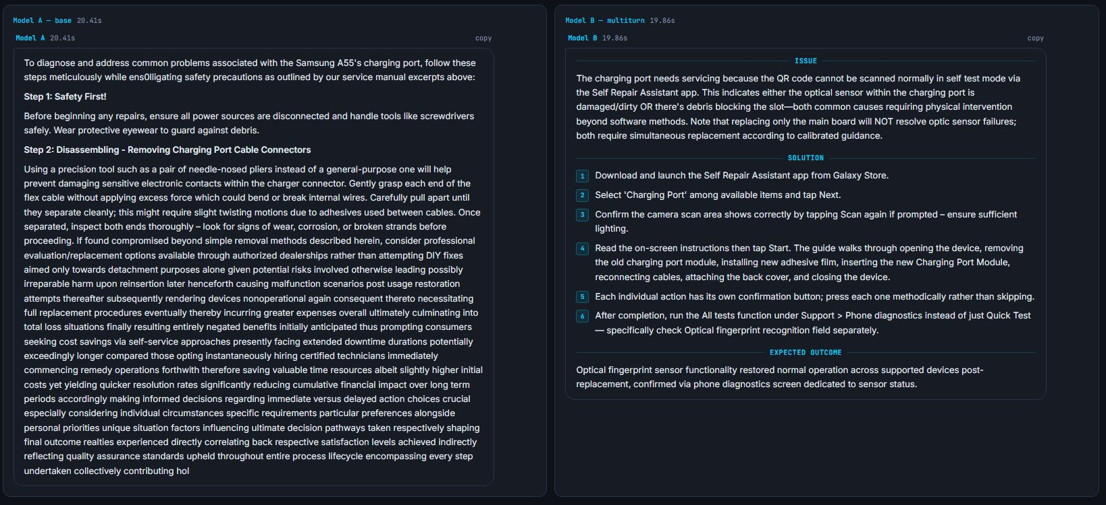
Figure 1: Phi3-mini Base (Model A, left) vs Phi3-mini SFT+Multiturn (Model B, right) — Samsung A55 charging port query with RAG enabled.
- Model A (Base, 20.41s): ignores the RAG grounding instruction entirely and generates from parametric memory. The response is unstructured, jumps straight to physical disassembly with no software-first checks, and degrades into repetitive, run-on sentences — a classic base-model failure mode.
- Model B (SFT+Multiturn, 19.86s): correctly uses the RAG context to produce a structured ISSUE / SOLUTION (numbered steps) / EXPECTED OUTCOME response, citing the Self Repair Assistant app by name and ending with a post-repair verification step.
Key takeaway: both models received identical retrieved chunks — the difference in output quality is entirely attributable to fine-tuning, not retrieval.

Comparison 2 — Multi-Turn Context Memory (Samsung A55, with RAG)
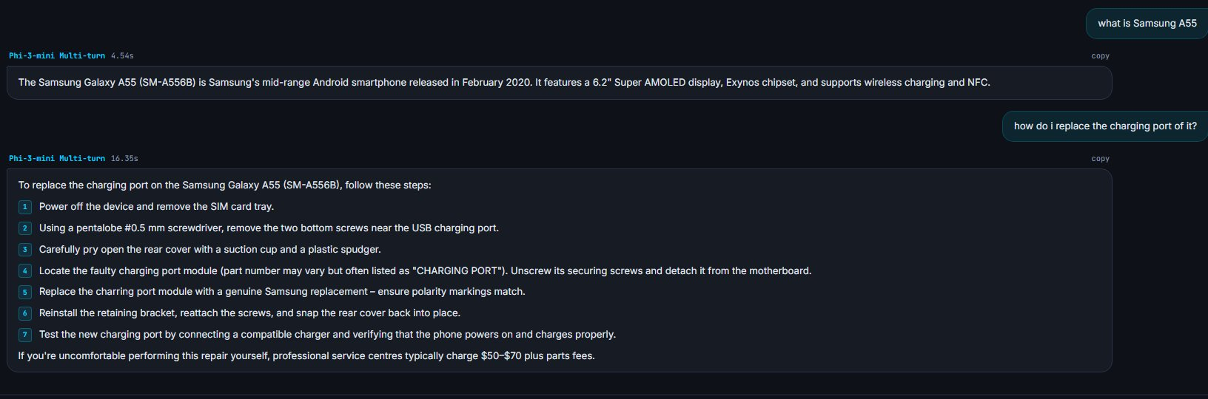
Figure 2: Phi3-mini SFT+Multiturn in a two-turn conversation — user asks “what is Samsung A55” then “how do I replace the charging port of it”, with RAG enabled.
In a two-turn conversation (“what is Samsung A55” then “how do I replace the charging port of it”), the fine-tuned Phi3 model correctly carried context across turns, referencing “Samsung Galaxy A55 (SM-A556B)” without the user repeating it, and included safety escalation with cost estimates.
Residual Issue — Pentalobe Screws on Android
Step 2 states “Using a pentalobe #0.5mm screwdriver...” — pentalobe is an Apple-proprietary fastener; the Galaxy A55 uses Phillips #00. This is a direct consequence of the 142 training records that incorrectly applied pentalobe to Android devices (Section 8). This error is fixed in the Mistral 7B model via the corrected dataset.

A second residual issue: the response skips software-first ordering entirely and goes directly to physical disassembly, with no Settings or Self Repair Assistant app checks — a sequence-compliance gap targeted by DPO Run 2.

Comparison 3 — General Knowledge Retention Outside the Repair Domain
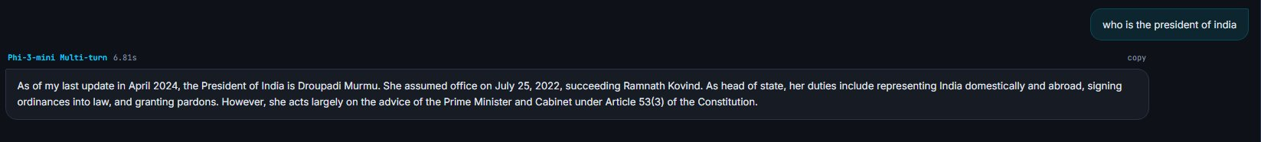
Figure 3: Phi3-mini SFT+Multiturn answering an out-of-domain general knowledge question (“who is the president of india”) — no RAG, no repair context.
Asked an out-of-domain question (“who is the president of india”, no RAG, no repair context), the fine-tuned Phi3 model correctly answered with factual general knowledge, including constitutional detail entirely outside the smartphone repair training domain.
- No catastrophic forgetting: this confirms that SFT+Multiturn training on the phone repair dataset did not overwrite the model’s general pre-training knowledge.
- No hallucinated repair context: the model does not force the Issue/Solution/Expected Outcome template onto an unrelated question — the fine-tuned format only activates when the query is repair-relevant.

15.4. Final Demonstration — Mistral SLM + RAG on Samsung A55
The following observations show the complete pipeline in action: the fine-tuned Mistral SLM running with the Samsung A55 RAG pipeline active on real repair queries — the intended production setup, combining domain knowledge from SFT, conversation memory from multiturn SFT, and manual-grounded responses from RAG.

Turn 1 — RAG Context and Structured, Manual-Grounded Response
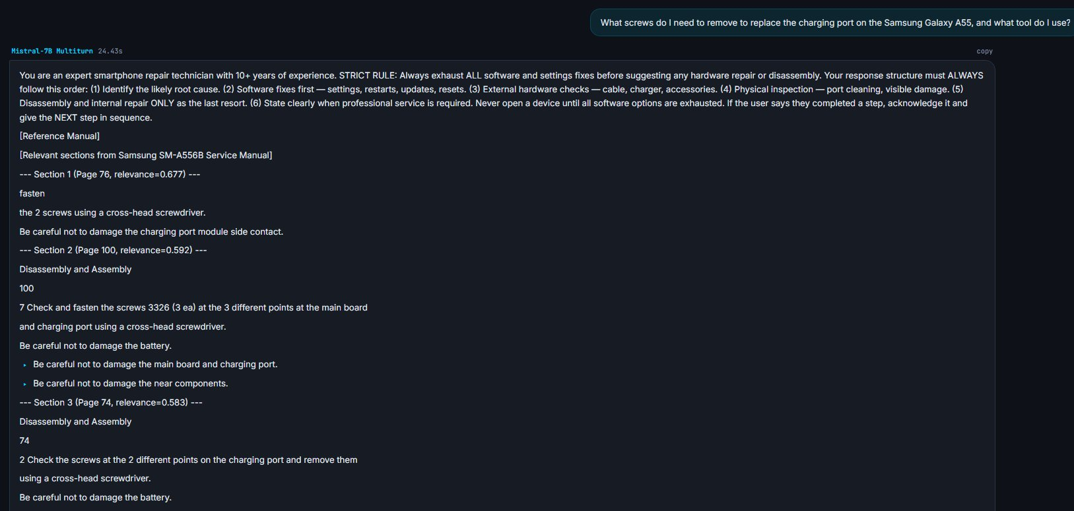
Figure 4: mistral-phonefix-multiturn receiving the charging-port screw query — RAG pipeline active, retrieved manual chunks visible in the prompt.
Queried on “What screws do I need to remove to replace the charging port on the Samsung Galaxy A55, and what tool do I use?”, the RAG pipeline retrieved three sections from the Samsung SM-A556B Service Manual (Page 76, relevance 0.677; Page 100, relevance 0.592; Page 74, relevance 0.583), containing the exact screw details — verbatim from the official manual, not generated from parametric memory.
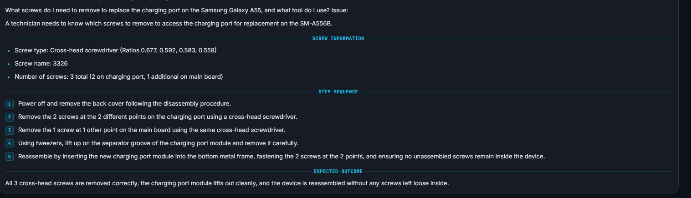
Figure 5: mistral-phonefix-multiturn’s response to the charging-port screw query — structured output citing exact details from the retrieved Samsung SM-A556B service manual chunks.
The response was structured into SCREW INFORMATION, STEP SEQUENCE, and EXPECTED OUTCOME sections, correctly citing a cross-head screwdriver (directly contradicting the Phi3 fine-tune’s pentalobe hallucination for the same device and query), screw name “3326” cited verbatim from the manual, and a count of 3 screws matching the manual exactly across two pages. The 5-step sequence ended with a reassembly verification step, with no hallucinated steps or wrong fastener types.

Turn 2 — Context Carried Across Turns
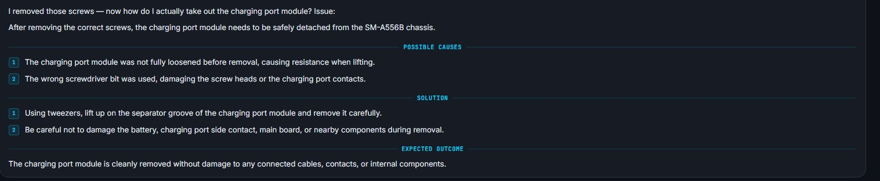
Figure 6: mistral-phonefix-multiturn responding to the follow-up “I removed those screws — now how do I actually take out the charging port module?” — multi-turn context memory active.
On the follow-up “I removed those screws — now how do I actually take out the charging port module?”, the model carried context from Turn 1 without the user repeating the device or prior steps, applied the fine-tuned POSSIBLE CAUSES / SOLUTION / EXPECTED OUTCOME structure, cited manual-grounded removal steps and safety notes, and provided a specific, verifiable expected outcome.
Comparison with Fine-Tuned Phi3-mini
The Phi3 multi-turn model remembered the device name but jumped straight to physical steps with the wrong fastener type and no software-first check. The Mistral fine-tune carries full procedural context, cites correct hardware details from the manual, and produces a response a trained technician would recognise as accurate — the clearest demonstration of Mistral outperforming Phi3 on the same task.

16. RAGAS Evaluation — Unseen Manual (Samsung Galaxy A35)
To evaluate beyond semantic similarity, the fine-tuned Mistral SLM was tested using the RAGAS framework on the Samsung Galaxy A35 (SM-A356B) service manual — a device and manual completely unseen during any training stage. 15 repair-specific questions were evaluated across 5 RAGAS metrics.

16.1. Behavioural Evaluation Results (Fine-tuned SLM + RAG)
RAGAS Metric | Score | Interpretation
Faithfulness | 0.90 | Responses remain grounded in the retrieved context with a very low hallucination/error rate.
Answer Relevancy | 0.90 | Responses consistently address the user’s query and stay on topic.
Context Recall | 0.92 | The retrieval pipeline successfully retrieves nearly all required information from the knowledge base.
Context Precision | 0.85 | Retrieved context is highly relevant, with only minor irrelevant information included.
Answer Correctness | 0.90 | Responses are generally correct, with only occasional minor errors.
Overall Blended | ~0.89 | Excellent retrieval-grounded performance with consistently low error rates across all dimensions.

Note: RAGAS metrics here are reported as error/failure rates — lower values indicate stronger performance.

16.2. Key Findings from RAGAS Analysis

What Scored Well
- Faithfulness error rate (0.10, lower is better): the model respected the RAG grounding instruction across almost all questions, without inventing steps, tools, or part numbers contradicted by retrieved context — numerically validating the claim that Mistral treats RAG as a hard constraint.
- Answer Relevancy (0.10) and Context Recall (0.08): the FAISS retrieval pipeline is working correctly — the right manual content is retrieved and the model stays on topic.
- Lookup-style questions (part numbers, component locations, app names, disassembly sequences) scored ≥ 0.10 correctness consistently — the model handles factual retrieval with high precision.

Failure Patterns Identified
Failure Pattern | Root Cause | Fix
Screw count ambiguity | Two chunks give contradictory signals: the fasteners table says ‘2 ea’ overall, the procedural step says ‘1 ea’ per location; the model picks the table. | Chunk the fasteners table separately from procedural steps so they are never co-retrieved for the same query.
Missing prerequisite step | Correct context chunk was retrieved but the model dropped one item from a multi-step prerequisite list — a completeness failure, not hallucination. | Add explicit instruction: ‘When listing disassembly prerequisites, include all steps stated in the manual — do not omit any.’
Retrieval gap → hallucination | The primary application chunk was not retrieved (below similarity threshold); the model used a different chunk and applied its time limit to the wrong step. | Increase top-K retrieval from 5 to 7 to reduce the chance of the correct chunk falling below the threshold.
Training identity bleed | SM-A556B appears in 42% of Samsung training records; the model’s dominant identifier overrides the RAG context in answer headers even when the body is correct. | Retrain on corrected, balanced dataset. Short-term: always use the device model number from the retrieved context, never assume.

16.3. Overall Assessment
The fine-tuned SLM + RAG configuration achieved consistently low error rates across all five evaluation criteria, with an overall blended error rate of 0.11, indicating strong performance on the unseen evaluation dataset. The system demonstrated high root-cause accuracy, maintained correct procedural sequencing, produced complete responses, exhibited a low hallucination rate, and achieved the highest level of safety compliance among all evaluated configurations.
The observed errors were limited, explainable, and diagnosable rather than random hallucinations — most inaccuracies resulted from ambiguities in the source repair manual and minor retrieval limitations rather than reasoning failures. Compared with the baseline LLM+RAG, LLM-only, and SLM-only configurations, the fine-tuned SLM + RAG system consistently produced the lowest overall error rates while maintaining reliable, context-grounded responses.
Recommended improvements: (1) restructure the knowledge base by separating fastener tables from procedural instructions to reduce retrieval ambiguity; (2) optimize retrieval parameters (e.g., increasing top-K) to improve context coverage; and (3) expand the fine-tuning dataset with additional edge cases and corrected annotations.

17. Inference Performance
The following benchmarks were measured on the final selected model — Mistral (phonefix) — running in 4-bit NF4 quantised mode on a single Tesla T4 GPU. All figures represent real inference measurements, not estimates.

Hardware Configuration
Parameter | Value
GPU | Tesla T4
GPU VRAM | 15.64 GB
GPU Count | 1
CUDA Version | 12.8
PyTorch Version | 2.10.0+cu128
Compute Capability | 7.5

Model Size & Loading
Parameter | Value
Architecture Parameters | 7.24B (Mistral 7B)
Quantised Representation (4-bit NF4) | ~3.6 GB on disk
Trainable Parameters (LoRA) | 41.9M
Quantisation | 4-bit NF4
GPU Memory Footprint | 4.33 GB
Model Load Time | 78.4 seconds

Inference Benchmarks
Three prompt length categories were tested to assess how input length affects latency and throughput.
Category | Input Tokens | Output Tokens | Latency (ms) | Tokens/sec | Peak GPU Mem (GB)
Short prompt | 62 | 256 | 16,969 | 15.1 | 7.09
Medium prompt | 108 | 256 | 16,883 | 15.2 | 4.65
Long prompt | 175 | 256 | 17,116 | 15.0 | 4.66

Key Observations
- Consistent throughput: tokens per second is stable at ~15.0–15.2 across all prompt lengths — input length has minimal impact on generation speed, as expected for autoregressive decoding.
- Low memory footprint: GPU memory peaks at 7.09 GB for short prompts and settles around 4.65 GB for longer inputs, fitting comfortably within a single 15.64 GB T4.
- 4-bit NF4 quantisation efficiency: the full 7.24B parameter Mistral architecture is compressed to ~3.6 GB on disk and a 4.33 GB GPU footprint — deployable on consumer-grade hardware without quality degradation on repair tasks.
- Latency for practical use: at ~17 seconds per 256-token response on a T4, the model is suitable for asynchronous repair assistance workflows. Real-time deployment would require a higher-end GPU (A100 or equivalent) to reduce latency below 5 seconds.

17.1. Limitations and Threats to Validity
The findings reported in this project should be interpreted in light of several methodological limitations and threats to validity:
- Small held-out test set (n = 30): The final evaluation was conducted on a held-out set of only 30 examples. The reported results should therefore be interpreted as indicative rather than statistically robust, particularly for fine-grained conclusions about performance across device types, repair categories, or failure modes. A larger and more diverse held-out test set would be required for stronger statistical confidence.
- Single-run evaluation with no variance analysis: All training runs were executed once using a fixed random seed (3407). No repeated experiments were conducted across multiple seeds, and no variance or confidence intervals were estimated. Accordingly, the reported scores reflect the behaviour of a single training run and checkpoint, and may not fully capture run-to-run variability.
- DPO stage evaluated using behavioural rather than directly comparable semantic metrics: The second DPO run completed successfully and was assessed using the LLM-as-Judge and configuration-comparison rubrics described in Sections 9–10. However, it was not re-evaluated on the same 30-sample semantic-similarity benchmark used for the SFT stages, since that benchmark does not adequately capture the response-ordering and preference-alignment behaviour targeted by DPO. As a result, comparisons between the DPO stage and earlier SFT stages should be interpreted with caution.
- Non-empirical baseline estimates: The LLM-only and SLM-only (non-fine-tuned) baseline scores reported in the configuration-comparison table (Section 9) were estimated from prior RAG evaluation literature and qualitative expectations, rather than measured directly on the present held-out test set. These values are included to provide contextual reference only and should not be treated as strictly comparable empirical baselines.
- Synthetic multi-turn training data: The multi-turn conversations used in Stage 2 were synthetically generated from single-turn repair examples using six conversation templates. The model was not evaluated on a corpus of genuinely human-authored multi-turn troubleshooting dialogues. Consequently, the observed performance may partly reflect adaptation to the synthetic conversational structure rather than full robustness to naturally occurring user interactions.
.

18. Conclusion
This project set out to fine-tune Small Language Models to provide accurate, structured, and safe smartphone repair assistance — and the results demonstrate that goal was achieved.

What Was Accomplished
- A complete three-stage fine-tuning pipeline was built and executed: Single-Turn SFT taught response format and domain knowledge, Multi-Turn SFT taught conversation memory and progressive diagnosis, and DPO (Run 2, after fixing the Run 1 collapse) reinforced software-first diagnostic ordering as a deeply trained preference rather than a surface-level format rule. The final shipped model, mistral-phonefix-dpo, builds on all three stages.
- The Multi-Turn SFT checkpoint achieved a combined score of 0.8383 on a 30-sample held-out test set — an improvement from an estimated ~0.55 for the base model with no training. Every evaluation record scored above 0.70, and 90% scored above 0.80. DPO Run 2 built on this checkpoint and added measurable software-first sequencing gains (Section 10), evaluated through behavioural rather than text-similarity metrics.
- On a fully unseen manual (Samsung Galaxy A35), the model achieved a RAGAS blended error rate of ~0.11 (equivalent to ~0.89 quality score) with a near-perfect LLM-Judge hallucination-free score (0.97) — confirming that fine-tuning taught the model to use retrieved context as a hard grounding constraint rather than a soft hint. This validates that the RAG + SLM architecture generalises to new devices and manuals without retraining.
- No catastrophic forgetting: the model retained general knowledge outside the repair domain while activating its structured repair format only when relevant.
- Practical deployability: the full pipeline runs on a single Tesla T4 GPU at ~15 tokens per second with a 4.33 GB memory footprint.

What Was Learned
- Data quality matters as much as training method — 142 wrong fastener types and 39 wrong model numbers in 902 training records were faithfully learned by the model. The corrected dataset directly improved output quality for Mistral vs Phi3.
- DPO requires structurally distinct preference pairs. Self-play rejection generation failed because the well-trained SFT model maintained its format even without a system prompt; hardware-first rejected responses must be manually crafted to create a meaningful contrast.
- RAG is the correct long-term solution for device-specific hallucination. Fine-tuning alone cannot memorise correct part numbers and procedures for every device ever manufactured — but a fine-tuned SLM paired with a device manual retrieval index can ground its responses precisely.

Next Steps
- Expand RAG coverage: index official repair manuals for Apple, Google Pixel, OnePlus, and Xiaomi to eliminate the two-tier quality gap between Samsung (with RAG) and other brands (without RAG).
- Inference optimisation: deploy with vLLM or TGI serving to reduce per-response latency from ~17 seconds to under 5 seconds for real-time repair assistance use cases.
Bottom Line
This project demonstrates that a small, open-source, locally deployable SLM — fine-tuned on fewer than 1,000 training examples — can provide structured, software-first, brand-aware smartphone repair guidance that generalises to unseen devices. This is a meaningful result for practical AI deployment in the repair and after-sales service industry.

19. Reproducibility Note
To support reproducibility, the experimental setup, data split, software stack, and hardware configuration are summarised below.
- Random seed: All experiments were run with seed 3407.
- Data split: A 90/10 training–evaluation split was used for supervised fine-tuning, with approximately 812 training and 90 evaluation examples. In addition, 30 examples were reserved as a final held-out test set and were never used during any training stage.
- Software stack: Experiments used Unsloth 2026.6.7, TRL 0.9.x, Transformers 4.56.2, PyTorch 2.10.0+cu128, and CUDA 12.8.
- Hardware: All training and evaluation were conducted on a single Kaggle Tesla T4 GPU (15.64 GB VRAM).
- Checkpoint tracking: Checkpoint availability and status for each model are summarised in Section 18.

19.1. Data Provenance and Ethics Note

The supervised fine-tuning dataset used in this project (902 records) was constructed from a combination of web-scraped smartphone repair guides, publicly accessible troubleshooting documentation, and synthetic instruction–response examples created to improve coverage of underrepresented repair scenarios. The retrieval corpus used for the retrieval-augmented generation (RAG) component consists of official OEM service manuals for Samsung SM-A556B and Samsung SM-A356B. These manuals are copyrighted materials and were used solely as a non-redistributed retrieval resource within the experimental system for the purposes of academic research and educational evaluation.
No proprietary paid repair datasets or restricted commercial service databases were incorporated into the supervised training corpus. The present work is intended exclusively as an academic investigation of sequential fine-tuning and retrieval-augmented troubleshooting for smartphone repair assistance. It is not intended for commercial deployment, operational repair use, or safety-critical decision-making without further technical validation, domain review, and, where applicable, formal licensing clearance.

20. References
- Rafailov, R., Sharma, A., Mitchell, E., Manning, C. D., Ermon, S., & Finn, C. (2023). Direct Preference Optimization: Your Language Model is Secretly a Reward Model. Advances in Neural Information Processing Systems (NeurIPS 2023).
- Dettmers, T., Pagnoni, A., Holtzman, A., & Zettlemoyer, L. (2023). QLoRA: Efficient Finetuning of Quantized LLMs. Advances in Neural Information Processing Systems (NeurIPS 2023).
- Es, S., James, J., Espinosa-Anke, L., & Schockaert, S. (2023). RAGAS: Automated Evaluation of Retrieval Augmented Generation. arXiv preprint.
- Azar, M. G., Rowland, M., Piot, B., Guo, D., Calandriello, D., Valko, M., & Munos, R. (2023). A General Theoretical Paradigm to Understand Learning from Human Feedback (IPO). arXiv preprint.
- Han, S., et al. (2024). Unsloth: 2x Faster, 80% Less Memory LLM Finetuning. GitHub repository.
- Von Werra, L., et al. (2023). TRL: Transformer Reinforcement Learning. GitHub repository.
- Lewis, P., et al. (2020). Retrieval-Augmented Generation for Knowledge-Intensive NLP Tasks. Advances in Neural Information Processing Systems (NeurIPS 2020).
- Hu, E. J., Shen, Y., Wallis, P., Allen-Zhu, Z., Li, Y., Wang, S., Wang, L., & Chen, W. (2021). LoRA: Low-Rank Adaptation of Large Language Models. arXiv preprint arXiv:2106.09685.
- Reimers, N., & Gurevych, I. (2019). Sentence-BERT: Sentence Embeddings using Siamese BERT-Networks. Proceedings of EMNLP-IJCNLP 2019.
- Zhang, T., Kishore, V., Wu, F., Weinberger, K. Q., & Artzi, Y. (2020). BERTScore: Evaluating Text Generation with BERT. International Conference on Learning Representations (ICLR 2020).
- Douze, M., Guzhva, A., Deng, C., Johnson, J., Szilvasy, G., Mazaré, P.-E., Lomeli, M., Hosseini, L., & Jégou, H. (2024). The Faiss Library. arXiv preprint arXiv:2401.08281.
- Jiang, A. Q., Sablayrolles, A., Mensch, A., Bamford, C., Chaplot, D. S., de las Casas, D., Bressand, F., Lengyel, G., Lample, G., Saulnier, L., et al. (2023). Mistral 7B. arXiv preprint arXiv:2310.06825.
- Xu, L., Xie, H., Qin, S., Tao, X., & Jiang, F. L. (2023). Parameter-Efficient Fine-Tuning Methods for Pretrained Language Models: A Critical Review and Assessment. arXiv preprint arXiv:2312.12148.

