PROJECT REPORT
(Project Semester January-April 2026)

Power-Aware CPU scheduling

This is Submitted By:
AYUSH SINGH
12413065
DEV CHAUDHARY
12412949
ARYAN
12412194
Programme and Section
B. Tech CSE & 2EO57
Course Code : CSE 316

Under the Guidance of

Sachin Kumar Chawla
ID: 32437

Discipline of CSE/IT

Lovely School of Computer Science and engineering

Lovely Professional University, Phagwara

CERTIFICATE

This is to certify that Ayush S bearing Registration no. 12413065 has completed CSE316 project titled, “Power-Aware CPU scheduling” under my guidance and supervision. To the best of my knowledge, the present work is the result of his/her original development, effort and study.

Signature and Name of the Supervisor
Designation of the Supervisor
School of Computer Science And Engineering
Lovely Professional University
Phagwara, Punjab.

Date:

DECLARATION

I, Ayush Singh, student of B. Tech under CSE/IT Discipline at, Lovely Professional University, Punjab, hereby declare that all the information furnished in this project report is based on my own intensive work and is genuine.

Date: Signature
Registration No. 12413065 Ayush Singh

1.Project Overview

PowerSched is a simulation-based system designed to demonstrate energy-aware CPU scheduling in heterogeneous computing environments. Unlike traditional schedulers that focus only on execution order and performance metrics, PowerSched emphasizes the balance between performance, power consumption, and thermal behavior.
The system integrates Dynamic Voltage and Frequency Scaling (DVFS), thermal-aware scheduling, and workload prediction to simulate how modern processors optimize resource utilization. It models how tasks are dynamically assigned to BIG and LITTLE cores based on their computational demand, while continuously adapting CPU frequency and monitoring temperature.
The primary objective of this project is to provide a practical and analytical understanding of how operating systems manage energy efficiency without compromising performance. Through simulation outputs, graphical analysis, and a lightweight dashboard, users can observe how scheduling decisions impact energy usage, system temperature, and task execution efficiency.

2. Module-Wise Breakdown
The project is divided into three major layers:

a) Core Scheduling Engine (C – Backend Logic)
🔹 Scheduler Design:
- Implements a custom energy-aware scheduling algorithm
- Assigns tasks based on:
  - Predicted workload
  - Core type (BIG / LITTLE)
  - System state (temperature, load)
🔹 Heterogeneous Core Model:
- BIG Core: High performance, high energy consumption
- LITTLE Core: Energy-efficient, lower performance
🔹 Thermal Awareness:
- Tracks system temperature dynamically
- Prevents overheating by:
  - Reducing frequency
  - Shifting tasks to efficient cores
🔹 Adaptive Control:
- Ensures system stability under high workloads
- Maintains a balance between performance and heat dissipation

c) Visualization & Analysis Layer
🔹 Data Export:
- Simulation results stored in CSV format:
  - Time
  - Task ID
  - Core type
  - Frequency
  - Energy
  - Temperature
🔹 Graphical Analysis:
- Generated using Python:
  - Energy vs Time
  - Temperature vs Time
  - CPU utilization trends
🔹 Lightweight Dashboard (HTML):
- Displays:
  - Task execution summary
  - Core assignment
  - Energy trends (basic charts)

3. Functionalities
🔹 Energy-Aware Scheduling
- Tasks are allocated based on predicted workload
- Heavy tasks → BIG core
- Light tasks → LITTLE core

🔹 Dynamic Frequency Scaling (DVFS)
- CPU frequency adapts in real time:
  - Improves performance during heavy load
  - Saves energy during low load

🔹 Thermal Regulation
- Monitors temperature continuously
- Prevents overheating using adaptive scheduling

🔹 Workload Prediction
- Predicts task behavior using burst time heuristics
- Enables smarter scheduling decisions

🔹 Real-Time Simulation Output
- Step-by-step execution logs
- Displays:
  - Core assignment
  - Frequency
  - Temperature
  - Energy usage

🔹 Performance Comparison
- Compares results with traditional scheduling approaches
- Evaluates:
  - Energy savings
  - Execution efficiency

4. Technology Used
🔹 Programming Language:
- C (Core simulation and scheduling logic)

🔹 Libraries & Tools:
- GCC – Compilation
- VS Code – Development
- Python (Matplotlib, Pandas) – Graph visualization
🔹 Additional Components:
- CSV File Handling – Data logging
- HTML + Chart.js – Lightweight UI dashboard

5.Flow Diagram:

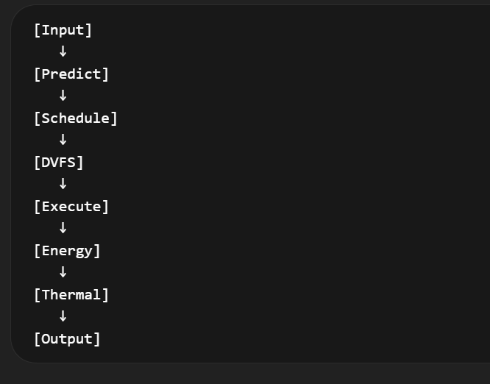
Step wise flow:
1.Input Initialization
2. Workload Prediction
3. Scheduling Decision
4. DVFS Adjustment
5. Task Execution
6. Energy Calculation
7. Thermal Update
8. Data Logging
9. Visualization & Output

6. Revision Tracking on GitHub
- Repository Name: Power Aware CPU scheduing
- GitHub Link:
https://github.com/AyushSingh008/-Energy-Aware-CPU-Scheduling-Simulator.git

7. Conclusion and Future Scope
- Conclusion
PowerSched successfully demonstrates how modern CPU scheduling can be optimized by integrating energy-aware techniques such as DVFS, thermal management, and workload prediction. Unlike traditional scheduling approaches that primarily focus on performance metrics, this project highlights the importance of balancing performance, power consumption, and system temperature.
The simulator provides a practical understanding of how tasks can be intelligently distributed across heterogeneous cores (BIG/LITTLE) while dynamically adjusting CPU frequency. Through simulation outputs, graphs, and a lightweight dashboard, the project effectively translates complex operating system concepts into a clear and analytical form.
Overall, PowerSched reflects real-world system design principles and showcases how adaptive scheduling can significantly improve energy efficiency without compromising performance.

- Future Scope
- Integration of machine learning models for more accurate task behavior prediction
- More realistic temperature simulation with cooling mechanisms and thresholds
- Comparison with Round Robin, Priority, and other scheduling techniques
- Analysis of latency, throughput, and energy per task
- More interactive UI with real-time charts and better graphical representation

8. References
- Operating System Concepts – Abraham Silberschatz
- Modern Processor Architecture (Intel Documentation)
- GSAP Official Documentation
- MDN Web Docs (JavaScript, HTML, CSS)
Appendix
- A. AI-Generated Project Elaboration / Breakdown Report
PowerSched is designed as a simulation-based system that bridges the gap between theoretical CPU scheduling concepts and their practical implementation. It models how modern processors manage tasks by incorporating energy-aware scheduling techniques into execution logic.
PowerSched emphasizes analytical understanding and system-level thinking, allowing users to observe how scheduling decisions affect energy consumption, system temperature, and overall performance. Through simulation outputs, data logging, and visualization, the project provides a clear representation of how modern operating systems optimize both efficiency and performance.

- B. Problem Statement
Modern computing systems, especially mobile and embedded devices, must balance high performance with low energy consumption. Traditional CPU scheduling algorithms primarily focus on performance metrics such as waiting time and turnaround time, often neglecting critical factors like power usage and thermal constraints.

C. Solution / Code:
