YATRASETU AI: AI-POWERED MULTILINGUAL SAFE-TRAVEL AND CROWD ADVISORY ASSISTANT FOR UTTARAKHAND
Minor Project Report
Submitted by
Ayush Singh (230240170024)
B.Tech CSE (AI/ML), 4th Year
In Partial Fulfillment of the Requirements
for the Degree of
Bachelor of Technology
in Computer Science and Engineering (AI/ML)

DEPARTMENT OF COMPUTER SCIENCE AND ENGINEERING
ROORKEE INSTITUTE OF TECHNOLOGY, ROORKEE
(Affiliated to VMSB Uttarakhand Technical University, Dehradun)
October 2026

DECLARATION
I declare that the work embodied in this Minor Project report entitled "YatraSetu AI: AI-Powered Multilingual Safe-Travel and Crowd Advisory Assistant for Uttarakhand" is my own original work carried out by me in the Department of Computer Science and Engineering for the session 2026-27 at "Roorkee Institute of Technology, Roorkee". The matter embodied in this project report has not been submitted elsewhere for the award of any other degree. I declare that I have faithfully acknowledged, given credit to and referred to the researchers wherever the work has been cited in the text and the body of the report. I further certify that I have not wilfully lifted up some other's work, para, text, data, results, etc. reported in the journals, books, magazines, reports, dissertations, theses, etc., or available at websites and have included them in this project report and cited as my own work.

Date:  Place: Roorkee | Ayush Singh  Roll No. 230240170024  (Signature of the student)

Name & Signature of  Internal Examiner | Name & Signature of  External Examiner

ACKNOWLEDGEMENT
I am very happy to acknowledge the many people who helped make my project "YatraSetu AI: AI-Powered Multilingual Safe-Travel and Crowd Advisory Assistant for Uttarakhand" a successful one.
I take this opportunity to express my deep sense of gratitude to our honourable Director, Dr Parag Jain, for providing an excellent academic climate in the college that made this endeavour possible.
I give my wholehearted admiration and a deep sense of gratitude to Dr Parul Choudhary, HOD, Department of Computer Science & Engineering, Roorkee Institute of Technology, Roorkee, for the inspiration, valuable guidance, encouragement, suggestions and overall help throughout the project.
Finally, I express my gratitude to all the teaching and non-teaching staff of the Department of Computer Science & Engineering, Roorkee Institute of Technology, Roorkee, for their timely support and suggestions, and to my family and friends for their constant encouragement.

Date: | Ayush Singh  Roll No. 230240170024

ABSTRACT
Uttarakhand received a record 6.03 crore visitors in 2025, including more than 51 lakh Char Dham pilgrims. Pilgrims make safety-critical decisions about when to travel, which route to take and whether they are fit to trek, but the information they need is scattered across portals, apps, press notes and social media, is rarely personalised and is often not available in their language. In 2025, Kedarnath recorded a single-day peak of 30,154 pilgrims against a recommended carrying capacity of about 13,111, landslides repeatedly halted the yatra, and 56 pilgrims died in its first 28 days, mostly from cardiac causes.
This project presents YatraSetu AI, a low-cost, multilingual, AI-driven safe-travel and crowd advisory assistant. A bilingual (English and Hindi) assistant answers questions using retrieval-augmented generation over verified content, cites its sources and handles emergencies through a deterministic safety path. A gradient-boosted regression model forecasts daily footfall at the five shrines and compares it with carrying capacity. An explainable route-risk model combines weather alerts, rainfall, official road status and terrain susceptibility, and alerts subscribed travellers by WhatsApp with SMS fallback, suggesting a safe halt. A rule-based module checks health readiness, and an officials' dashboard supports bilingual advisories with two-person approval, analytics and an audit log.
The prototype is built with Python, FastAPI, scikit-learn and a Progressive Web App front-end, and runs fully offline, with optional Bhashini and LLM integration. Evaluation shows 95.0% top-3 retrieval accuracy on a 40-question bilingual gold set, 100% recall of emergency messages, 13.3% mean absolute percentage error for 7-day crowd forecasts on a held-out season, and all 18 automated tests passing.
Keywords: Smart tourism, Retrieval-Augmented Generation, crowd forecasting, gradient boosting, landslide risk, multilingual AI, Uttarakhand, Char Dham.

TABLE OF CONTENTS
Contents Page No.
DECLARATION i
ACKNOWLEDGEMENT ii
ABSTRACT iii
LIST OF FIGURES vi
LIST OF TABLES vii
1. INTRODUCTION 1
1.1 Background of the Project 1
1.2 Problem Statement 2
1.3 Project Objective 3
1.4 Advantages of this Project 3
1.5 Scope of Project 4
1.6 Tools & Technology Used 4
1.7 Organisation of the Report 5
2. ANALYSIS 6
2.1 Study of the Existing System 6
2.2 Literature Review 6
2.3 Data Analysis 8
2.4 Requirement Analysis 10
2.5 Feasibility Analysis 10
2.6 Gaps in Reported and Existing Work, and Motivation 11
3. SOFTWARE REQUIREMENTS SPECIFICATION 13
3.1 System Configurations 13
3.2 Introduction 14
3.3 Overall Description 15
3.4 Functional Requirements 16
3.5 Non-Functional Requirements 18
3.6 Use Case Model 19
3.7 Data Flow Diagrams 20
3.8 Entity Relationship Model and Data Dictionary 22
3.9 External Interface Requirements 23
4. TECHNOLOGY USED AND ITS DESCRIPTION 25
4.1 System Architecture 25
4.2 Python and FastAPI 26
4.3 Machine Learning with scikit-learn 27
4.4 Retrieval-Augmented Generation, LLM Integration and Bhashini 29
4.5 Route-Risk Scoring Algorithm 30
4.6 Health-Readiness Rules 31
4.7 Database 31
4.8 Front-End: HTML5, CSS3, JavaScript and Progressive Web App 31
4.9 Messaging and Advisory Workflow 31
4.10 Security and Privacy 32
4.11 Testing Tools 32
5. CODING 33
5.1 Project Structure 33
5.2 Hybrid TF-IDF retriever (app/knowledge_base.py) 34
5.3 Intent classifier with emergency override (app/intent.py) 35
5.4 Conversation orchestrator (app/assistant.py) 35
5.5 Crowd forecasting model and evaluation (app/forecast.py) 37
5.6 Route-risk scoring and safe-halt search (app/risk.py) 38
5.7 Four-eyes approval and alert dispatch (app/alerts.py) 39
5.8 LLM grounding guardrail (app/llm.py) 39
5.9 Health-readiness rules (app/health.py) 40
5.10 REST API endpoints and role-based access (app/main.py) 41
5.11 Chat client in the traveller web app (app/static/app.js) 42
5.12 Integration test of the advisory workflow (tests/test_core.py) 42
6. SCREENSHOTS 44
6.1 Traveller Web App 44
6.2 Officials' Dashboard 49
6.3 Testing and Evaluation Results 53
7. CONCLUSION 56
7.1 Conclusion 56
7.2 Achievement of Objectives 56
7.3 Limitations 57
7.4 Future Scope 57
8. BIBLIOGRAPHY 58

LIST OF FIGURES
Figure 1.1: Total visitors to Uttarakhand, 2021 to 2025 (Tourism Department data reported by ETV Bharat, 2026a) 1
Figure 2.1: Daily limits per shrine compared with the observed Kedarnath peak (The Quint, 2022; ETV Bharat, 2026b; Counterview, 2025) 9
Figure 2.2: Project schedule (Gantt chart) 11
Figure 3.1: Use case diagram of YatraSetu AI 19
Figure 3.2: Data flow diagram, Level 0 (context diagram) 20
Figure 3.3: Data flow diagram, Level 1 21
Figure 3.4: Entity relationship diagram 22
Figure 4.1: Layered architecture of YatraSetu AI 25
Figure 4.2: Processing flow of a user message in the assistant 29
Figure 4.3: Sequence diagram of advisory drafting, approval and broadcast 32
Figure 6.1: Assistant answering registration, Hindi crowd and route questions 44
Figure 6.2: Emergency override and off-topic fallback 45
Figure 6.3: Crowd forecast for Kedarnath for the opening week of 2027 against carrying capacity 45
Figure 6.4: Live route-risk map and explained segment scores for the Kedarnath route 46
Figure 6.5: Health-readiness self-check for a 62-year-old pilgrim with high BP and heart disease 46
Figure 6.6: Trip subscription with consent, and SOS with nearest help 47
Figure 6.7: Mobile view: Hindi question about helicopter booking 48
Figure 6.8: Dashboard login (editor and approver roles) 49
Figure 6.9: Dashboard overview: KPIs, questions by intent and live route risk 49
Figure 6.10: Editor drafts a bilingual advisory, which waits for approval 50
Figure 6.11: Approver publishes the advisory: 4 recipients, 3 by WhatsApp and 1 by SMS fallback 50
Figure 6.12: Road-status update and IMD district alert entry 51
Figure 6.13: Alert delivery log in the traveller's language, with SMS fallback 51
Figure 6.14: Forecast model back-test on the held-out 2025 season 52
Figure 6.15: Audit log of official actions 52
Figure 6.16: Automated test run: 18 tests passed 54
Figure 6.17: Output of the offline evaluation script 54
Figure 6.18: Evaluation results of the AI components 55
Figure 6.19: Kedarnath forecast vs. actual on the held-out 2025 season (synthetic history) 55

LIST OF TABLES
Table 1.1: Project objectives and measurable targets 3
Table 1.2: Scope of the project 4
Table 1.3: Tools and technologies 4
Table 2.1: Existing systems and their limitations 6
Table 2.2: Summary of literature review 8
Table 2.3: Key figures used in the analysis 9
Table 2.4: Stakeholders and their needs 10
Table 2.5: Indicative deployment cost (INR) 10
Table 3.1: Definitions and abbreviations 14
Table 3.2: User classes 15
Table 3.3: Functional requirements 16
Table 3.4: Non-functional requirements 18
Table 3.5: Use case descriptions 19
Table 3.6: Data dictionary (main tables) 23
Table 3.7: Software interfaces 23
Table 4.1: Main REST API endpoints 26
Table 4.2: Forecast model features (all known 7 days in advance) 28
Table 4.3: Health-readiness rules 31
Table 5.1: Source modules 33
Table 6.1: Representative test cases 53
Table 6.2: Evaluation results 54
Table 7.1: Objectives versus achievement 56

CHAPTER 1
INTRODUCTION

1.1 Background of the Project
Uttarakhand, known as Devbhoomi (the land of the gods), is one of India's most visited Himalayan states. It is home to the Char Dham shrines (Yamunotri, Gangotri, Kedarnath and Badrinath), Hemkund Sahib, the pilgrim cities of Haridwar and Rishikesh, and hill stations such as Mussoorie and Nainital. According to Uttarakhand Tourism Department data reported by ETV Bharat (2026a), the state received 6,03,21,194 visitors in 2025, the highest since its formation, including 1.93 lakh foreign tourists. Tourism has been estimated at roughly a quarter of the state's gross domestic product (Down To Earth), so it supports the livelihoods of drivers, hotel and homestay owners, porters, pony operators and small shopkeepers across the hills.
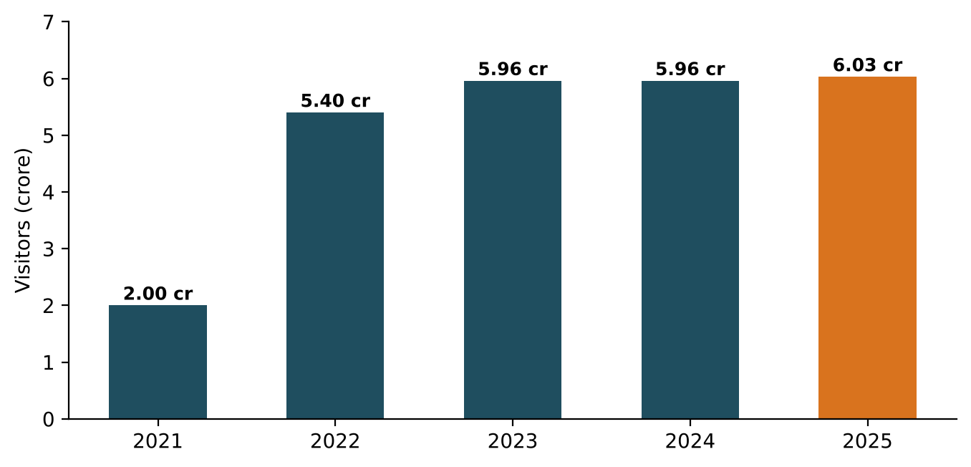
Figure 1.1: Total visitors to Uttarakhand, 2021 to 2025 (Tourism Department data reported by ETV Bharat, 2026a)
The Char Dham Yatra is the most concentrated and riskiest part of this flow. In 2025 it drew 51,06,346 pilgrims, about 3.05 lakh more than in 2024 (Counterview, 2025), over a season of roughly six months, along narrow mountain highways and treks of up to about 18 km at altitudes above 3,000 m. The 2013 Kedarnath disaster showed how quickly extreme rainfall can turn a pilgrimage into a humanitarian crisis, and how much depends on timely information and coordination (Rautela, 2013). Rainfall-triggered landslides remain one of the deadliest hazards in the Himalaya (Froude and Petley, 2018).
At the same time, digital technology has changed what is possible. The idea of smart tourism uses information and communication technology to give travellers context-aware services and to help destinations manage visitor flows (Gretzel et al., 2015). Transformer-based language models (Vaswani et al., 2017; Brown et al., 2020) can hold natural conversations, and Retrieval-Augmented Generation (RAG) lets such models answer from a curated knowledge source instead of from memory (Lewis et al., 2020). India's national language platform Bhashini and open models such as IndicTrans2 (Gala et al., 2023) make translation and speech services available for Indian languages. Machine-learning forecasting methods (Taylor and Letham, 2018; Ke et al., 2017) can predict demand from historical patterns.
YatraSetu AI (setu means bridge) brings these building blocks together in a single, low-cost system for Uttarakhand: a multilingual assistant for pilgrims, a crowd-forecasting service, a route-risk and alert service, a health-readiness module, and a dashboard for district officials. This report describes the analysis, requirements, design, implementation and evaluation of a working prototype of the system.

1.2 Problem Statement
Field reports, official data and expert analysis point to one underlying failure: travellers make high-stakes decisions (when to go, which route to take, whether they are fit to trek) without timely, trustworthy and personalised information in a language they understand, while authorities lack forecasting and targeted-broadcast tools to spread crowds and warn people early. It shows up as five pain points:
- Fragmented information (P1). Registration, weather warnings, road status, helicopter booking, medical posts and shrine timings are spread across separate portals, apps, press notes and social media posts. No single channel answers a traveller's actual question.
- Unpredictable, over-capacity crowding (P2). Kedarnath recorded 30,154 pilgrims on 2 May 2025, while a 2025 carrying-capacity study recommended about 13,111 per day (ETV Bharat, 2026b). The same season had 86 zero-pilgrim shrine-days caused by weather and closures (Counterview, 2025).
- Weather and landslide disruptions (P3). On 3 July 2025 heavy rain triggered landslides and the yatra was halted (News On AIR, 2025). In September 2025 about 2,500 tourists were stranded in Mussoorie after roads and bridges were damaged (Business Today, 2025).
- Preventable health emergencies (P4). 56 pilgrims died in the first 28 days of the 2025 yatra, mostly from cardiac causes and mostly people over 50 (ETV Bharat, 2025).
- Language, literacy and connectivity barriers (P5). Pilgrims come from every state, many are elderly, and network coverage along routes is uneven, so English-first, text-heavy apps exclude the people at highest risk.
Problem statement
Design and build a low-cost, multilingual, AI-driven assistant that gives each Char Dham traveller verified, personalised guidance on when to travel, which route is safe and how to prepare, and that gives district officials crowd forecasts and a controlled channel to publish advisories and alert travellers on affected routes, using existing public data and open AI components.

1.3 Project Objective
The aim of the project is to design, implement and evaluate a working prototype of YatraSetu AI. The specific objectives are:
Table 1.1: Project objectives and measurable targets
ID | Objective | Measurable target
O1 | Build a bilingual (English and Hindi) conversational assistant that answers common yatra questions from verified content with sources | Top-3 retrieval accuracy of 90% or more on a 40-question gold set; every answer shows its source
O2 | Forecast daily footfall at the five shrines and compare it with carrying capacity | MAPE of 20% or less on normal days of a held-out season
O3 | Score route-segment risk from weather alerts, road status and terrain, and alert subscribed travellers | Alerts generated automatically for Orange or Red segments, with SMS fallback
O4 | Provide a rule-based health-readiness self-check and SOS | Correct category for all test profiles; nearest help found from GPS position
O5 | Provide an officials' dashboard with two-person (four-eyes) approval of advisories | Author cannot approve own advisory; approved advisory immediately answerable by the assistant
O6 | Keep the design low-cost, private and replicable | Runs offline on a laptop; consent and hashing of phone numbers; open-source stack

1.4 Advantages of this Project
- Safety first: emergencies are detected deterministically and answered with 112/108 instructions without depending on an AI model.
- Trustworthy answers: every answer is grounded in approved official content or live data, and the source and last-updated date are shown.
- Inclusive: works in Hindi and English out of the box, with an adapter for other Indian languages through Bhashini; designed for WhatsApp and SMS, which most pilgrims already use.
- Better crowd distribution: a 7-day outlook against carrying capacity helps pilgrims pick lighter days and helps officials plan staff and parking.
- Targeted warnings: only travellers whose route actually crosses an affected segment are alerted, with a suggested safe halt.
- Accountable governance: four-eyes approval, role-based access and an audit log of every advisory and road-status change.
- Low cost and easy to build: no new hardware; mainstream open-source tools; the full prototype runs on a laptop.

1.5 Scope of Project
The scope of the prototype is defined below. Items marked out of scope are either already handled by official systems or need hardware, partnerships or data access beyond a student project.
Table 1.2: Scope of the project
In scope | Out of scope
Char Dham and Hemkund Sahib routes from Rishikesh (19 towns, 18 route segments) | Statewide tourism (hill stations, wildlife parks); planned as future work
Bilingual assistant (web app, WhatsApp webhook); Bhashini adapter for other languages | Voice calls (IVR) and Garhwali/Kumaoni speech recognition
Crowd forecasting with a trained model; carrying-capacity bands; alternative dates | CCTV, drone or sensor-based live crowd counting
Route-risk scoring; road-status and IMD-alert entry; safe-halt suggestion | Issuing official warnings (the system amplifies, never replaces, IMD/USDMA)
Trip subscription with consent; WhatsApp alerts with SMS fallback (simulated gateway) | Yatra registration, payments, helicopter or hotel booking
Health readiness self-check and SOS with nearest help | Medical diagnosis or treatment advice
Officials' dashboard: advisories, approvals, analytics, model metrics, audit log | Integration with live government databases (needs a data-sharing agreement)

1.6 Tools & Technology Used
Table 1.3: Tools and technologies
Category | Tool / technology | Use in the project
Programming language | Python 3.11+, JavaScript (ES2020) | Back-end, machine learning, front-end logic
Web framework | FastAPI, Uvicorn, Pydantic | REST API, request validation, automatic API documentation
Machine learning | scikit-learn, NumPy, pandas | TF-IDF retrieval, logistic-regression intent model, gradient-boosting forecaster
Language AI | Bhashini API (optional), any OpenAI-compatible LLM API (optional) | Translation for more Indian languages; generative RAG answers
Database | SQLite (prototype); PostgreSQL + PostGIS (production design) | Subscriptions, advisories, outbox, logs, audit
Front-end | HTML5, CSS3, JavaScript, Canvas, SVG, Service Worker | Progressive Web App, charts and route-risk map without external libraries
Messaging | WhatsApp Business Cloud API (webhook), SMS gateway | Inbound questions and outbound alerts (simulated outbox in prototype)
Testing | pytest, FastAPI TestClient, Playwright | Unit and API tests, automated screenshots
Design and documentation | Graphviz, Matplotlib, MS Word | UML/DFD/ER diagrams, charts, report
Version control and IDE | Git, Visual Studio Code | Source management and development

1.7 Organisation of the Report
Chapter 2 analyses the existing systems and literature, studies the available data and identifies the gaps that motivate the work. Chapter 3 is the Software Requirements Specification with system configuration, functional and non-functional requirements and UML/DFD/ER models. Chapter 4 describes the architecture, technologies and algorithms. Chapter 5 presents the code organisation and key listings. Chapter 6 shows screenshots of the working system together with test and evaluation results. Chapter 7 concludes with achievements, limitations and future scope, and Chapter 8 lists the bibliography.

CHAPTER 2
ANALYSIS
This chapter studies the systems that pilgrims and officials use today, reviews the relevant research, analyses the available data, examines feasibility and concludes with the gaps in existing work that motivate YatraSetu AI.

2.1 Study of the Existing System
Information for Char Dham travellers is currently provided by several independent systems, each covering one function:
Table 2.1: Existing systems and their limitations
Existing system | What it provides | Limitation for the traveller
Registration & Tourist Care portal and Tourist Care Uttarakhand app (Government of Uttarakhand, 2024) | Mandatory yatra registration, QR code, some tourist information | Transactional; does not answer free-form questions, forecast crowds or give route-specific warnings
Uttarakhand Bhookamp Alert app (USDMA) (Deccan Herald, 2021) | Earthquake early warning | Single hazard; not linked to the traveller's route or trip dates
IMD district warnings and USDMA bulletins | Colour-coded district rainfall alerts | District-level, technical; not translated into "what should I do on my route"
Police and district press notes, social media posts | Road closures, traffic diversions | Scattered, often only in Hindi or English, easy to miss; no targeting
Helplines (112, 108, tourist helplines) | Emergency and general help | Overloaded during peaks; no self-service
Private travel apps and websites | Bookings, generic guides | Not authoritative; fake helicopter-booking sites are a known fraud risk

The common weakness is that none of these systems combines verified information + personalisation (route, date, age, language) + prediction + targeted alerts. Officials also have no single place to publish an advisory once and have it reach every affected traveller in their language.

2.2 Literature Review

2.2.1 Smart tourism
Gretzel et al. (2015) define smart tourism as tourism supported by integrated efforts at a destination to collect and aggregate data from physical infrastructure, social connections and organisational sources, and to use advanced technologies to turn that data into on-site experiences and business value. They stress real-time, context-aware services for travellers and data-driven management for destinations. YatraSetu applies this idea to pilgrimage safety rather than only to marketing or convenience.

2.2.2 Language models and Retrieval-Augmented Generation
The Transformer architecture (Vaswani et al., 2017) is the basis of modern language models, and Brown et al. (2020) showed that very large models can perform many tasks from a few examples. Such models can, however, produce fluent but unsupported statements; Ji et al. (2023) survey this hallucination problem and its mitigation. Lewis et al. (2020) proposed Retrieval-Augmented Generation, which retrieves relevant passages from an external corpus and conditions generation on them, improving factuality and allowing the knowledge to be updated without retraining. Classical retrieval models such as TF-IDF weighting (Salton and Buckley, 1988) and BM25 (Robertson and Zaragoza, 2009) remain strong, transparent baselines (Manning et al., 2008). For safety-critical advice, YatraSetu therefore uses RAG with strict grounding and a deterministic fallback.

2.2.3 Indian language technology
Gala et al. (2023) released IndicTrans2, open machine-translation models covering all 22 scheduled Indian languages. The Government of India's Bhashini platform exposes translation for 22 languages and speech recognition and synthesis for 12 languages through APIs (UNICEF). These resources make a multilingual assistant feasible without training new models.

2.2.4 Demand forecasting
Hyndman and Athanasopoulos (2021) describe forecasting methods from exponential smoothing to regression with calendar effects. Taylor and Letham (2018) introduced Prophet, an additive model with trend, seasonality and holiday components, for forecasting at scale. Gradient boosting (Friedman, 2001) and its efficient histogram-based implementations such as LightGBM (Ke et al., 2017) are widely used for tabular prediction because they capture non-linear interactions between features such as season position, weekday and weather. YatraSetu uses histogram gradient boosting on features known in advance.

2.2.5 Landslide hazard and early warning
Froude and Petley (2018) compiled 4,862 fatal non-seismic landslides between 2004 and 2016 and identified the Himalayan arc as a global hotspot, with most events triggered by rainfall. Kirschbaum and Stanley (2018) built a satellite-rainfall-based model (LHASA) that combines rainfall with a static susceptibility map to give near-real-time landslide hazard for situational awareness. Rautela (2013) analysed the 2013 Kedarnath disaster and highlighted gaps in warning, communication and regulation of pilgrim flows. YatraSetu's route-risk score follows the same principle of combining dynamic rainfall/alert information with static susceptibility, at the scale of road segments.

2.2.6 Software requirements engineering
The requirements in this project follow IEEE Std 830-1998 and its successor ISO/IEC/IEEE 29148:2018, and the process models described by Pressman and Maxim (2020) and Sommerville (2016).
Table 2.2: Summary of literature review
Author (Year) | Focus | Key contribution | Use / gap for this project
Gretzel et al. (2015) | Smart tourism | Framework for data-driven, real-time tourist services | Applied to pilgrimage safety; no Himalayan pilgrimage system found
Vaswani et al. (2017); Brown et al. (2020) | Language models | Transformer; few-shot learning | Enable natural-language assistant
Lewis et al. (2020) | RAG | Retrieval + generation for factual answers | Core answer method; needs domain knowledge base
Ji et al. (2023) | Hallucination | Survey of causes and mitigation | Motivates grounding guardrail and fallback
Gala et al. (2023); Bhashini | Indian languages | Translation for 22 languages | Multilingual access for pilgrims
Taylor and Letham (2018); Ke et al. (2017) | Forecasting | Seasonal models; gradient boosting | Shrine footfall forecasting
Froude and Petley (2018); Kirschbaum and Stanley (2018) | Landslides | Global inventory; rainfall + susceptibility hazard model | Route-segment risk score
Rautela (2013) | Kedarnath 2013 | Lessons on warning and pilgrim management | Need for early, targeted communication

2.3 Data Analysis
Publicly reported data was analysed to size the problem and to set design parameters.
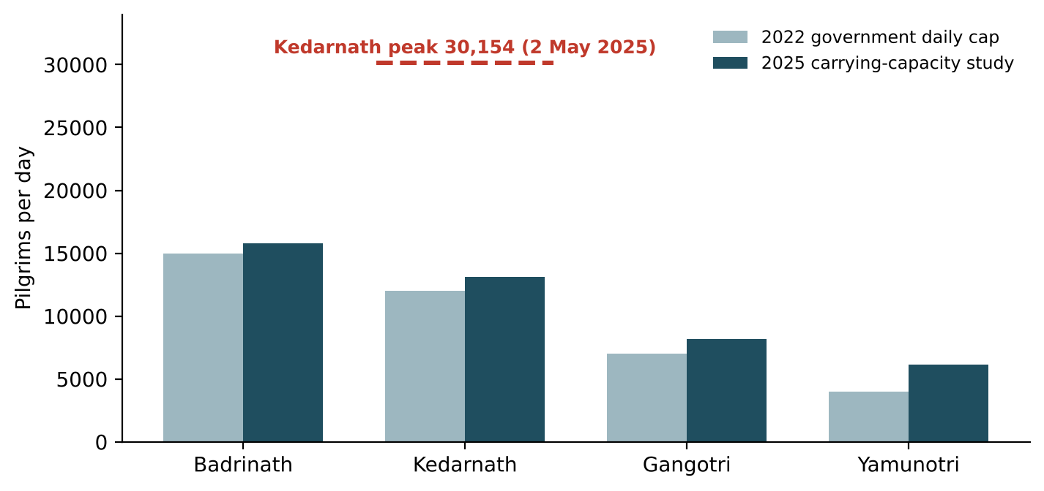
Figure 2.1: Daily limits per shrine compared with the observed Kedarnath peak (The Quint, 2022; ETV Bharat, 2026b; Counterview, 2025)
Table 2.3: Key figures used in the analysis
Indicator | Value | Source
Visitors to Uttarakhand, 2025 | 6,03,21,194 | ETV Bharat (2026a)
Char Dham pilgrims, 2025 (2024) | 51,06,346 (48,01,167) | Counterview (2025)
Highest single-day footfall, 2025 | 30,154 at Kedarnath, 2 May 2025 | Counterview (2025)
Zero-pilgrim shrine-days, 2025 | 86 | Counterview (2025)
Recommended daily capacity (2025 study) | Badrinath 15,778; Kedarnath 13,111; Gangotri 8,178; Yamunotri 6,160 | ETV Bharat (2026b)
Pilgrim deaths, first 28 days of 2025 yatra | 56 (Kedarnath route 26), mostly cardiac | ETV Bharat (2025)
Registrations by 21 June 2025 | About 45 lakh | The Week (2025)
Tourists stranded in Mussoorie, Sept 2025 | About 2,500 | Business Today (2025)

Three conclusions follow. First, demand is highly peaked: the opening weeks and weekends exceed carrying capacity by a large margin, so even modest shifting of demand to lighter days has value. Second, disruption is frequent and route-specific, so warnings must be tied to the traveller's segment and dates. Third, the people most at risk are elderly pilgrims from many language backgrounds, so the interface must be simple, multilingual and work on WhatsApp and SMS.

2.4 Requirement Analysis
Table 2.4: Stakeholders and their needs
Stakeholder | Need | How YatraSetu responds
Pilgrim / tourist | Reliable answers, best day to travel, route safety | Assistant, crowd forecast, route risk, alerts
Elderly / low-literacy traveller | Simple, own-language, voice-friendly help | Hindi/English, quick-reply buttons, Bhashini adapter
District official (editor) | Publish road and weather advisories quickly | Advisory drafting with bilingual text, road-status entry
Senior official (approver) | Control over what is broadcast | Four-eyes approval, audit log
Tourism department | Insight into traveller concerns and crowding | Query analytics, forecast metrics
Health department | Screening compliance for 50+ pilgrims | Screening reminders and medical-post finder

2.5 Feasibility Analysis

2.5.1 Technical feasibility
All components are mature and available as open-source libraries or public APIs: FastAPI and scikit-learn for the back-end and models, Bhashini for Indian languages, and standard web technologies for the front-end. No new hardware or model training at scale is required. The prototype in this report demonstrates technical feasibility directly.

2.5.2 Economic feasibility
The prototype was built with free, open-source software on a personal laptop. For a state-level deployment, indicative costs are shown below (estimates at typical market rates, not quotations).
Table 2.5: Indicative deployment cost (INR)
Item | Basis | Amount
Development team (6 months) | ML engineer, full-stack and front-end developers, part-time UX/QA and lead | about 19.1 lakh
Cloud, field testing, security audit, contingency | Development environment, user trials on route, VAPT, 10% contingency | about 5.7 lakh
Annual operations | Hosting, LLM API, WhatsApp/SMS messages, one maintenance engineer | about 21 lakh per year
Cost per pilgrim per season | 21 lakh / 51 lakh pilgrims | about 0.41

2.5.3 Operational feasibility
Pilgrims already use WhatsApp and must already register digitally, so no new app installation is needed. The main operational dependency is that district control rooms enter road status and approve advisories; the dashboard workflow is designed to take only a few minutes. A data-sharing agreement is needed to replace the synthetic footfall history with official counts.

2.5.4 Schedule feasibility
The project was planned over a 16-week semester as shown below and completed within the schedule.
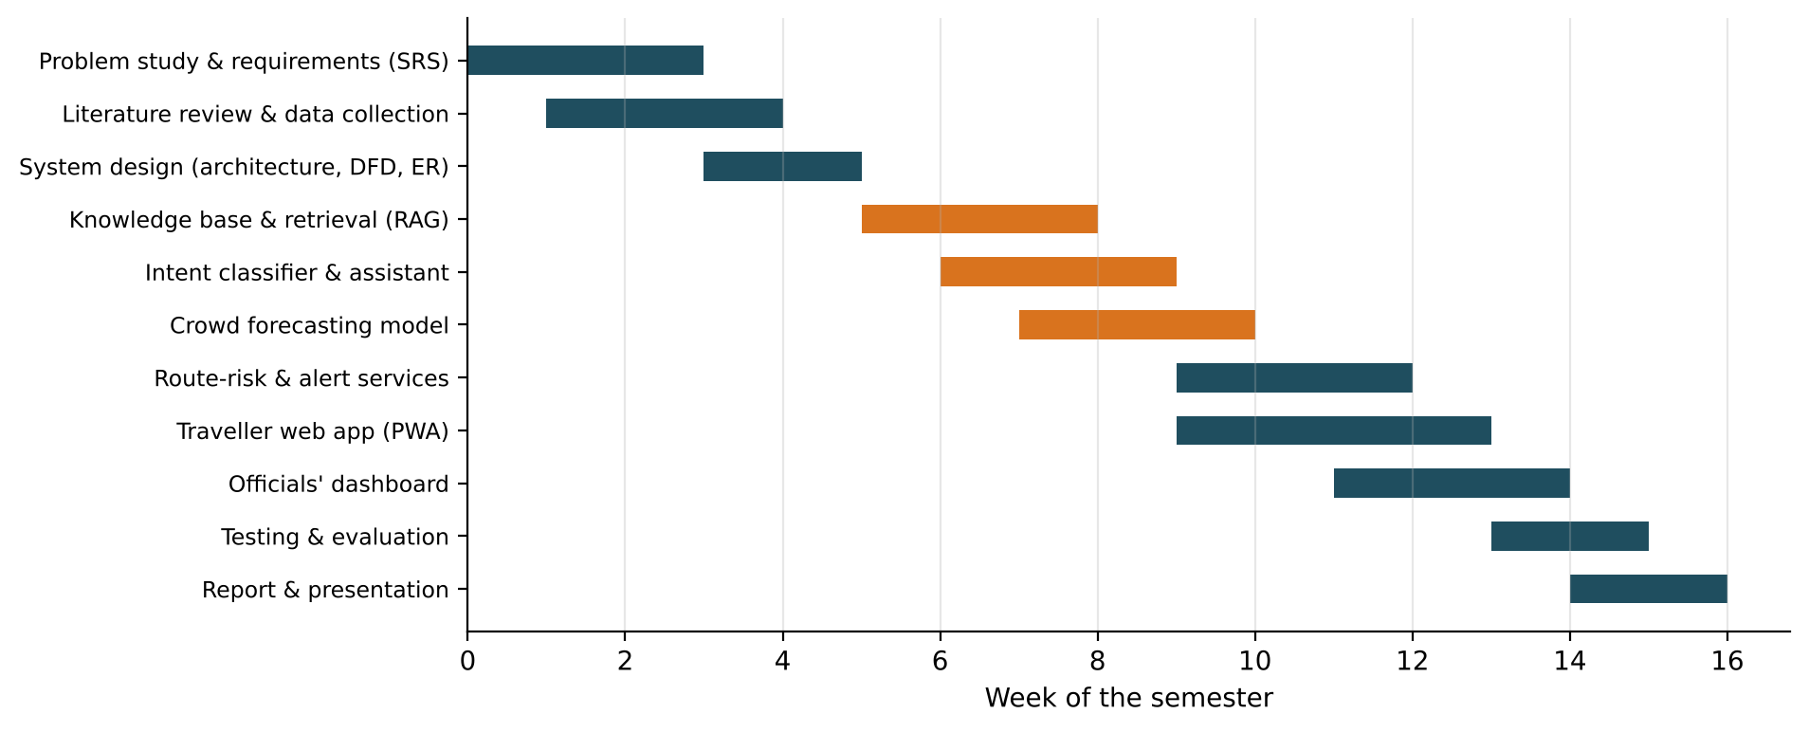
Figure 2.2: Project schedule (Gantt chart)

2.6 Gaps in Reported and Existing Work, and Motivation
From the study of existing systems, the literature and the data, the following gaps were identified:
- No single, conversational source of verified yatra information. Existing apps are transactional or single-hazard; travellers must search across many sources.
- No public crowd forecast linked to carrying capacity. Capacity studies and daily counts exist, but travellers cannot see in advance which days will be over capacity.
- Warnings are district-level, not route- and date-specific. Research on landslide hazard combines rainfall with susceptibility, but this is not turned into personalised advice for travellers on a road segment.
- Language and accessibility gaps. Most services are English or Hindi only and text-heavy, although Indian-language AI is now available through Bhashini and open models.
- Unsafe use of generative AI. General-purpose chatbots can hallucinate; safety-critical travel advice needs grounding, citations and a deterministic emergency path.
Motivation. As a student of an Uttarakhand institution specialising in AI/ML, the author was motivated by the repeated news of stranded and ill pilgrims during each yatra season. The project shows that a small, well-designed system built from open components can close these gaps: it gives every pilgrim a trusted assistant in their language, helps spread crowds, and gives officials a fast, accountable way to warn exactly the people who need it.

CHAPTER 3
SOFTWARE REQUIREMENTS SPECIFICATION
This chapter specifies YatraSetu AI following the structure of IEEE Std 830-1998 and ISO/IEC/IEEE 29148:2018. It refines the objectives of Chapter 1 into a complete information description, functional and behavioural requirements, performance and design constraints, and validation criteria.

3.1 System Configurations
The software requirement specification is produced at the end of the analysis task. The function and performance allocated to the software are refined by establishing a complete information description, a detailed functional description, a representation of system behaviour, performance and design constraints, and validation criteria.

3.1.1 Software requirements
- Operating system: Windows 10/11, macOS 12 or later, or Ubuntu 22.04 LTS
- Coding language: Python 3.11 or later (back-end, ML); JavaScript ES2020 (front-end)
- Framework: FastAPI 0.110+ with Uvicorn ASGI server and Pydantic validation
- Machine learning libraries: scikit-learn 1.4+, pandas 2.x, NumPy
- Front-end: HTML5, CSS3, JavaScript (Progressive Web App, Canvas and SVG charts)
- Database: SQLite 3 (prototype); PostgreSQL 15 with PostGIS (production design)
- Browser: Google Chrome 90+, Safari 15+, Firefox 90+ (desktop or mobile)
- Development tools: Visual Studio Code, Git, pytest, Playwright
- Optional services: Bhashini API credentials; an OpenAI-compatible LLM API key; WhatsApp Business Platform account

3.1.2 Hardware requirements
- Development system: Intel Core i5 (8th gen) / AMD Ryzen 5 / Apple M1 or better
- RAM: 8 GB (4 GB minimum)
- Hard disk: 1 GB free space for code, virtual environment and data
- Production server (recommended): 4 vCPU, 8 GB RAM, 50 GB SSD, auto-scaling during the yatra season
- Client device: any Android 8+ or iOS 14+ smartphone with WhatsApp or a browser; any mobile phone for SMS alerts

3.2 Introduction

3.2.1 Purpose
This SRS describes the functional, interface, data and quality requirements of YatraSetu AI version 1.0. It is intended for developers, testers, evaluators and the potential sponsor (Uttarakhand Tourism Development Board and district administrations).

3.2.2 Product scope
YatraSetu AI is a multilingual assistant and advisory platform for Char Dham and Hemkund Sahib travellers. It provides grounded question answering, crowd forecasts, route-risk alerts, health-readiness guidance and SOS, together with a dashboard for officials to publish verified advisories. Registration, booking and medical diagnosis are out of scope.

3.2.3 Definitions, acronyms and abbreviations
Table 3.1: Definitions and abbreviations
Term | Meaning
RAG | Retrieval-Augmented Generation: answers are produced only from retrieved, approved passages
LLM | Large Language Model
TF-IDF | Term Frequency-Inverse Document Frequency text representation
Bhashini | Government of India national language-technology platform (translation, ASR, TTS)
PWA | Progressive Web App: installable web app with offline caching
Carrying capacity | Recommended maximum daily pilgrims a shrine can safely host
Advisory | Official notice (road, weather, crowd, health) approved by an authorised official
Route segment | Stretch of road or trek between two named towns, e.g. Guptkashi to Sonprayag
Four-eyes rule | An advisory must be approved by a different person from its author
MAPE | Mean Absolute Percentage Error
IMD / USDMA | India Meteorological Department / Uttarakhand State Disaster Management Authority
RBAC | Role-Based Access Control

3.3 Overall Description

3.3.1 Product perspective
YatraSetu AI is a new, self-contained system that works alongside existing government systems. It reads aggregated footfall data, weather alerts and road status, and it links travellers to official portals for registration and booking. It does not write to any government system.

3.3.2 Product functions
- Answer travel, registration, weather, route, shrine and health-preparedness questions in the user's language, with sources.
- Show a 7-day crowd outlook for each shrine and suggest lighter dates or an alternative shrine.
- Score the risk of every route segment and show it on a map with explanations; suggest a safe halt.
- Let users subscribe a trip with consent and receive alerts by WhatsApp with SMS fallback.
- Run a health-readiness self-check and show screening points and medical posts on the route.
- Provide an SOS function that shares location and finds the nearest help.
- Let officials draft, approve and broadcast advisories, update road status and weather alerts, and view analytics, delivery logs, model metrics and the audit log.

3.3.3 User classes and characteristics
Table 3.2: User classes
User class | Characteristics | Main functions used
Pilgrim / tourist | Any age, any Indian language, varied digital literacy, often on low bandwidth | Assistant, crowd forecast, route risk, health check, alerts, SOS
Editor (district official) | Control-room staff; drafts advisories and updates road status | Advisories, road status and weather, overview
Approver (senior official, e.g. DDMO) | Authorises what is broadcast | Approval, delivery log, audit log
Administrator / analyst | Maintains knowledge base, reviews analytics and model quality | Analytics, forecast-model page

3.3.4 Operating environment
The server runs as a Python ASGI application on Linux, macOS or Windows, or in a container on a cloud platform such as MeghRaj (GI Cloud). Clients use any modern mobile or desktop browser, WhatsApp, or SMS.

3.3.5 Design and implementation constraints
- Answers to factual questions must come only from approved content or live service data; no free-form generation of safety facts.
- Emergency messages must be handled by deterministic rules, never by a probabilistic model.
- Every broadcast must have a named approver who is different from the author.
- Personal data must be minimised, stored in India and processed only with consent (DPDP Act, 2023).
- The front-end must work on low bandwidth and must not depend on external CDNs.

3.3.6 Assumptions and dependencies
Aggregated daily footfall counts can be obtained from the tourism department under a data-sharing agreement; until then a synthetic history calibrated to published season totals is used. Officials will enter road status during the season. Bhashini, WhatsApp Business Platform and LLM APIs remain available for the optional integrations.

3.4 Functional Requirements
Each requirement is given a priority using the MoSCoW scheme (M = Must, S = Should, C = Could) and its status in the prototype.
Table 3.3: Functional requirements
ID | Requirement | Pri. | Prototype status
FR-01 | Accept text questions via web app and WhatsApp webhook; detect language automatically, with manual override | M | Implemented
FR-02 | Accept voice notes and reply with speech (Bhashini ASR/TTS) | S | Planned (adapter ready)
FR-03 | Answer from the approved knowledge base using retrieval and show source and last-updated date | M | Implemented
FR-04 | Give a safe fallback with helpline/112 when retrieval confidence is low or the question is off-topic | M | Implemented
FR-05 | Detect emergencies deterministically and return safety instructions and SOS | M | Implemented
FR-06 | Provide quick-reply buttons for common questions | M | Implemented
FR-07 | Deep-link to official portals instead of performing registration or booking | M | Implemented (content)
FR-08 | Load daily footfall history per shrine | M | Implemented (CSV)
FR-09 | Forecast daily footfall 7 days ahead for five shrines | M | Implemented
FR-10 | Classify each day as Low / Moderate / High / Over capacity against carrying capacity | M | Implemented
FR-11 | Suggest up to two lighter dates and one alternative shrine for crowded days | S | Implemented
FR-12 | Accept IMD/USDMA district alerts and rainfall (feed or manual entry) | M | Implemented
FR-13 | Let officials mark a segment Open, Restricted or Closed with reason and expected reopening | M | Implemented
FR-14 | Compute a 0-100 risk score and Green/Yellow/Orange/Red level per segment with explanations | M | Implemented
FR-15 | Let users subscribe a trip with explicit consent | M | Implemented
FR-16 | Notify affected subscribers by WhatsApp with SMS fallback | M | Implemented (simulated gateway)
FR-17 | Include the nearest safe halt with facilities in every route alert | S | Implemented
FR-18 | Run a health self-check and return a readiness category with guidance (no diagnosis) | M | Implemented
FR-19 | Remind pilgrims aged 50+ about mandatory screening and list screening points on the route | M | Implemented
FR-20 | List medical posts on the route and give acclimatisation tips | S | Implemented
FR-21 | One-tap SOS sharing location and opening the 112 dialler; find nearest help | M | Implemented
FR-22 | Cache the app shell for offline use | S | Implemented (service worker)
FR-23 | Role-based login for officials (editor, approver) | M | Implemented
FR-24 | Editors draft advisories with English and Hindi text, segment and validity | M | Implemented
FR-25 | Only a different approver can publish; publishing updates the knowledge base and broadcasts alerts | M | Implemented
FR-26 | Dashboard map of route risk and forecast vs. capacity | M | Implemented
FR-27 | Analytics on questions by intent and language, grounded-answer rate | S | Implemented
FR-28 | Show forecast-model accuracy and back-test chart | S | Implemented
FR-29 | Record an audit log of logins, advisories, approvals, road and weather changes and SOS | M | Implemented
FR-30 | Export daily and seasonal reports (PDF/CSV) | C | Planned

3.5 Non-Functional Requirements
Table 3.4: Non-functional requirements
ID | Attribute | Requirement | Prototype measurement
NFR-01 | Performance | Text answer within 4 s (95th percentile) | About 5 ms retrieval + intent per query on a laptop
NFR-02 | Alert latency | Alerts dispatched within 5 minutes of approval | Dispatched in the same request as approval
NFR-03 | Availability | 99.5% during the yatra season | Design target (stateless API, DB backups)
NFR-04 | Scalability | 5 lakh daily users at peak | Design target (horizontal scaling)
NFR-05 | Graceful degradation | If LLM/Bhashini fail, extractive answers and alerts still work | Implemented; offline mode is the default
NFR-06 | Localisation | Hindi and English; more languages via Bhashini | Hindi and English end to end
NFR-07 | Accessibility | WCAG 2.1 AA (W3C, 2018); large text; simple flows | Responsive layout, 15-16 px text, high contrast
NFR-08 | Low bandwidth | No external CDN; small payload | No third-party front-end libraries
NFR-09 | Privacy | Consent, minimisation, deletion (DPDP Act, 2023) | Consent required; phone stored as salted SHA-256 hash + masked number
NFR-10 | Security | Authentication, RBAC, input validation, audit | Token login, roles, Pydantic validation, audit log
NFR-11 | Answer accuracy | Top-3 retrieval accuracy of 90% or more | 95.0% on 40-question gold set
NFR-12 | Hallucination control | No unsupported numbers in generated answers | Numeric grounding check + fallback
NFR-13 | Forecast accuracy | MAPE of 20% or less on normal days | 13.3% on held-out 2025 season
NFR-14 | Maintainability | Modular code, automated tests | 11 modules; 18 automated tests passing
NFR-15 | Portability | Runs on any OS / cloud | Pure Python + browser; one-command setup script

3.6 Use Case Model
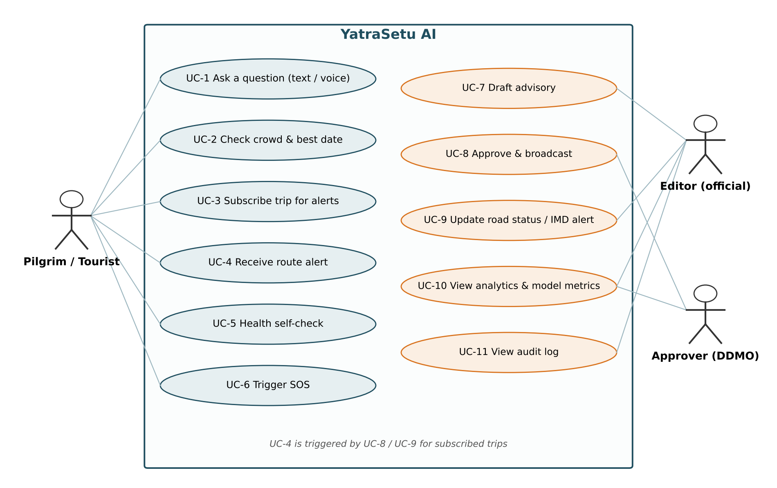
Figure 3.1: Use case diagram of YatraSetu AI
Table 3.5: Use case descriptions
ID | Use case | Actor | Main success scenario
UC-1 | Ask a question | Pilgrim | Types a question in Hindi or English; receives a grounded answer with sources
UC-2 | Check crowd | Pilgrim | Selects shrine and date; sees 7-day forecast, bands and alternatives
UC-3 | Subscribe trip | Pilgrim | Enters phone, shrine, dates and gives consent; gets confirmation
UC-4 | Receive alert | Pilgrim | Receives WhatsApp (or SMS) alert with reason, safe halt and 112
UC-5 | Health self-check | Pilgrim | Enters age, conditions, symptoms; gets readiness category and route medical posts
UC-6 | Trigger SOS | Pilgrim | Presses SOS; location message, 112 link and nearest help are shown
UC-7 | Draft advisory | Editor | Enters title, English and Hindi text, segment, validity; advisory saved as pending
UC-8 | Approve and broadcast | Approver | Approves pending advisory; knowledge base updated; affected subscribers alerted
UC-9 | Update road status / IMD alert | Editor / Approver | Marks segment closed or enters district alert; risk scores and alerts update
UC-10 | View analytics and model | Official | Views question statistics, delivery log, forecast accuracy
UC-11 | View audit log | Official | Reviews every action with actor and time

3.7 Data Flow Diagrams
The context diagram (Level 0) shows YatraSetu AI as a single process exchanging data with pilgrims, officials and external data sources. Level 1 decomposes it into five processes and five data stores.
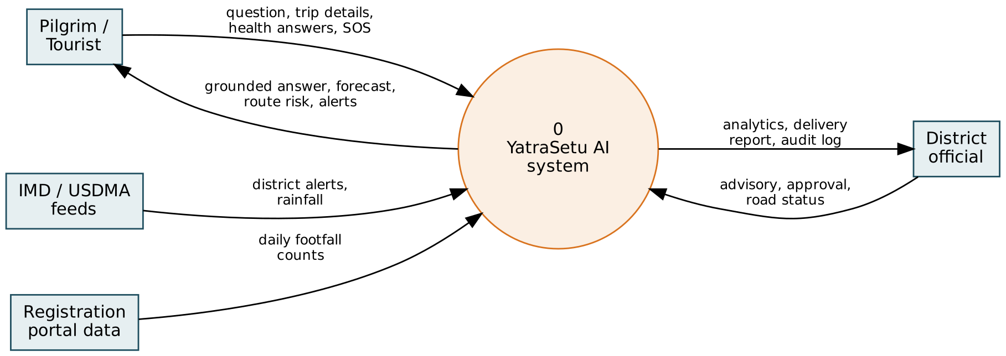
Figure 3.2: Data flow diagram, Level 0 (context diagram)
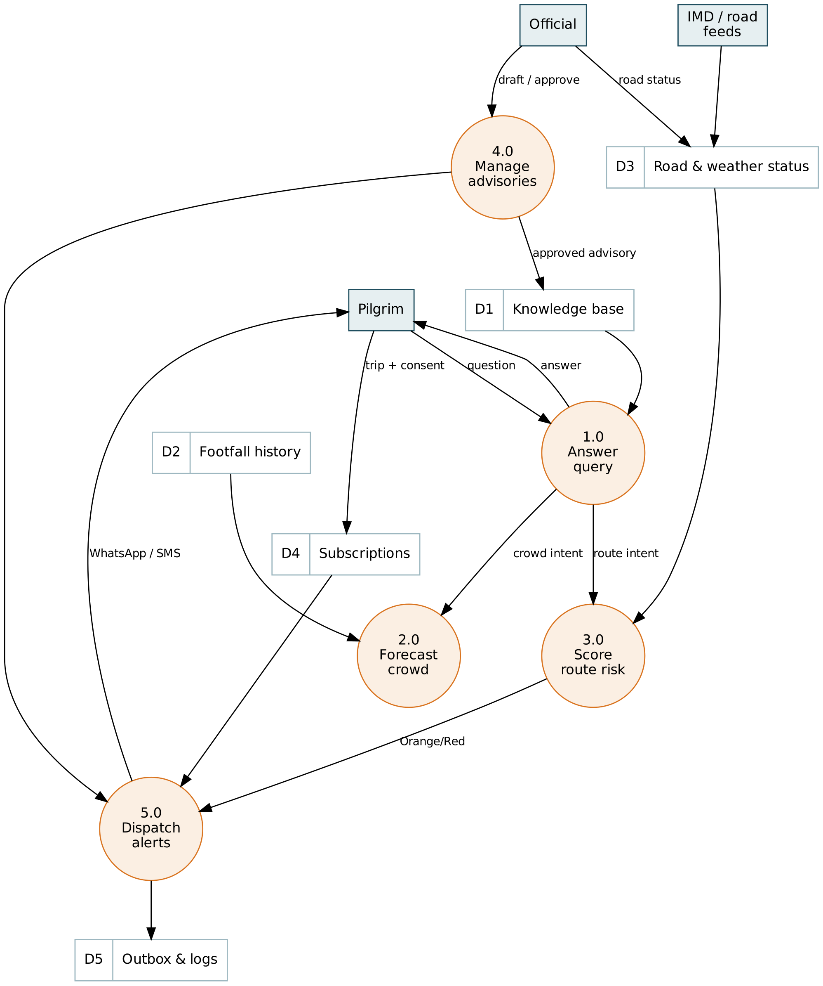
Figure 3.3: Data flow diagram, Level 1

3.8 Entity Relationship Model and Data Dictionary
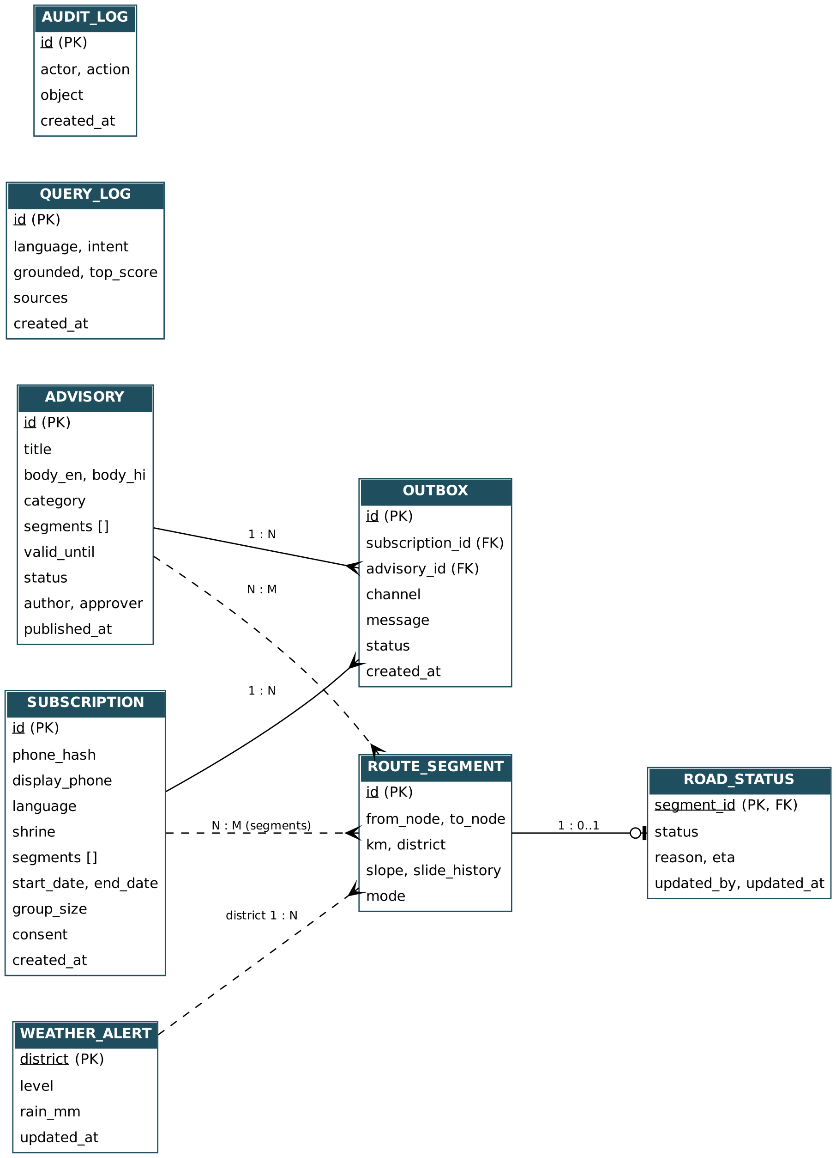
Figure 3.4: Entity relationship diagram
Table 3.6: Data dictionary (main tables)
Table | Key fields | Purpose / retention
subscriptions | id, phone_hash, display_phone, language, shrine, segments, start_date, end_date, group_size, consent | Trips subscribed for alerts; deleted after the trip (90 days in production)
advisories | id, title, body_en, body_hi, category, segments, valid_until, status, author, approver | Official notices; expired advisories are excluded from answers
outbox | id, subscription_id, advisory_id, channel, message, status | Every alert sent, by channel, with delivery status
road_status | segment_id, status, reason, eta, updated_by | Latest official status of each route segment
weather_alerts | district, level, rain_mm | Latest IMD/USDMA alert per district
query_log | language, intent, grounded, top_score, sources | Anonymous analytics; no message text stored
audit_log | actor, action, object, created_at | Accountability for all official actions

3.9 External Interface Requirements

3.9.1 User interfaces
- Traveller web app: five tabs (Assistant, Crowd forecast, Route risk, Health check, Trip alerts and SOS); responsive for phones; Devanagari-capable fonts.
- WhatsApp: plain-text questions to the business number; answers with source line.
- SMS: alert text of up to about 300 characters when WhatsApp delivery fails.
- Officials' dashboard: login, overview KPIs and map, advisories, road status and weather, alert delivery, forecast model, audit log.

3.9.2 Software interfaces
Table 3.7: Software interfaces
System | Direction | Data | Protocol
WhatsApp Business Cloud API | In / out | User messages; alerts | HTTPS webhook (verify token), REST
Bhashini pipeline API | Out | Translation for Indian languages | REST (optional)
LLM provider (OpenAI-compatible) | Out | Grounded answer generation | REST (optional)
IMD / USDMA alerts | In | District alert level, rainfall | Feed or dashboard entry
Footfall data (tourism department) | In | Daily counts per shrine | CSV (data agreement)
SMS gateway | Out | Fallback alerts | REST (simulated)

3.9.3 Communication interfaces
All client-server communication uses HTTP(S) with JSON bodies. The REST API is self-documented with OpenAPI at the /docs endpoint. Officials authenticate with a session token sent in the X-Token header.

CHAPTER 4
TECHNOLOGY USED AND ITS DESCRIPTION
This chapter describes the architecture of YatraSetu AI and each technology and algorithm used, explaining why it was chosen and how it is applied.

4.1 System Architecture
YatraSetu AI follows a layered, service-oriented architecture. All channels talk to a single API gateway; domain services orchestrate the AI engines; all state is kept in the data layer; and external feeds are read-only.
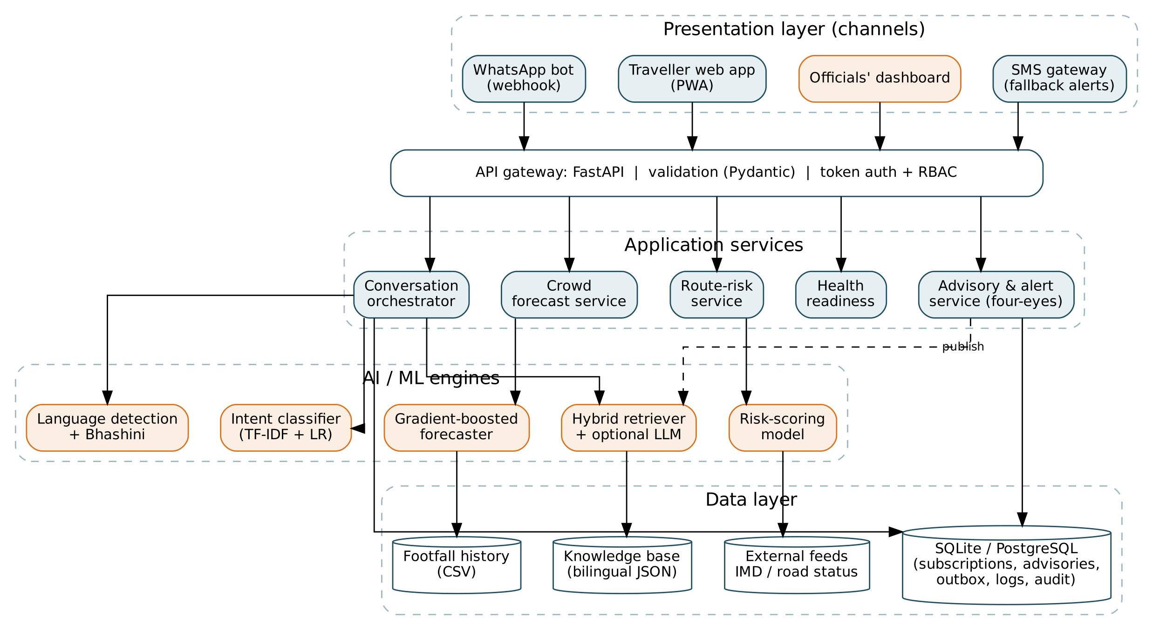
Figure 4.1: Layered architecture of YatraSetu AI
- Presentation layer: traveller Progressive Web App, WhatsApp webhook, SMS gateway (outbound) and the officials' dashboard.
- API gateway: FastAPI application that validates every request with Pydantic models and enforces token authentication and role-based access for official endpoints.
- Application services: conversation orchestrator, crowd-forecast service, route-risk service, health-readiness service and the advisory/alert service.
- AI/ML engines: language detection and Bhashini adapter, intent classifier, hybrid retriever with optional LLM, gradient-boosted forecaster and the risk-scoring model.
- Data layer: relational database (SQLite in the prototype, PostgreSQL/PostGIS in production), the bilingual knowledge base, the footfall history and external feeds.

4.2 Python and FastAPI
Python was chosen because it is the standard language for machine learning and has mature libraries for data handling and web services. FastAPI is a modern, high-performance web framework built on the ASGI standard. Its features used in this project are:
- Type-based validation with Pydantic: request bodies such as ChatIn, SubscribeIn and AdvisoryIn are declared as classes with constraints (e.g. phone number pattern, group size between 1 and 60); invalid input is rejected automatically with HTTP 422.
- Dependency injection: the functions user() and require(role) are injected into protected endpoints to enforce login and roles (editor vs. approver).
- Automatic OpenAPI documentation at /docs for every endpoint, useful for integration with government systems.
- Uvicorn ASGI server for serving the API and static files; the app also serves the PWA and dashboard pages.
Table 4.1: Main REST API endpoints
Method and path | Purpose | Access
POST /api/chat | Ask the assistant | Public
GET /api/forecast/{shrine} | 7-day crowd forecast | Public
GET /api/forecast/{shrine}/suggest | Lighter dates and alternative shrine | Public
GET /api/risk/network, /api/risk/trip/{shrine} | Route-risk map and trip risk | Public
POST /api/subscribe | Subscribe a trip (consent required) | Public
POST /api/health/check | Health-readiness self-check | Public
POST /api/sos | SOS message and nearest help | Public
GET, POST /webhook/whatsapp | WhatsApp verification and inbound messages | Platform
POST /api/admin/login | Official login, returns token | Officials
POST /api/admin/advisories | Draft advisory | Editor
POST /api/admin/advisories/{id}/approve | Approve and broadcast | Approver
POST /api/admin/road-status, /api/admin/weather | Update road status / IMD alert | Officials
GET /api/admin/analytics, outbox, audit | Dashboard data | Officials
GET /api/model/metrics | Forecast back-test and accuracy | Public (read-only)

4.3 Machine Learning with scikit-learn
scikit-learn (Pedregosa et al., 2011) provides well-tested implementations of the text-representation, classification and regression algorithms used in the project, together with NumPy and pandas for numerical and tabular data.

4.3.1 TF-IDF representation and cosine similarity
Text is converted to vectors with Term Frequency-Inverse Document Frequency weighting (Salton and Buckley, 1988; Manning et al., 2008). With sublinear term frequency and smoothed inverse document frequency, the weight of term t in document d is:
w(t, d) = (1 + ln tf(t, d)) x ( ln((1 + N) / (1 + df(t))) + 1 )

where tf(t,d) = count of t in d, N = number of documents, df(t) = documents containing t.
Vectors are L2-normalised, and similarity is cos(q, d) = (q . d) / (|q| |d|)

Two vectorisers are used together. A word-level model rewards exact terms such as "registration" or "Gaurikund". A character n-gram model (3 to 5 characters within word boundaries) is robust to spelling variants, Hindi inflections and mixed scripts. The hybrid retrieval score is:
score(q, d) = alpha x cos_word(q, d) + (1 - alpha) x cos_char(q, d), alpha = 0.5

Each document has an English and a Hindi view; the document score is the maximum over its views.

A third, stop-word-filtered word model measures how many content words the question shares with the knowledge base. If this content overlap is below a threshold (0.05), the question is treated as off-topic and the assistant gives a safe fallback instead of a loosely related answer (FR-04).

4.3.2 Intent classification with logistic regression
Intent (crowd, route, health, registration, booking, general) is predicted by a multinomial logistic-regression model on character n-gram TF-IDF features, trained on labelled English and Hindi example utterances. For feature vector x and class k the model computes:
P(y = k | x) = exp(w_k . x + b_k) / SUM_j exp(w_j . x + b_j) (softmax)
predicted intent = argmax_k P(y = k | x)

A deterministic emergency override runs before the model: regular-expression patterns in English and Hindi (e.g. "chest pain", "stuck", "accident", "सीने में दर्द", "फंस") immediately route the message to the emergency response. This guarantees that emergencies never depend on a probabilistic classifier.

4.3.3 Crowd forecasting with gradient boosting
Footfall is forecast with scikit-learn's HistGradientBoostingRegressor, a histogram-based gradient-boosting decision-tree model similar to LightGBM (Ke et al., 2017). Gradient boosting (Friedman, 2001) builds an additive model of regression trees, each fitted to the negative gradient (residuals) of the loss of the previous model:
F_0(x) = mean(y)
F_m(x) = F_(m-1)(x) + nu x h_m(x), h_m fitted to residuals r_i = y_i - F_(m-1)(x_i)

Target: y = ln(1 + visitors) (stabilises variance across shrines)
Settings: 400 iterations, learning rate nu = 0.05, 31 leaves, shrine as categorical feature

Table 4.2: Forecast model features (all known 7 days in advance)
Feature | Description
shrine_code | Shrine as a categorical feature
day_of_season, days_to_close | Position in the season (captures opening surge and closing tail)
month, weekday, is_weekend | Calendar effects
is_holiday | National holidays and summer-vacation period
rain_mm, alert_level | Forecast rainfall and IMD alert level (climatology when no forecast is available)

Accuracy is measured with the Mean Absolute Percentage Error on a held-out season, excluding disrupted days (closures), and with the share of days whose predicted crowd band matches the actual band:
MAPE = (100 / n) x SUM_i | y_i - y_hat_i | / y_i

Crowd band from ratio r = forecast / capacity:
Low: r < 0.60 Moderate: 0.60 <= r < 0.85 High: 0.85 <= r < 1.00 Over capacity: r >= 1.00

Because official shrine-wise daily counts require a data-sharing agreement, the model is trained on a synthetic history for 2022 to 2025 generated by a documented script. The generator reproduces the observed shape of the yatra: season totals calibrated to published figures (about 51 lakh in 2025), an opening-day surge (about 31,000 at Kedarnath, close to the reported 30,154), a May-June peak, a monsoon trough with closure days, and weekend/holiday uplift. The pipeline is unchanged when real data replaces the file.

4.4 Retrieval-Augmented Generation, LLM Integration and Bhashini
The assistant follows the RAG pattern (Lewis et al., 2020). The flow of a message is shown below.
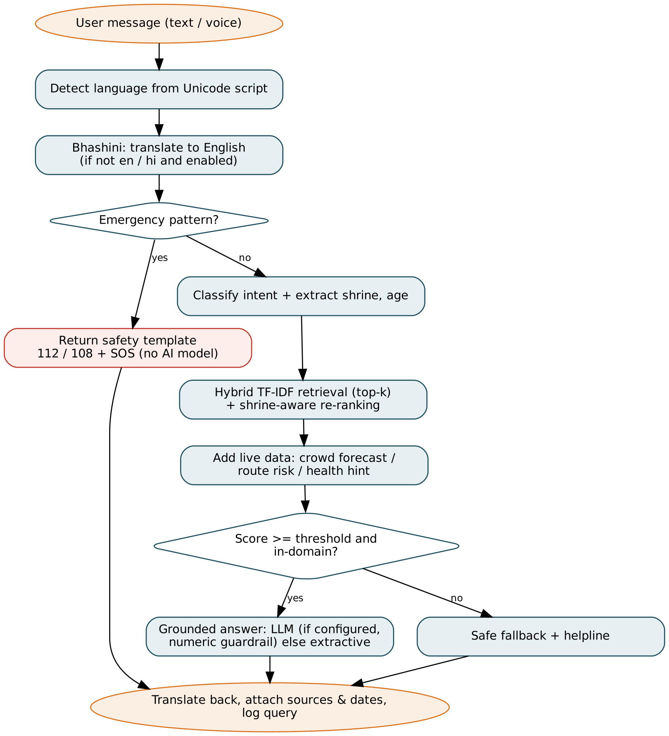
Figure 4.2: Processing flow of a user message in the assistant
- Language detection: the dominant Unicode script of the message identifies the language (Devanagari, Gujarati, Tamil, etc.; Latin defaults to English).
- Translation (optional): for languages other than English and Hindi, the Bhashini pipeline translates to English and the answer back; without credentials the system answers in English with a note.
- Emergency check and intent classification (Section 4.3.2) and extraction of the shrine name and age.
- Retrieval: hybrid TF-IDF search over the bilingual knowledge base and published advisories, with shrine-aware re-ranking (documents whose title names the requested shrine are boosted).
- Live enrichment: for crowd questions the 7-day forecast is added; for route questions the trip risk and safe halt are added.
- Answer generation: if an LLM is configured, the top passages are sent with a strict system prompt (answer only from passages, cite them, say NOT_FOUND otherwise). A guardrail checks that every number in the answer appears in the passages (reducing hallucination; Ji et al., 2023); otherwise, or if no LLM is configured, an extractive answer is built from the most relevant sentences of the best passage.
- Output: sources and last-updated dates are attached and an anonymous log entry (language, intent, grounded flag, sources) is stored.
Before any text is sent to an external LLM, phone numbers and e-mail addresses are redacted. If the LLM or Bhashini is unavailable, the system degrades gracefully to the offline extractive mode.

4.5 Route-Risk Scoring Algorithm
Following the principle of combining dynamic triggers with static susceptibility (Kirschbaum and Stanley, 2018), each of the 18 route segments receives a transparent 0-100 score:
R = A + 20 x min(rain_mm, 150) / 150 + w x S + D (capped at 100)

A = alert points: None 0, Yellow 15, Orange 30, Red 45 (IMD district alert)
S = susceptibility: 5 x (slope_class - 1) + 1.5 x min(past_slides, 10)
w = 1.0 if an alert is active or rain >= 20 mm, else 0.4
D = road-status points: Open 0, Restricted 20, Closed 100

Level: R < 25 Green, R < 45 Yellow, R < 65 Orange, otherwise Red; Closed is always Red

Every contributing factor is returned with the score and shown to the user (e.g. "IMD Orange alert in Rudraprayag (+30)"), so the advice is explainable. When the worst segment of a trip is Orange or Red, the safe-halt search walks back along the trip to the nearest town that has both accommodation and medical facilities.
For SOS, the nearest town with medical facilities is found with the haversine great-circle distance between the user's GPS position and town coordinates:
a = sin^2(dlat/2) + cos(lat1) cos(lat2) sin^2(dlon/2)
distance = 2 x 6371 km x asin( sqrt(a) )

4.6 Health-Readiness Rules
The health module is deliberately rule-based and conservative, because medical advice must be predictable and must not be presented as a diagnosis.
Table 4.3: Health-readiness rules
Input | Rule | Result
Any red flag (chest pain, breathlessness at rest, recent surgery/heart attack, fainting) | Overrides everything | Do not trek now + 112/108
Age 60+ / 50 to 59 | +2 / +1 points | Screening reminder for 50+
Heart disease, lung disease, pregnancy | +2 points each
High BP, diabetes | +1 point each
Low walking fitness | +1 point
Total points | 0 / 1-2 / 3 or more | Ready / Caution / Consult doctor first

4.7 Database
SQLite is used in the prototype because it needs no server and is part of Python. The schema (Section 3.8) is portable to PostgreSQL with PostGIS for production, where segment geometries and spatial queries (e.g. subscribers within a buffer around a landslide) can be handled natively. Phone numbers are never stored in clear text: a salted SHA-256 hash is used to identify the subscriber and only a masked form (e.g. 98******10) is shown to officials.

4.8 Front-End: HTML5, CSS3, JavaScript and Progressive Web App
The traveller app and dashboard are written in plain HTML5, CSS3 and JavaScript without external libraries or CDNs, so they load quickly on weak networks. Charts are drawn on the HTML Canvas and the route-risk map is generated as SVG from the route network. A web-app manifest and a service worker make the app installable and cache its assets for offline use. The layout is responsive and uses fonts that support Devanagari.

4.9 Messaging and Advisory Workflow
Inbound WhatsApp messages arrive at a webhook in the format of the WhatsApp Business Cloud API and are answered by the same assistant. Outbound alerts are written to an outbox table, which simulates the WhatsApp and SMS gateways: if WhatsApp delivery fails, an SMS copy is sent. The advisory workflow enforces the four-eyes principle, as shown in the sequence diagram.
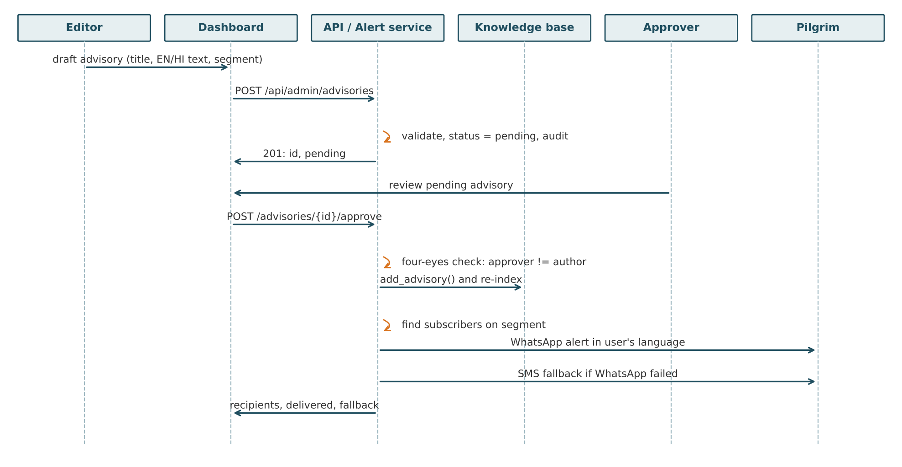
Figure 4.3: Sequence diagram of advisory drafting, approval and broadcast

4.10 Security and Privacy
- Authentication and RBAC: officials log in and receive a random session token; editor and approver roles are enforced on each endpoint.
- Four-eyes rule: an advisory cannot be approved by its author.
- Input validation: every request body is validated with Pydantic (types, lengths, patterns).
- Data minimisation and consent: trip details are stored only with explicit consent; analytics store intent and language, not message text (DPDP Act, 2023).
- PII redaction: phone numbers and e-mails are removed before text is sent to an external LLM.
- Audit log: logins, advisories, approvals, road and weather changes and SOS events are recorded with actor and time.

4.11 Testing Tools
pytest runs 18 automated unit and API tests, using FastAPI's TestClient to call the endpoints in-process. A separate evaluation script measures retrieval, intent, emergency and forecast accuracy on held-out data. Playwright (headless Chromium) was used to drive the user interface and capture the screenshots in Chapter 6.

CHAPTER 5
CODING
The prototype is written in about 2,400 lines of Python, JavaScript, HTML and CSS. This chapter presents the project structure and the most important parts of the code. The complete, runnable source code is provided in the project folder YatraSetu-AI and can be started with the single command ./run.sh.

5.1 Project Structure
YatraSetu-AI/
├── app/
│ ├── main.py FastAPI app: REST API, WhatsApp webhook, pages
│ ├── assistant.py conversation orchestrator
│ ├── knowledge_base.py bilingual knowledge base + hybrid retriever
│ ├── intent.py intent classifier + emergency override
│ ├── language.py language detection + Bhashini client
│ ├── llm.py optional LLM call + grounding guardrail
│ ├── forecast.py crowd forecasting model
│ ├── risk.py route-risk scoring, safe halt
│ ├── health.py health-readiness rules
│ ├── alerts.py subscriptions, advisories, alert dispatch
│ ├── db.py, config.py persistence and configuration
│ ├── data/ knowledge_base.json, shrines.json,
│ │ routes.json, footfall_history.csv
│ └── static/ index.html, app.js, admin.html, admin.js,
│ charts.js, style.css, manifest.json, sw.js
├── scripts/ generate_data.py, seed_demo.py, evaluate.py
├── tests/ test_core.py, gold_set.json
├── docs/ screenshots/, evaluation_results.json
├── requirements.txt, run.sh, README.md

Table 5.1: Source modules
Module | Lines | Responsibility
app/main.py | 292 | API gateway, request models, authentication, WhatsApp webhook
app/assistant.py | 158 | Conversation orchestrator
app/alerts.py | 133 | Subscriptions, advisories, alert dispatch
app/forecast.py | 126 | Crowd forecasting and evaluation
app/knowledge_base.py | 114 | Knowledge base and hybrid retriever
app/intent.py | 105 | Intent classifier, emergency override, entity extraction
app/db.py | 105 | Database schema and helpers
app/risk.py | 103 | Route-risk scoring and safe-halt search
app/language.py | 86 | Language detection, Bhashini client
app/health.py, app/llm.py, app/config.py | 141 | Health rules, LLM guardrail, configuration
app/static/* | 673 | Traveller PWA, dashboard, charts, styles, service worker
scripts/* | 203 | Synthetic data generation, demo seeding, evaluation
tests/test_core.py | 137 | 18 unit and API tests

5.2 Hybrid TF-IDF retriever (app/knowledge_base.py)
The retriever builds three TF-IDF models over the English and Hindi views of each document. search() combines word and character similarities and keeps the best view per document; content_overlap() is the off-topic gate.
def build(self):
self.views = [] # (doc_index, lang, text)
active = self.active_docs()
self._active = active
for i, d in enumerate(active):
for lang, t in d.text.items():
self.views.append((i, lang, f"{d.title}. {t}"))
corpus = [v[2] for v in self.views]
self.word_vec = TfidfVectorizer(analyzer="word", token_pattern=r"(?u)\b\w+\b", sublinear_tf=True)
# content-word model (stop words removed) used as an out-of-domain gate (FR-04)
self.gate_vec = TfidfVectorizer(analyzer="word", token_pattern=TOKEN, stop_words=STOP, sublinear_tf=True)
self.Xg = self.gate_vec.fit_transform(corpus)
self.char_vec = TfidfVectorizer(analyzer="char_wb", ngram_range=(3, 5), sublinear_tf=True)
self.Xw = self.word_vec.fit_transform(corpus)
self.Xc = self.char_vec.fit_transform(corpus)

def search(self, query: str, k: int = 3, alpha: float = 0.5):
"""Return [(doc, lang_of_best_view, score)] sorted by score."""
sw = cosine_similarity(self.word_vec.transform([query]), self.Xw)[0]
sc = cosine_similarity(self.char_vec.transform([query]), self.Xc)[0]
s = alpha * sw + (1 - alpha) * sc
best = {}
for vi, score in enumerate(s):
di, lang, _ = self.views[vi]
if di not in best or score > best[di][1]:
best[di] = (lang, float(score))
ranked = sorted(best.items(), key=lambda kv: kv[1][1], reverse=True)[:k]
return [(self._active[di], lang, score) for di, (lang, score) in ranked]

def content_overlap(self, query: str) -> float:
"""Max similarity on content words only; ~0 for questions unrelated to the yatra."""
return float(cosine_similarity(self.gate_vec.transform([query]), self.Xg).max())

5.3 Intent classifier with emergency override (app/intent.py)
The classifier is a scikit-learn pipeline of character n-gram TF-IDF and multinomial logistic regression. classify() first applies the deterministic emergency patterns.
def __init__(self):
X, y = [], []
for label, examples in TRAINING.items():
X += examples
y += [label] * len(examples)
self.model = make_pipeline(
TfidfVectorizer(analyzer="char_wb", ngram_range=(2, 5), sublinear_tf=True),
LogisticRegression(max_iter=2000, C=8.0),
)
self.model.fit(X, y)
shrines = json.loads((DATA_DIR / "shrines.json").read_text(encoding="utf-8"))["shrines"]
self.shrine_terms = {}
for s in shrines:
for term in {s["id"], s["name"].lower(), s["name_hi"], s["name"].split()[0].lower()}:
self.shrine_terms[term] = s["id"]
self.shrine_terms.update({"kedar": "kedarnath", "badri": "badrinath", "hemkund": "hemkund",
"केदार": "kedarnath", "बद्री": "badrinath", "बदरीनाथ": "badrinath"})

def classify(self, text: str):
if self.is_emergency(text):
return "emergency", 1.0
proba = self.model.predict_proba([text.lower()])[0]
i = proba.argmax()
return self.model.classes_[i], float(proba[i])

5.4 Conversation orchestrator (app/assistant.py)
respond() implements the full pipeline of Figure 4.2: language handling, emergency path, retrieval with shrine-aware re-ranking, live enrichment, grounded answer generation and logging.
def respond(text: str, lang_override: str | None = None):
lang = lang_override or detect_language(text)
work_lang, note = lang, ""
query = text
if lang not in ("en", "hi"):
if bhashini.enabled:
query = bhashini.translate(text, lang, "en")
work_lang = "en"
else:
work_lang = "en"
note = T["en"]["other_lang"].format(lang=LANG_NAMES.get(lang, lang))
intent, conf = classifier.classify(query)
shrine = classifier.shrine(query)
result = {"language": lang, "intent": intent, "confidence": round(conf, 2), "shrine": shrine,
"sources": [], "live": {}, "grounded": False, "mode": "extractive"}

if intent == "emergency": # FR-04: deterministic, never via the LLM
result.update(answer=T[work_lang]["emergency"], grounded=True, mode="safety-template", sos=True)
return _finish(result, lang, work_lang, note, 1.0)

hits = kb.search(query, k=6)
if shrine: # shrine-aware re-ranking: prefer passages that mention the shrine the user asked about
names = {forecaster.shrines[shrine]["name"], forecaster.shrines[shrine]["name_hi"]}
def boost(d):
if any(n in d.title for n in names):
return 1.8
return 1.1 if any(n in " ".join(d.text.values()) for n in names) else 1.0
hits = sorted(((d, l, sc * boost(d)) for d, l, sc in hits), key=lambda h: -h[2])
hits = hits[:TOP_K] if not (intent in INTENT_TOPICS) else hits
top = hits[0][2] if hits else 0.0
parts = []
if intent == "crowd" and shrine:
line, fc = _crowd_line(shrine, work_lang)
parts.append(line); result["live"]["forecast"] = fc
if intent == "route" and shrine:
line, tr = _route_line(shrine, work_lang)
parts.append(line); result["live"]["route"] = {"worst": tr["worst"], "advice": tr["advice"]}
age = classifier.age(query)
if intent == "health" and age and age >= 50:
parts.append(T[work_lang]["health_age"].format(age=age))

in_domain = kb.content_overlap(query) >= CONTENT_THRESHOLD
if parts:
# live data already answers the question: only add knowledge that matches the intent's topic
topics = INTENT_TOPICS.get(intent, set())
hits = [h for h in hits if h[0].topic in topics]
top = hits[0][2] if hits else 0.0
hits = hits[:TOP_K]
if top >= RETRIEVAL_THRESHOLD and in_domain:
doc, view_lang, _ = hits[0]
passages = [h[0].text.get(work_lang) or h[0].text["en"] for h in hits if h[2] >= max(RETRIEVAL_THRESHOLD, 0.7 * top)]
generated = llm.generate(query, passages)
if generated:
parts.append(generated); result["mode"] = "llm-rag"
else:
use_lang = work_lang if work_lang in doc.text else "en"
parts.append(kb.best_sentences(doc, use_lang, query, n=3))
result["grounded"] = True
result["sources"] = [{"title": h[0].title, "source": h[0].source, "updated": h[0].updated, "score": round(h[2], 3)}
for h in hits if h[2] >= max(RETRIEVAL_THRESHOLD, 0.7 * top)]
elif parts:
result["grounded"] = True # answer built only from live, official data feeds
result["sources"] = [{"title": "Live data", "source": "YatraSetu forecast / route-risk services",
"updated": date.today().isoformat(), "score": None}]
else:
parts.append(T[work_lang]["fallback"]); result["mode"] = "fallback"

result["answer"] = " ".join(parts)
return _finish(result, lang, work_lang, note, top)

5.5 Crowd forecasting model and evaluation (app/forecast.py)
The model is trained on log(1 + visitors). _evaluate() trains on earlier seasons and tests on the latest one, reporting MAPE on normal days and crowd-band accuracy.
def _fit(self, df):
m = HistGradientBoostingRegressor(max_iter=400, learning_rate=0.05, max_leaf_nodes=31,
categorical_features=[0], random_state=7)
m.fit(df[FEATURES], np.log1p(df["visitors"]))
return m

def _evaluate(self):
"""Train on all seasons except the last, test on the last (NFR-13)."""
test_year = int(self.df["year"].max())
train, test = self.df[self.df.year < test_year], self.df[self.df.year == test_year]
m = self._fit(train)
pred = np.expm1(m.predict(test[FEATURES]))
normal = (test["disrupted"] == 0) & (test["visitors"] >= 200)
per_shrine = {}
for sid in self.shrines:
mask = normal & (test["shrine"] == sid)
per_shrine[sid] = round(mape(test.loc[mask, "visitors"], pred[mask.values]), 1)
# Band accuracy: does the predicted crowd band match the actual band?
cap = test["shrine"].map(lambda s: self.shrines[s]["capacity"])
band_ok = [band(p / c) == band(a / c) for p, a, c in zip(pred, test["visitors"], cap)]
return {
"test_season": test_year, "train_rows": int(len(train)), "test_rows": int(len(test)),
"mape_normal_days": round(mape(test.loc[normal, "visitors"], pred[normal.values]), 1),
"mape_by_shrine": per_shrine,
"band_accuracy": round(100 * float(np.mean(band_ok)), 1),
"test_frame": test.assign(predicted=pred.round()),
}

def forecast(self, sid: str, start: date, days: int = 7, weather=None):
"""weather: optional {date_iso: (rain_mm, alert_level)} from the live IMD feed."""
weather = weather or {}
cap = self.shrines[sid]["capacity"]
out = []
for i in range(days):
d = start + timedelta(i)
rain, lvl = weather.get(d.isoformat(), (None, 0))
feats, open_ = self.features_for(sid, d, rain, lvl)
if not open_:
out.append({"date": d.isoformat(), "open": False, "visitors": 0, "ratio": 0, "band": "Closed"})
continue
v = float(np.expm1(self.model.predict(pd.DataFrame([feats])[FEATURES])[0]))
out.append({"date": d.isoformat(), "open": True, "visitors": int(round(v, -1)),
"ratio": round(v / cap, 2), "band": band(v / cap), "alert_level": lvl})
return {"shrine": sid, "name": self.shrines[sid]["name"], "capacity": cap, "days": out}

5.6 Route-risk scoring and safe-halt search (app/risk.py)
score_segment() is a pure function implementing the formula of Section 4.5 and returning human-readable factors. safe_halt() walks back along the trip to a town with stay and medical facilities.
def score_segment(seg: dict, alert: str = "None", rain_mm: float = 0.0, status: str = "Open"):
"""Return (score, level, factors). Pure function, unit-tested."""
factors = []
s = 0.0
a = ALERT_POINTS.get(alert, 0)
if a:
factors.append(f"IMD {alert} alert in {seg['district']} (+{a})")
s += a
r = min(rain_mm, 150) / 150 * 20 # up to +20 for very heavy rain
if r >= 1:
factors.append(f"Forecast rain {rain_mm:.0f} mm (+{r:.0f})")
s += r
susc = (seg["slope"] - 1) * 5 + min(seg["slide_history"], 10) * 1.5 # up to +25
# susceptibility only matters when it is raining or an alert is active
weight = 1.0 if (a or rain_mm >= 20) else 0.4
s += susc * weight
factors.append(f"Terrain susceptibility (slope class {seg['slope']}, {seg['slide_history']} past slides) (+{susc * weight:.0f})")
st = STATUS_POINTS.get(status, 0)
if st:
factors.append(f"Road status: {status} (+{st})")
s += st
s = min(round(s), 100)
lvl = "Red" if status == "Closed" else level(s)
return s, lvl, factors

def safe_halt(segment_id: str):
"""FR-17: the nearest town with stay + medical facilities on the traveller's side of the blockage."""
seg = SEGMENTS[segment_id]
# walk back along any trip that contains this segment
for trip in TRIPS.values():
if segment_id in trip:
idx = trip.index(segment_id)
for back in reversed(trip[: idx + 1]):
node = SEGMENTS[back]["from"]
f = NODES[node]["facilities"]
if "stay" in f and ("medical" in f or "hospital" in f):
return {"node": node, "name": NODES[node]["name"], "facilities": f}
n = NODES[seg["from"]]
return {"node": seg["from"], "name": n["name"], "facilities": n["facilities"]}

5.7 Four-eyes approval and alert dispatch (app/alerts.py)
approve_advisory() enforces the four-eyes rule, adds the advisory to the knowledge base and dispatches alerts. _send() simulates the WhatsApp gateway with SMS fallback.
def _send(sub, advisory_id, text):
"""Simulated gateway: numbers whose masked form ends in '0' fail on WhatsApp to demo SMS fallback."""
ok = not sub["display_phone"].endswith("0")
db.execute("INSERT INTO outbox(subscription_id, advisory_id, channel, message, status, created_at) VALUES (?,?,?,?,?,?)",
(sub["id"], advisory_id, "whatsapp", text, "delivered" if ok else "failed", db.now()))
if not ok: # FR-16: SMS fallback
db.execute("INSERT INTO outbox(subscription_id, advisory_id, channel, message, status, created_at) VALUES (?,?,?,?,?,?)",
(sub["id"], advisory_id, "sms", text[:300], "delivered", db.now()))
return ok

def approve_advisory(aid: int, approver: str):
adv = db.rows("SELECT * FROM advisories WHERE id=?", (aid,))
if not adv:
raise ValueError("Advisory not found")
adv = adv[0]
if adv["status"] != "pending":
raise ValueError("Advisory already processed")
if adv["author"] == approver:
raise PermissionError("Four-eyes rule: the author cannot approve their own advisory")
db.execute("UPDATE advisories SET status='published', approver=?, published_at=? WHERE id=?", (approver, db.now(), aid))
adv = db.rows("SELECT * FROM advisories WHERE id=?", (aid,))[0]
kb.add_advisory(adv) # FR-25: knowledge base updated
sent = failed = 0
for sub in _affected(json.loads(adv["segments"])): # FR-25: broadcast to affected subscribers
if _send(sub, aid, compose(adv, sub)):
sent += 1
else:
failed += 1
db.audit(approver, "publish_advisory", {"id": aid, "whatsapp_delivered": sent, "sms_fallback": failed})
return {"id": aid, "recipients": sent + failed, "whatsapp_delivered": sent, "sms_fallback": failed}

5.8 LLM grounding guardrail (app/llm.py)
Text is redacted before leaving the system, and a generated answer is rejected if it contains a number that does not appear in the retrieved passages.
def redact(text: str) -> str:
"""Remove phone numbers and e-mail addresses before text leaves the system (NFR-16)."""
text = re.sub(r"\b\d{10,12}\b", "[PHONE]", text)
return re.sub(r"\S+@\S+", "[EMAIL]", text)

def numbers_grounded(answer: str, passages: list[str]) -> bool:
nums = set(re.findall(r"\d[\d,\.]*", answer)) - {str(i) for i in range(1, 10)}
joined = " ".join(passages)
return all(n.rstrip(".,") in joined for n in nums)

def generate(question: str, passages: list[str]):
if not enabled():
return None
import requests
ctx = "\n".join(f"[{i + 1}] {p}" for i, p in enumerate(passages))
body = {"model": LLM_MODEL, "temperature": 0.1, "max_tokens": 300,
"messages": [{"role": "system", "content": SYSTEM_PROMPT},
{"role": "user", "content": f"Passages:\n{ctx}\n\nQuestion: {redact(question)}"}]}
try:
r = requests.post(LLM_API_URL, json=body, timeout=20, headers={"Authorization": f"Bearer {LLM_API_KEY}"})
r.raise_for_status()
ans = r.json()["choices"][0]["message"]["content"].strip()
except Exception:
return None # NFR-05 graceful degradation
if "NOT_FOUND" in ans or not numbers_grounded(ans, passages):
return None
return ans

5.9 Health-readiness rules (app/health.py)
assess() applies the rules of Table 4.3 and lists screening points and medical posts along the chosen route.
def assess(age: int, conditions: list[str], red_flags: list[str], fitness: str, shrine: str):
"""Return category (Ready / Caution / Consult doctor first / Do not trek now) with reasons and actions."""
reasons, actions = [], []
if red_flags:
cat = "Do not trek now"
reasons += [RED_FLAGS[r] for r in red_flags if r in RED_FLAGS]
actions += ["Do not start the trek. Visit the nearest medical relief post or hospital today.",
"In an emergency call 112 (or 108 for an ambulance)."]
else:
points = 0
if age >= 60:
points += 2; reasons.append("Age 60 or above")
elif age >= 50:
points += 1; reasons.append("Age 50 or above")
for c in conditions:
if c in CONDITIONS:
points += 2 if c in ("heart", "asthma", "pregnancy") else 1
reasons.append(CONDITIONS[c])
if fitness == "low":
points += 1; reasons.append("Low walking fitness (cannot walk 5 km comfortably)")
cat = "Ready" if points == 0 else "Caution" if points <= 2 else "Consult doctor first"
if cat == "Consult doctor first":
actions.append("Get a doctor's fitness certificate before travelling; consider pony, palki or helicopter instead of walking.")
if cat != "Ready":
actions.append("Rest a night at an intermediate halt to acclimatise; walk slowly with breaks.")
actions.append("Carry your regular medicines and prescriptions; drink enough water; keep warm.")
if age >= 50:
actions.insert(0, "Health screening is mandatory for pilgrims aged 50+: get screened at the screening point on your route.")
# FR-19 / FR-20: screening points and medical posts along the chosen route
nodes = []
for sid in TRIPS.get(shrine, []):
for n in (SEGMENTS[sid]["from"], SEGMENTS[sid]["to"]):
if n not in nodes:
nodes.append(n)
screening = [NODES[n]["name"] for n in nodes if "screening" in NODES[n]["facilities"]]
medical = [NODES[n]["name"] for n in nodes if {"medical", "hospital"} & set(NODES[n]["facilities"])]
return {"category": cat, "reasons": reasons, "actions": actions,
"screening_points": screening, "medical_posts": medical,
"disclaimer": "This is general readiness guidance, not a medical diagnosis. Follow doctors and official health advisories."}

5.10 REST API endpoints and role-based access (app/main.py)
require() is a FastAPI dependency factory enforcing roles. The chat, approve and SOS endpoints show validation, role checks and the haversine nearest-help search.
def require(role):
def dep(u=Depends(user)):
if u["role"] != role:
raise HTTPException(403, f"Only {role}s can do this")
return u
return dep

@app.post("/api/chat")
def chat(body: ChatIn):
return respond(body.text.strip(), body.language)

@app.post("/api/admin/advisories/{aid}/approve")
def approve(aid: int, u=Depends(require("approver"))):
try:
return alerts.approve_advisory(aid, u["username"])
except (ValueError, PermissionError) as e:
raise HTTPException(400, str(e))

@app.post("/api/sos")
def sos(body: SosIn):
maps = f"https://maps.google.com/?q={body.lat:.5f},{body.lon:.5f}"
msg = f"SOS from {body.name} via YatraSetu. Location: {maps}. Please call me or 112."
help_nodes = [n for n in NODES.values() if {"medical", "hospital"} & set(n["facilities"])]
nearest = min(help_nodes, key=lambda n: haversine_km(body.lat, body.lon, n["lat"], n["lon"]))
dist = haversine_km(body.lat, body.lon, nearest["lat"], nearest["lon"])
db.audit("public", "sos", {"lat": body.lat, "lon": body.lon})
return {"message": msg, "dial": "tel:112", "whatsapp_share": f"https://wa.me/?text={quote(msg)}",
"sms_links": [f"sms:{c}?body={quote(msg)}" for c in body.contacts], "nearest_help": nearest["name"], "nearest_km": round(dist, 1),
"nearest_facilities": nearest["facilities"]}

5.11 Chat client in the traveller web app (app/static/app.js)
The browser client posts the question, renders the answer with its sources and fills the 'last response details' panel.
async function ask(text) {
if (!text.trim()) return;
addMsg(esc(text), "user"); $("#q").value = "";
const wait = addMsg("…", "bot");
try {
const r = await api("/api/chat", { text, language: $("#lang").value || null });
const src = r.sources.map(s => `<span class="src">📄 ${esc(s.title)} · ${esc(s.updated)}</span>`).join("");
wait.innerHTML = esc(r.answer) + (src ? `<div class="meta">${src}</div>` : "");
if (r.sos) { wait.classList.add("sos"); wait.innerHTML += `<div class="meta"><a href="tel:112"><b>📞 Call 112</b></a></div>`; }
$("#details").innerHTML = `<table class="t"><tr><th>Field</th><th>Value</th></tr>
<tr><td>Language</td><td>${esc(r.language)}</td></tr><tr><td>Intent</td><td>${esc(r.intent)} (confidence ${r.confidence})</td></tr>
<tr><td>Shrine detected</td><td>${esc(r.shrine || "–")}</td></tr><tr><td>Answer mode</td><td>${esc(r.mode)}</td></tr>
<tr><td>Grounded</td><td>${r.grounded ? "✅ yes" : "⚠️ no (fallback)"}</td></tr>
<tr><td>Sources (similarity)</td><td>${r.sources.map(s => esc(s.title) + (s.score != null ? ` (${s.score})` : "")).join("<br>") || "–"}</td></tr></table>`;
} catch (e) { wait.innerHTML = "Sorry, something went wrong: " + esc(e.message); }
}

5.12 Integration test of the advisory workflow (tests/test_core.py)
This integration test subscribes two travellers, checks that roles are enforced, approves an advisory, verifies the SMS fallback and confirms that the assistant can immediately answer from the new advisory.
def test_four_eyes_and_broadcast_with_sms_fallback():
db.init_db()
today = date.today().isoformat()
alerts.subscribe("9876543210", "hi", "kedarnath", today, today, 2, True) # masked number ends in 0 -> SMS fallback
alerts.subscribe("9811122233", "en", "kedarnath", today, today, 2, True)
ed = client.post("/api/admin/login", json={"username": "editor", "password": "editor123"}).json()["token"]
ap = client.post("/api/admin/login", json={"username": "approver", "password": "approver123"}).json()["token"]
adv = {"title": "Road closed", "body_en": "Debris near Sonprayag.", "body_hi": "सोनप्रयाग के पास मलबा।",
"segments": ["guptkashi_sonprayag"], "valid_until": today}
# approver cannot draft; editor cannot approve
assert client.post("/api/admin/advisories", json=adv, headers={"X-Token": ap}).status_code == 403
aid = client.post("/api/admin/advisories", json=adv, headers={"X-Token": ed}).json()["id"]
assert client.post(f"/api/admin/advisories/{aid}/approve", headers={"X-Token": ed}).status_code == 403
r = client.post(f"/api/admin/advisories/{aid}/approve", headers={"X-Token": ap}).json()
assert r["recipients"] == 2 and r["sms_fallback"] == 1
# the published advisory is now retrievable by the assistant
ans = client.post("/api/chat", json={"text": "Is there debris near Sonprayag?"}).json()
assert any("Road closed" in s["title"] for s in ans["sources"])

CHAPTER 6
SCREENSHOTS
All screenshots below were captured from the running prototype (python run.sh, demo data loaded) using an automated browser. The demo state includes an Orange rainfall alert in Rudraprayag district (85 mm), a restricted segment near Joshimath and five subscribed trips.

6.1 Traveller Web App
Assistant. A registration question is answered from the official content with its source and date. A Hindi crowd question is answered in Hindi with the live 7-day forecast. A route question returns the live route risk (Guptkashi to Sonprayag is Red because of the Orange alert, heavy rain and high susceptibility) with the safe halt Guptkashi. The right panel shows the detected intent, confidence, answer mode and sources.
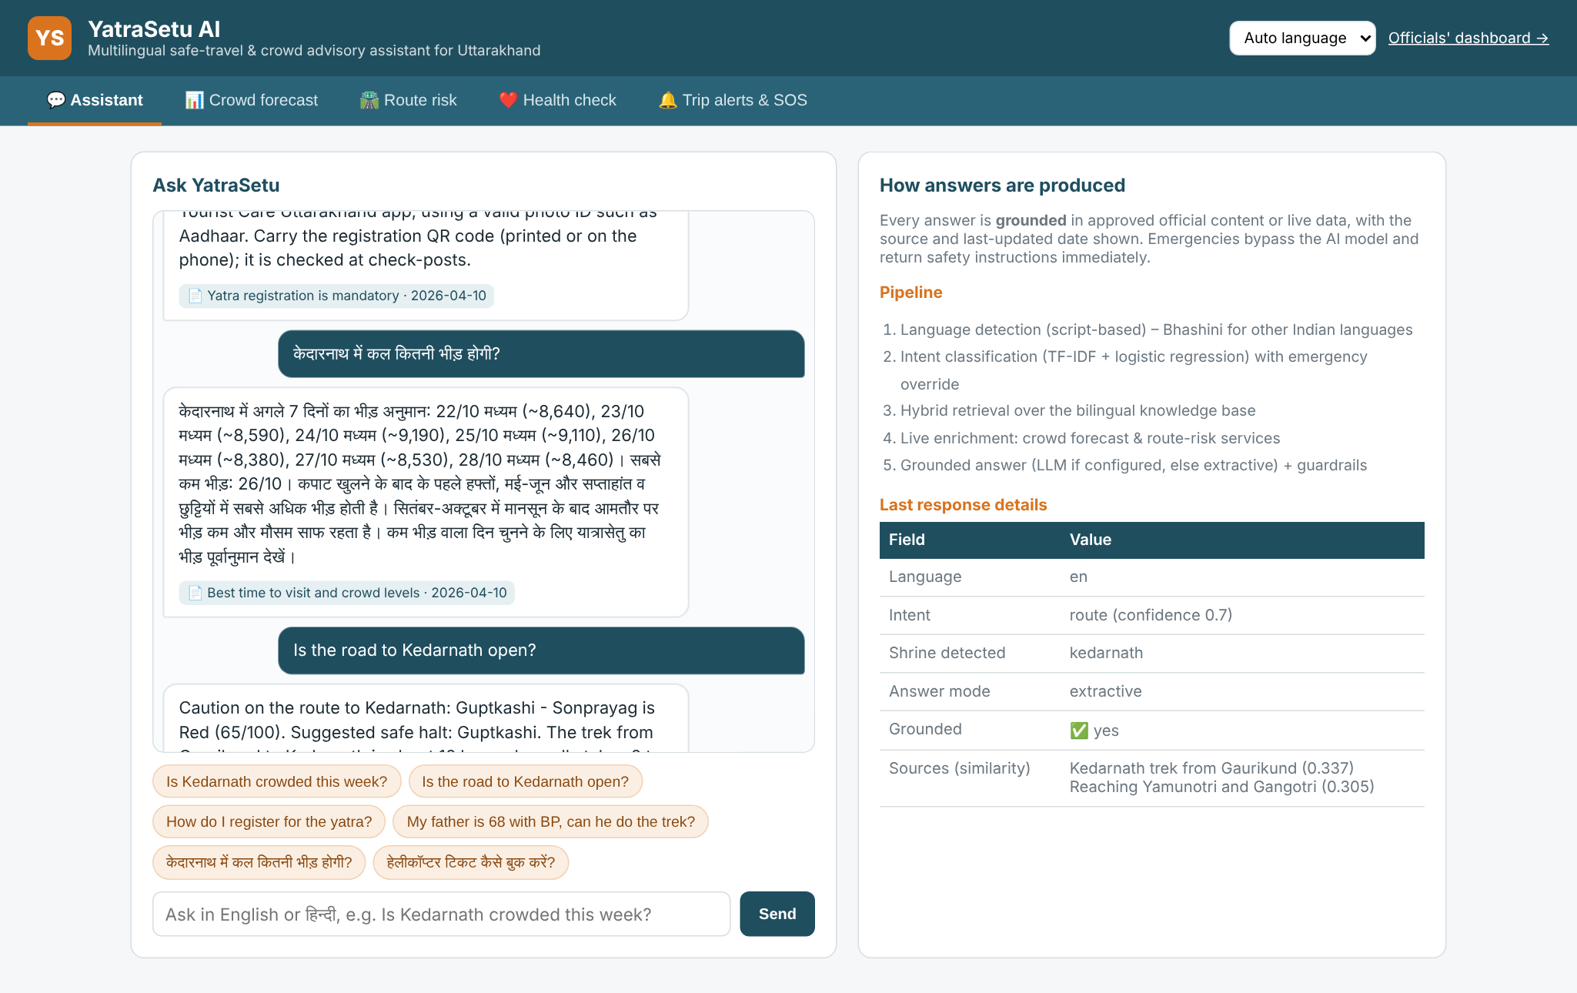
Figure 6.1: Assistant answering registration, Hindi crowd and route questions
An emergency message is answered immediately with 112/108 instructions and a call button, without using the AI model. An unrelated question (GDP of Brazil) is rejected with a safe fallback instead of a loosely related answer.
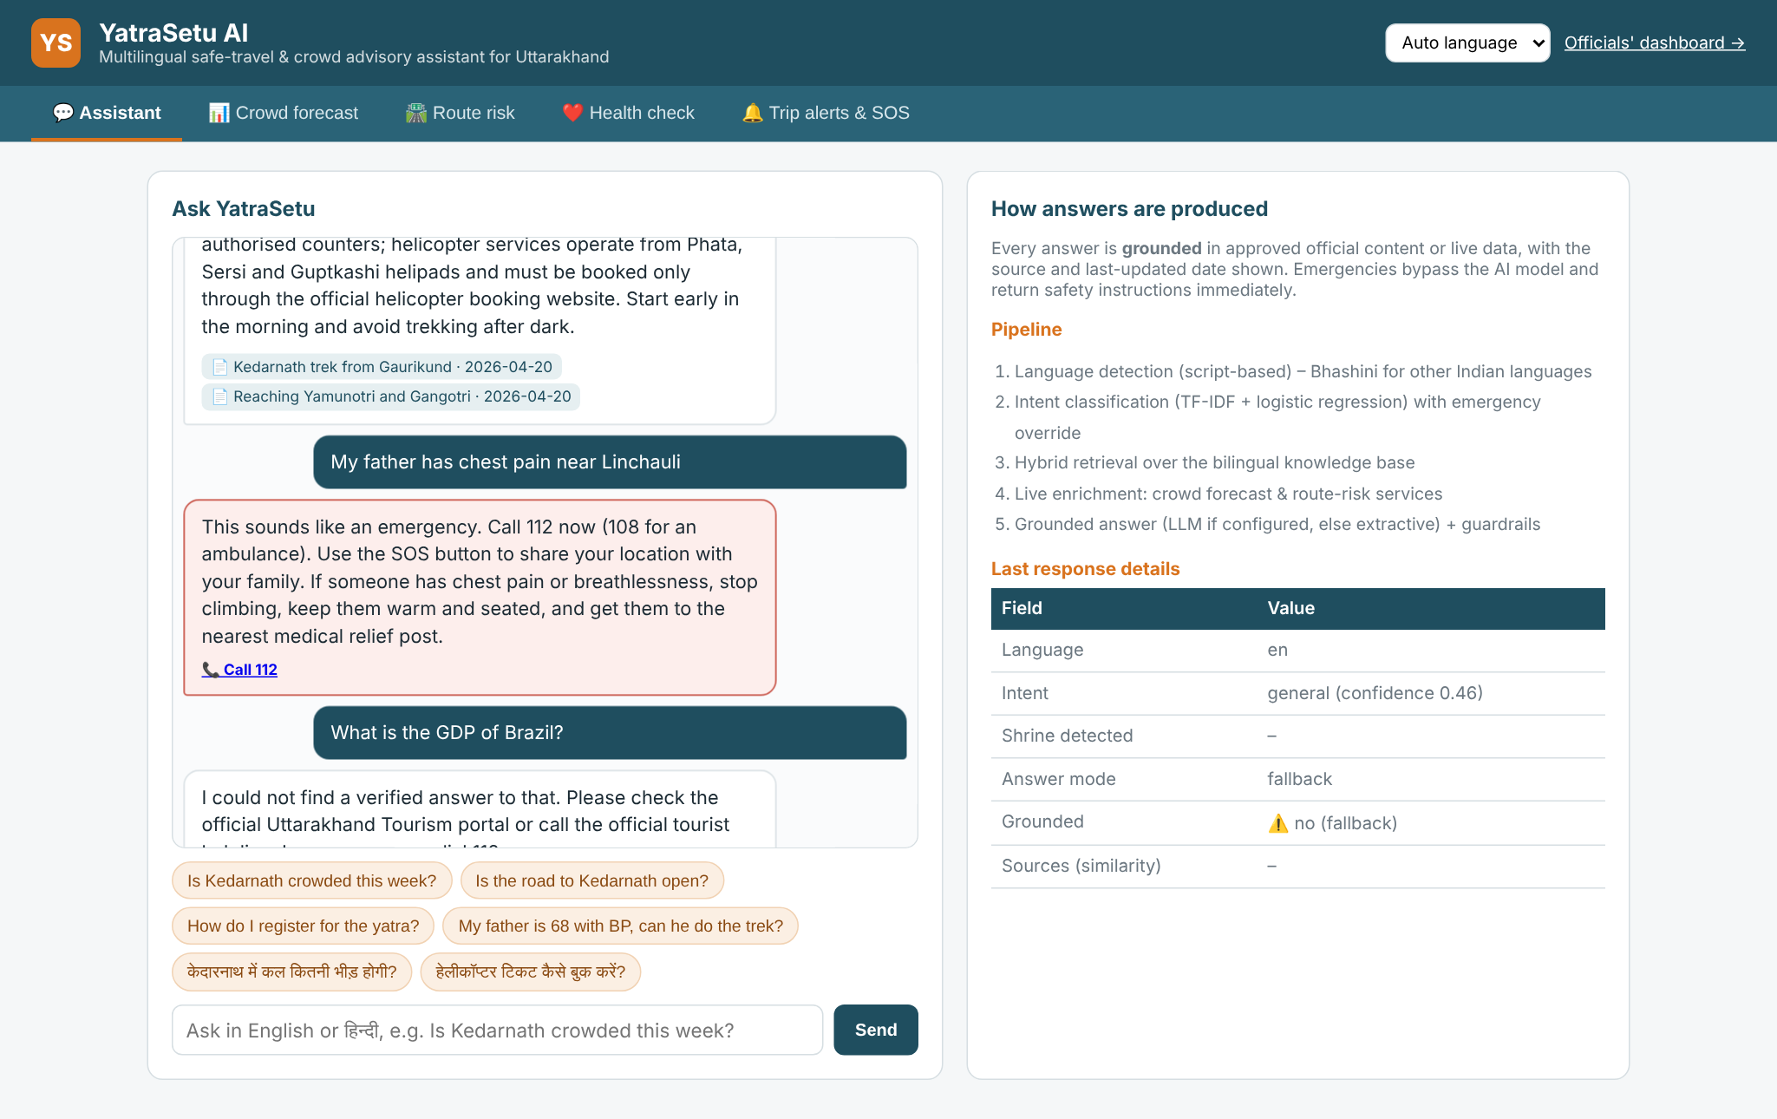
Figure 6.2: Emergency override and off-topic fallback
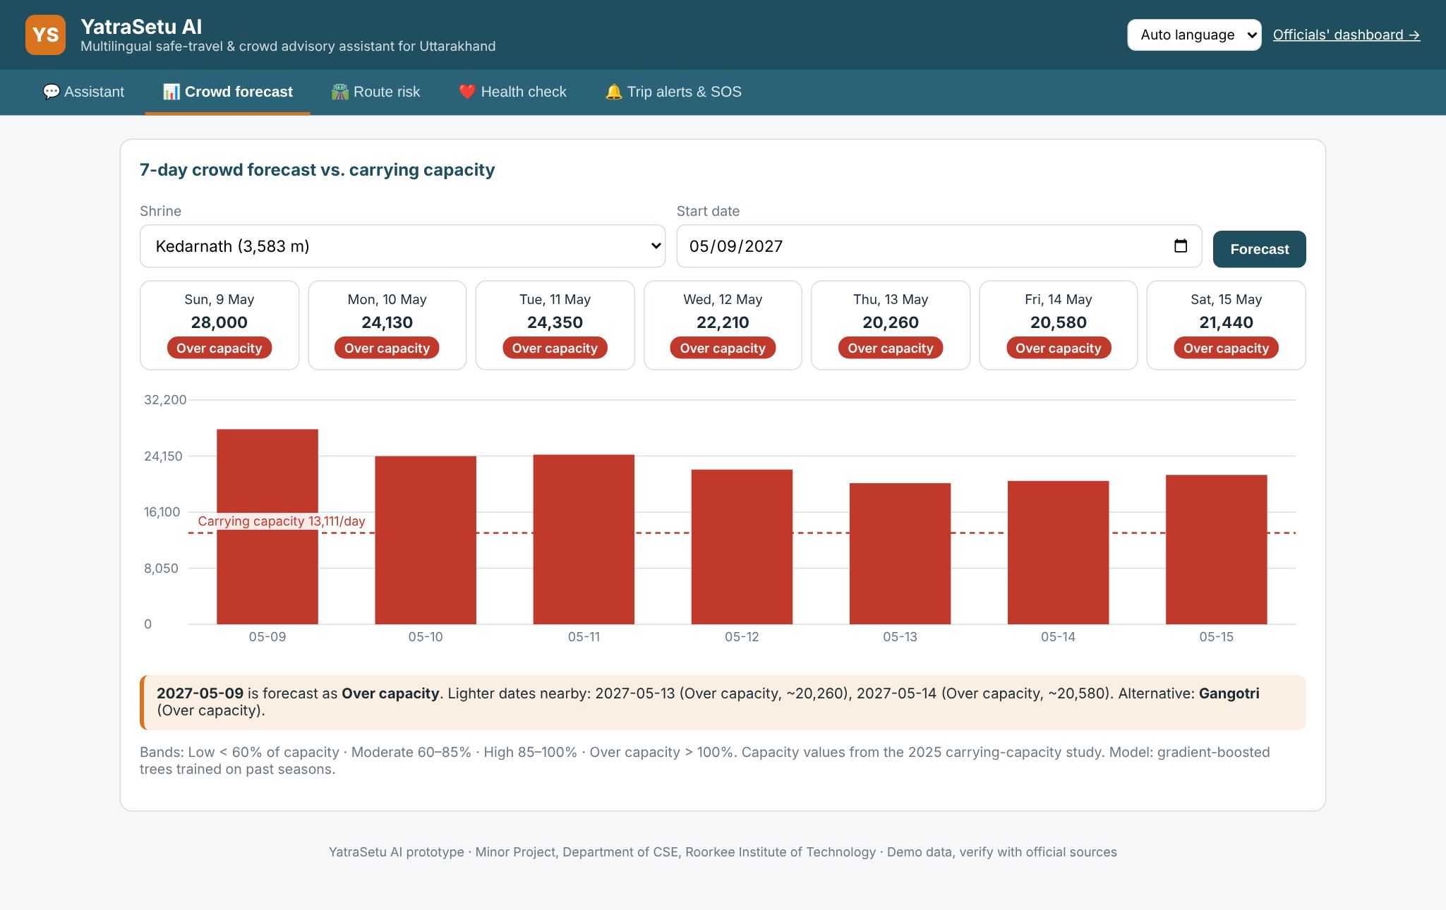
Figure 6.3: Crowd forecast for Kedarnath for the opening week of 2027 against carrying capacity
The crowd forecast for the expected opening week of the 2027 season shows every day over the carrying capacity of 13,111, with the opening day highest. The system suggests the lightest nearby dates and an alternative shrine.
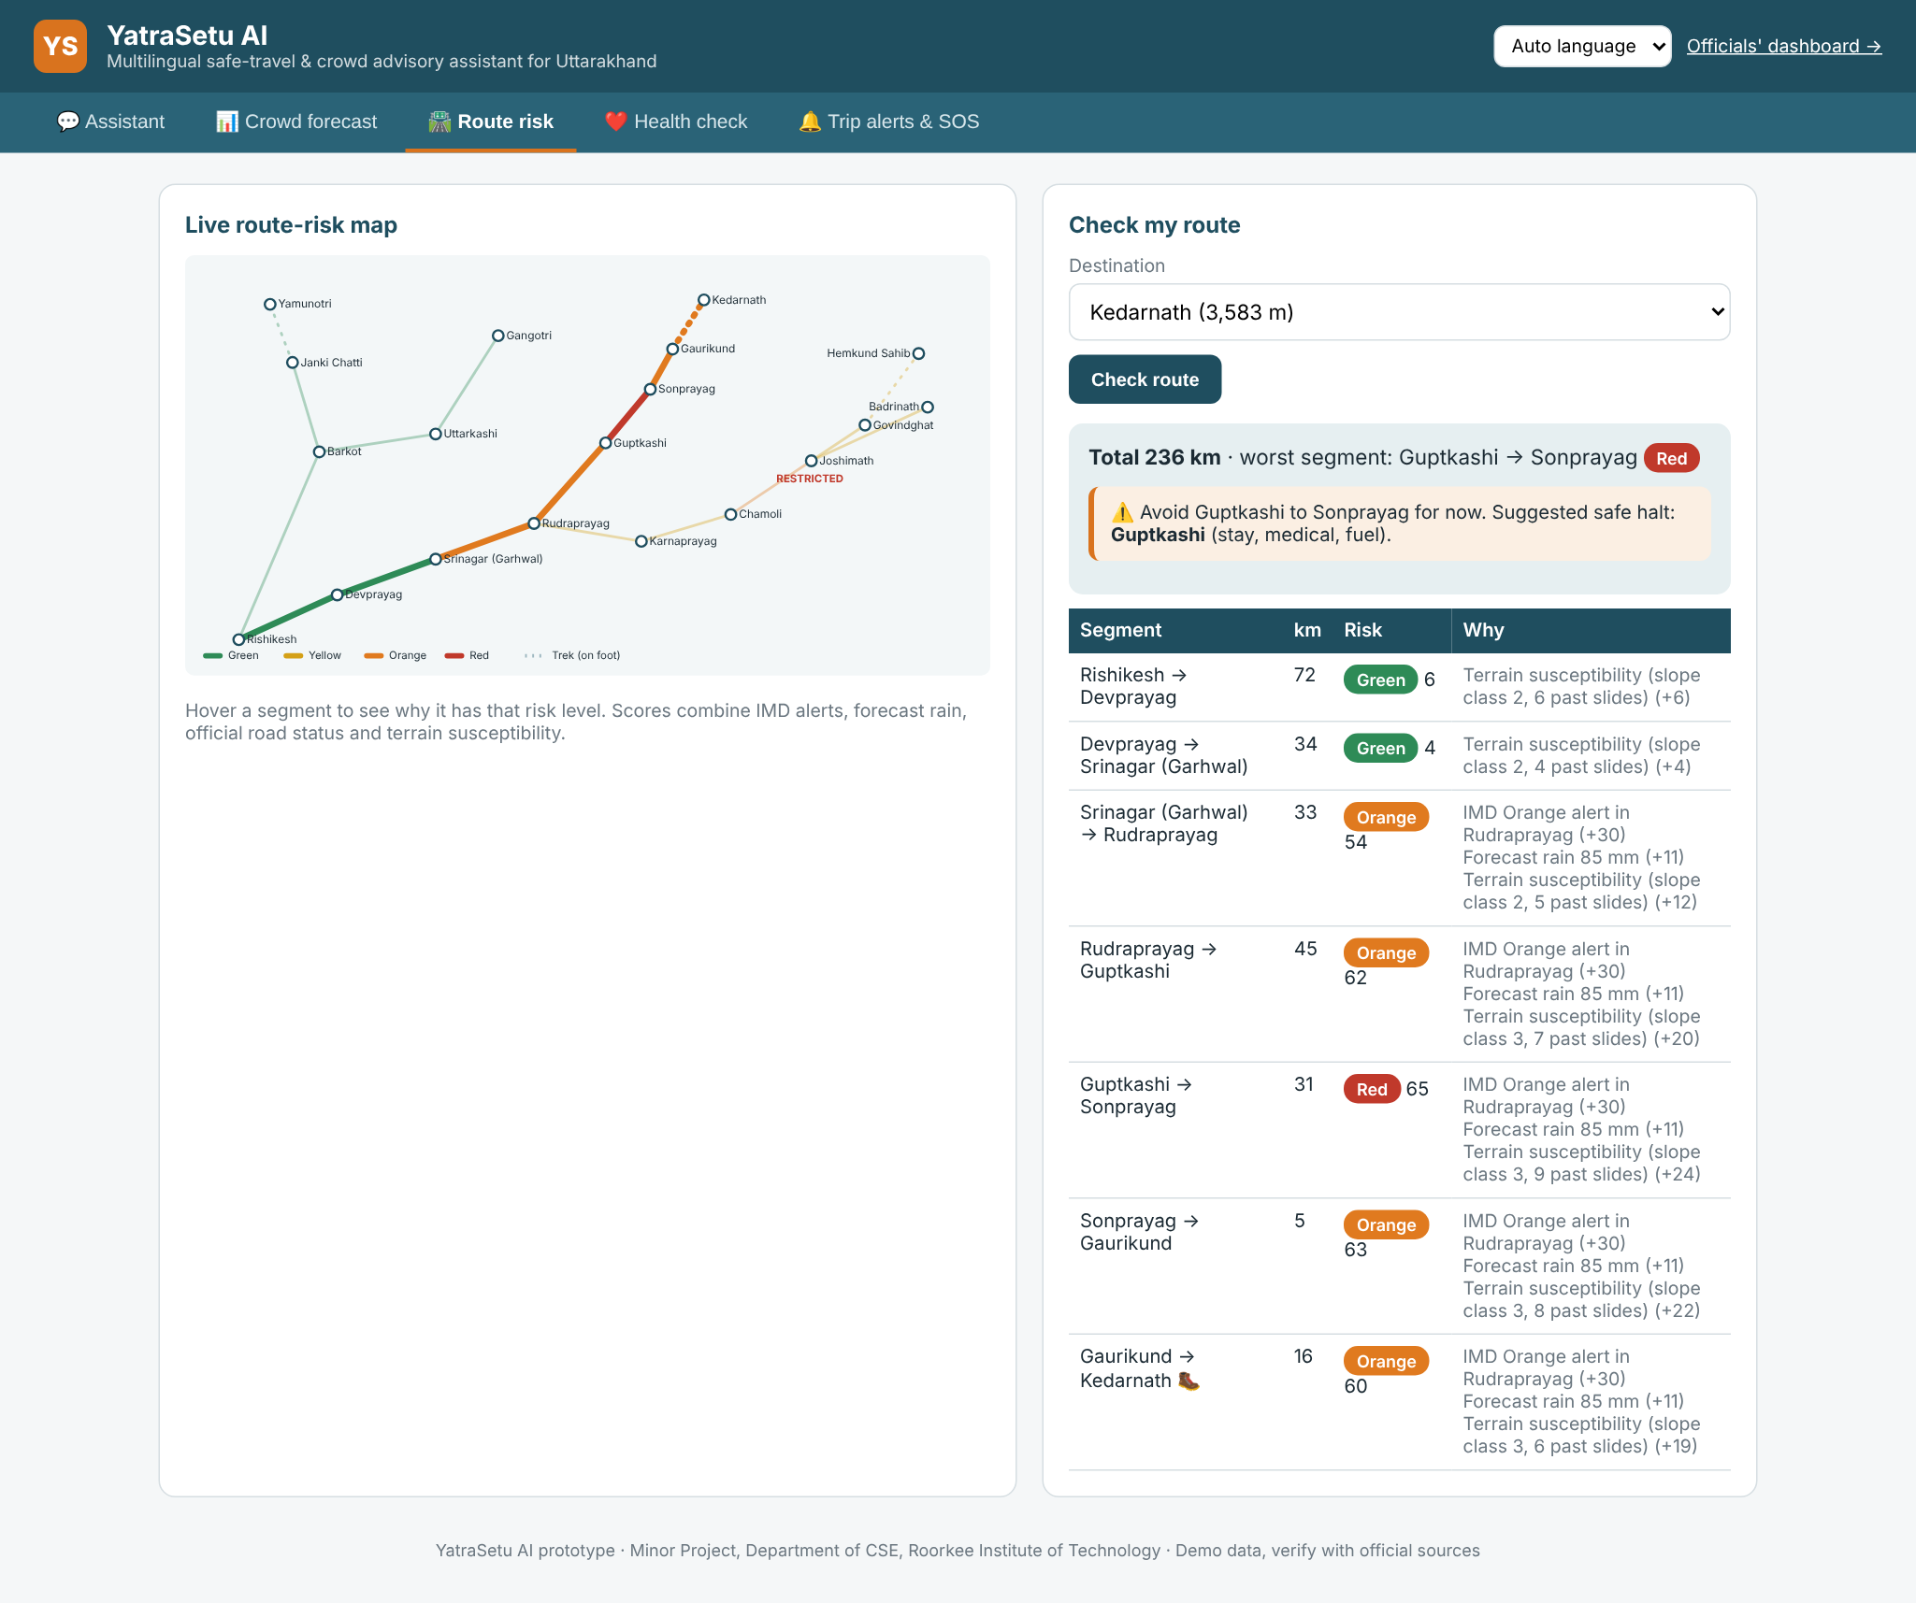
Figure 6.4: Live route-risk map and explained segment scores for the Kedarnath route
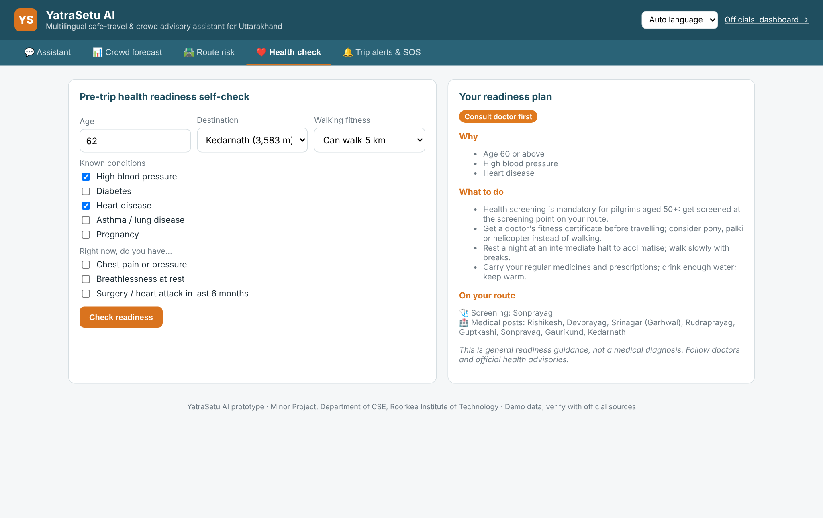
Figure 6.5: Health-readiness self-check for a 62-year-old pilgrim with high BP and heart disease
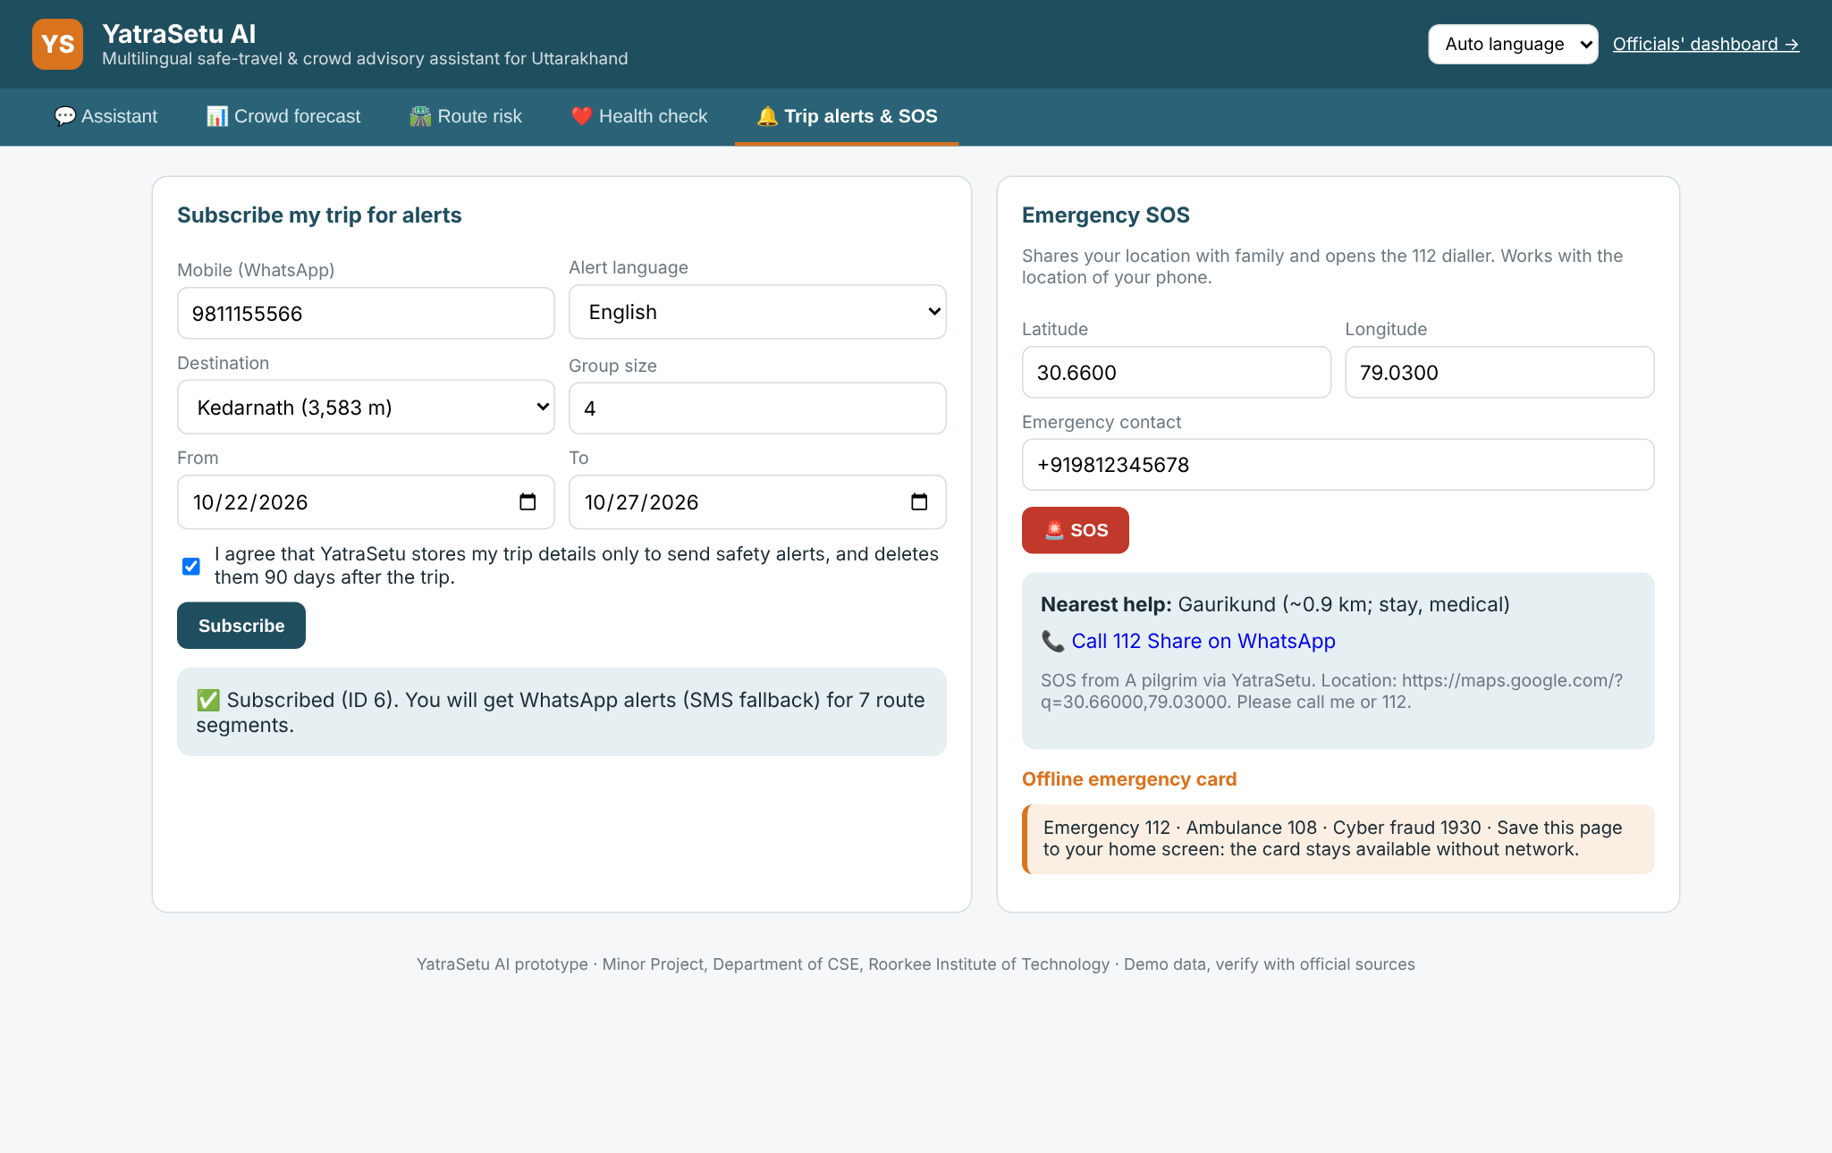
Figure 6.6: Trip subscription with consent, and SOS with nearest help
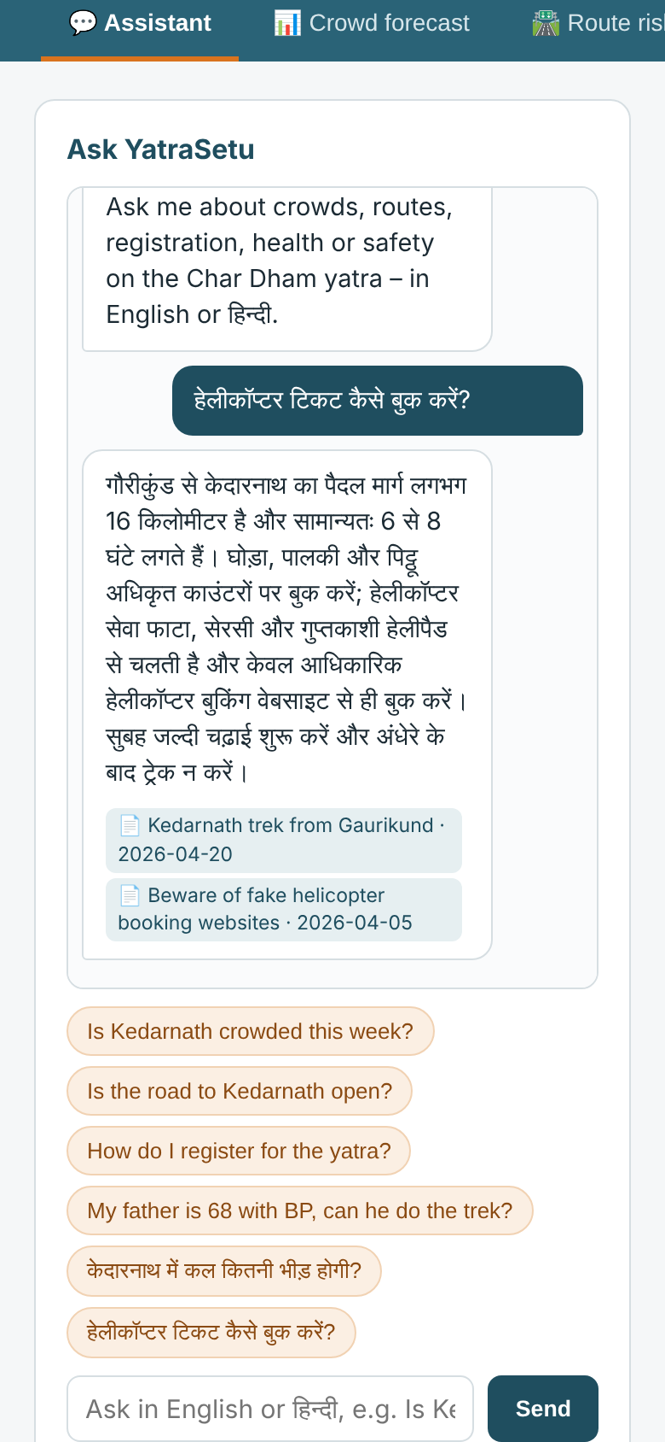
Figure 6.7: Mobile view: Hindi question about helicopter booking

6.2 Officials' Dashboard
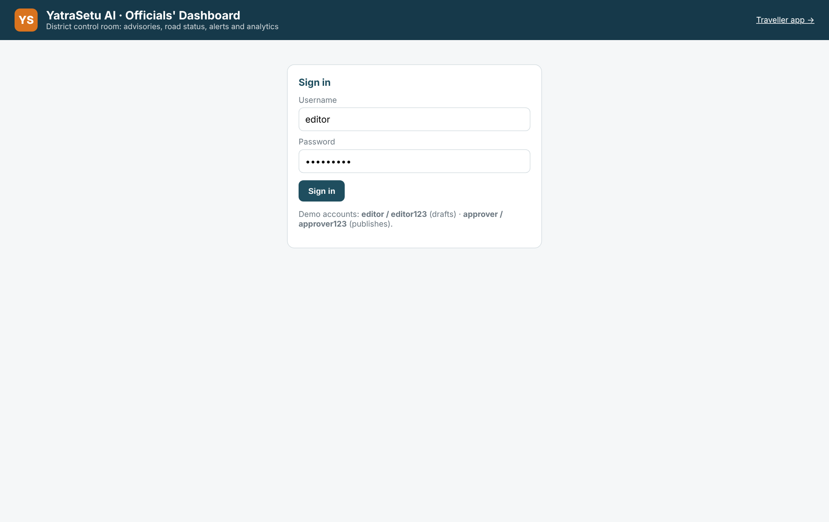
Figure 6.8: Dashboard login (editor and approver roles)
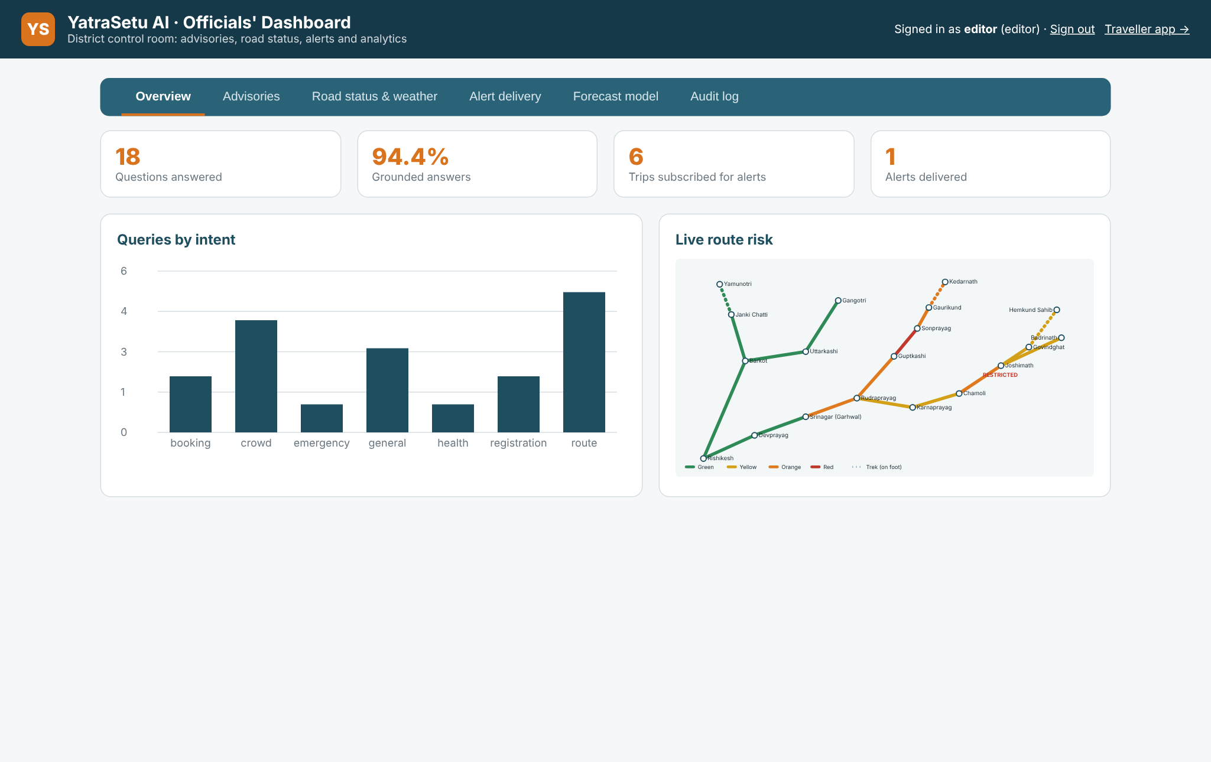
Figure 6.9: Dashboard overview: KPIs, questions by intent and live route risk
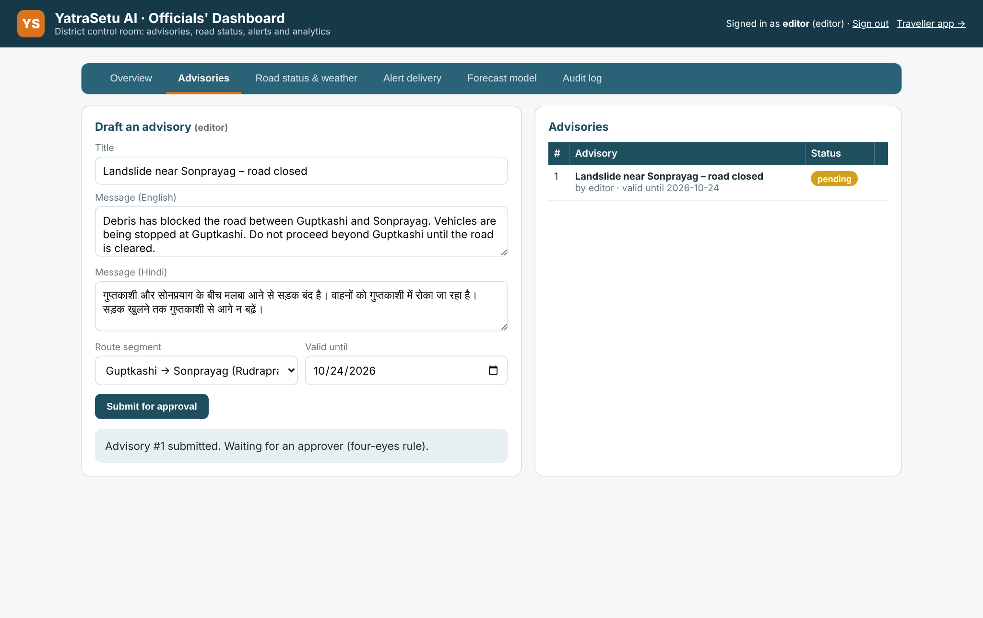
Figure 6.10: Editor drafts a bilingual advisory, which waits for approval
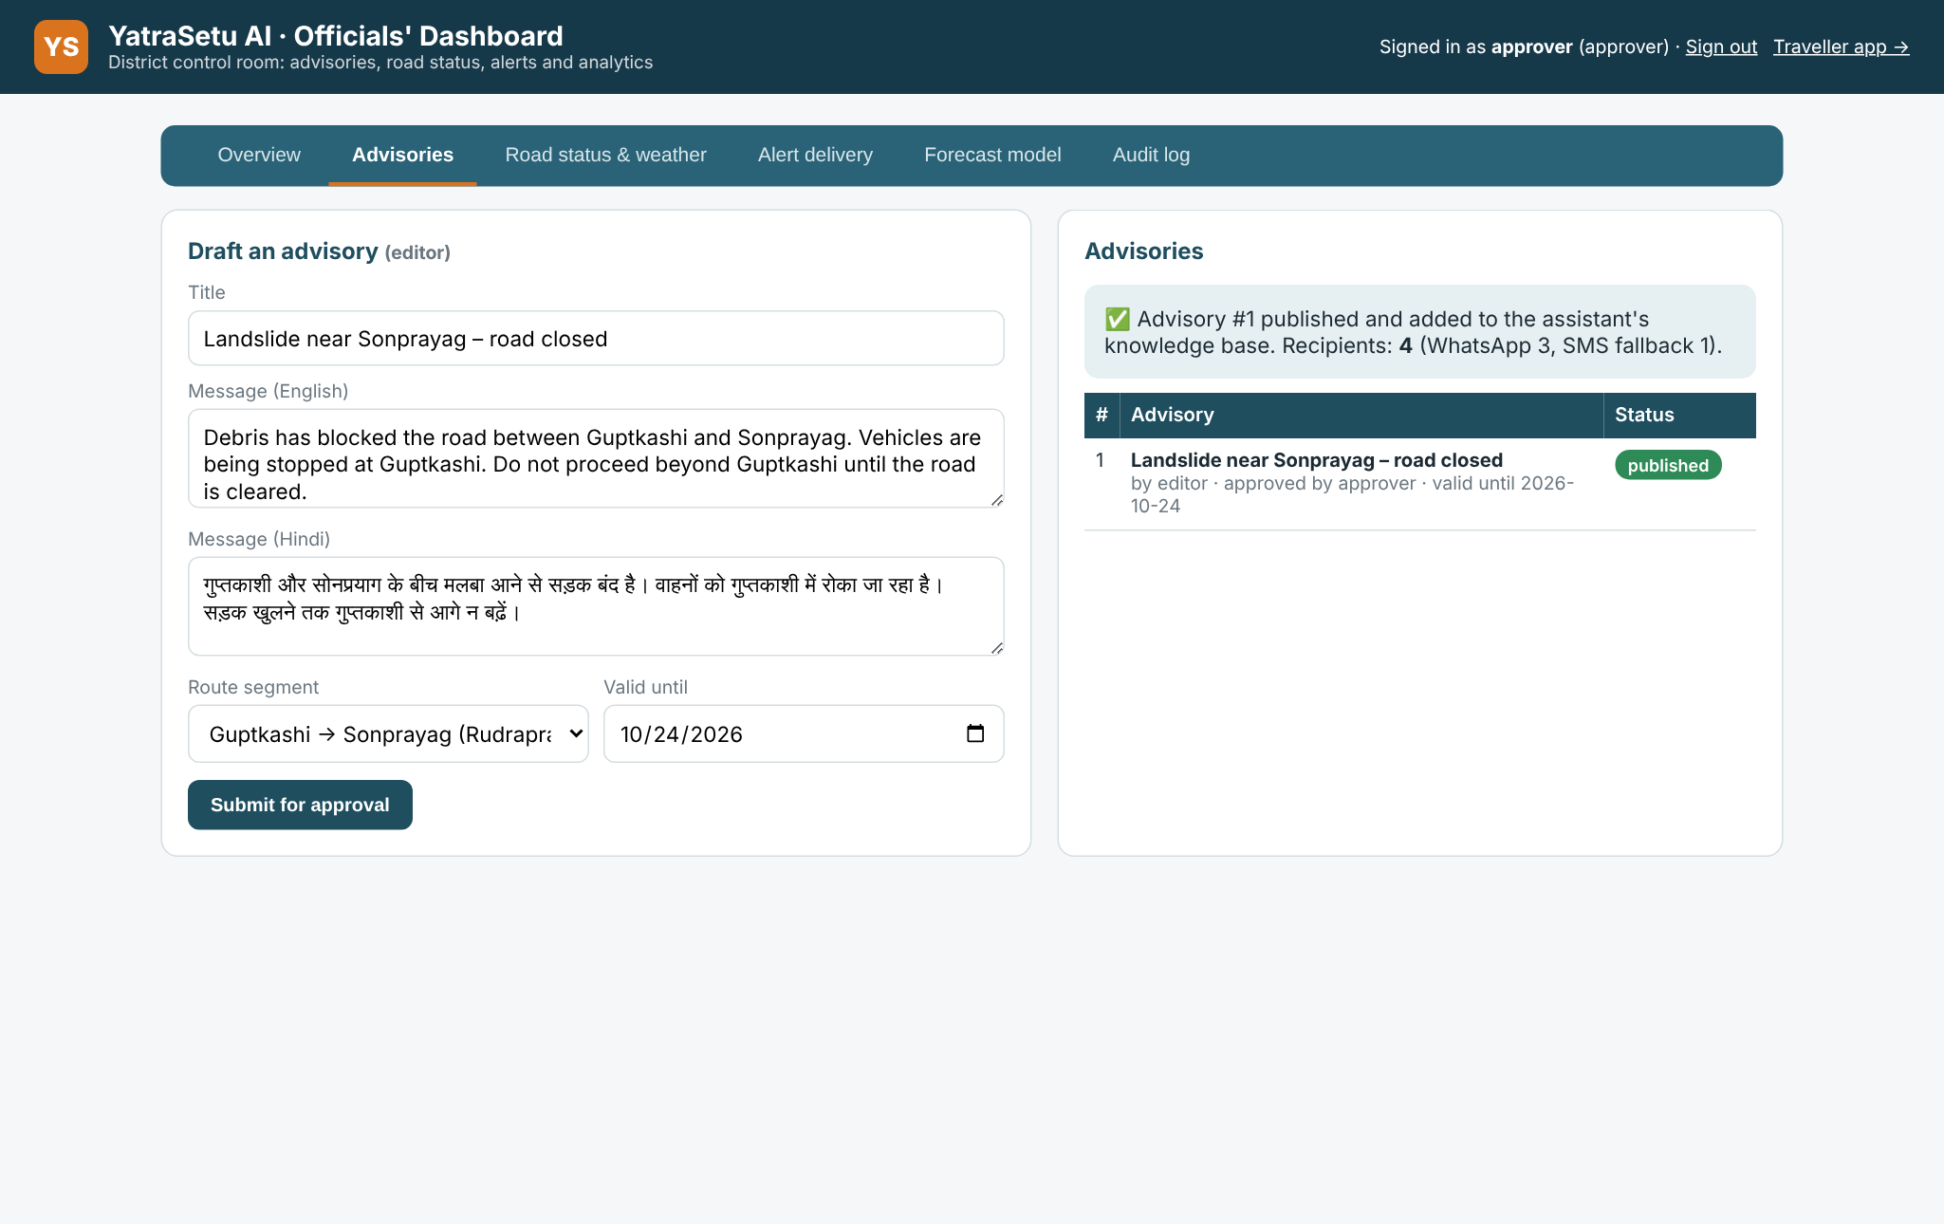
Figure 6.11: Approver publishes the advisory: 4 recipients, 3 by WhatsApp and 1 by SMS fallback
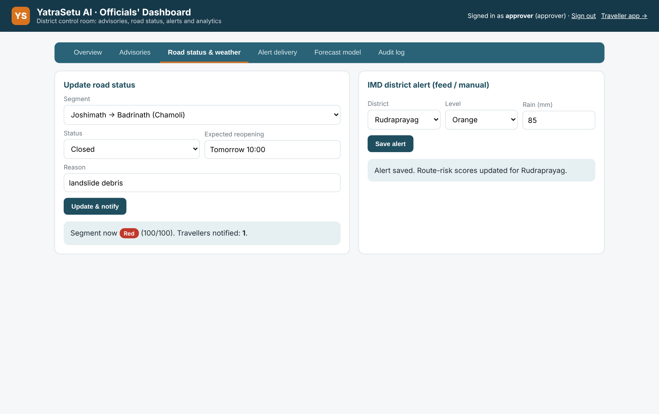
Figure 6.12: Road-status update and IMD district alert entry
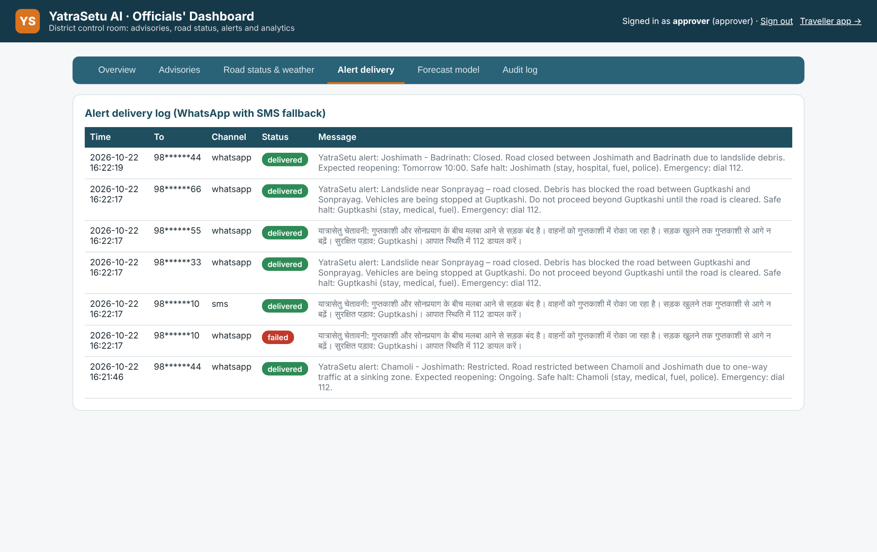
Figure 6.13: Alert delivery log in the traveller's language, with SMS fallback
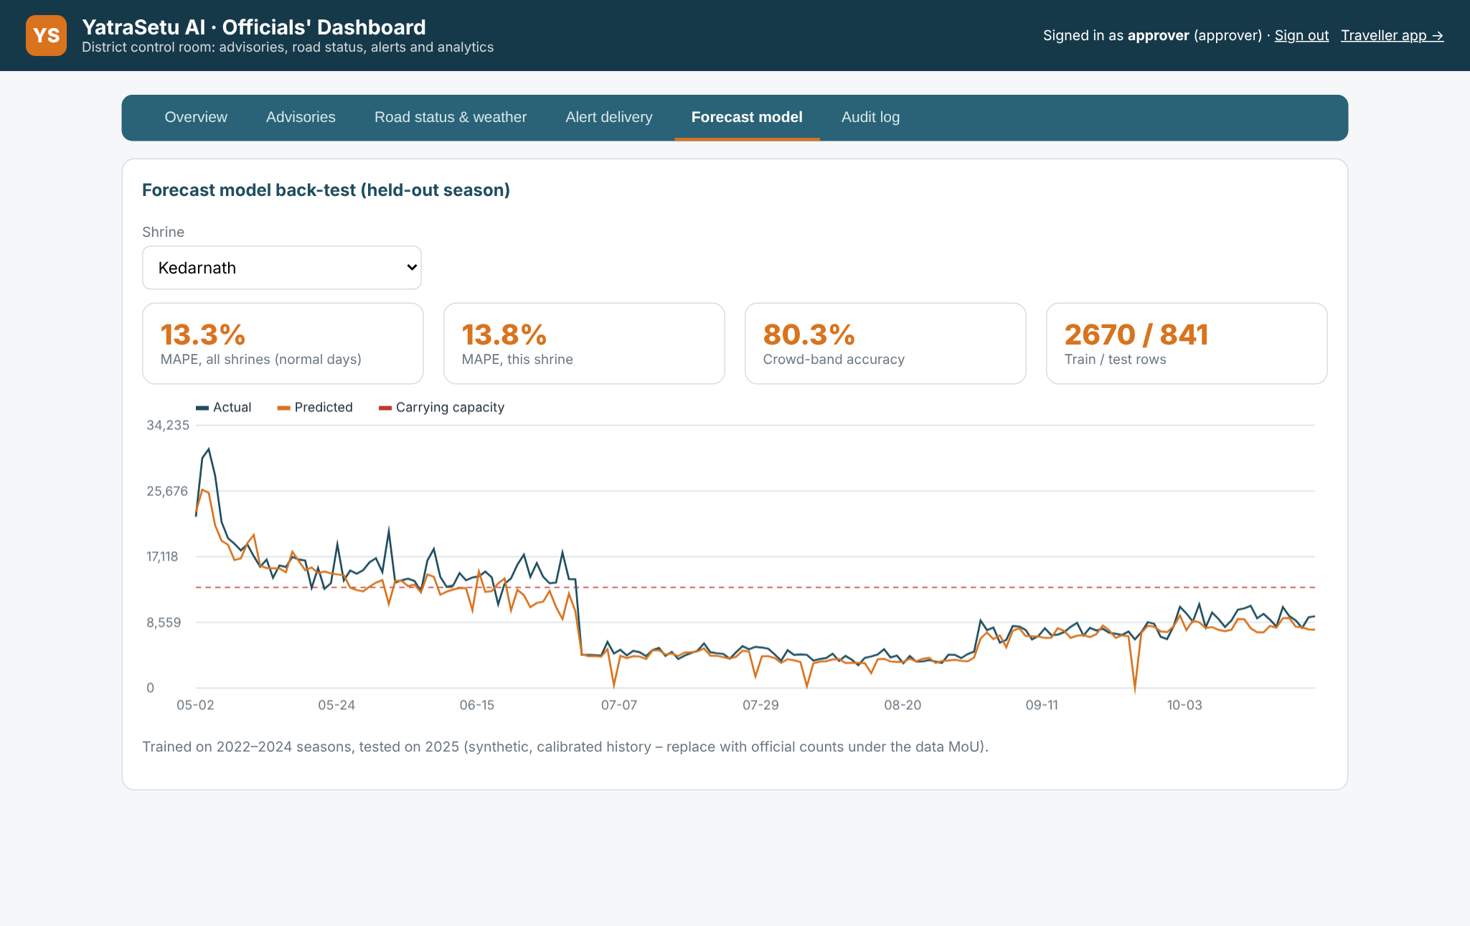
Figure 6.14: Forecast model back-test on the held-out 2025 season
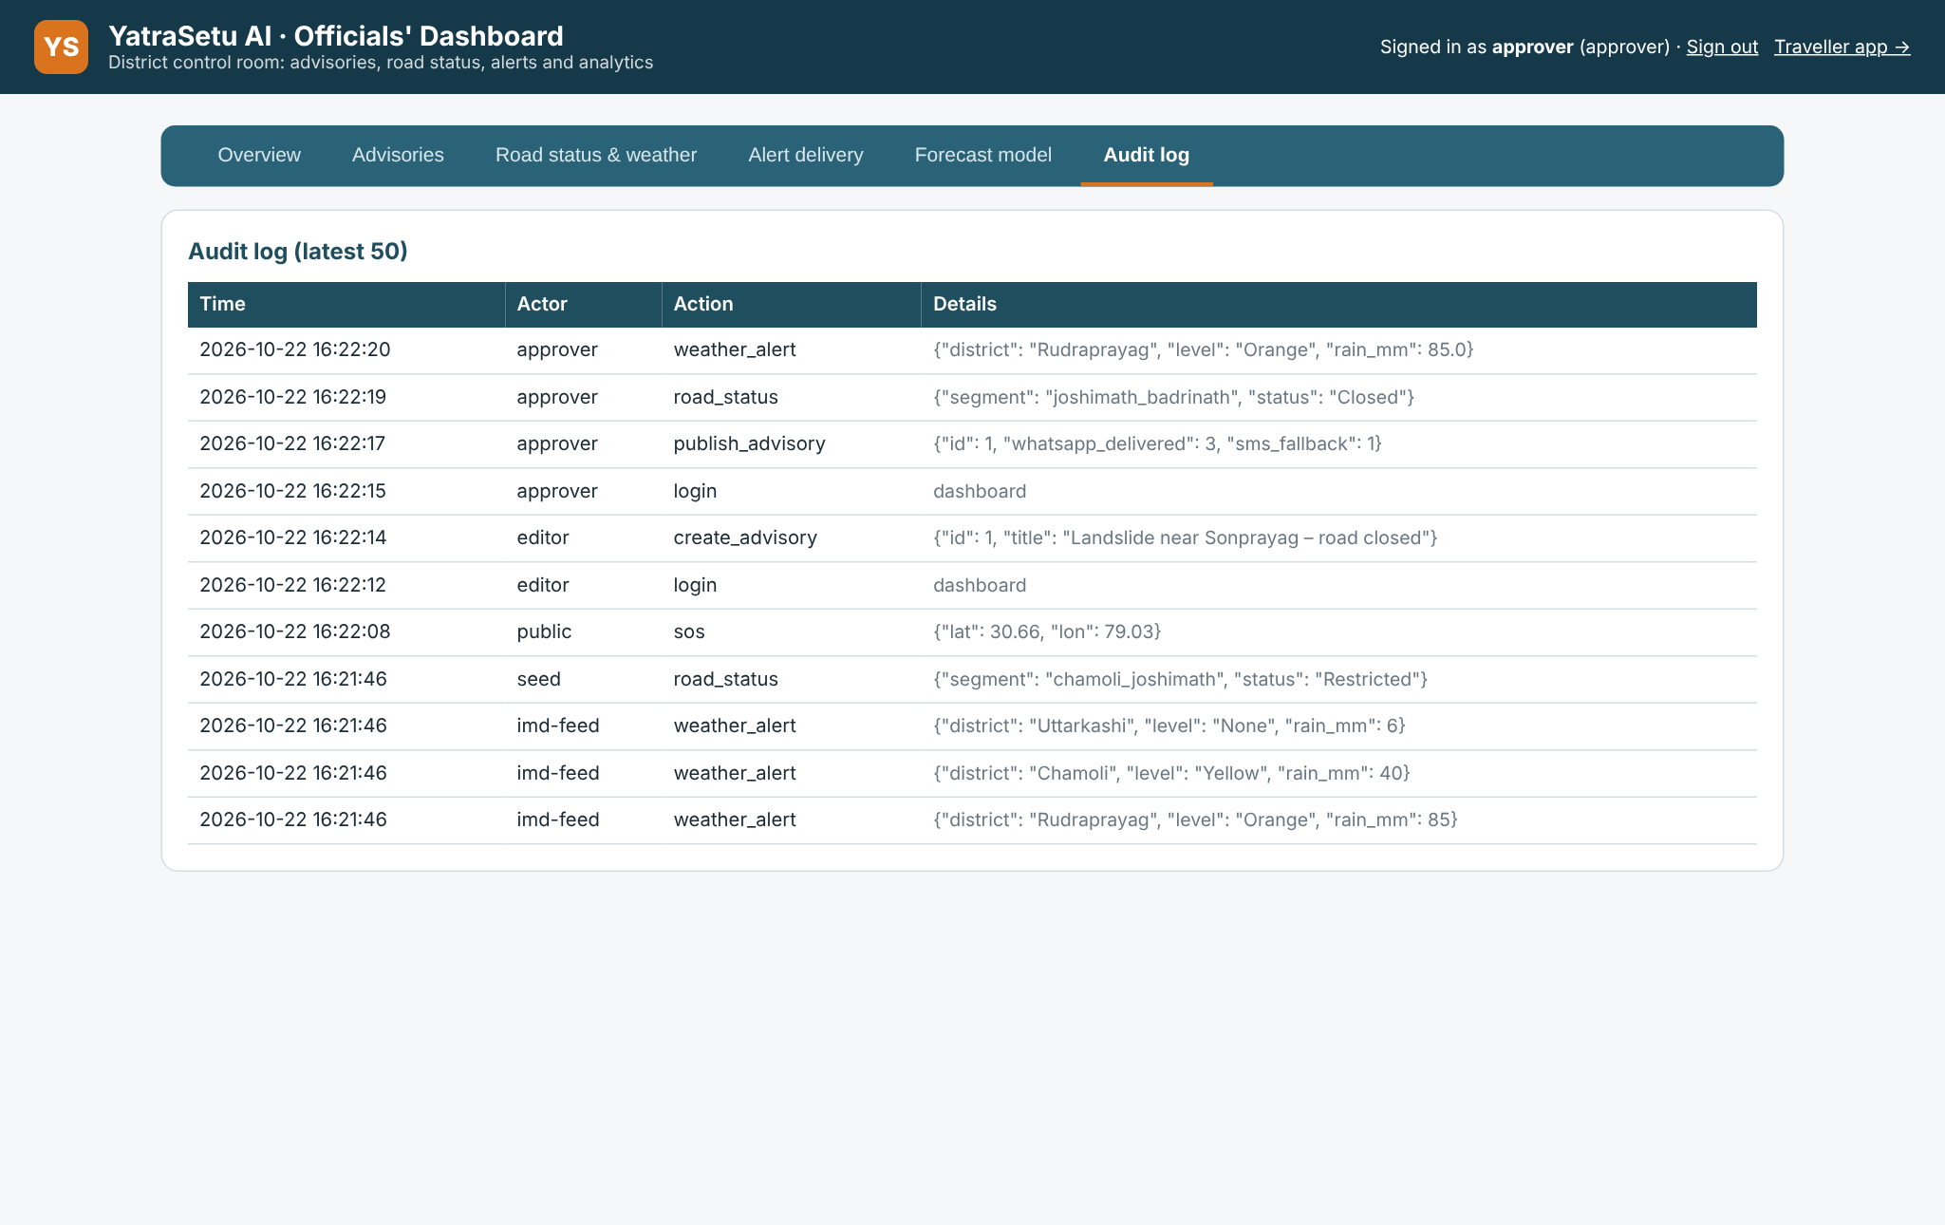
Figure 6.15: Audit log of official actions

6.3 Testing and Evaluation Results

6.3.1 Test cases
Table 6.1: Representative test cases
TC | Test | Expected result | Result
TC-01 | Detect language of English, Hindi and Gujarati text | en, hi, gu | Pass
TC-02 | "my father has chest pain" / "हम फंस गए हैं" | Intent = emergency | Pass
TC-03 | Extract shrine from "is kedar crowded" and age from "68 years" | kedarnath, 68 | Pass
TC-04 | Forecast 7 days in season; MAPE on held-out season | 7 positive values; MAPE <= 20% | Pass (13.3%)
TC-05 | Forecast in January (season closed) | All days Closed | Pass
TC-06 | Closed segment | Score 100, level Red | Pass
TC-07 | Risk with Red alert and 140 mm rain vs. calm | Higher score, Orange/Red | Pass
TC-08 | Safe halt for Sonprayag to Gaurikund | Town with stay + medical | Pass
TC-09 | Health check with chest pain | Do not trek now | Pass
TC-10 | 68 years, BP + heart disease | Consult doctor first; Sonprayag screening | Pass
TC-11 | LLM answer with number not in passages | Rejected by guardrail | Pass
TC-12 | Ask registration question via API | Grounded answer with registration source | Pass
TC-13 | Ask in Hindi | Answer in Devanagari | Pass
TC-14 | Off-topic question | Fallback with 112 | Pass
TC-15 | Subscribe without consent | HTTP 400 | Pass
TC-16 | Approver drafts / editor approves / author self-approval | HTTP 403 / 403; approval by approver succeeds | Pass
TC-17 | Broadcast to 2 subscribers, one failing on WhatsApp | 2 recipients, 1 SMS fallback; advisory answerable | Pass
TC-18 | Dashboard API without login | HTTP 401 | Pass

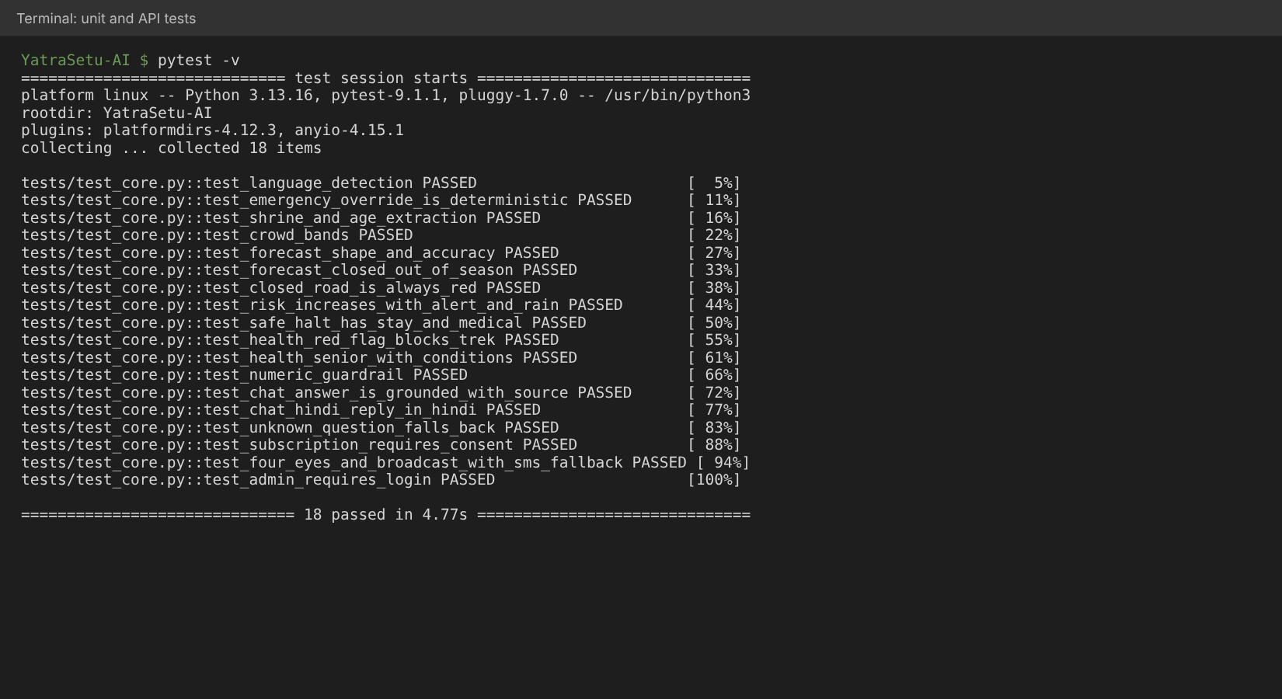
Figure 6.16: Automated test run: 18 tests passed

6.3.2 AI component evaluation
The evaluation script measures the AI components on data not used for training: a gold set of 40 bilingual questions (27 English, 13 Hindi) written independently of the intent-training examples, 10 emergency phrasings, 10 off-topic questions and the held-out 2025 forecasting season.
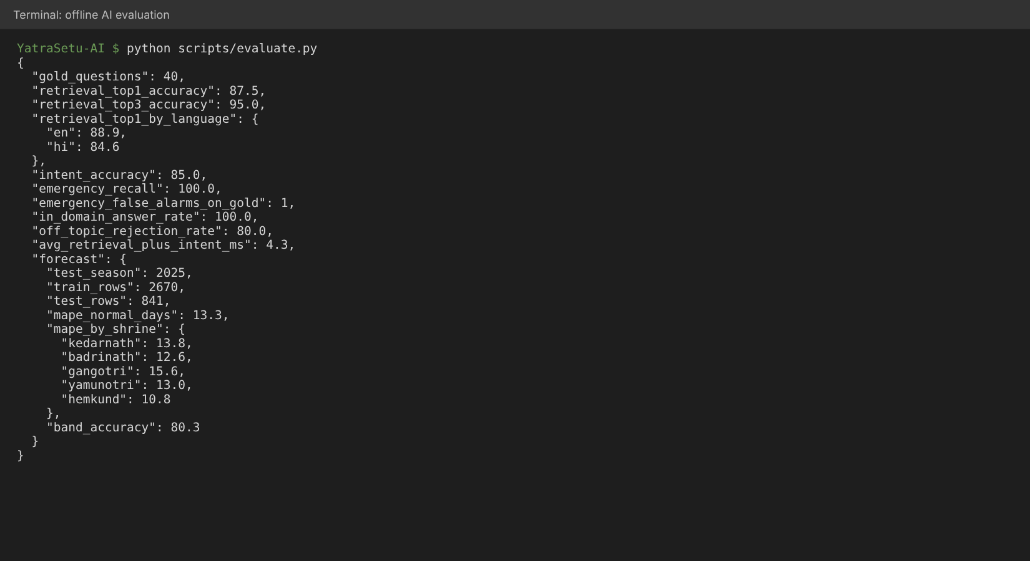
Figure 6.17: Output of the offline evaluation script
Table 6.2: Evaluation results
Component | Metric | Result | Target
Retrieval | Top-1 / top-3 accuracy (40 questions) | 87.5% / 95.0% | Top-3 >= 90%
Retrieval | Top-1 accuracy, English / Hindi | 88.9% / 84.6% | -
Intent classifier | Accuracy on unseen questions | 85.0% | -
Emergency override | Recall on 10 emergency messages | 100% | 100%
Emergency override | False alarms on 40 normal questions | 1 ("emergency number" question) | Low
Domain gate | In-domain answered / off-topic rejected | 100% / 80% | -
Forecasting | MAPE, normal days, all shrines (2025) | 13.3% | <= 20%
Forecasting | MAPE by shrine (Kedarnath, Badrinath, Gangotri, Yamunotri, Hemkund) | 13.8, 12.6, 15.6, 13.0, 10.8% | <= 20%
Forecasting | Crowd-band accuracy | 80.3% | -
Performance | Retrieval + intent time per question | about 4.3 ms | < 4 s total

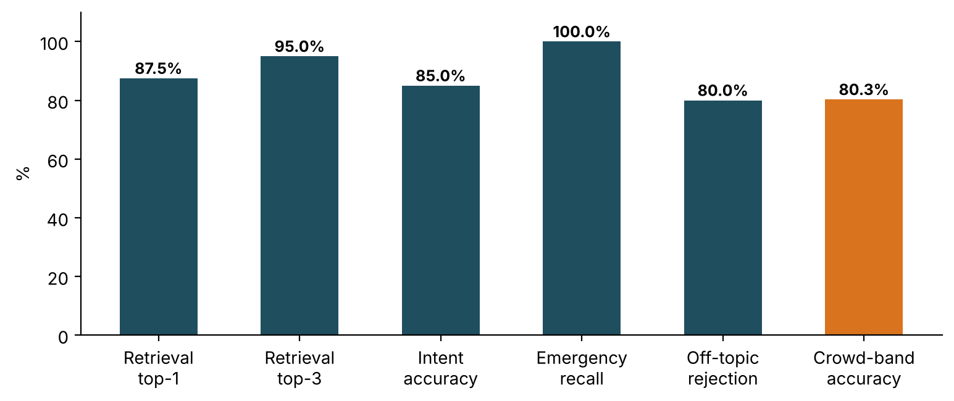
Figure 6.18: Evaluation results of the AI components
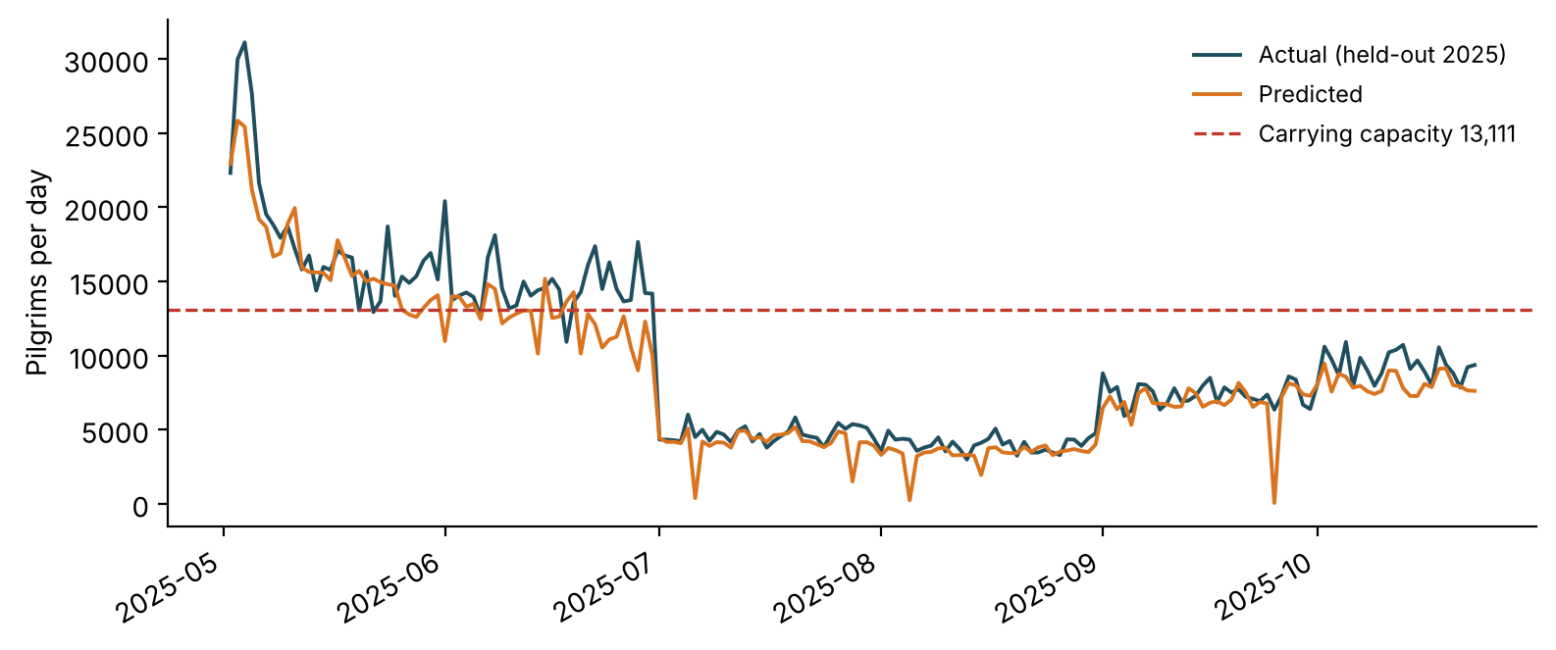
Figure 6.19: Kedarnath forecast vs. actual on the held-out 2025 season (synthetic history)

CHAPTER 7
CONCLUSION

7.1 Conclusion
This project set out to address a real and recurring problem in Uttarakhand: millions of pilgrims make safety-critical travel decisions with fragmented, generic information, while officials lack tools to forecast crowds and warn the right people in time. YatraSetu AI shows that a small, well-designed system built from open components can close much of this gap.
The working prototype combines a bilingual retrieval-grounded assistant with a deterministic emergency path, a gradient-boosted crowd forecaster linked to carrying capacity, an explainable route-risk model with safe-halt advice, a health-readiness module, consent-based trip alerts with SMS fallback, and an officials' dashboard with four-eyes approval and a full audit trail. All 18 automated tests pass, retrieval reaches 95% top-3 accuracy on a bilingual gold set, every emergency phrasing was caught, and the forecaster achieves 13.3% MAPE on a held-out season. The system runs on an ordinary laptop with no external services, and can be connected to Bhashini, an LLM and the WhatsApp Business Platform through configuration.

7.2 Achievement of Objectives
Table 7.1: Objectives versus achievement
Objective | Target | Achieved
O1 Bilingual grounded assistant | Top-3 retrieval >= 90%; sources shown | 95.0% top-3; source and date on every grounded answer
O2 Crowd forecast vs. capacity | MAPE <= 20% | 13.3% MAPE; 80.3% band accuracy; alternatives suggested
O3 Route risk and alerts | Automatic alerts for Orange/Red; SMS fallback | Implemented and tested (TC-06 to TC-08, TC-17)
O4 Health check and SOS | Correct categories; nearest help | Implemented and tested (TC-09, TC-10)
O5 Dashboard with four-eyes approval | Self-approval blocked; advisory immediately answerable | Implemented and tested (TC-16, TC-17)
O6 Low-cost, private, replicable | Offline; consent; hashed phone numbers | Runs offline; open-source; one-command setup

7.3 Limitations
- The footfall history is synthetic (calibrated to published totals); forecast accuracy must be re-validated on official daily counts.
- The knowledge base is a demonstration set of 13 documents; a production system needs content curated and maintained with the tourism, health and police departments.
- Hindi and English are supported end to end; other languages depend on Bhashini credentials, and voice input/output is not yet implemented.
- WhatsApp and SMS delivery are simulated through an outbox; live integration requires business verification and DLT-registered templates.
- Route attributes (slope class, landslide history) are illustrative planning values, not survey data.
- The extractive answer mode can include less relevant sentences for broad questions; the optional LLM mode improves fluency but needs an API and careful evaluation.

7.4 Future Scope
- Sign a data-sharing agreement to train on official daily footfall and registration data, and add real IMD feed integration.
- Add voice notes (Bhashini ASR/TTS) and an IVR line for feature-phone users; research Garhwali and Kumaoni language support.
- Use multilingual dense embeddings and re-ranking to improve retrieval, and evaluate an LLM-based answer mode with human reviewers.
- Integrate satellite rainfall nowcasts and landslide susceptibility maps (as in LHASA) for finer route-risk estimates.
- Pilot with district control rooms of Rudraprayag and Chamoli during a yatra season and measure impact on crowd peaks and response times.
- Extend to Kanwar Yatra, Adi Kailash, Valley of Flowers and to other Himalayan states.

CHAPTER 8
BIBLIOGRAPHY
References are arranged in alphabetical order of the first author's surname (or organisation).
[1] Brown, T., Mann, B., Ryder, N., Subbiah, M., Kaplan, J., Dhariwal, P. and Amodei, D. et al., Language Models are Few-Shot Learners, Advances in Neural Information Processing Systems, 33, 1877-1901, 2020.
[2] Business Today, Rain fury in Uttarakhand: Cloudburst in Chamoli, 2,500 tourists stranded in Mussoorie, restoration work underway, 18 September 2025. Available: https://www.businesstoday.in
[3] Counterview, Rising footfall, rising risks: SDC Foundation seeks focus on safety and carrying capacity in Char Dham Yatra, December 2025. Available: https://www.counterview.in/2025/12/rising-footfall-rising-risks-sdc-seeks.html
[4] Deccan Herald, CM Dhami launches Uttarakhand Bhookamp Alert app, August 2021. Available: https://www.deccanherald.com
[5] Down To Earth, Tourism in Uttarakhand needs regulation. Available: https://www.downtoearth.org.in/environment/tourism-in-uttarakhand-needs-regulation-41499
[6] ETV Bharat, Why Char Dham witnesses high death toll? 56 devotees died in 28 days, 28 May 2025. Available: https://www.etvbharat.com
[7] ETV Bharat, Uttarakhand records all-time high tourist footfall in 2025, crosses 6 crore mark, February 2026 (cited as ETV Bharat, 2026a). Available: https://www.etvbharat.com
[8] ETV Bharat, Adequate attention needs to be paid to carrying capacity of Chardham Yatra shrines, May 2026 (cited as ETV Bharat, 2026b). Available: https://www.etvbharat.com
[9] Friedman, J.H., Greedy Function Approximation: A Gradient Boosting Machine, The Annals of Statistics, 29(5), 1189-1232, 2001.
[10] Froude, M.J. and Petley, D.N., Global fatal landslide occurrence from 2004 to 2016, Natural Hazards and Earth System Sciences, 18, 2161-2181, 2018.
[11] Gala, J., Chitale, P.A., Raghavan, A.K., Gumma, V., Doddapaneni, S., Kumar, A., Khapra, M.M., Dabre, R. and Kunchukuttan, A. et al., IndicTrans2: Towards High-Quality and Accessible Machine Translation Models for all 22 Scheduled Indian Languages, Transactions on Machine Learning Research, 2023.
[12] Government of India, Digital Personal Data Protection Act, 2023 (No. 22 of 2023), Ministry of Electronics and Information Technology, 2023.
[13] Government of Uttarakhand, Registration and Tourist Care System: Registration Process Steps, Uttarakhand Tourism Development Board, 2024. Available: https://registrationandtouristcare.uk.gov.in
[14] Gretzel, U., Sigala, M., Xiang, Z. and Koo, C., Smart tourism: foundations and developments, Electronic Markets, 25(3), 179-188, 2015.
[15] Hyndman, R.J. and Athanasopoulos, G., Forecasting: Principles and Practice, 3rd edition, OTexts, Melbourne, 2021.
[16] IEEE, IEEE Recommended Practice for Software Requirements Specifications, IEEE Std 830-1998, 1998.
[17] ISO/IEC/IEEE, Systems and software engineering: Life cycle processes, Requirements engineering, ISO/IEC/IEEE 29148:2018, 2018.
[18] Ji, Z., Lee, N., Frieske, R., Yu, T., Su, D., Xu, Y., Ishii, E., Bang, Y.J., Madotto, A. and Fung, P., Survey of Hallucination in Natural Language Generation, ACM Computing Surveys, 55(12), 1-38, 2023.
[19] Ke, G., Meng, Q., Finley, T., Wang, T., Chen, W., Ma, W., Ye, Q. and Liu, T.-Y., LightGBM: A Highly Efficient Gradient Boosting Decision Tree, Advances in Neural Information Processing Systems, 30, 3146-3154, 2017.
[20] Kirschbaum, D. and Stanley, T., Satellite-Based Assessment of Rainfall-Triggered Landslide Hazard for Situational Awareness, Earth's Future, 6(3), 505-523, 2018.
[21] Lewis, P., Perez, E., Piktus, A., Petroni, F., Karpukhin, V., Goyal, N., Kuttler, H., Lewis, M., Yih, W., Rocktaschel, T., Riedel, S. and Kiela, D., Retrieval-Augmented Generation for Knowledge-Intensive NLP Tasks, Advances in Neural Information Processing Systems, 33, 9459-9474, 2020.
[22] Manning, C.D., Raghavan, P. and Schutze, H., Introduction to Information Retrieval, Cambridge University Press, 2008.
[23] News On AIR, Heavy rain triggers landslides in Uttarakhand; Char Dham Yatra halted, 3 July 2025. Available: https://www.newsonair.gov.in
[24] Pedregosa, F., Varoquaux, G., Gramfort, A., Michel, V., Thirion, B., Grisel, O. and Duchesnay, E. et al., Scikit-learn: Machine Learning in Python, Journal of Machine Learning Research, 12, 2825-2830, 2011.
[25] Pressman, R.S. and Maxim, B.R., Software Engineering: A Practitioner's Approach, 9th edition, McGraw-Hill Education, 2020.
[26] Rautela, P., Lessons learnt from the Deluge of Kedarnath, Uttarakhand, India, Asian Journal of Environment and Disaster Management, 5(2), 2013.
[27] Robertson, S. and Zaragoza, H., The Probabilistic Relevance Framework: BM25 and Beyond, Foundations and Trends in Information Retrieval, 3(4), 333-389, 2009.
[28] Salton, G. and Buckley, C., Term-weighting approaches in automatic text retrieval, Information Processing and Management, 24(5), 513-523, 1988.
[29] Sommerville, I., Software Engineering, 10th edition, Pearson, 2016.
[30] Taylor, S.J. and Letham, B., Forecasting at Scale, The American Statistician, 72(1), 37-45, 2018.
[31] The Quint, Char Dham Yatra: Uttarakhand Govt Fixes Daily Cap on Pilgrims Visiting Shrines, May 2022. Available: https://www.thequint.com
[32] The Week, Char Dham Yatra breaks records with unprecedented number of pilgrims, 24 June 2025. Available: https://www.theweek.in
[33] UNICEF, Bhashini AI: Making Languages More Accessible with Digital Technology, UNICEF Digital Impact. Available: https://www.unicef.org/digitalimpact
[34] Vaswani, A., Shazeer, N., Parmar, N., Uszkoreit, J., Jones, L., Gomez, A.N., Kaiser, L. and Polosukhin, I., Attention Is All You Need, Advances in Neural Information Processing Systems, 30, 5998-6008, 2017.
[35] W3C, Web Content Accessibility Guidelines (WCAG) 2.1, World Wide Web Consortium Recommendation, 2018.

