**Internal Assessment 2**

**E-Commerce Amplify CRUD App with Auth**

By

Ayush Solanki

**AUTH - MODULE**

Login

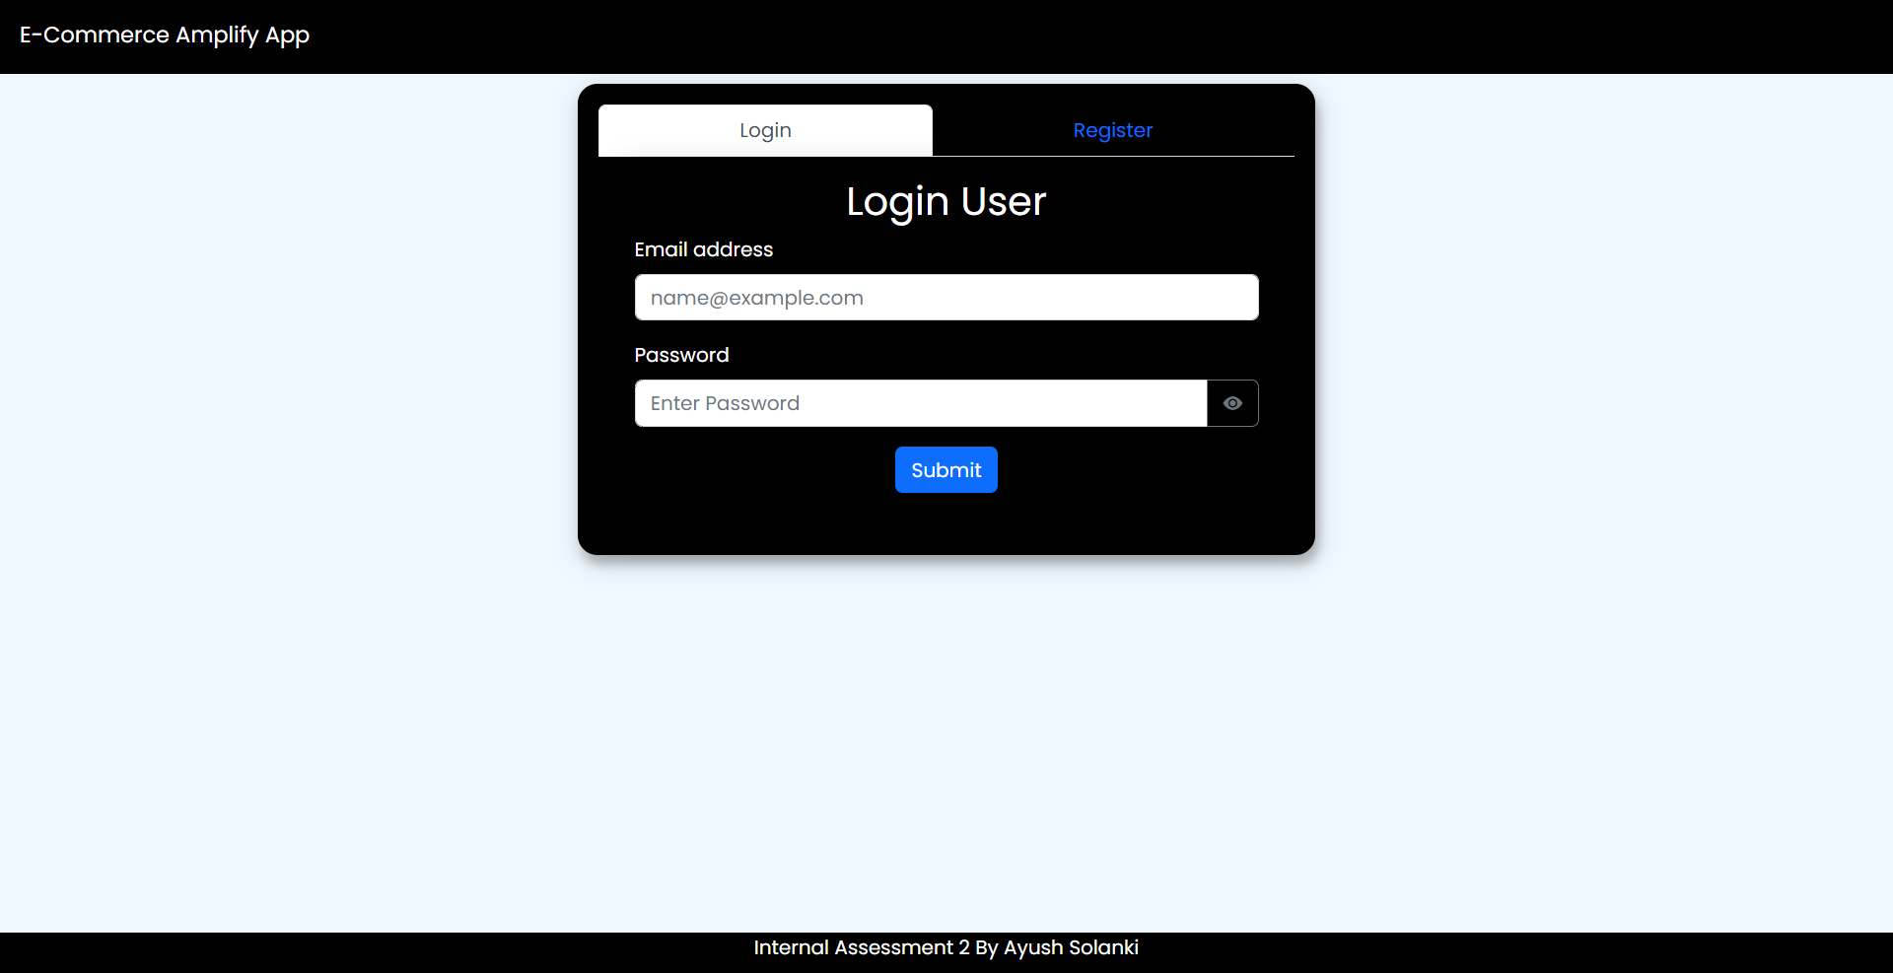

Register

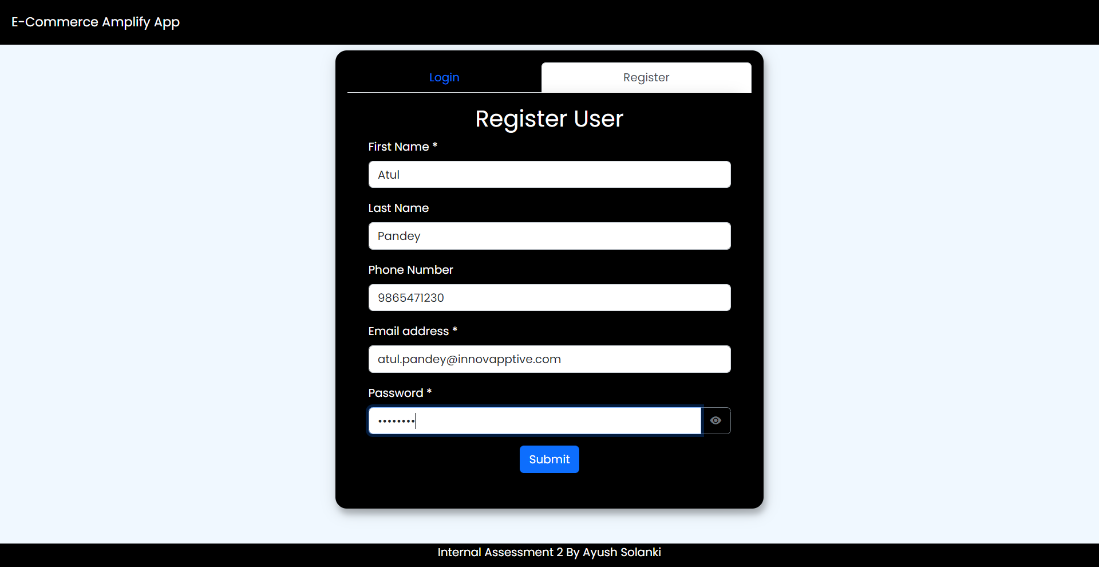

Confirm User

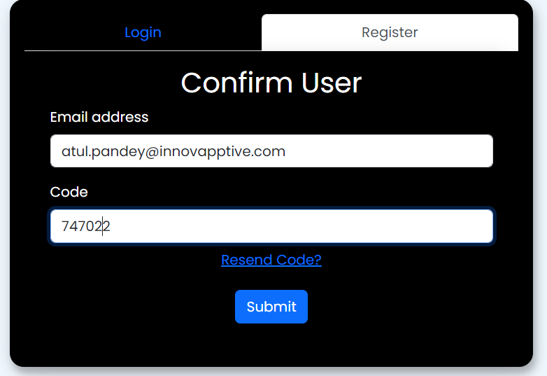

**HOME – MODULE**

Home Page – List of Items

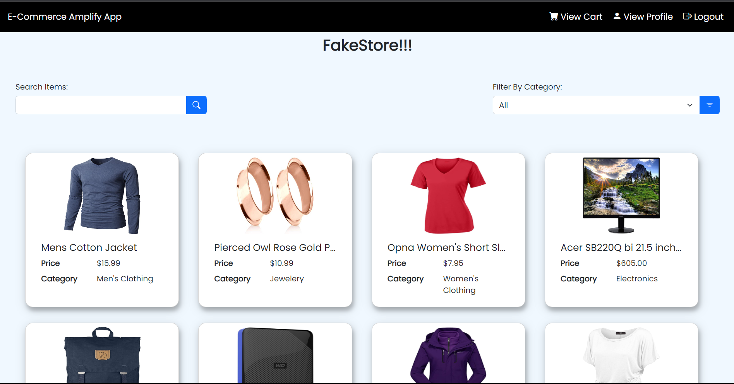

Home Page – Search Items by title

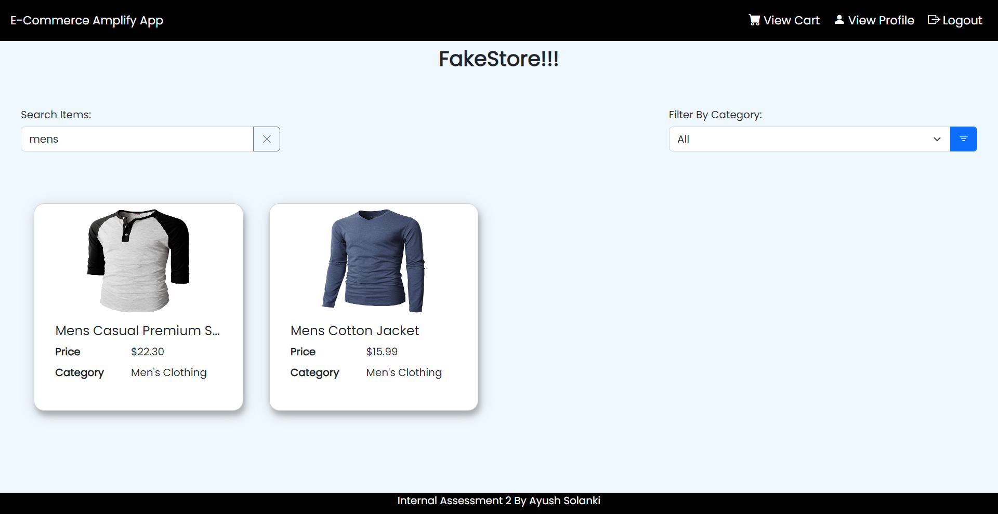

Home Page - Filter Items by category

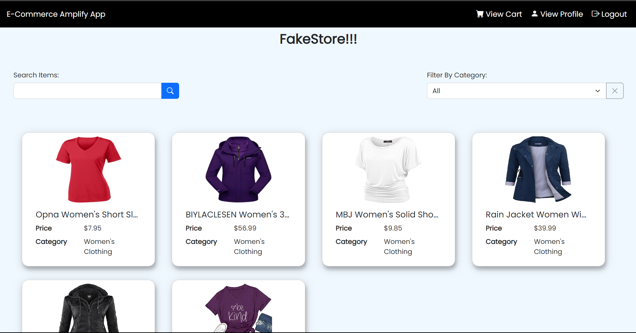

**ITEM DETAILS – MODULE**

Item Details Page

* Clicking on Items in Home page redirects to Item Details Page

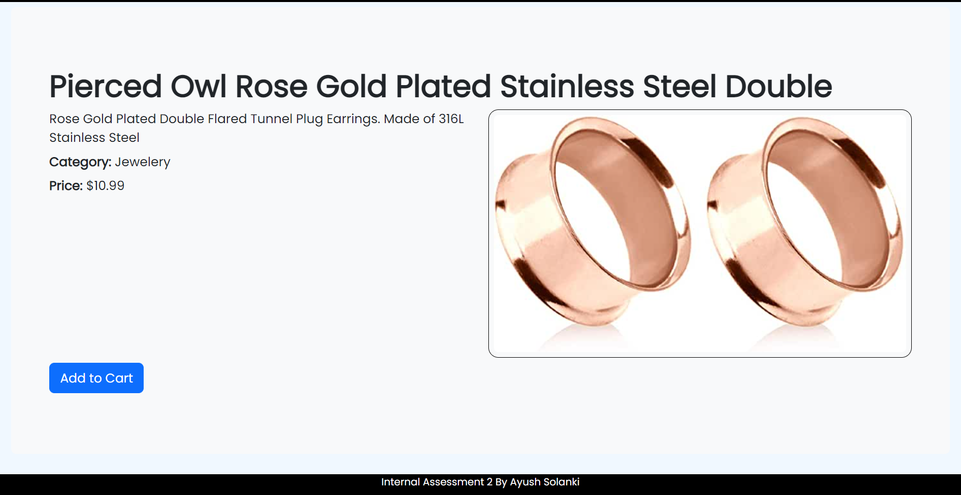

**CART – MODULE**

Cart Page

* Clicking add to cart on Item Details Page adds that item to cart and redirects to cart page
* User can increase or decrease the quantity of the item and also remove the item from the cart

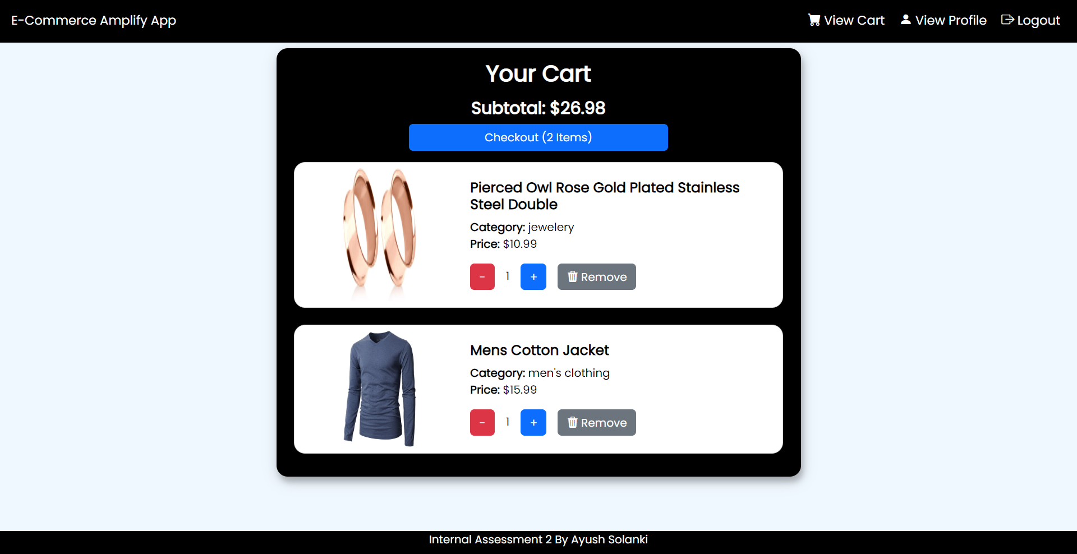

Remove Item from Cart Modal

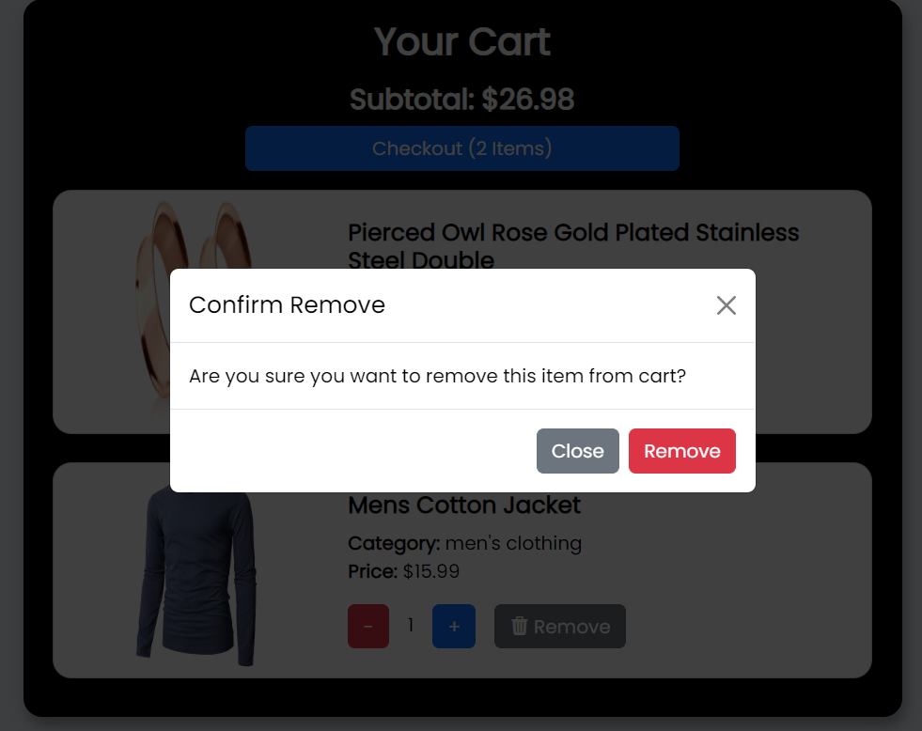

**USER PROFILE – MODULE**

Profile Page

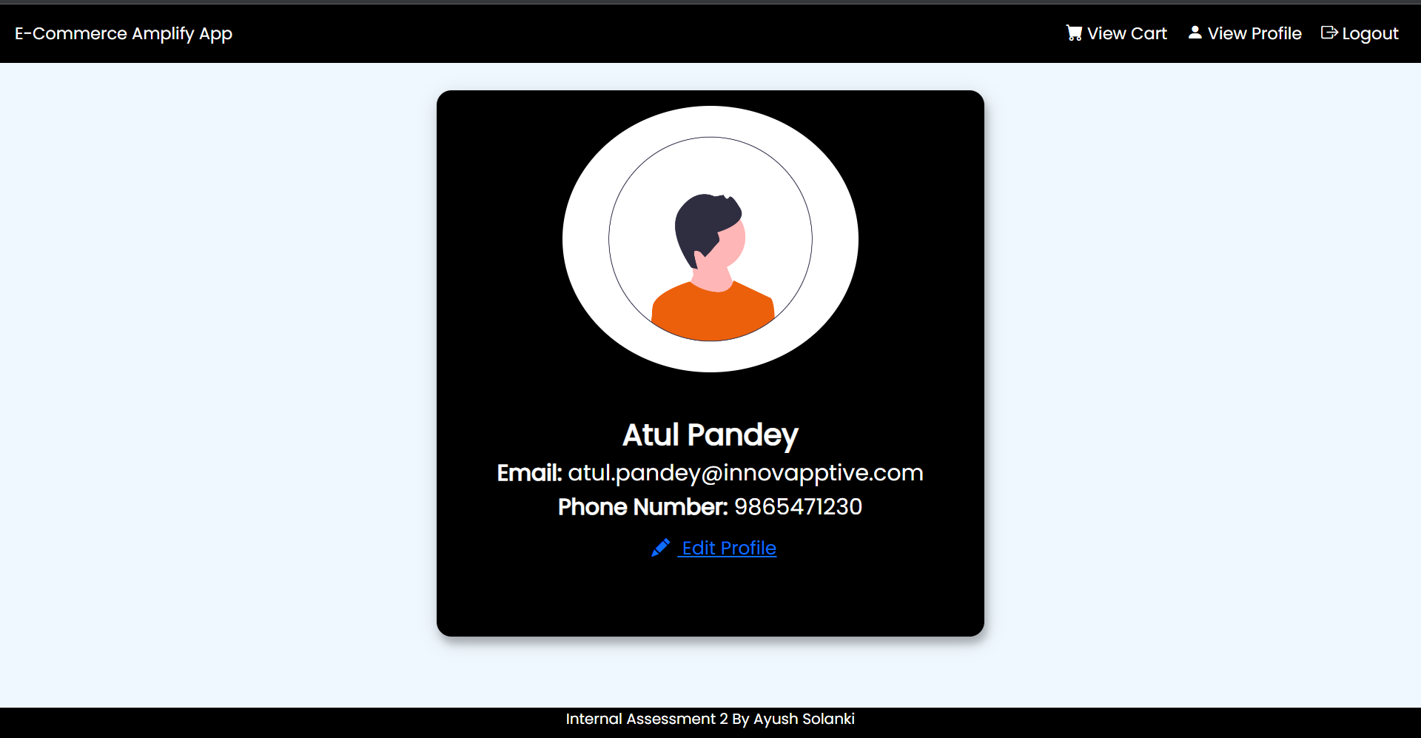

Edit Profile Modal

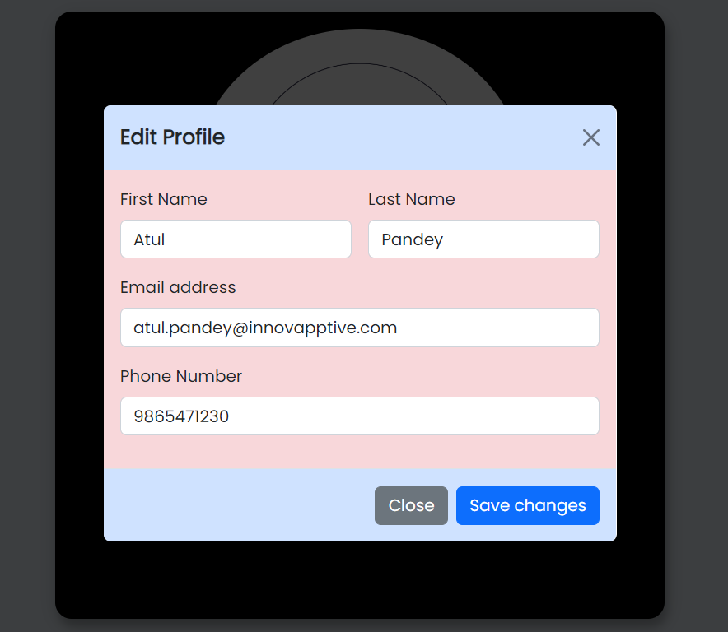

**MISC**

Loading Screen:

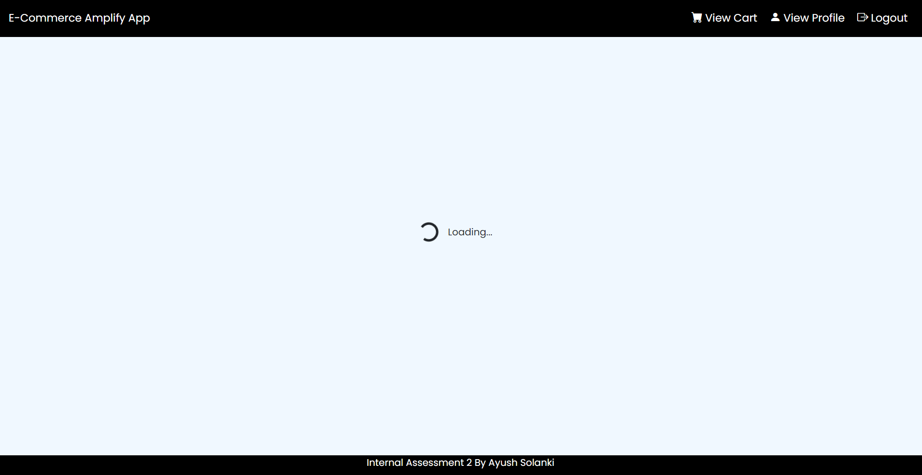

Toast for Success:

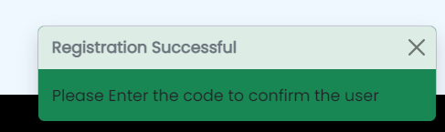

Toast for Failure:

