The Title Goes Here With Each Initial Letter Capitalized
Author's Name and Author's Name
Replace this text with authors' affiliation, (use complete addresses) including email of the corresponding author
Continue Here

The abstract should be written in English using the Times New Roman font (14 point for the Title and 11 point for the text), and should be single spaced. In the book of abstracts, papers will be printed reduced by 88%. The document (including title, authors, affiliation, postal address, figures and references) must be fitted within one page with a top margin of 30 mm and a bottom margin of 25 mm. The main text consists of two columns with 81 mm wide, spaced 8 mm apart.

The title, author(s) and affiliation(s) should be centered. Section titles should start without
indentation. Leave a space of one line between the affiliation(s) and the first section title, and one line between text and figures (tables etc.) or captions. Underline the name of the author who will present the paper. Please write the e-mail address of the corresponding author at the end of the references (*).
The author should send the author information and the abstract pdf file to the conference secretariat. The author should select suitable topics numbers from the list. The decision will be made by the Conference Committee.
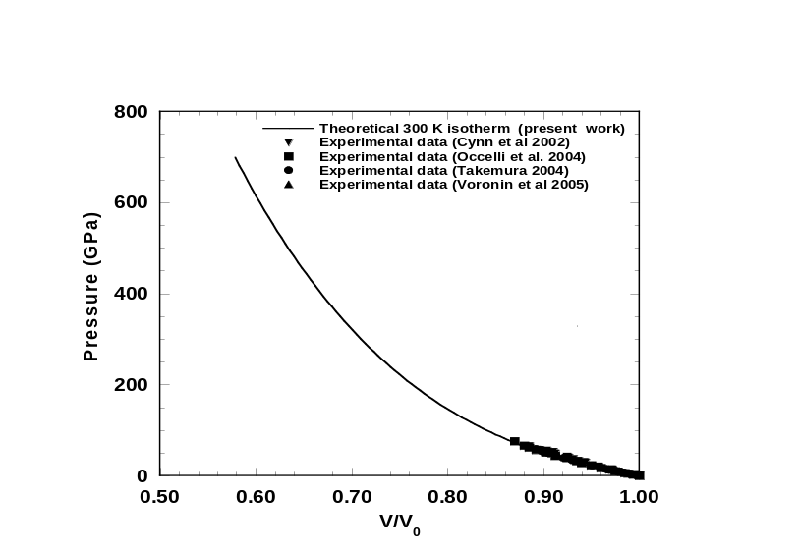
Figure 1. Figures and Tables should be included in the main text.

References
[1] H. Cynn, J.E. Klepeis, C-S Yoo and David Young, Phys. Rev. Lett., 88,135701-1(2002).
[2] Takemura Kenichi, Phys. Rev. B, 70, 012101, (2004).
* xxxxx@yyyyy.com(e-mail address of the corresponding author)

