**COMPUTER ARCHITECTURE AND ORGANISATION – LAB**

**ASSIGNMENT 1**

NAME: PRATHAM JAISWAL

ROLL NUMBER: 2023BEE-028

**HALF ADDER**

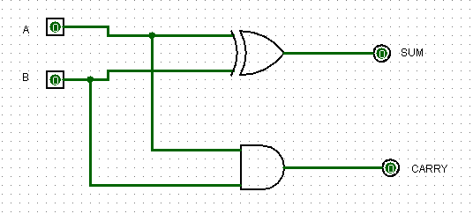

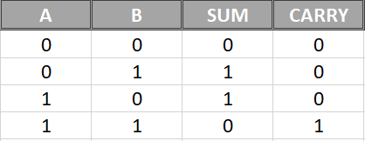

**FULL ADDER**

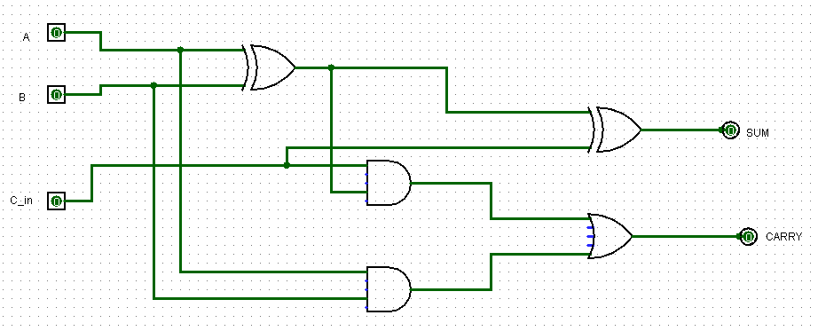

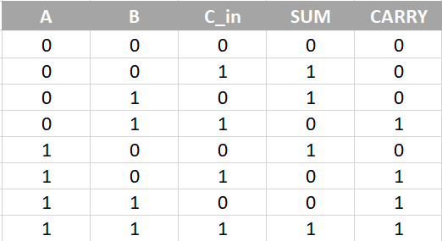

**HALF SUBTRACTOR**

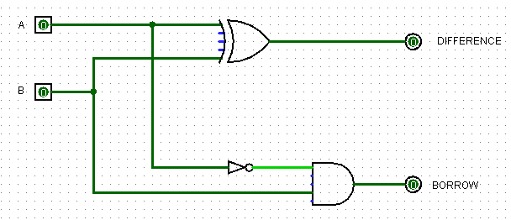

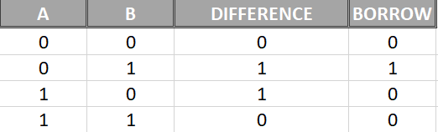

**FULL SUBTRACTOR**

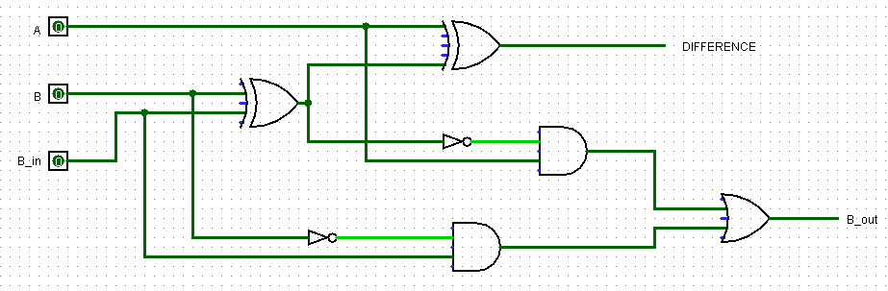

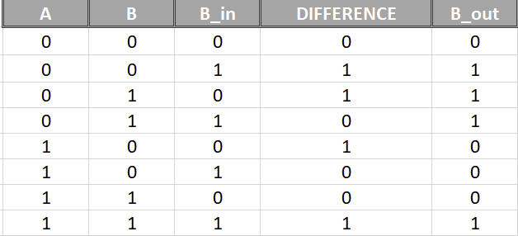

**BINARY TO GRAY**

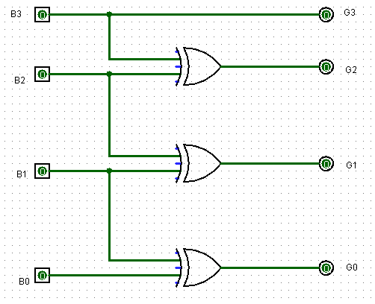

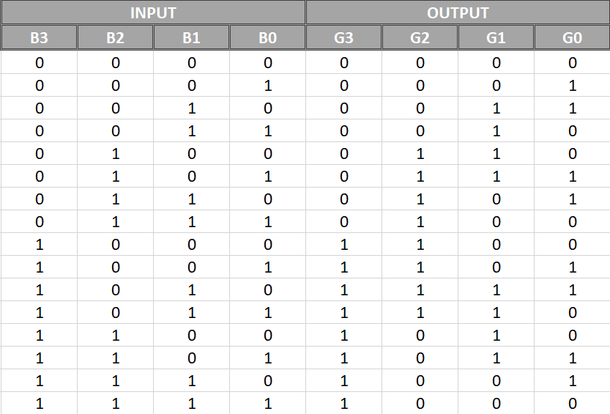

**GRAY TO BINARY**

