**COA LAB**

**ASSIGNMENT-2**

Name: Ayush Srivastava

Roll No: 2023BEE-009

Q1: Even Parity Generator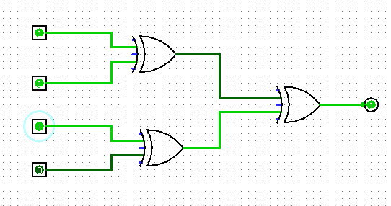

| **a** | **b** | **c** | **d** | **x** |
| --- | --- | --- | --- | --- |
| 0 | 0 | 0 | 0 | 0 |
| 0 | 0 | 0 | 1 | 1 |
| 0 | 0 | 1 | 0 | 1 |
| 0 | 0 | 1 | 1 | 0 |
| 0 | 1 | 0 | 0 | 1 |
| 0 | 1 | 0 | 1 | 0 |
| 0 | 1 | 1 | 0 | 0 |
| 0 | 1 | 1 | 1 | 1 |
| 1 | 0 | 0 | 0 | 1 |
| 1 | 0 | 0 | 1 | 0 |
| 1 | 0 | 1 | 0 | 0 |
| 1 | 0 | 1 | 1 | 1 |
| 1 | 1 | 0 | 0 | 0 |
| 1 | 1 | 0 | 1 | 1 |
| 1 | 1 | 1 | 0 | 1 |
| 1 | 1 | 1 | 1 | 0 |

Q2: Odd Parity Generator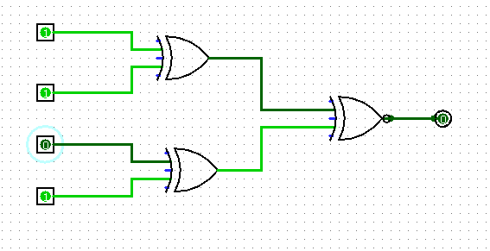

| a | b | c | d | x |
| --- | --- | --- | --- | --- |
| 0 | 0 | 0 | 0 | 1 |
| 0 | 0 | 0 | 1 | 0 |
| 0 | 0 | 1 | 0 | 0 |
| 0 | 0 | 1 | 1 | 1 |
| 0 | 1 | 0 | 0 | 0 |
| 0 | 1 | 0 | 1 | 1 |
| 0 | 1 | 1 | 0 | 1 |
| 0 | 1 | 1 | 1 | 0 |
| 1 | 0 | 0 | 0 | 0 |
| 1 | 0 | 0 | 1 | 1 |
| 1 | 0 | 1 | 0 | 1 |
| 1 | 0 | 1 | 1 | 0 |
| 1 | 1 | 0 | 0 | 1 |
| 1 | 1 | 0 | 1 | 0 |
| 1 | 1 | 1 | 0 | 0 |
| 1 | 1 | 1 | 1 | 1 |