AN INTERNSHIP REPORT ON
RTL-TO-GDSII IMPLEMENTATION AND VALIDATION
OF A UART MODULE FOR A NEW PROCESS DESIGN KIT (PDK)
SUBMITTED IN THE FULFILLMENT OF THE REQUIREMENT
FOR THE
AWARD OF THE DEGREE OF
BACHELOR OF TECHNOLOGY
[Electronics & Communication Engineering]
SUBMITTED BY
AYUSH THAKUR
ROLL NO. 23DEC009
UNDER THE SUPERVISION OF
[SUPERVISOR'S NAME]
[SUPERVISOR'S DESIGNATION], SEMI-CONDUCTOR LABORATORY (SCL)

Electronics & Communication Engineering
[NATIONAL INSTITUTE OF TECHNOLOGY , HAMIRPUR]
(June – July, 2026)

ACKNOWLEDGEMENT
I would like to express my sincere gratitude to the Semi-Conductor Laboratory (SCL), Mohali, for giving me the opportunity to carry out my summer internship in the VLSI Design Division, and for access to the design infrastructure that made this project possible.
I am deeply thankful to my supervisor, [Supervisor's Name], [Supervisor's Designation], SCL Mohali, for the constant guidance, technical inputs and patience extended throughout this internship, particularly while working through the complete RTL-to-GDSII flow on a new process design kit.
I would also like to thank the faculty of the [Department Name], [Your College / University Name], for their continued support and encouragement, and everyone at SCL Mohali who directly or indirectly helped me during the course of this internship.

ABSTRACT
A Process Design Kit (PDK) supplied by a semiconductor foundry contains the standard-cell libraries, technology files and design-rule decks that are used to translate a digital circuit description into a manufacturable layout. Before a new or updated PDK can be released for general chip-design use, it is common practice to exercise it through a complete RTL-to-GDSII design flow on a representative digital circuit, so that its cell timing models, physical design rules and Layout-versus-Schematic (LVS) decks can be checked end to end.
This report documents a summer internship project carried out in the VLSI Design Division of the Semi-Conductor Laboratory (SCL), Mohali, in which the Universal Asynchronous Receiver/Transmitter (UART) module of a microcontroller was used as the test vehicle to validate a new PDK. The UART module was designed at the Register Transfer Level (RTL) in Verilog and functionally verified using a testbench, with waveforms observed in GTKWave. The verified RTL was synthesized into a gate-level netlist using the open-source Yosys synthesis suite, mapped to the standard-cell library of the new PDK. The resulting netlist was carried through the complete physical design flow in OpenROAD – I/O pad insertion, floorplanning, power distribution network (PDN) generation, placement, clock tree synthesis (CTS) and routing – to obtain a fully routed layout.
Static Timing Analysis (STA) was performed on the routed design to check timing closure, and a post-layout, delay-annotated gate-level simulation was carried out and compared against the pre-layout RTL simulation. The final layout was verified for Design Rule Check (DRC) and Layout-versus-Schematic (LVS) compliance in KLayout before GDSII stream-out. Together, these steps are intended to demonstrate [insert final utilisation, timing slack (WNS/TNS) and DRC/LVS status once available] and to confirm the correctness and readiness of the new PDK for subsequent digital design use at SCL.

TABLE OF CONTENTS

(Right-click the table above and choose “Update Field” in Microsoft Word after all chapters and page numbers are finalised.)

LIST OF FIGURES
Figure 4.1 RTL-to-GDSII design flow implemented for PDK validation
Figure 5.1 UART frame format and transmitter–receiver interface signals
Figure 5.2 RTL (pre-synthesis) simulation waveform of the UART module (GTKWave)
Figure 6.1 Yosys synthesis log and gate-level netlist statistics
Figure 7.1 Physical design (back-end) flow followed in OpenROAD
Figure 7.2 I/O pad ring inserted around the top module
Figure 7.3 Floorplan view of the design
Figure 7.4 Power distribution network (PDN) view
Figure 7.5 Placement view of standard cells
Figure 7.6 Clock tree generated during CTS
Figure 7.7 Fully routed layout
Figure 8.1 STA timing report summary
Figure 9.1 Post-layout gate-level simulation waveform
Figure 10.1 DRC report summary
Figure 10.2 LVS report summary
Figure 10.3 Final GDSII layout viewed in KLayout

LIST OF TABLES
Table 7.1 Floorplanning rules and guidelines used
Table 8.1 STA summary (WNS / TNS)
Table 9.1 Comparison of pre-layout and post-layout simulation results
Table 11.1 Summary of key implementation results
Note: renumber / update this list once your own screenshots and additional figures have been inserted into the chapters below.

CHAPTER 1

INTRODUCTION TO THE ORGANIZATION

1.1 Overview
The Semi-Conductor Laboratory (SCL), Mohali, is an autonomous research and development institute functioning under the Ministry of Electronics and Information Technology (MeitY), Government of India. Established in the late 1970s as the Semiconductor Complex Limited and later reconstituted as an autonomous laboratory, SCL is the country's principal in-house facility for the design, fabrication, packaging and testing of integrated circuits and MEMS devices, and has historically supported strategic applications including India's space programme.
SCL operates an in-house 8-inch CMOS wafer fabrication line and a 6-inch MEMS wafer line at a 180 nm technology node, supported by dedicated design, assembly-and-packaging, and reliability-and-quality-assurance groups, giving it complete, end-to-end control over the semiconductor value chain from circuit design to packaged, qualified silicon.
As part of the Government of India's broader India Semiconductor Mission, SCL is currently undergoing a significant modernisation and capacity-expansion programme. This includes the development and qualification of new process technology platforms and process design kits (PDKs) as SCL works to extend its capability beyond its current 180 nm CMOS offering. Validating a new PDK by carrying a representative digital design through the complete RTL-to-GDSII flow, as described in this report, is a small but concrete part of that larger qualification effort.

1.2 Departments in SCL
The organisational structure of SCL includes several specialised divisions that together cover the complete IC design-to-fabrication cycle:
- VLSI Design Division – responsible for digital, analog and mixed-signal circuit design, and for the design-enablement/EDA infrastructure, including PDK bring-up and validation.
- VLSI and MEMS Fabrication Divisions – operate the 8-inch CMOS and 6-inch MEMS wafer fabrication lines.
- VLSI Testing Division – carries out wafer- and package-level electrical testing and device characterisation.
- Assembly and Packaging Division – performs die bonding, wire bonding and hermetic packaging for high-reliability applications.
- Reliability and Quality Assurance Division – conducts qualification testing, in-line inspection and failure analysis across all stages of production.

1.3 VLSI Design Division
The VLSI Design Division maintains a comprehensive Electronic Design Automation (EDA) environment supporting digital, analog and mixed-signal ASIC development, built around industry-standard commercial tools alongside growing use of open-source RTL-to-GDSII flows for rapid prototyping, PDK bring-up exercises and academic/internship projects such as this one.
SCL also runs a Chips-to-Startup programme through which numerous student-designed chips have already been fabricated using EDA tools made available to academic users, reflecting the division's continued emphasis on hands-on IC design training alongside its core PDK and product-design responsibilities. The present internship, carried out in this division, focused specifically on exercising a newly developed PDK using an open-source RTL-to-GDSII toolchain (Yosys, OpenROAD, KLayout and GTKWave) on the UART module of a microcontroller.

CHAPTER 2

INTRODUCTION TO THE PROJECT

2.1 Overview
This chapter introduces the motivation, aim and scope of the internship project, and gives a roadmap of the topics covered in the remaining chapters of this report.

2.2 Motivation: Why a New PDK Must Be Validated
A Process Design Kit (PDK) is the collection of files – standard-cell libraries (Liberty timing models, LEF abstracts, GDS/layout views), I/O pad libraries, technology and layer-map files, and Design Rule Check (DRC) / Layout-versus-Schematic (LVS) rule decks – that allows an EDA toolchain to turn a digital circuit description into a manufacturable chip layout on a specific process.
Before a new or updated PDK is released for general use, it needs to be exercised end-to-end: synthesis tools must be able to map logic onto its standard cells correctly, physical design tools must be able to place and route using its layers and design rules without violations, and the resulting layout must pass DRC and LVS against its own rule decks. Running a real, representative digital design through the complete flow is one of the most effective ways to catch inconsistencies in a new PDK before it is handed over to chip designers.

2.3 Project Aim and Objectives
Aim: To validate a new Process Design Kit (PDK) by implementing the UART (Universal Asynchronous Receiver/Transmitter) module of a microcontroller through the complete RTL-to-GDSII design flow using open-source EDA tools.
Objectives:
- Design and functionally verify the UART module at the RTL level in Verilog.
- Synthesize the verified RTL into a gate-level netlist mapped to the new PDK's standard-cell library using Yosys.
- Carry the netlist through the complete physical design flow (pad insertion, floorplanning, PDN, placement, CTS and routing) in OpenROAD, using the new PDK's technology and cell data.
- Perform Static Timing Analysis (STA) to check timing closure against the new PDK's timing models.
- Perform post-layout, delay-annotated gate-level simulation and compare it against the pre-layout RTL simulation.
- Verify the final layout for DRC and LVS compliance in KLayout and generate a GDSII file.

2.4 Why the UART Module Was Chosen as the Test Vehicle
The UART (Universal Asynchronous Receiver/Transmitter) block of a microcontroller was chosen as the digital design used to exercise the new PDK. It is small enough to carry through the complete RTL-to-GDSII flow quickly, yet complex enough to be a meaningful test: it contains independent transmit- and receive-side finite-state-machine (FSM) controllers, shift registers and a baud-rate generator, together with a small number of I/O pins, so it exercises a reasonable cross-section of the standard-cell library (combinational gates, flip-flops, clock buffers) as well as the I/O pad library and the routing/DRC rules – much as a small process-control or test-chip block would.
This makes the UART module a practical, self-contained vehicle for confirming that the new PDK's libraries and rule decks behave correctly across an entire design flow, before larger and more complex blocks are attempted on the same PDK.

2.5 Scope of Work
The project was carried out in four broad stages:
- RTL Design and Verification: Writing the UART module in Verilog and verifying its functionality against a testbench.
- Logic Synthesis: Converting the verified RTL into a gate-level netlist mapped to the new PDK's standard-cell library using Yosys.
- Physical Design: Implementing the netlist as a routed layout using OpenROAD – covering pad insertion, floorplanning, power distribution, placement, clock tree synthesis and routing.
- Verification and Sign-off: Performing STA and post-layout simulation, and verifying the final layout for DRC/LVS compliance in KLayout before GDSII generation.

2.6 Roadmap of the Report
Chapter 3 introduces the software tools used in this project – Yosys, OpenROAD, KLayout and GTKWave. Chapter 4 gives an overview of the complete RTL-to-GDSII design flow with a flow diagram. Chapter 5 covers the RTL design and functional verification of the UART module. Chapter 6 covers logic synthesis using Yosys. Chapter 7 covers the physical design implementation in OpenROAD, including pad insertion, floorplanning, PDN generation, placement, clock tree synthesis and routing. Chapter 8 covers Static Timing Analysis, and Chapter 9 covers post-layout gate-level simulation. Chapter 10 covers physical verification (DRC/LVS) and GDSII generation in KLayout. Chapters 11 and 12 present the results, conclusion and future scope, followed by references in Chapter 13.

CHAPTER 3

SOFTWARE TOOLS REQUIRED

3.1 Overview
This project used a fully open-source RTL-to-GDSII toolchain. This chapter briefly introduces each tool and the role it plays in the overall flow described in later chapters.

3.2 Yosys
Yosys is an open-source logic synthesis framework for Verilog RTL designs. It reads in the RTL, performs process, optimisation and technology-mapping passes, and – using the ABC logic-synthesis and technology-mapping engine together with the Liberty (.lib) timing file of the target library – maps the design onto the actual standard cells of the new PDK, producing a gate-level netlist. In this project, Yosys is the point at which the new PDK's standard-cell library is first exercised.

3.3 OpenROAD
OpenROAD is an open-source RTL-to-GDSII physical design tool that automates the complete back-end flow – floorplanning, power distribution network (PDN) generation, placement, clock tree synthesis (CTS), global and detailed routing, parasitic extraction and static timing analysis – with minimal manual intervention. OpenROAD consumes the new PDK's technology LEF, cell LEF/Liberty views and routing rules directly, so every stage of the physical design flow in Chapter 7 also serves as a check on the corresponding part of the new PDK.

3.4 KLayout
KLayout is an open-source layout viewer and editor for GDSII and OASIS files. Beyond viewing and editing layout geometry, KLayout provides a scripting-based DRC (Design Rule Check) and LVS (Layout-versus-Schematic) engine that can run the new PDK's own rule decks against the generated layout. In this project, KLayout is used both to inspect the final layout visually and to sign it off for DRC and LVS compliance before GDSII stream-out (Chapter 10).

3.5 GTKWave
GTKWave is an open-source waveform viewer for VCD (Value Change Dump) and similar simulation-output formats. It does not simulate the design itself – RTL and gate-level simulations in this project were run using a Verilog simulator (e.g. Icarus Verilog) to generate the VCD dump, which was then loaded into GTKWave to visually inspect signal transitions. GTKWave is used twice in this flow: once for the pre-layout RTL functional simulation (Chapter 5) and again for the post-layout, delay-annotated gate-level simulation (Chapter 9).

CHAPTER 4

THE RTL TO GDSII DESIGN FLOW

4.1 Overview
“RTL to GDSII” refers to the complete sequence of steps by which a digital circuit description written at the Register Transfer Level (RTL) is turned into GDSII – the layout file format used to fabricate a chip. The flow is broadly split into a front-end half, which turns RTL into a gate-level netlist of standard cells, and a back-end (physical design) half, which turns that netlist into a fully placed-and-routed layout.
For this project, the same flow serves a dual purpose: it produces a working implementation of the UART module, and – because every stage draws on a different part of the new PDK (cell timing models, LEF abstracts, routing rules, DRC/LVS decks) – it also validates that the new PDK is usable end to end.

4.2 Stages of the Flow
The flow followed in this project consists of the following stages, each described in detail in the chapter indicated:
- RTL Design – the UART module is described in synthesizable Verilog (Chapter 5).
- RTL Functional Verification – the RTL is verified against a testbench, with waveforms viewed in GTKWave (Chapter 5).
- Logic Synthesis – Yosys maps the verified RTL onto the new PDK's standard-cell library, producing a gate-level netlist (Chapter 6).
- Physical Design – OpenROAD implements the netlist as a layout through I/O pad insertion, floorplanning, power distribution network (PDN) generation, placement, clock tree synthesis (CTS) and routing (Chapter 7).
- Static Timing Analysis (STA) – the routed design is checked for setup/hold timing closure (Chapter 8).
- Post-Layout Simulation – the gate-level netlist, back-annotated with delays extracted from the routed layout, is re-simulated to confirm functional correctness under real timing (Chapter 9).
- Physical Verification – the final layout is checked for DRC and LVS compliance in KLayout (Chapter 10).
- GDSII Generation – a foundry-ready GDSII stream file is produced (Chapter 10).

4.3 Flow Diagram
Figure 4.1 summarises the complete flow followed in this project, from RTL design through to the final, PDK-validated GDSII layout.
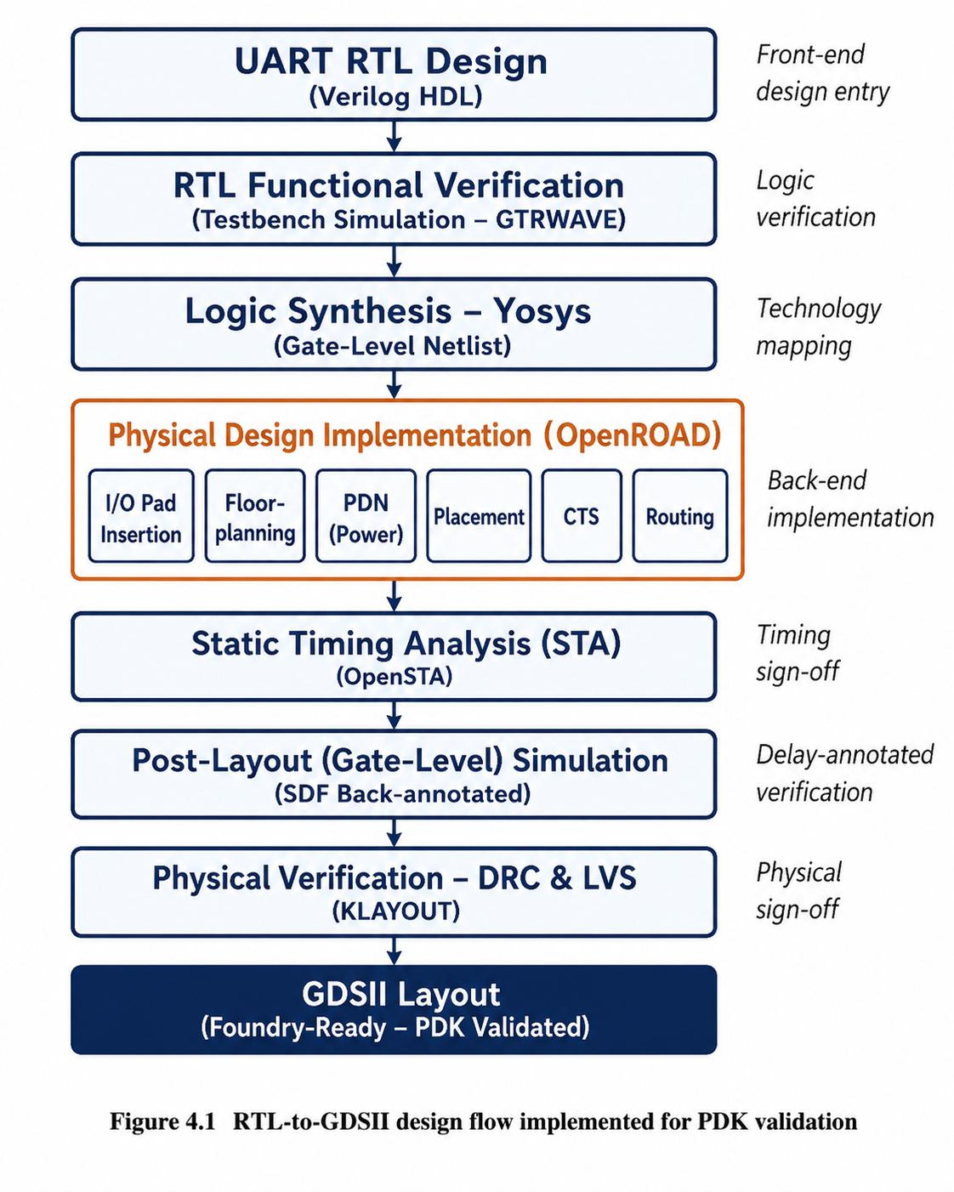
Figure 4.1 RTL-to-GDSII design flow implemented for PDK validation

CHAPTER 5

RTL DESIGN AND FUNCTIONAL VERIFICATION OF THE UART MODULE

5.1 The UART Protocol: An Overview
The Universal Asynchronous Receiver/Transmitter (UART) is an asynchronous, full-duplex serial communication protocol commonly used to connect a microcontroller to peripheral devices such as GPS receivers, Bluetooth/Wi-Fi modules, RFID readers, debug consoles and PC host interfaces. Unlike synchronous protocols such as SPI, a UART link carries no shared clock line between the two ends: it uses just two independent, unidirectional signals, TX (Transmit, driven by the sender) and RX (Receive, read by the far end), cross-connected between exactly two devices along with a common ground reference.
Because there is no shared clock, both ends must independently be configured with the same baud rate (bits per second) and frame format in advance. Each byte is sent as an asynchronous frame: the line idles at logic-1 when no data is being sent; a start bit (always logic-0) marks the beginning of a frame and lets the receiver synchronise to it; this is followed by the data bits (typically 8, transmitted LSB-first), an optional parity bit for basic error detection, and one or two stop bit(s) (always logic-1) that mark the end of the frame. The receiver samples each incoming bit at its midpoint using an internally generated clock running at a multiple (typically 16×) of the baud rate, so that small clock-frequency mismatches between transmitter and receiver do not corrupt the data within a single frame.
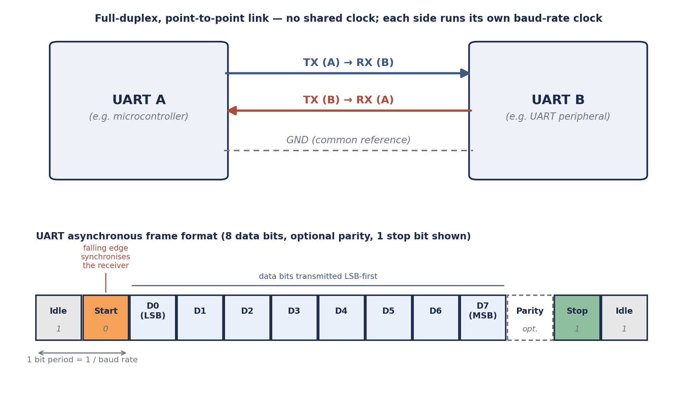
Figure 5.1 UART frame format and transmitter–receiver interface signals

5.2 Role of UART within a Microcontroller SoC
Within a microcontroller, the UART block is typically implemented as a memory-mapped peripheral: a baud-rate/control register sets the baud-rate divisor and frame format (data-bit count, parity, stop-bit count), a status register reports TX-empty, RX-data-ready, framing-error, parity-error and overrun-error flags, and separate TX-data and RX-data registers hold the byte to be transmitted and the byte most recently received. The peripheral's TX and RX signals are ultimately routed to dedicated I/O pads at the chip boundary so that they can connect to external devices.

5.3 RTL Architecture of the Designed UART Module
The UART module implemented in this project follows a conventional architecture consisting of: (a) a baud-rate generator that divides the system clock down to the configured baud rate and to an internal 16× oversampling tick used for receiver sampling; (b) a transmitter datapath comprising an FSM controller and a parallel-to-serial shift register that sequences the idle, start-bit, data-bit, parity-bit and stop-bit phases of an outgoing frame on TX; (c) a receiver datapath comprising an independent FSM controller and a serial-to-parallel shift register that detects the start-bit edge on RX, samples each data bit at its mid-point using the oversampling tick, checks the parity and stop bit, and flags framing/parity/overrun errors; and (d) configuration and status registers that expose the module's control and status bits to the rest of the microcontroller.

5.4 Verilog RTL Code
📌 Insert your UART module Verilog RTL code here (e.g. as a screenshot or as a monospaced code listing). Include the testbench used to verify it, and label this as Code Listing 5.1 (RTL) and 5.2 (Testbench) if both are included.

5.5 Functional Simulation and Results
The RTL was simulated against a self-checking testbench that drives known bytes into the UART transmitter and checks that the receiver correctly recovers each byte. The waveform should be checked for: correct start-bit detection and mid-bit sampling by the receiver at the configured baud rate; correct serialisation of the TX data, LSB-first, framed by the start and stop bits; correct parity generation and checking, if enabled; and correct assertion of the RX-data-ready flag (and, for deliberately malformed frames, the framing-error flag) once a complete frame has been received.

[ Insert here: GTKWave screenshot of the RTL simulation, showing TX, RX, the internal baud-rate tick and the internal shift-register value ]
Figure 5.2 RTL (pre-synthesis) simulation waveform of the UART module (GTKWave)

CHAPTER 6

LOGIC SYNTHESIS USING YOSYS

6.1 Overview of Logic Synthesis
Logic synthesis is the process of translating a behavioural/RTL description of a circuit into a structural gate-level netlist built entirely from the standard cells available in a target library – in this case, the standard-cell library supplied with the new PDK. This is the first point in the flow at which the new PDK's cells are actually used, since the synthesis tool must map every RTL construct (adders, multiplexers, registers, etc.) onto real AND/OR/NAND/flip-flop/etc. cells with real, PDK-specific timing characteristics.

6.2 Synthesis Flow in Yosys
A typical Yosys synthesis run for this project follows the sequence below:
- read_verilog – reads in the UART RTL source files.
- hierarchy -check -top uart_top – elaborates the design hierarchy and checks it is well-formed.
- proc, opt, fsm, memory, opt – a series of passes that convert always blocks into basic logic, extract and optimise the FSM, and resolve any memory constructs.
- techmap – maps generic RTL logic onto generic gate primitives.
- dfflibmap -liberty <pdk>.lib – maps generic flip-flops onto the actual sequential cells in the new PDK's Liberty file.
- abc -liberty <pdk>.lib – uses the ABC engine to perform technology mapping and optimisation onto the new PDK's combinational standard cells.
- clean, write_verilog / write_blif – cleans up the netlist and writes out the final gate-level netlist for use by OpenROAD.

6.3 Generating the Gate-Level Netlist
📌 Insert your Yosys synthesis script/commands and the resulting synthesis log here.

[ Insert here: Terminal screenshot of the Yosys ‘stat’ output and/or a snippet of the generated gate-level netlist ]
Figure 6.1 Yosys synthesis log and gate-level netlist statistics

6.4 Synthesis Report
Table 6.1 summarises the key statistics reported by Yosys after synthesis (fill in from your synthesis log):
Parameter | Value
Total number of standard cells | [ ]
Number of combinational cells | [ ]
Number of sequential cells (flip-flops) | [ ]
Number of I/O ports | [ ]
Estimated chip area (from synthesis) | [ ]

CHAPTER 7

PHYSICAL DESIGN IMPLEMENTATION USING OPENROAD

7.1 Overview
Physical design (also called the “back-end” of the flow) is the process of converting the gate-level netlist produced by synthesis into an actual chip layout: every standard cell is given a physical location, the chip's power and clock networks are built, and every electrical connection in the netlist is realised as a metal wire, all while obeying the new PDK's design rules. This chapter follows the physical design flow shown in Figure 7.1, implemented using OpenROAD.
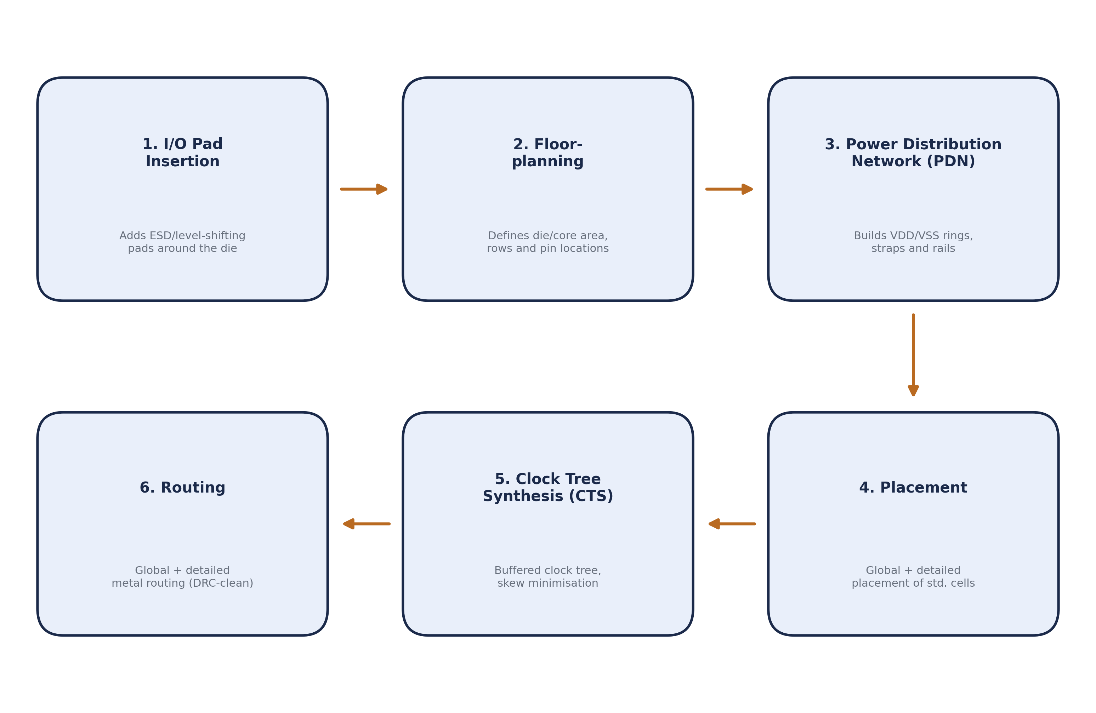
Figure 7.1 Physical design (back-end) flow followed in OpenROAD

7.2 I/O Pad Insertion (Padding of the Top Module)

7.2.1 Why Padding Is Required
Before floorplanning can begin, the top-level module is “padded” – that is, dedicated I/O pad cells from the new PDK's pad library are added around its periphery, one per chip-level pin (TX, RX, plus power/ground pads). Padding is required for several reasons:
- Level shifting and drive strength: internal standard cells are sized to drive small on-chip loads; I/O pads are specifically designed to drive the much larger capacitive loads presented by external pins, bond wires and PCB traces.
- ESD and over-voltage protection: pads incorporate electrostatic-discharge (ESD) protection structures that standard core cells do not have, protecting the internal logic from damage during handling and assembly.
- Defining the chip boundary: the pad ring physically defines the periphery of the die and fixes the order and location of every external pin – information the floorplanning step needs before it can lay out the core area inside that ring.
- Packaging interface: each pad provides a bond pad that can be wire-bonded (or bump-bonded) to the package, without which the finished die cannot be connected to the outside world at all.
Because the pad ring determines the outer boundary that everything else (floorplan, PDN, routing) is built inside, pad insertion is carried out first, ahead of floorplanning.

[ Insert here: OpenROAD/KLayout screenshot showing the padded top module with TX/RX and power/ground pads placed around the periphery ]
Figure 7.2 I/O pad ring inserted around the top module

7.3 Floorplanning

7.3.1 Floorplanning Rules and Guidelines
Before generating the floorplan, a set of guidelines was followed to ensure the design would be routable and DRC-clean on the new PDK. These are summarised in Table 7.1.
Guideline | Purpose
Core utilisation kept in the 40–60% range for the first pass | Leaves enough free area for the placer and router to work without excessive congestion
Core aspect ratio kept close to 1 (square-ish) | Avoids very long, thin cores that make clock and power distribution harder to balance
Core-to-die margin sized to fit the PDN rings and pad ring | Ensures the power ring and I/O pads do not overlap the standard-cell rows
Standard-cell rows aligned to the new PDK's site definition | Guarantees every placed cell sits on a legal row/site position
Keep-out margins reserved around pad and macro corners | Prevents routing or placement conflicts near the chip boundary

7.3.2 Floorplanning Process
With the guidelines above as input, the floorplanning step in OpenROAD: (1) defines the die area and the core area, either from an explicit width/height or from a target utilisation and aspect ratio; (2) lays down standard-cell rows and sites across the core area, matching the new PDK's site definition; (3) fixes the locations of the chip-level I/O pins (already broadly set by the pad ring from Section 7.2); and (4) inserts tap/end-cap cells along the rows, which provide the well/substrate contacts required by the new PDK to prevent latch-up – something only a real, PDK-specific floorplan step can properly validate.

[ Insert here: OpenROAD floorplan view showing the die area, core area, standard-cell rows and pin locations ]
Figure 7.3 Floorplan view of the design

7.4 Power Distribution Network (PDN)

7.4.1 Purpose of the PDN
The Power Distribution Network delivers VDD and VSS from the chip's power pads to every standard cell in every row, with low enough resistance to keep IR drop and electromigration within acceptable limits. Because the PDN is built entirely from the new PDK's metal stack, it also directly exercises that stack's layer resistances, via rules and minimum-width/spacing rules for power routing.

7.4.2 PDN Construction Sequence
The PDN is built up in a fixed order, since each layer of the network depends on the one below it already being in place:
- Global connect: the VDD/VSS pins of every standard cell are logically tied to the design's power and ground nets.
- Core ring: a ring of VDD/VSS metal is drawn around the core area on a chosen pair of upper metal layers.
- Standard-cell rails: horizontal VDD/VSS rails are drawn on the lowest metal layer (M1), one pair per standard-cell row, following the row pitch set during floorplanning.
- Power straps: additional VDD/VSS stripes are added on intermediate/upper metal layers at a regular pitch, to supplement the rails over the whole core.
- Via stacks: vias are inserted to stitch the straps to the ring and the rails to the straps, so that power can actually flow from the ring down to every row.
- Pad connection: the completed ring/strap network is finally connected to the chip's dedicated power and ground I/O pads.

[ Insert here: OpenROAD view of the completed PDN, showing the core ring, straps and standard-cell rails ]
Figure 7.4 Power distribution network (PDN) view

7.5 Placement

7.5.1 Global Placement
Global placement uses an analytical placement algorithm to spread all standard cells across the core area so as to minimise an estimate of total wirelength while respecting the target density, without yet snapping cells to exact legal row positions.

7.5.2 Detailed Placement (Legalization)
Detailed placement then legalises this rough placement: every cell is snapped onto a legal site on its row, overlaps are removed, and local placement is fine-tuned, all while honouring the keep-outs created by the PDN straps and pad-ring blockages from the previous steps.

[ Insert here: OpenROAD placement view showing standard cells legalised into rows across the core area ]
Figure 7.5 Placement view of standard cells

7.6 Clock Tree Synthesis (CTS)
Clock Tree Synthesis distributes the clock from a single root to every sequential element in the design – in this case, every flip-flop in the UART module's FSM controllers and shift registers – with insertion delays balanced and skew minimised, so that all registers sample data on effectively the same clock edge. CTS builds a buffered clock tree (typically an H-tree or similar balanced topology) using clock buffer/inverter cells from the new PDK's library, sized and inserted so as to meet maximum-transition and maximum-capacitance limits defined for those cells. Because it relies entirely on the new PDK's characterised clock-cell timing data, CTS is also an effective check of that part of the library.

[ Insert here: OpenROAD CTS view showing the buffered clock tree feeding all flip-flops in the design ]
Figure 7.6 Clock tree generated during CTS

7.7 Routing

7.7.1 Global Routing
Global routing performs a coarse-grained routing pass over a grid of routing cells (gcells), assigning each net to a rough path and set of layers, and estimating routing congestion so that any hotspots can be addressed before detailed routing begins.

7.7.2 Detailed Routing
Detailed routing then converts these coarse paths into actual metal-layer geometry – wires and vias – for every net, strictly obeying the new PDK's minimum width, spacing and via rules. Detailed routing is where the new PDK's DRC deck is exercised most heavily, since the router must produce a fully connected, DRC-clean layout using only the routing rules supplied in the kit.

[ Insert here: OpenROAD routing view of the fully routed UART design ]
Figure 7.7 Fully routed layout

CHAPTER 8

STATIC TIMING ANALYSIS (STA)

8.1 Purpose of STA
Static Timing Analysis checks, without simulating any input vectors, whether every timing path in the design meets its setup and hold requirements at the target clock frequency, using the delay of every routed wire and standard cell in the design. Because those delays come directly from the new PDK's Liberty (.lib) timing models combined with the parasitics extracted from the actual routed layout, STA is an important cross-check of how accurately the new PDK's timing characterisation matches the physical implementation it produced.

8.2 Key Timing Concepts
- Setup slack: the margin between the time data becomes stable at a flip-flop's input and the next active clock edge; negative setup slack means the path is too slow for the target clock period.
- Hold slack: the margin ensuring data does not change too soon after a clock edge, guaranteeing a flip-flop correctly captures the intended value; negative hold slack indicates a race condition.
- WNS (Worst Negative Slack): the single largest timing violation found anywhere in the design.
- TNS (Total Negative Slack): the sum of all negative slacks across every violating path, giving a sense of how widespread the violations are.
- Critical path: the timing path with the least slack – the path that ultimately limits the maximum clock frequency of the design.

8.3 STA Flow
STA was run using OpenSTA (integrated within the OpenROAD flow), which reads in: the gate-level netlist produced by Yosys, the new PDK's Liberty timing library, the SDC (Synopsys Design Constraints) file defining the clock and any I/O timing constraints, and the SPEF parasitics extracted from the fully routed layout. OpenSTA then reports the worst setup and hold paths, along with the WNS/TNS summary for the design.

8.4 Timing Report
📌 Insert your STA timing report / OpenSTA log here (worst setup and hold path reports, and the WNS/TNS summary).

[ Insert here: OpenSTA report screenshot showing the worst setup/hold paths and the WNS/TNS summary ]
Figure 8.1 STA timing report summary
Table 8.1 summarises the overall timing sign-off result (fill in from your STA report):
Parameter | Value
Target clock period / frequency | [ ]
Worst Negative Slack (WNS) – setup | [ ]
Total Negative Slack (TNS) – setup | [ ]
Worst hold slack | [ ]
Number of violating paths | [ ]

CHAPTER 9

POST-LAYOUT (GATE-LEVEL) SIMULATION

9.1 Purpose of Post-Layout Simulation
Static Timing Analysis confirms, path by path, that the design meets timing on paper. Post-layout simulation complements this by re-running the same functional testbench against the actual gate-level netlist, back-annotated with real delays (via an SDF – Standard Delay Format – file) extracted from the fully routed layout. Unlike a zero-delay or purely combinational pre-layout simulation, this can reveal glitches, races or functional issues that only appear once real gate and interconnect delays are present, giving a more realistic prediction of silicon behaviour.

9.2 Simulation Setup
The post-layout simulation uses the gate-level netlist (Chapter 6), the SDF delay file generated from the routed layout, the new PDK's standard-cell simulation models, and the same testbench used for RTL verification in Chapter 5, so that the pre- and post-layout results can be compared directly. Output waveforms are again viewed in GTKWave.
📌 Insert your post-layout simulation command/script (netlist + SDF + testbench) here.

9.3 Output Waveforms and Delay Observations
Record the measured propagation delay from each internal baud-tick-driven state transition to the corresponding TX output change, and separately from an incoming RX start-bit edge to the receiver reaching its mid-bit sampling point, noting any differences from the pre-layout RTL waveform in Section 5.5.

[ Insert here: GTKWave screenshot of the SDF-annotated gate-level simulation, showing TX, RX, the baud-rate tick and the observed propagation delays ]
Figure 9.1 Post-layout gate-level simulation waveform

9.4 Comparison Between Pre-Layout and Post-Layout Simulation
Table 9.1 compares the pre-layout (RTL) and post-layout (gate-level, SDF-annotated) simulation results:
Parameter | Pre-Layout (RTL) Simulation | Post-Layout (Gate-Level) Simulation
Functional correctness | [ ] | [ ]
Baud-tick-to-output delay (TX / RX) | [ ] | [ ]
Observed setup margin | [ ] | [ ]
Glitches / hazards observed | [ ] | [ ]
As expected, the post-layout simulation is functionally identical to the pre-layout RTL simulation (assuming timing closure was achieved in Chapter 8), but shows additional, realistic propagation delay contributed by actual standard-cell and interconnect delays, which the zero-delay RTL simulation does not model.

CHAPTER 10

PHYSICAL VERIFICATION AND GDSII GENERATION USING KLAYOUT

10.1 Role of KLayout
With the design routed and timing-clean, KLayout was used to perform the final physical sign-off of the layout – Design Rule Check (DRC) and Layout-versus-Schematic (LVS) – and to generate the final GDSII file, all using the new PDK's own rule decks.

10.2 Design Rule Check (DRC)
DRC verifies that every shape drawn in the layout obeys the new PDK's foundry design rules – minimum widths, spacings, enclosures, density limits, and so on – implemented as a KLayout DRC script supplied with the PDK. Running DRC on this design is, in effect, also a test of the rule deck itself: a clean DRC run confirms both that OpenROAD produced manufacturable geometry and that the new PDK's rule deck is complete and self-consistent.
📌 Insert your KLayout DRC run log / rule-deck name and result summary here.

[ Insert here: KLayout DRC report screenshot showing the rule deck used and the resulting violation count (ideally zero) ]
Figure 10.1 DRC report summary

10.3 Layout-versus-Schematic (LVS)
LVS extracts a transistor/connectivity-level netlist directly from the drawn GDSII layout and compares it, node for node, against the reference netlist produced by synthesis, to confirm that the layout implements exactly the intended circuit. A clean LVS run catches shorts, opens or missing devices introduced during physical design, and – for a new PDK – also confirms that its device- and layer-extraction rules are correctly defined.
📌 Insert your KLayout LVS run log and result summary here.

[ Insert here: KLayout LVS report screenshot confirming a netlist match between the layout and the reference netlist ]
Figure 10.2 LVS report summary

10.4 GDSII Stream-Out
Once DRC and LVS are both clean, the final layout is written out as a GDSII stream file – the industry-standard format used to hand a design off to a mask shop or foundry. A DRC-clean, LVS-clean GDSII produced entirely through this open-source RTL-to-GDSII flow is the practical proof that the new PDK is usable end to end for digital design.

[ Insert here: KLayout view of the final, sign-off-clean GDSII layout of the UART module ]
Figure 10.3 Final GDSII layout viewed in KLayout

CHAPTER 11

RESULTS AND CONCLUSION

11.1 Summary of Key Results
Table 11.1 summarises the key results obtained from carrying the UART module through the complete RTL-to-GDSII flow on the new PDK (fill in from the earlier chapters):
Parameter | Value
Technology / PDK used | [ ]
Core utilisation | [ ]
Total standard-cell count | [ ]
Die / core area | [ ]
Target clock period / frequency | [ ]
WNS / TNS (setup) | [ ]
DRC violations | [ ]
LVS status | [ ]

11.2 Conclusion
This project successfully implemented the UART module of a microcontroller through the complete RTL-to-GDSII design flow – RTL design and verification, logic synthesis in Yosys, physical design in OpenROAD (pad insertion, floorplanning, PDN generation, placement, CTS and routing), Static Timing Analysis, post-layout simulation, and physical verification (DRC/LVS) and GDSII generation in KLayout – entirely using the new PDK under evaluation.
Beyond producing a working implementation of the UART module itself, the exercise served as an end-to-end validation of the new PDK: its standard-cell and I/O libraries were exercised during synthesis and physical design, its metal stack and routing rules were exercised during PDN generation and routing, its timing models were checked against STA and post-layout simulation results, and its DRC/LVS rule decks were directly exercised during physical verification. [Insert a final one- to two-sentence statement on the overall PDK-readiness conclusion once the results in Table 11.1 are filled in.]

CHAPTER 12

FUTURE SCOPE
Based on the work carried out during this internship, the following directions are identified for future development:
- Extend the same flow to a larger portion of the microcontroller (e.g. additional peripherals such as SPI or I2C, or a small CPU core), to further stress-test the new PDK on a wider variety of standard cells and macro sizes.
- Add power and IR-drop / electromigration sign-off analysis on the PDN, beyond the functional PDN generation covered in this project.
- Perform multi-corner, multi-mode (PVT) STA rather than a single-corner analysis, to validate the new PDK's timing models across process, voltage and temperature variation.
- Add Design-for-Test (DFT) features such as scan-chain insertion, and re-run the flow to validate the new PDK's scan-cell library.
- Use the methodology and results from this project as a starting point for a full tape-out attempt on the new PDK.

CHAPTER 13

REFERENCES
[1] Yosys Open SYnthesis Suite – Documentation, https://yosyshq.net/yosys/
[2] The OpenROAD Project – Documentation, https://openroad.readthedocs.io/
[3] KLayout – Layout Viewer and Editor, Documentation, https://www.klayout.de/
[4] GTKWave – Waveform Viewer, Documentation, https://gtkwave.sourceforge.net/
[5] Weste, N. and Harris, D., “CMOS VLSI Design: A Circuits and Systems Perspective,” 4th Edition, Pearson.
[6] National Semiconductor, “PC16550D Universal Asynchronous Receiver/Transmitter with FIFOs,” UART reference datasheet.
[7] Semi-Conductor Laboratory (SCL), Government of India – Official website, https://www.scl.gov.in/

