**01: Implementing the Singleton Pattern**

* **DEFINING A SINGLETON FILE**

public class Logger {

private Logger() {

System.out.println("Logger initialized.");

}

public static Logger getInstance() {

if (instance == null) {

instance = new Logger(); // Lazy initialization

}

return instance;

}

public void log(String message) {

System.out.println("[LOG]: " + message);

}

}

* **CLASS FOR TESTING**

package Singleton_class;

public class TestLogger {

public static void main(String[] args) {

Logger logger1 = Logger.getInstance();

logger1.log("First message");

Logger logger2 = Logger.getInstance();

logger2.log("Second message");

if (logger1 == logger2) {

System.out.println("Both logger instances are the same (Singleton verified).");

} else {

System.out.println("Different logger instances (Singleton violated).");

}

}

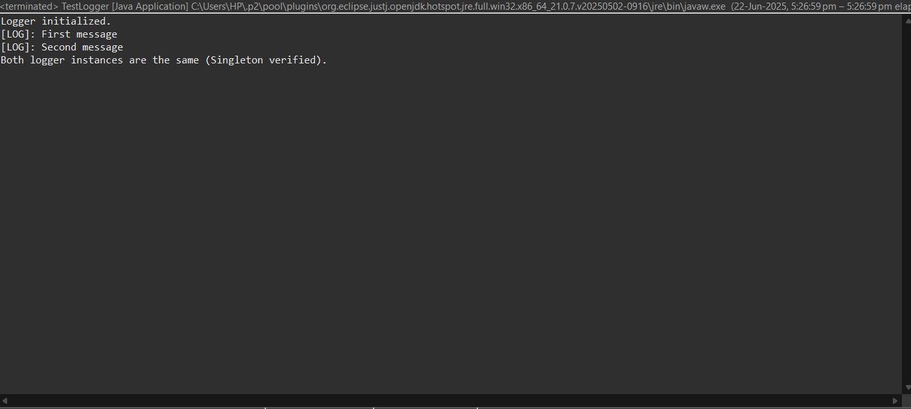}

**02 : Implementing the Factory Method Pattern**

* **PROJECT STRUCTURE**

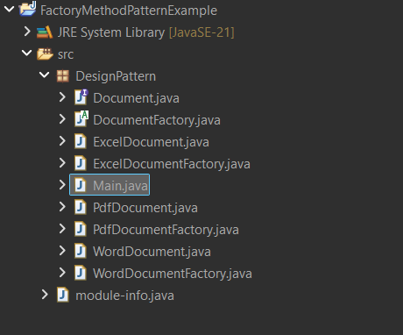

* **DOCUMENT CLASS**

public interface Document {

void open();

}

* **CONCRETE DOCUMENT CLASS**

// WordDocument.java

public class WordDocument implements Document {

@Override

public void open() {

System.out.println("Opening Word document...");

}

}

// PdfDocument.java

public class PdfDocument implements Document {

@Override

public void open() {

System.out.println("Opening PDF document...");

}

}

// ExcelDocument.java

public class ExcelDocument implements Document {

@Override

public void open() {

System.out.println("Opening Excel document...");

}

}

* **DOCUMENT FACTORY CLASS**

// DocumentFactory.java

public abstract class DocumentFactory {

public abstract Document createDocument();

}

* **CONCRETE FACTORIES**

// WordDocumentFactory.java

public class WordDocumentFactory extends DocumentFactory {

@Override

public Document createDocument() {

return new WordDocument();

}

}

// PdfDocumentFactory.java

public class PdfDocumentFactory extends DocumentFactory {

@Override

public Document createDocument() {

return new PdfDocument();

}

}

// ExcelDocumentFactory.java

public class ExcelDocumentFactory extends DocumentFactory {

@Override

public Document createDocument() {

return new ExcelDocument();

}

}

* **TESTING MAIN METHOD**

// Main.java

public class Main {

public static void main(String[] args) {

// Create Word Document

DocumentFactory wordFactory = new WordDocumentFactory();

Document wordDoc = wordFactory.createDocument();

wordDoc.open();

// Create PDF Document

DocumentFactory pdfFactory = new PdfDocumentFactory();

Document pdfDoc = pdfFactory.createDocument();

pdfDoc.open();

// Create Excel Document

DocumentFactory excelFactory = new ExcelDocumentFactory();

Document excelDoc = excelFactory.createDocument();

excelDoc.open();

}

}

* **OUTPUT**

