**01 : Setting up JUNIT**

**CODE :**

pom.xml –

<project xmlns="http://maven.apache.org/POM/4.0.0"

xmlns:xsi="http://www.w3.org/2001/XMLSchema-instance"

xsi:schemaLocation="http://maven.apache.org/POM/4.0.0

https://maven.apache.org/xsd/maven-4.0.0.xsd">

<modelVersion>4.0.0</modelVersion>

<groupId>com.example</groupId>

<artifactId>JUnitSetupExample</artifactId>

<version>0.0.1-SNAPSHOT</version>

<dependencies>

<dependency>

<groupId>junit</groupId>

<artifactId>junit</artifactId>

<version>4.13.2</version>

<scope>test</scope>

</dependency>

</dependencies>

</project>

Screenshot :

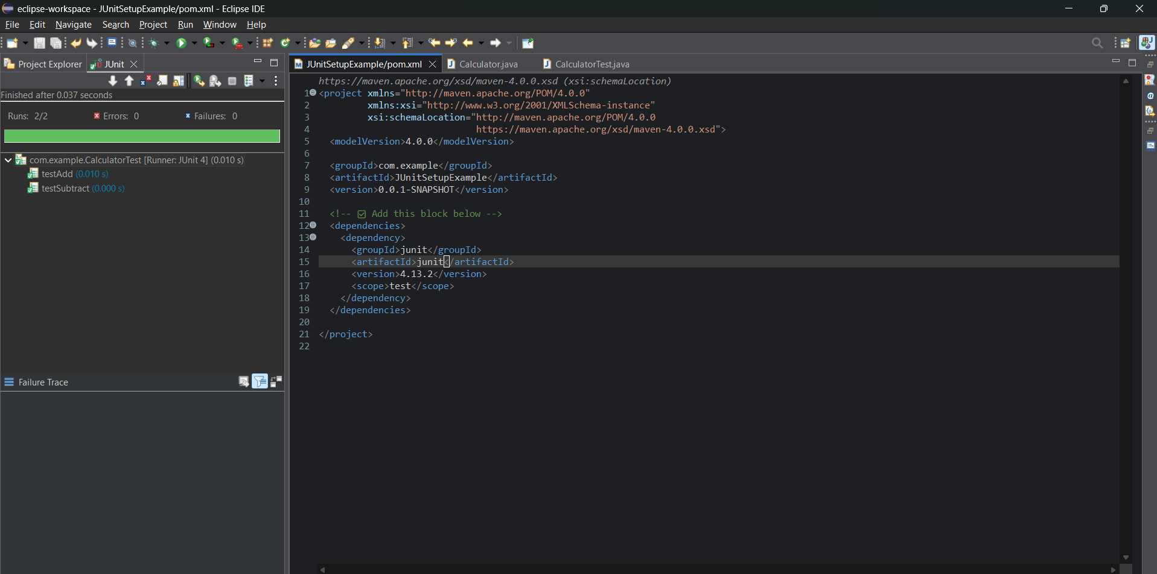

**CalculatorTest** -

package com.example;

import org.junit.Test;

import static org.junit.Assert.*;

public class CalculatorTest {

*@Test*

public void testAdd() {

Calculator calc = new Calculator();

int result = calc.add(2, 3);

*assertEquals*(5, result);

}

*@Test*

public void testSubtract() {

Calculator calc = new Calculator();

int result = calc.subtract(5, 2);

***assertEquals*(3, result);**

**}**

**}**

Screenshot :

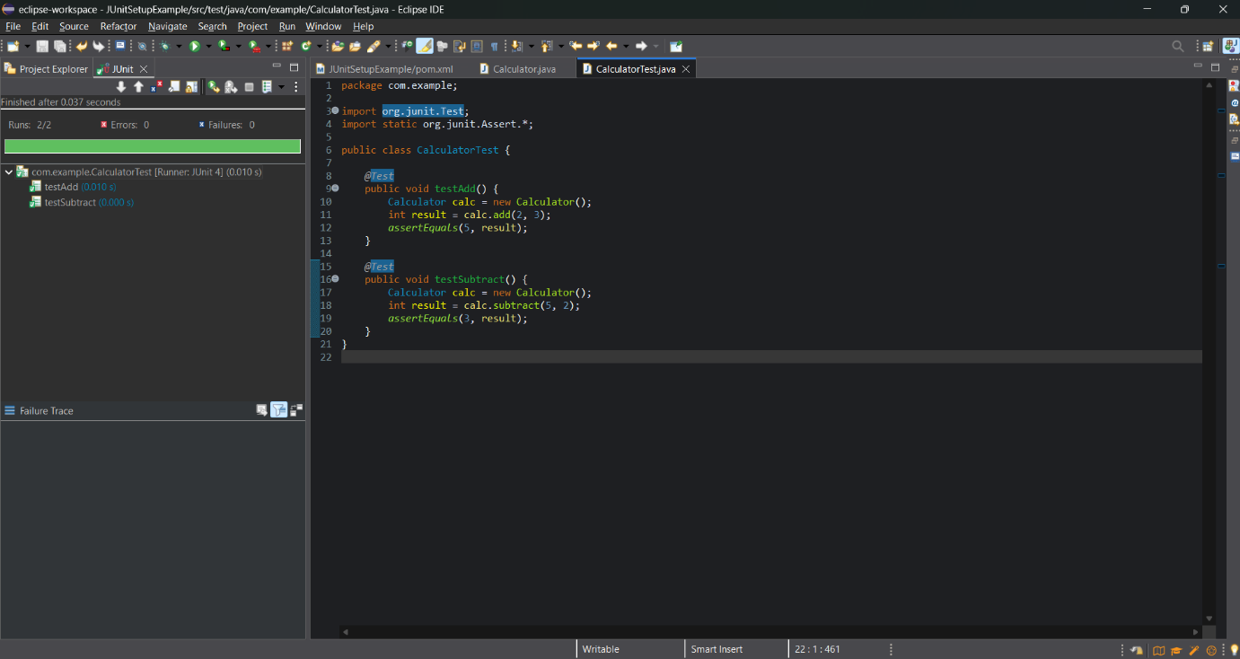

Calculator :

package com.example;

public class Calculator {

public int add(int a, int b) {

return a + b;

}

public int subtract(int a, int b) {

return a - b;

}

}

ScreenShot :

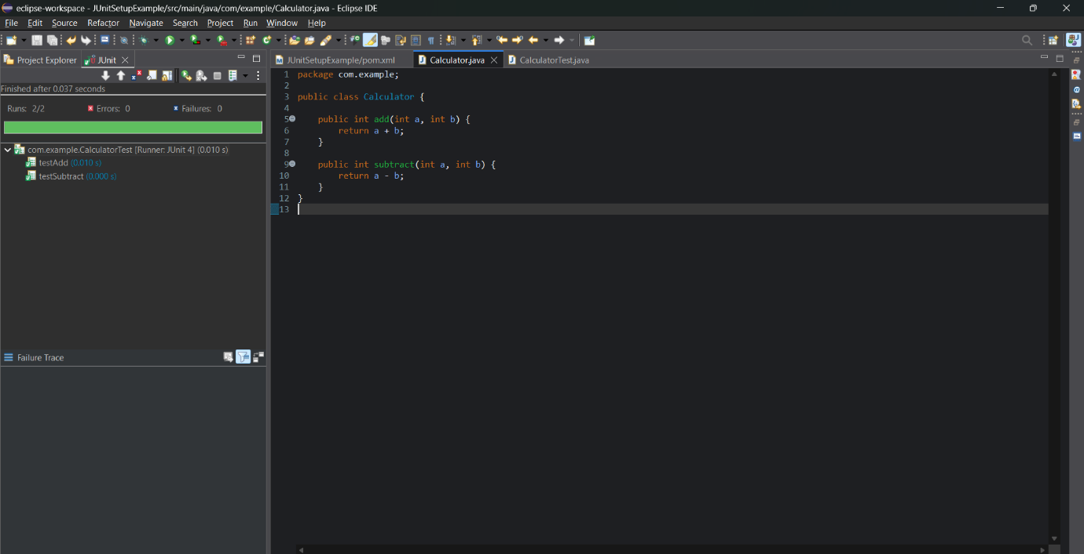

**02: Assertions in JUnit**

**CODE:**

**package com.example;**

**import org.junit.Test;**

**import static org.junit.Assert.*;**

**public class AssertionsTest {**

***@Test***

**public void testAssertions() {**

***assertEquals*(5, 2 + 3);**

***assertTrue*(5 > 3);**

***assertFalse*(5 < 3);**

***assertNull*(null);**

***assertNotNull*(new Object());**

**}**

**}**

SCREENSHOT:

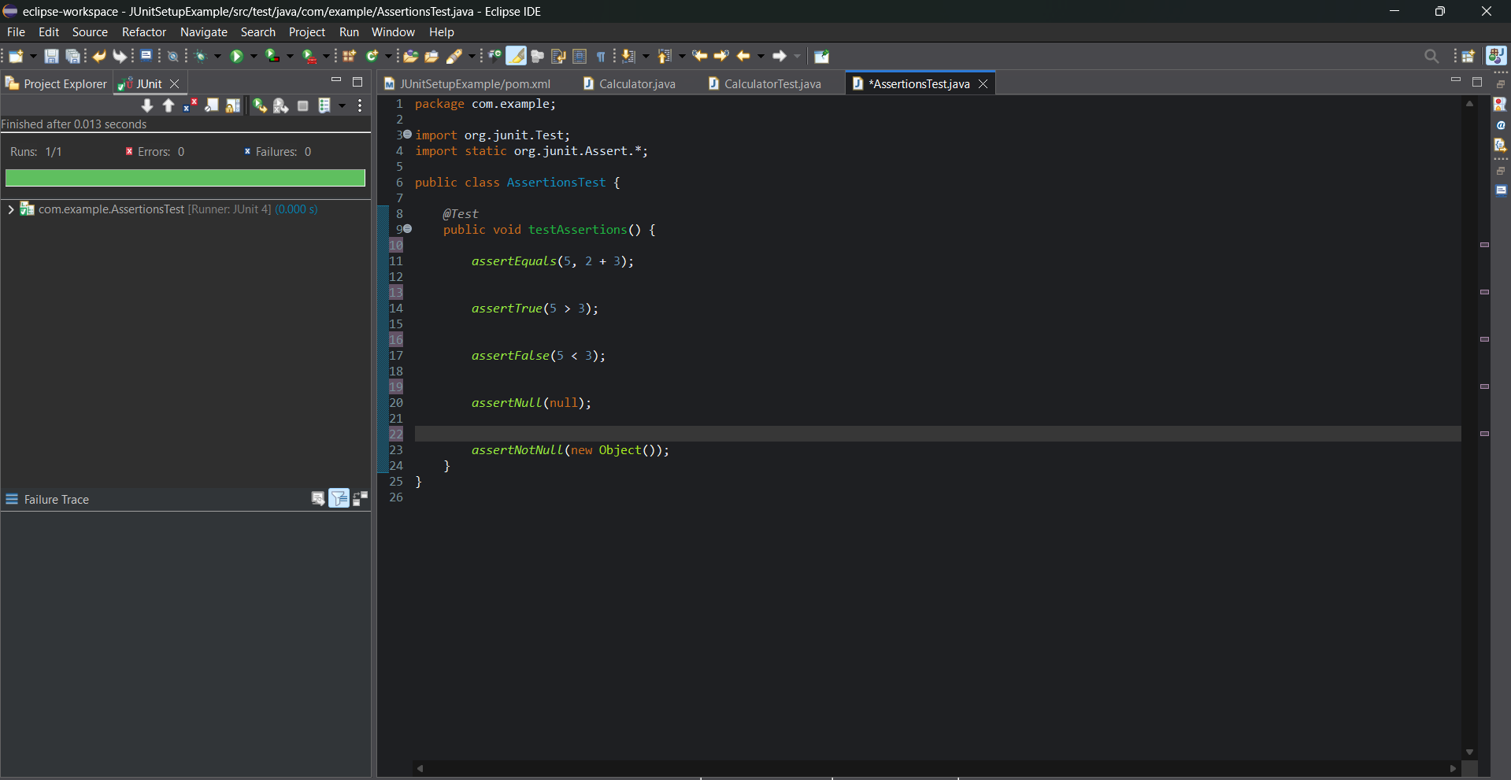

**03 : Arrange-Act-Assert (AAA) Pattern, Test Fixtures, Setup and Teardown Methods in Junit**

**CODE :**

**package com.example;**

**import org.junit.Before;**

**import org.junit.After;**

**import org.junit.Test;**

**import static org.junit.Assert.*;**

**public class CalculatorLifecycleTest {**

**private Calculator calculator;**

***@Before***

**public void setUp() {**

**System.*out*.println("Setting up calculator...");**

**calculator = new Calculator(); // Arrange**

**}**

***@After***

**public void tearDown() {**

**System.*out*.println("Cleaning up after test...");**

**calculator = null;**

**}**

***@Test***

**public void testAddition() {**

**int result = calculator.add(10, 5);**

***assertEquals*(15, result);**

**}**

***@Test***

**public void testSubtraction() {**

**int result = calculator.subtract(10, 5);**

***assertEquals*(5, result);**

**}**

**}**

**OUTPUT :**

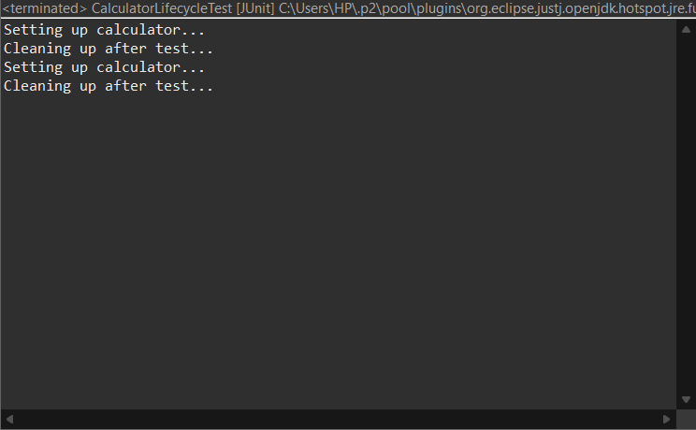

ScreenShot :

