**01 : Configuring a basic Spring Application**

* Project Structure

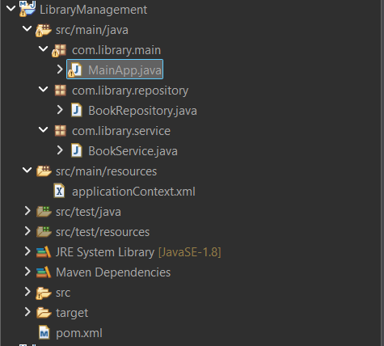

**CODE :**

* BookRepository

package com.library.repository;

public class BookRepository {

public void displayBooks() {

System.*out*.println("Books retrieved from BookRepository.");

}

}

* BookService

package com.library.service;

import com.library.repository.BookRepository;

public class BookService {

private BookRepository bookRepository;

public void setBookRepository(BookRepository bookRepository) {

this.bookRepository = bookRepository;

}

public void showBooks() {

System.***out***.println("Inside BookService:");

bookRepository.displayBooks();

}

}

* MainApp

package com.library.main;

import org.springframework.context.ApplicationContext;

import org.springframework.context.support.ClassPathXmlApplicationContext;

import com.library.service.BookService;

public class MainApp {

public static void main(String[] args) {

ApplicationContext context = new ClassPathXmlApplicationContext("applicationContext.xml");

BookService bookService = (BookService) context.getBean("bookService");

bookService.showBooks();

}

}

* Pom.xml

<project xmlns="http://maven.apache.org/POM/4.0.0" xmlns:xsi="http://www.w3.org/2001/XMLSchema-instance" xsi:schemaLocation="http://maven.apache.org/POM/4.0.0 https://maven.apache.org/xsd/maven-4.0.0.xsd">

<modelVersion>4.0.0</modelVersion>

<groupId>com.cognizant</groupId>

<artifactId>spring-ioc-demo_first</artifactId>

<version>0.0.1-SNAPSHOT</version>

<dependencies>

<dependency>

<groupId>org.springframework</groupId>

<artifactId>spring-context</artifactId>

<version>5.3.33</version>

</dependency>

</dependencies>

</project>

* applicationContext.xml

<?xml version="1.0" encoding="UTF-8"?>

<beans xmlns="http://www.springframework.org/schema/beans"

xmlns:xsi="http://www.w3.org/2001/XMLSchema-instance"

xsi:schemaLocation="

http://www.springframework.org/schema/beans

https://www.springframework.org/schema/beans/spring-beans.xsd">

<?xml version="1.0" encoding="UTF-8"?>

<beans xmlns="http://www.springframework.org/schema/beans"

xmlns:xsi="http://www.w3.org/2001/XMLSchema-instance"

xsi:schemaLocation="

http://www.springframework.org/schema/beans

https://www.springframework.org/schema/beans/spring-beans.xsd">

<bean id="bookRepository" class="com.library.repository.BookRepository" />

<bean id="bookService" class="com.library.service.BookService">

<property name="bookRepository" ref="bookRepository" />

</bean>

</beans>

OUTPUT :

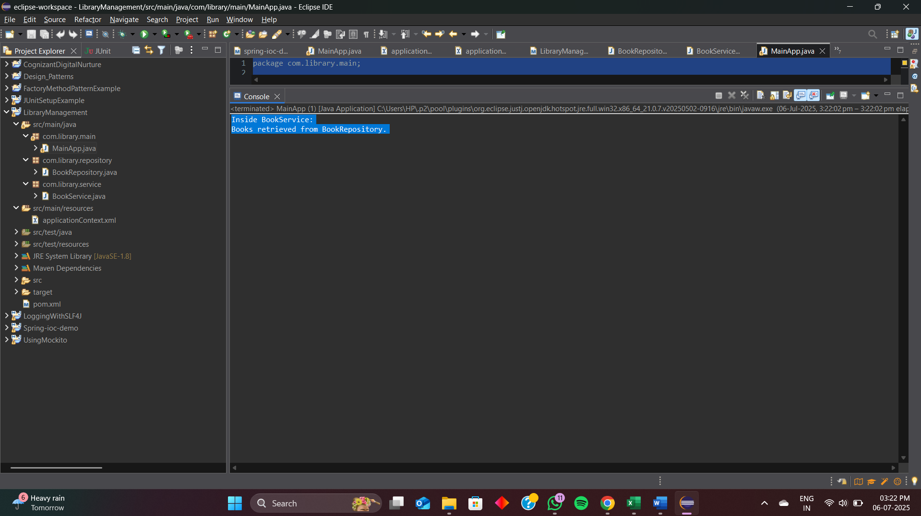

**02 : Implementing Dependency Injection**

* Project Structure



**CODE :**

* BookRepository

package com.library.repository;

public class BookRepository {

public void displayBooks() {

System.*out*.println("Books retrieved from BookRepository.");

}

}

* BookService

package com.library.service;

import com.library.repository.BookRepository;

public class BookService {

private BookRepository bookRepository;

public void setBookRepository(BookRepository bookRepository) {

this.bookRepository = bookRepository;

}

public void showBooks() {

System.***out***.println("Inside BookService:");

bookRepository.displayBooks();

}

}

* MainApp

package com.library.main;

import org.springframework.context.ApplicationContext;

import org.springframework.context.support.ClassPathXmlApplicationContext;

import com.library.service.BookService;

public class MainApp {

public static void main(String[] args) {

ApplicationContext context = new ClassPathXmlApplicationContext("applicationContext.xml");

BookService bookService = (BookService) context.getBean("bookService");

bookService.showBooks();

}

}

* Pom.xml

<project xmlns="http://maven.apache.org/POM/4.0.0" xmlns:xsi="http://www.w3.org/2001/XMLSchema-instance" xsi:schemaLocation="http://maven.apache.org/POM/4.0.0 https://maven.apache.org/xsd/maven-4.0.0.xsd">

<modelVersion>4.0.0</modelVersion>

<groupId>com.cognizant</groupId>

<artifactId>spring-ioc-demo_first</artifactId>

<version>0.0.1-SNAPSHOT</version>

<dependencies>

<dependency>

<groupId>org.springframework</groupId>

<artifactId>spring-context</artifactId>

<version>5.3.33</version>

</dependency>

</dependencies>

</project>

* applicationContext.xml

<?xml version="1.0" encoding="UTF-8"?>

<beans xmlns="http://www.springframework.org/schema/beans"

xmlns:xsi="http://www.w3.org/2001/XMLSchema-instance"

xsi:schemaLocation="

http://www.springframework.org/schema/beans

https://www.springframework.org/schema/beans/spring-beans.xsd">

<?xml version="1.0" encoding="UTF-8"?>

<beans xmlns="http://www.springframework.org/schema/beans"

xmlns:xsi="http://www.w3.org/2001/XMLSchema-instance"

xsi:schemaLocation="

http://www.springframework.org/schema/beans

https://www.springframework.org/schema/beans/spring-beans.xsd">

<bean id="bookRepository" class="com.library.repository.BookRepository" />

<bean id="bookService" class="com.library.service.BookService">

<property name="bookRepository" ref="bookRepository" />

</bean>

</beans>

OUTPUT :



04: Creating and Configuring a Maven Project

* CODE :

<project xmlns="http://maven.apache.org/POM/4.0.0"

xmlns:xsi="http://www.w3.org/2001/XMLSchema-instance"

xsi:schemaLocation="http://maven.apache.org/POM/4.0.0

https://maven.apache.org/xsd/maven-4.0.0.xsd">

<modelVersion>4.0.0</modelVersion>

<groupId>com.library</groupId>

<artifactId>LibraryManagement</artifactId>

<version>1.0-SNAPSHOT</version>

<properties>

<java.version>1.8</java.version>

</properties>

<dependencies>

<!-- Spring Context -->

<dependency>

<groupId>org.springframework</groupId>

<artifactId>spring-context</artifactId>

<version>5.3.32</version>

</dependency>

<!-- Spring AOP -->

<dependency>

<groupId>org.springframework</groupId>

<artifactId>spring-aop</artifactId>

<version>5.3.32</version>

</dependency>

<!-- Spring Web MVC -->

<dependency>

<groupId>org.springframework</groupId>

<artifactId>spring-webmvc</artifactId>

<version>5.3.32</version>

</dependency>

</dependencies>

<build>

<plugins>

<!-- Compiler Plugin -->

<plugin>

<groupId>org.apache.maven.plugins</groupId>

<artifactId>maven-compiler-plugin</artifactId>

<version>3.8.1</version>

<configuration>

<source>1.8</source>

<target>1.8</target>

</configuration>

</plugin>

</plugins>

</build>

</project>

**OVERVIEW -**

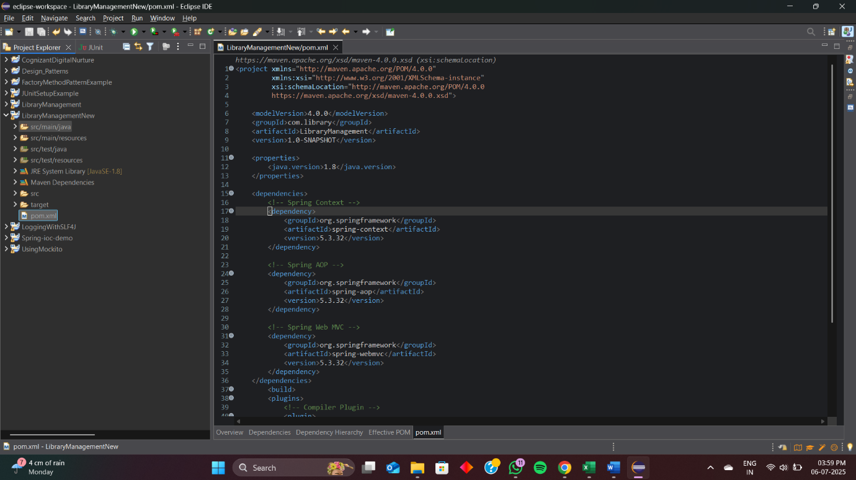

**05 : Configuring the Spring IoC Container**

* Project Structure

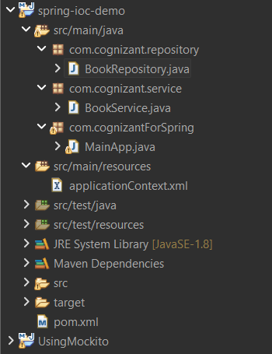

CODE :

* BookRepository

package com.cognizant.repository;

public class BookRepository {

public void displayBooks() {

System.***out***.println("Books from BookRepository");

}

}

* BookService

package com.cognizant.service;

import com.cognizant.repository.BookRepository;

public class BookService {

private BookRepository bookRepository;

public void setBookRepository(BookRepository bookRepository) {

this.bookRepository = bookRepository;

}

public void listBooks() {

System.***out***.println("Inside BookService");

bookRepository.displayBooks();

}

}

* MainApp

package com.cognizantForSpring;

import com.cognizant.service.BookService;

import org.springframework.context.ApplicationContext;

import org.springframework.context.support.ClassPathXmlApplicationContext;

public class MainApp {

public static void main(String[] args) {

ApplicationContext context = new ClassPathXmlApplicationContext("applicationContext.xml");

BookService service = context.getBean("bookService", BookService.class);

service.listBooks();

}

}

* ApplicationContext.xml

<?xml version="1.0" encoding="UTF-8"?>

<beans xmlns="http://www.springframework.org/schema/beans"

xmlns:xsi="http://www.w3.org/2001/XMLSchema-instance"

xsi:schemaLocation="

http://www.springframework.org/schema/beans

https://www.springframework.org/schema/beans/spring-beans.xsd">

<bean id="bookRepository" class="com.cognizant.repository.BookRepository" />

<bean id="bookService" class="com.cognizant.service.BookService">

<property name="bookRepository" ref="bookRepository" />

</bean>

</beans>

* Pom.xml

<project xmlns="http://maven.apache.org/POM/4.0.0"

xmlns:xsi="http://www.w3.org/2001/XMLSchema-instance"

xsi:schemaLocation="http://maven.apache.org/POM/4.0.0

http://maven.apache.org/xsd/maven-4.0.0.xsd">

<modelVersion>4.0.0</modelVersion>

<groupId>com.example</groupId>

<artifactId>spring-ioc-demo</artifactId>

<version>1.0-SNAPSHOT</version>

<dependencies>

<!-- Spring Core -->

<dependency>

<groupId>org.springframework</groupId>

<artifactId>spring-context</artifactId>

<version>5.3.33</version>

</dependency>

</dependencies>

</project>

OUTPUT :

