**01:Creating Microservices for account and loan**

1. Account Microservice

* **Code:**
* Pom.xml

<?xml version="1.0" encoding="UTF-8"?>

<project xmlns="http://maven.apache.org/POM/4.0.0" xmlns:xsi="http://www.w3.org/2001/XMLSchema-instance"

xsi:schemaLocation="http://maven.apache.org/POM/4.0.0 https://maven.apache.org/xsd/maven-4.0.0.xsd">

<modelVersion>4.0.0</modelVersion>

<parent>

<groupId>org.springframework.boot</groupId>

<artifactId>spring-boot-starter-parent</artifactId>

<version>3.5.3</version>

<relativePath/> <!-- lookup parent from repository -->

</parent>

<groupId>com.cognizant</groupId>

<artifactId>account</artifactId>

<version>0.0.1-SNAPSHOT</version>

<name>account</name>

<description>Account Microservice</description>

<url/>

<licenses>

<license/>

</licenses>

<developers>

<developer/>

</developers>

<scm>

<connection/>

<developerConnection/>

<tag/>

<url/>

</scm>

<properties>

<java.version>21</java.version>

</properties>

<dependencies>

<dependency>

<groupId>org.springframework.boot</groupId>

<artifactId>spring-boot-starter-web</artifactId>

</dependency>

<dependency>

<groupId>org.springframework.boot</groupId>

<artifactId>spring-boot-devtools</artifactId>

<scope>runtime</scope>

<optional>true</optional>

</dependency>

<dependency>

<groupId>org.springframework.boot</groupId>

<artifactId>spring-boot-starter-test</artifactId>

<scope>test</scope>

</dependency>

</dependencies>

<build>

<plugins>

<plugin>

<groupId>org.springframework.boot</groupId>

<artifactId>spring-boot-maven-plugin</artifactId>

</plugin>

</plugins>

</build>

</project>

* AccountController.java

package com.cognizant.account.controller;

import org.slf4j.Logger;

import org.slf4j.LoggerFactory;

import org.springframework.web.bind.annotation.GetMapping;

import org.springframework.web.bind.annotation.PathVariable;

import org.springframework.web.bind.annotation.RestController;

import java.util.HashMap;

import java.util.Map;

@RestController

public class AccountController {

private static final Logger LOGGER = LoggerFactory.getLogger(AccountController.class);

@GetMapping("/accounts/{number}")

public Map<String, Object> getAccountDetails(@PathVariable String number) {

LOGGER.info("START - getAccountDetails() for account number: {}", number);

Map<String, Object> accountDetails = new HashMap<>();

accountDetails.put("number", number);

accountDetails.put("type", "savings");

accountDetails.put("balance", 234343);

LOGGER.info("END - getAccountDetails(), returning: {}", accountDetails);

return accountDetails;

}

}

* AccountApplication.java

package com.cognizant.account;

import org.springframework.boot.SpringApplication;

import org.springframework.boot.autoconfigure.SpringBootApplication;

@SpringBootApplication

public class AccountApplication {

public static void main(String[] args) {

SpringApplication.run(AccountApplication.class, args);

}

}

* **application.properties**

spring.application.name=loan

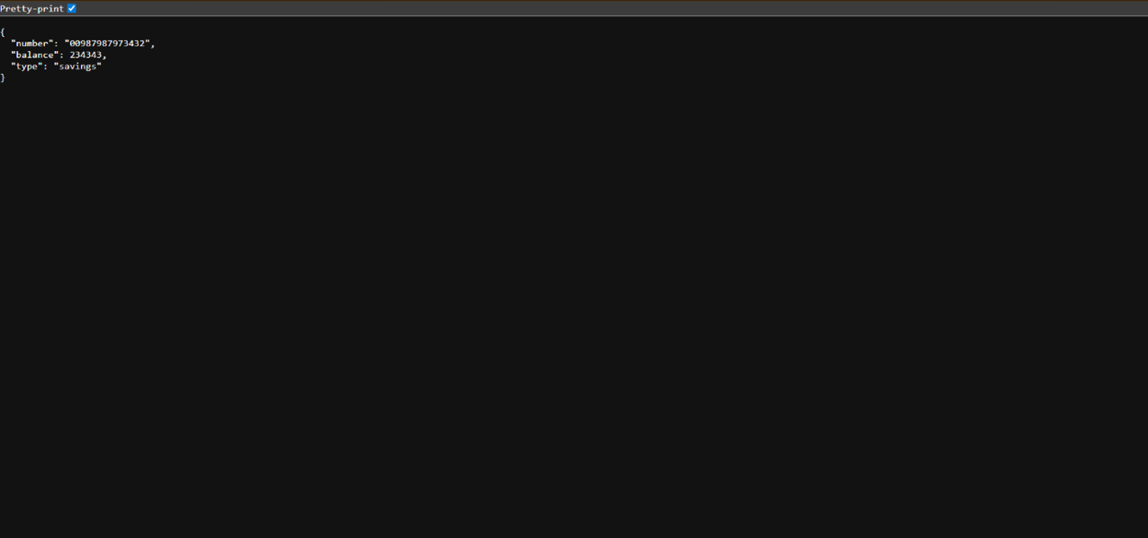

2. Loan Microservice

* **Code:**
* **pom.xml**

<?xml version="1.0" encoding="UTF-8"?>

<project xmlns="http://maven.apache.org/POM/4.0.0" xmlns:xsi="http://www.w3.org/2001/XMLSchema-instance"

xsi:schemaLocation="http://maven.apache.org/POM/4.0.0 https://maven.apache.org/xsd/maven-4.0.0.xsd">

<modelVersion>4.0.0</modelVersion>

<parent>

<groupId>org.springframework.boot</groupId>

<artifactId>spring-boot-starter-parent</artifactId>

<version>3.5.3</version>

<relativePath/> <!-- lookup parent from repository -->

</parent>

<groupId>com.cognizant</groupId>

<artifactId>loan</artifactId>

<version>0.0.1-SNAPSHOT</version>

<name>loan</name>

<description>Loan Microservice</description>

<url/>

<licenses>

<license/>

</licenses>

<developers>

<developer/>

</developers>

<scm>

<connection/>

<developerConnection/>

<tag/>

<url/>

</scm>

<properties>

<java.version>21</java.version>

</properties>

<dependencies>

<dependency>

<groupId>org.springframework.boot</groupId>

<artifactId>spring-boot-starter-web</artifactId>

</dependency>

<dependency>

<groupId>org.springframework.boot</groupId>

<artifactId>spring-boot-devtools</artifactId>

<scope>runtime</scope>

<optional>true</optional>

</dependency>

<dependency>

<groupId>org.springframework.boot</groupId>

<artifactId>spring-boot-starter-test</artifactId>

<scope>test</scope>

</dependency>

</dependencies>

<build>

<plugins>

<plugin>

<groupId>org.springframework.boot</groupId>

<artifactId>spring-boot-maven-plugin</artifactId>

</plugin>

</plugins>

</build>

</project>

* **LoanController.java**

package com.cognizant.loan.controller;

import org.slf4j.Logger;

import org.slf4j.LoggerFactory;

import org.springframework.web.bind.annotation.GetMapping;

import org.springframework.web.bind.annotation.PathVariable;

import org.springframework.web.bind.annotation.RestController;

import java.util.HashMap;

import java.util.Map;

@RestController

public class LoanController {

private static final Logger LOGGER = LoggerFactory.getLogger(LoanController.class);

@GetMapping("/loans/{number}")

public Map<String, Object> getLoanDetails(@PathVariable String number) {

LOGGER.info("START - getLoanDetails() for loan number: {}", number);

Map<String, Object> loanDetails = new HashMap<>();

loanDetails.put("number", number);

loanDetails.put("type", "car");

loanDetails.put("loan", 400000);

loanDetails.put("emi", 3258);

loanDetails.put("tenure", 18);

LOGGER.info("END - getLoanDetails(), returning: {}", loanDetails);

return loanDetails;

}

}

* **LoanApplication.java**

package com.cognizant.loan;

import org.springframework.boot.SpringApplication;

import org.springframework.boot.autoconfigure.SpringBootApplication;

@SpringBootApplication

public class LoanApplication {

public static void main(String[] args) {

SpringApplication.run(LoanApplication.class, args);

}

}

* **application.properties**

spring.application.name=loan

server.port=8081

* **Output:**

