**01:Create a React Application named “cricketapp”.**

* **CODE:**
* App.js

import React from 'react';

import { ListofPlayers } from './components/ListofPlayers';

import { Scorebelow70 } from './components/Scorebelow70';

import { players } from './playersData';

import { OddPlayers } from './components/OddPlayers';

import { EvenPlayers } from './components/EvenPlayers';

import { ListofIndianPlayers, IndianPlayers } from './components/ListofIndianPlayers';

function App() {

const flag = false;

const IndianTeamNames = [

"Sachin1", "Dhoni2", "Virat3", "Rohit4", "Yuvraj5", "Raina6"

];

if (flag === true) {

return (

<div>

<h1>List of Players</h1>

<ListofPlayers players={players} />

<hr />

<h1>List of Players having Scores Less than 70</h1>

<Scorebelow70 players={players} />

</div>

);

} else {

return (

<div>

<h1>Indian Team</h1>

<h2>Odd Players</h2>

<OddPlayers players={IndianTeamNames} />

<hr />

<h2>Even Players</h2>

<EvenPlayers players={IndianTeamNames} />

<hr />

<h1>List of Indian Players Merged:</h1>

<ListofIndianPlayers IndianPlayers={IndianPlayers} />

</div>

);

}

}

export default App;

* playersData.js

export const players = [

{ id: 1, name: "Jack", score: 50 },

{ id: 2, name: "Michael", score: 70 },

{ id: 3, name: "John", score: 40 },

{ id: 4, name: "Ann", score: 61 },

{ id: 5, name: "Elisabeth", score: 61 },

{ id: 6, name: "Sachin", score: 95 },

{ id: 7, name: "Dhoni", score: 100 },

{ id: 8, name: "Virat", score: 84 },

{ id: 9, name: "Jadeja", score: 64 },

{ id: 10, name: "Raina", score: 75 },

{ id: 11, name: "Rohit", score: 80 }

];

* ListofPlayers.jsx

import React from 'react';

export const ListofPlayers = ({ players }) => {

return (

<div>

<ul>

{players.map(item => (

<li key={item.id}>

Mr. {item.name} <span>{item.score}</span>

</li>

))}

</ul>

</div>

);

};

* ListofIndianPlayers.jsx

import React from 'react';

const T20Players = ['First Player', 'Second Player', 'Third Player'];

const RanjiTrophyPlayers = ['Fourth Player', 'Fifth Player', 'Sixth Player'];

export const IndianPlayers = [...T20Players, ...RanjiTrophyPlayers];

export const ListofIndianPlayers = ({ IndianPlayers }) => {

return (

<div>

<ul>

{IndianPlayers.map((player, index) => (

<li key={index}>Mr. {player}</li>

))}

</ul>

</div>

);

};

* Scorebelow70.jsx

import React from 'react';

export const Scorebelow70 = ({ players }) => {

const playersBelow70 = players.filter(item => item.score <= 70);

return (

<div>

<ul>

{playersBelow70.map(item => (

<li key={item.id}>

Mr. {item.name} <span>{item.score}</span>

</li>

))}

</ul>

</div>

);

};

* EvenPlayers.jsx

import React from 'react';

export function EvenPlayers({ players }) {

const [, second, , fourth, , sixth] = players;

return (

<div>

<ul>

<li>Second : {second}</li>

<li>Fourth : {fourth}</li>

<li>Sixth : {sixth}</li>

</ul>

</div>

);

}

OddPlayers.jsx

import React from 'react';

export function OddPlayers({ players }) {

const [first, , third, , fifth] = players;

return (

<div>

<ul>

<li>First : {first}</li>

<li>Third : {third}</li>

<li>Fifth : {fifth}</li>

</ul>

</div>

);

}

* **OUTPUT:**

When flag = true

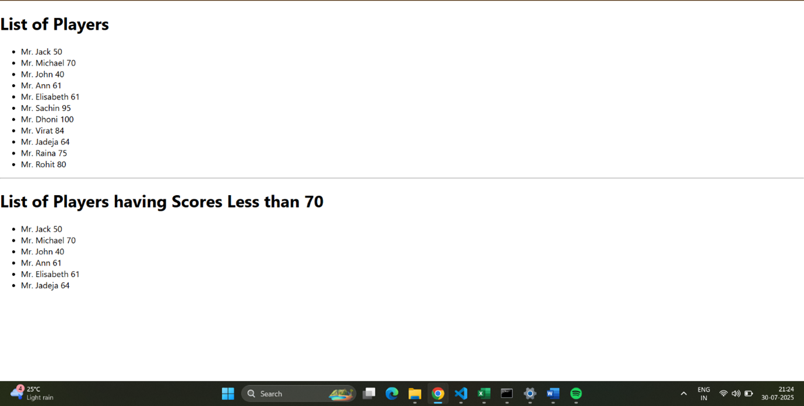

When flag = false

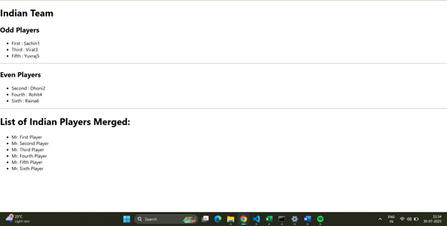

**02**:Create a React Application named “officespacerentalapp” which uses React JSX to create elements, attributes and renders DOM to display the page.

* **CODE:**
* App.js

import React from 'react';

import './App.css';

const OFFICE_IMAGE_URL = 'https://officebanao.com/wp-content/uploads/2024/06/office-with-lot-desks-computers.jpg';

const pageHeading = "Office Space";

const jsxatt = <img src={OFFICE_IMAGE_URL} width="25%" height="25%" alt="Office Space" />;

const ItemName = {

Name: "DBS",

Rent: 50000,

Address: "Chennai"

};

const officeItems = [

{ id: 1, name: "Tech Hub Co.", rent: 75000, address: "Bangalore" },

{ id: 2, name: "Innovate Space", rent: 45000, address: "Hyderabad" },

{ id: 3, name: "City Towers", rent: 60000, address: "Mumbai" },

{ id: 4, name: "Green Offices", rent: 59999, address: "Delhi" },

{ id: 5, name: "Skyline Suite", rent: 82000, address: "Pune" }

];

function App() {

const getRentStyle = (rent) => {

return {

color: rent <= 60000 ? 'red' : 'green',

fontWeight: 'bold'

};

};

return (

<div className="App">

<h1>{pageHeading}, at Affordable Range</h1>

{jsxatt}

<h1>Name: {ItemName.Name}</h1>

<h3 style={getRentStyle(ItemName.Rent)}>

Rent: Rs. {ItemName.Rent}

</h3>

<h3>Address: {ItemName.Address}</h3>

<hr style={{ margin: '30px 0' }} />

<h2>More Office Spaces:</h2>

{officeItems.map(office => (

<div key={office.id} style={{ marginBottom: '20px', border: '1px solid #ccc', padding: '15px', borderRadius: '8px' }}>

<h3>Name: {office.name}</h3>

<h3 style={getRentStyle(office.rent)}>

Rent: Rs. {office.rent}

</h3>

<h3>Address: {office.address}</h3>

</div>

))}

</div>

);

}

export default App;

**OUTPUT:**

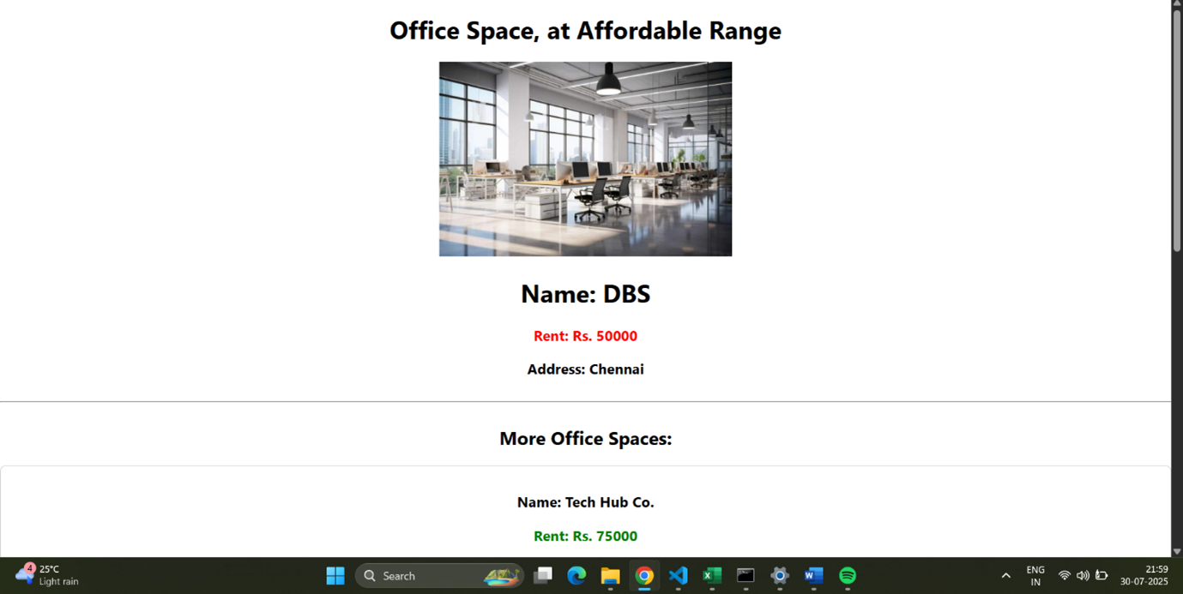

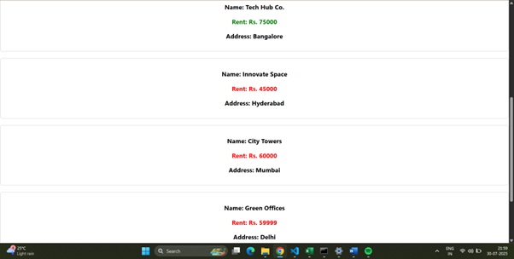

**03**:Create a React Application “eventexamplesapp” to handle various events of the form elements in HTML.

Create a “CurrencyConvertor” component which will convert the Indian Rupees to Euro when the Convert button is clicked.

* **CODE:**
* App.js

import React, { useState } from 'react';

import './App.css';

function App() {

const [count, setCount] = useState(0);

const [amount, setAmount] = useState('');

const [currency, setCurrency] = useState('');

const incrementCounter = () => {

setCount(prevCount => prevCount + 1);

};

const sayHello = () => {

alert("Hello! Member1");

};

const handleIncrementClick = () => {

incrementCounter();

sayHello();

};

const decrementCounter = () => {

setCount(prevCount => prevCount - 1);

};

const sayWelcome = (message) => {

alert(message);

};

const handleClickMe = (event) => {

console.log("Synthetic Event:", event);

console.log("Event type:", event.type);

alert("I was clicked");

};

const handleAmountChange = (e) => {

setAmount(e.target.value);

};

const handleCurrencyChange = (e) => {

setCurrency(e.target.value);

};

const handleSubmit = (e) => {

e.preventDefault();

const euroRate = 0.0099;

const convertedAmount = parseFloat(amount) * euroRate;

if (!isNaN(convertedAmount)) {

alert(`Converting to Euro Amount is ${convertedAmount.toFixed(2)}`);

} else {

alert("Please enter a valid amount.");

}

};

return (

<div className="App">

<h1>Counter: {count}</h1>

<div className="button-group">

<button onClick={handleIncrementClick}>Increment</button>

<button onClick={decrementCounter}>Decrement</button>

<button onClick={() => sayWelcome("Welcome")}>Say Welcome</button>

<button onClick={handleClickMe}>Click on me</button>

</div>

<h1 style={{ color: 'green', marginTop: '40px' }}>Currency Convertor!!!</h1>

<form onSubmit={handleSubmit} className="currency-form">

<div className="form-group">

<label htmlFor="amount">Amount:</label>

<input

type="number"

id="amount"

value={amount}

onChange={handleAmountChange}

placeholder="Enter amount in INR"

/>

</div>

<div className="form-group">

<label htmlFor="currency">Currency:</label>

<input

type="text"

id="currency"

value={currency}

onChange={handleCurrencyChange}

placeholder="e.g., Euro"

/>

</div>

<button type="submit">Submit</button>

</form>

</div>

);

}

export default App;

* App.css

.App {

font-family: Arial, sans-serif;

padding: 20px;

}

.button-group button {

margin: 5px;

padding: 10px 15px;

font-size: 16px;

cursor: pointer;

border: 1px solid #ccc;

border-radius: 5px;

background-color: #f0f0f0;

}

.button-group button:hover {

background-color: #e0e0e0;

}

.currency-form {

display: flex;

flex-direction: column;

align-items: center;

gap: 15px;

margin-top: 20px;

padding: 20px;

border: 1px solid #eee;

border-radius: 8px;

max-width: 400px;

box-shadow: 0 2px 5px rgba(0,0,0,0.1);

}

.currency-form .form-group {

display: flex;

flex-direction: column;

align-items: flex-start;

width: 100%;

}

.currency-form label {

margin-bottom: 5px;

font-weight: bold;

}

.currency-form input {

width: 100%;

padding: 8px;

border: 1px solid #ccc;

border-radius: 4px;

font-size: 16px;

}

.currency-form button[type="submit"] {

padding: 10px 20px;

font-size: 18px;

background-color: #007bff;

color: white;

border: none;

border-radius: 5px;

cursor: pointer;

}

.currency-form button[type="submit"]:hover {

background-color: #0056b3;}

**OUTPUT:**

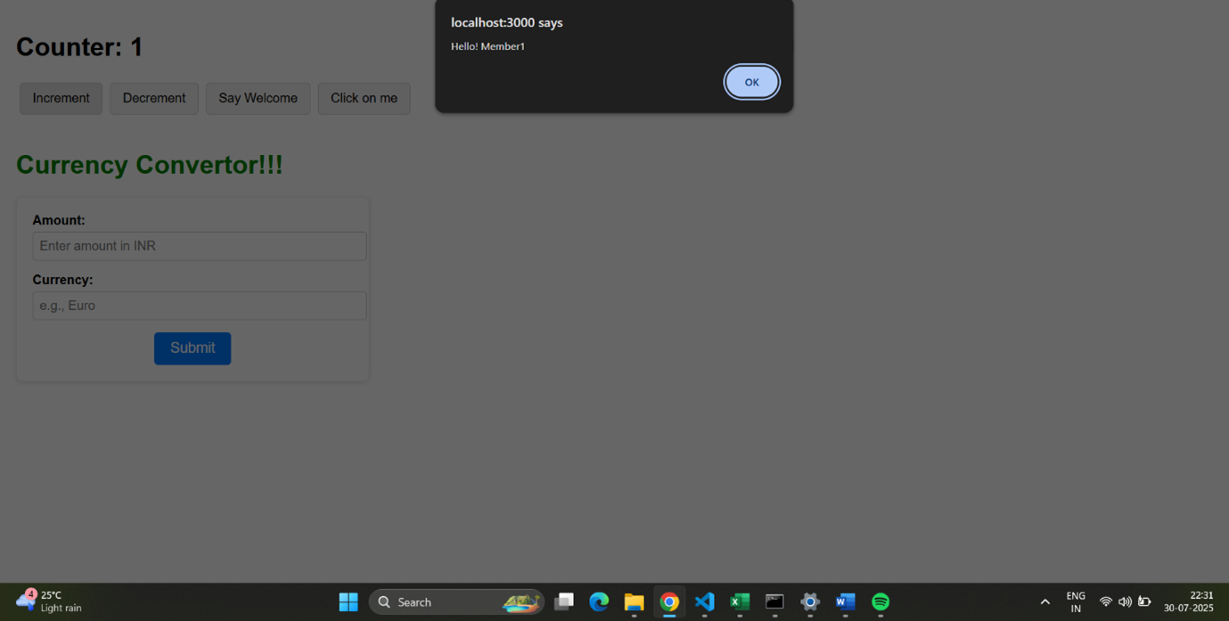

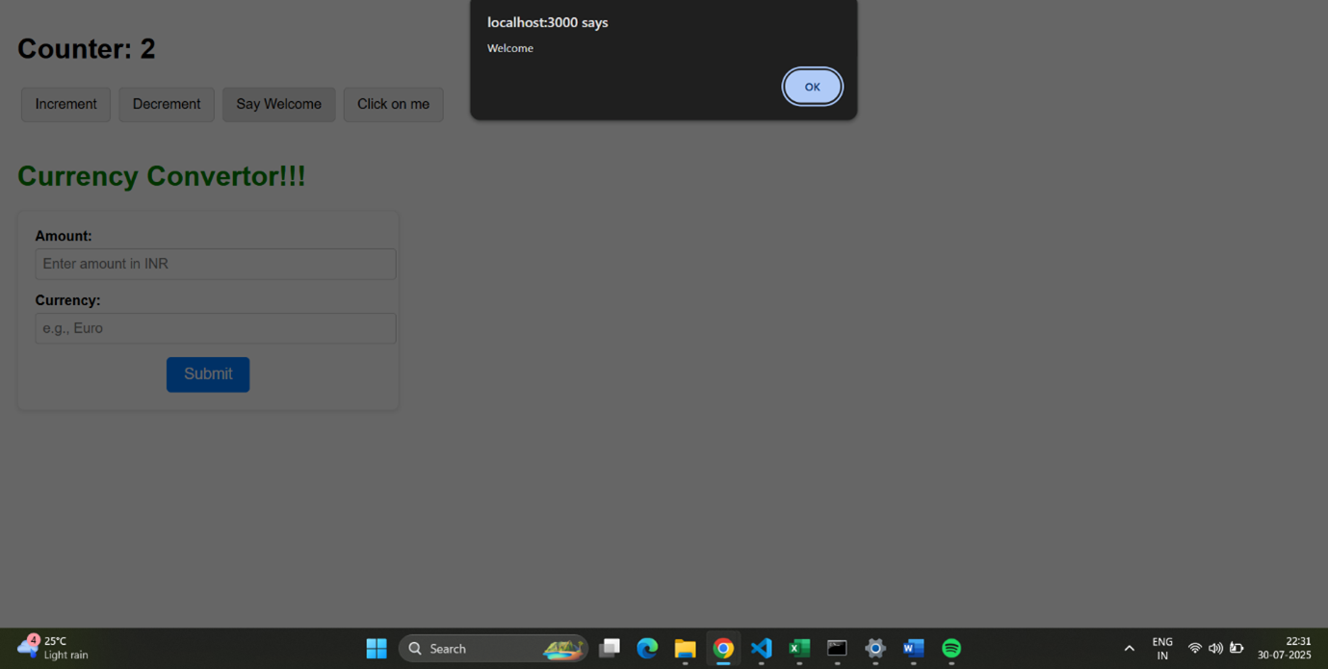

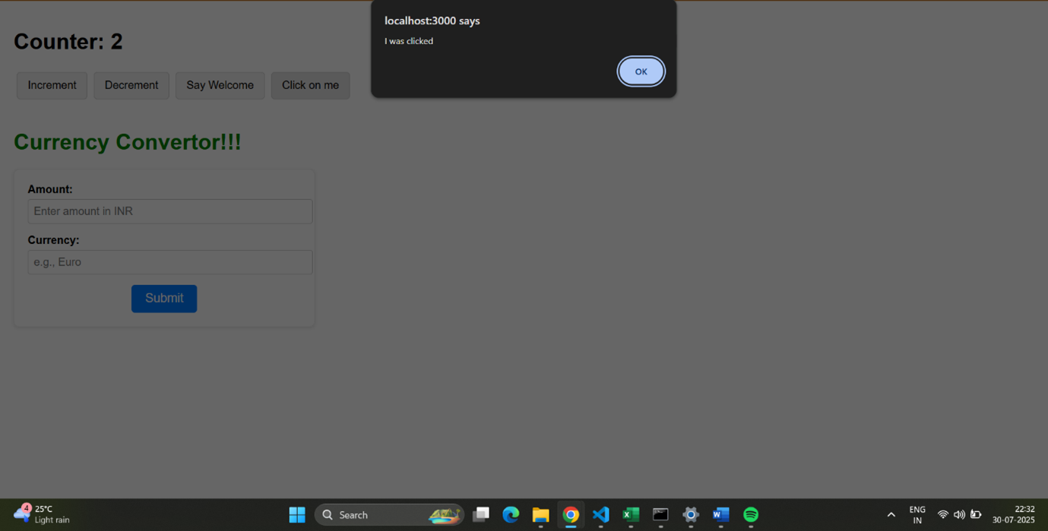

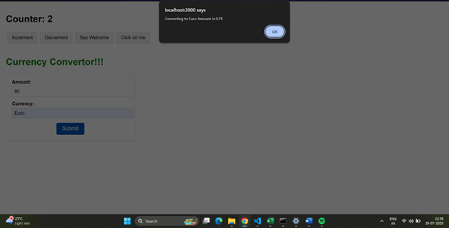

**04:**Create a React Application named “ticketbookingapp” where the guest user can browse the page where the flight details are displayed whereas the logged in user only can book tickets.

* **CODE:**
* LoginButton.jsx

import React from 'react';

function LoginButton(props) {

return (

<button onClick={props.onClick}>

Login

</button>

);

}

export default LoginButton;

* LogoutButton.jsx

import React from 'react';

function LogoutButton(props) {

return (

<button onClick={props.onClick}>

Logout

</button>

);

}

export default LogoutButton;

* UserGreeting.jsx

import React from 'react';

function UserGreeting() {

return <h1>Welcome back</h1>;

}

export default UserGreeting;

* GuestGreeting.jsx

import React from 'react';

function GuestGreeting() {

return <h1>Please sign up.</h1>;

}

export default GuestGreeting;

* Greeting.jsx

import React from 'react';

import UserGreeting from './UserGreeting';

import GuestGreeting from './GuestGreeting';

function Greeting(props) {

const isLoggedIn = props.isLoggedIn;

if (isLoggedIn) {

return <UserGreeting />;

}

return <GuestGreeting />;

}

export default Greeting;

* App.js

import React, { useState } from 'react';

import Greeting from './components/Greeting';

import LoginButton from './components/LoginButton';

import LogoutButton from './components/LogoutButton';

import './App.css';

function App() {

const [isLoggedIn, setIsLoggedIn] = useState(false);

const handleLoginClick = () => {

setIsLoggedIn(true);

};

const handleLogoutClick = () => {

setIsLoggedIn(false);

};

let button;

if (isLoggedIn) {

button = <LogoutButton onClick={handleLogoutClick} />;

} else {

button = <LoginButton onClick={handleLoginClick} />;

}

return (

<div className="App">

<Greeting isLoggedIn={isLoggedIn} />

{button}

</div>

);

}

export default App;

* App.css

.App {

font-family: Arial, sans-serif;

text-align: center;

padding: 50px;

display: flex;

flex-direction: column;

justify-content: center;

align-items: center;

}

h1 {

margin-bottom: 20px;

}

button {

padding: 10px 20px;

font-size: 16px;

margin-top: 20px;

cursor: pointer;

border: 1px solid #ccc;

border-radius: 5px;

background-color: #f0f0f0;

}

button:hover {

background-color: #e0e0e0;

}

**OUTPUT:**

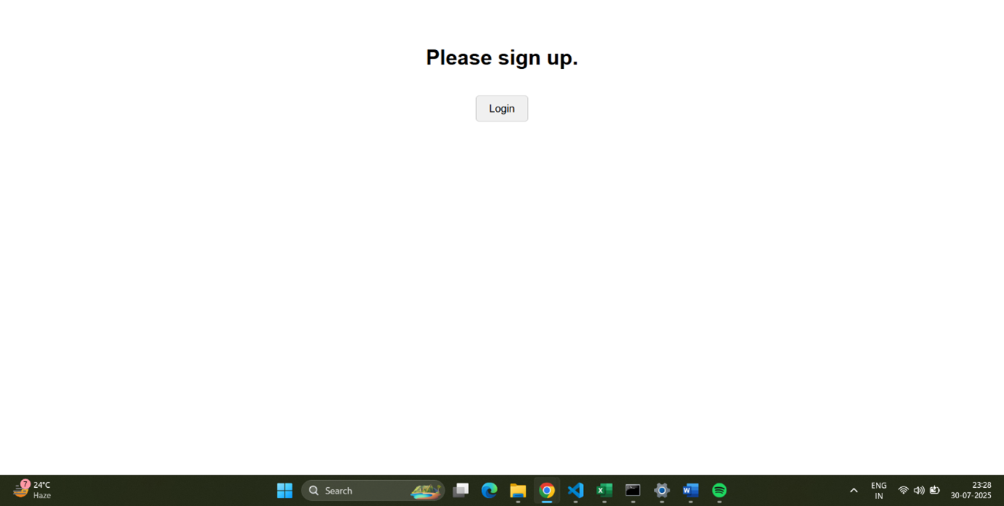

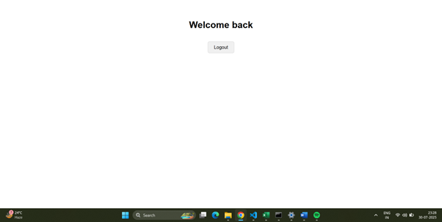

**05**:Create a React App named “bloggerapp” in with 3 components.

1. Book Details

2. Blog Details

3. Course Details

* **CODE:**
* booksData.js

export const books = [

{ id: 101, bname: 'Master React', price: 670 },

{ id: 102, bname: 'Deep Dive into Angular 11', price: 800 },

{ id: 103, bname: 'Mongo Essentials', price: 450 },

];

* blogsData.js

export const blogs = [

{ id: 201, title: 'React Learning', author: 'Stephen Biz', content: 'Welcome to learning React!' },

{ id: 202, title: 'Installation', author: 'Schewzdenier', content: 'You can install React from npm.' },

{ id: 203, title: 'Component Life Cycle', author: 'Jane Doe', content: 'Understanding component lifecycle methods.' },

];

* coursesData.jsx

export const courses = [

{ id: 301, name: 'Angular', date: '4/5/2021' },

{ id: 302, name: 'React', date: '6/3/2020' },

{ id: 303, name: 'Vue.js', date: '1/15/2022' },

];

* BookDetails.jsx

import React from 'react';

const BookItem = ({ book }) => (

<div>

<h3>{book.bname}</h3>

<h4>{book.price}</h4>

</div>

);

const BookDetails = ({ books }) => {

const bookdet = (

<ul>

{books.map(book => (

<li key={book.id}>

<BookItem book={book} />

</li>

))}

</ul>

);

return (

<div className="book-details">

<h1>Book Details</h1>

{bookdet}

</div>

);

};

export default BookDetails;

* BlogDetails.jsx

import React from 'react';

const BlogItem = ({ blog }) => (

<div>

<h3>{blog.title}</h3>

<h4>{blog.author}</h4>

<p>{blog.content}</p>

</div>

);

const BlogDetails = ({ blogs }) => {

const content = (

<ul>

{blogs.map(blog => (

<li key={blog.id}>

<BlogItem blog={blog} />

</li>

))}

</ul>

);

return (

<div className="blog-details">

<h1>Blog Details</h1>

{content}

</div>

);

};

export default BlogDetails;

* CourseDetails.jsx

import React from 'react';

const CourseItem = ({ course }) => (

<div>

<h3>{course.name}</h3>

<h4>{course.date}</h4>

</div>

);

const CourseDetails = ({ courses }) => {

const coursedet = (

<ul>

{courses.map(course => (

<li key={course.id}>

<CourseItem course={course} />

</li>

))}

</ul>

);

return (

<div className="course-details">

<h1>Course Details</h1>

{coursedet}

</div>

);

};

export default CourseDetails;

* ConditionalRenderer.jsx

import React from 'react';

const ConditionalRenderer = ({ showType }) => {

let renderedContent;

if (showType === 'books') {

renderedContent = <p>Showing Books via if/else</p>;

} else if (showType === 'blogs') {

renderedContent = <p>Showing Blogs via if/else</p>;

} else if (showType === 'courses') {

renderedContent = <p>Showing Courses via if/else</p>;

} else {

renderedContent = <p>No specific type selected (if/else)</p>;

}

const showMessage = showType === 'all';

const isSpecialCase = showType === 'special';

return (

<div style={{ border: '1px dashed #666', padding: '15px', margin: '20px 0' }}>

<h2>Conditional Rendering Examples</h2>

<h3>1. If/Else (Element Variable)</h3>

{renderedContent}

<h3>2. Logical && Operator</h3>

{showMessage && <p>This message appears when 'all' is selected (Logical &&)</p>}

<h3>3. Ternary Operator</h3>

{isSpecialCase ? (

<p>This is a special case (Ternary True)</p>

) : (

<p>This is a normal case (Ternary False)</p>

)}

<h3>4. Preventing Component Rendering (returning null)</h3>

{showType === 'none' ? null : <p>This component renders unless 'none' is selected</p>}

</div>

);

};

export default ConditionalRenderer;

* App.js

import React, { useState } from 'react';

import BookDetails from './components/BookDetails';

import BlogDetails from './components/BlogDetails';

import CourseDetails from './components/CourseDetails';

import ConditionalRenderer from './components/ConditionalRenderer';

import { books } from './data/booksData';

import { blogs } from './data/blogsData';

import { courses } from './data/coursesData';

import './App.css';

function App() {

const [activeSection, setActiveSection] = useState('all');

return (

<div className="App">

<h1>Blogger App Content</h1>

<div className="controls">

<button onClick={() => setActiveSection('books')}>Show Books</button>

<button onClick={() => setActiveSection('blogs')}>Show Blogs</button>

<button onClick={() => setActiveSection('courses')}>Show Courses</button>

<button onClick={() => setActiveSection('all')}>Show All Conditional</button>

<button onClick={() => setActiveSection('special')}>Show Special Conditional</button>

<button onClick={() => setActiveSection('none')}>Hide Conditional</button>

</div>

<div className="content-layout">

<div className="section st2">

<CourseDetails courses={courses} />

</div>

<div className="section v1">

<BookDetails books={books} />

</div>

<div className="section mystyle1">

<BlogDetails blogs={blogs} />

</div>

</div>

<ConditionalRenderer showType={activeSection} />

{activeSection === 'all' && (

<p style={{ marginTop: '20px', fontWeight: 'bold' }}>

You are viewing all conditional rendering examples.

</p>

)}

</div>

);

}

export default App;

* App.css

body {

margin: 0;

font-family: Arial, sans-serif;

padding: 20px;

background-color: #f4f4f4;

}

.App {

text-align: center;

max-width: 1200px;

margin: 0 auto;

padding: 20px;

background-color: #fff;

box-shadow: 0 0 10px rgba(0, 0, 0, 0.1);

border-radius: 8px;

}

h1 {

color: #333;

margin-bottom: 5px;

}

h2 {

color: #555;

margin-top: 5px;

margin-bottom: 5px;

}

h3 {

color: #444;

font-size: 1.2em;

margin-bottom: 5px;

}

h4 {

color: #666;

font-size: 1em;

margin-bottom: 10px;

}

ul {

list-style: none;

padding: 0;

margin: 0;

}

li {

margin-bottom: 5px;

padding: 5px;

border-bottom: 1px dashed #eee;

}

li:last-child {

border-bottom: none;

}

.controls button {

margin: 5px;

padding: 10px 15px;

font-size: 16px;

cursor: pointer;

border: 1px solid #007bff;

border-radius: 5px;

background-color: #007bff;

color: white;

transition: background-color 0.3s ease;

}

.controls button:hover {

background-color: #0056b3;

}

.content-layout {

display: flex;

justify-content: space-around;

align-items: flex-start;

flex-wrap: wrap;

margin-top: 20px;

}

.section {

flex: 1;

min-width: 280px;

margin: 10px;

padding: 20px;

border: 1px solid #ddd;

border-radius: 8px;

background-color: #f9f9f9;

box-shadow: 0 2px 5px rgba(0,0,0,0.05);

}

.content-layout .section + .section {

border-left: 2px solid #28a745;

}

* **OUTPUT:**

