

**A**

**PROJECT REPORT**

**FOR**

**SUBJECT: LAB II- PROJECT PHASE II**

**ON**

**Intelligent Farmers E-Marketplace with Prediction of Crop Risk Factors**

Submitted in partial fulfilment of the requirement for the award of

**Bachelor of Engineering**

**In**

**Computer Science and Engineering**

**Punyashlok Ahilyadevi Holkar Solapur University**

By

|  |  |
| --- | --- |
| Ms.Ayusha Sandeep Bhola | 36 |
| Ms.Shrutika Sunil Chendake | 37 |
| Ms.Megha Shivanand Karjol | 38 |
| Ms.Akshata Shrinivas Machal | 39 |

Under the Guidance of

**Mr. P. S. R. Patnaik**



**DEPARTMENT OF COMPUTER SCIENCE AND ENGINEERING**

**WALCHAND INSTITUTE OF TECHNOLOGY**

**SOLAPUR - 413006**

**(2020-2021)**



**Certificate**

This is to certify that the project entitled

**Intelligent Farmers E-Marketplace with Prediction of Crop Risk Factors**

Is submitted by

|  |  |
| --- | --- |
| Ayusha Sandeep Bhola | 36 |
| Shrutika Sunil Chendake | 37 |
| Megha Shivanand Karjol | 38 |
| Akshata Shrinivas Machal | 39 |

**(Prof. Mr. Guide name) (Dr. Mrs.A.M.Pujar)**

***Project Guide Head***

**Dept of Computer Sc. & Engg**

**(Dr. S .A. Halkude)**

**Principal**

**DEPARTMENT OF COMPUTER SCIENCE AND ENGINEERING**

**WALCHAND INSTITUE OF TECHNOLOGY**

**SOLAPUR**

**(2020-2021)**



**Project Approval Sheet**

The Project Entitled

**Intelligent Farmers E-Marketplace with Prediction of Crop Risk Factors**

Submitted by

|  |  |
| --- | --- |
| Ms.Ayusha Sandeep Bhola | 36 |
| Ms.Shrutika Sunil Chendake | 37 |
| Ms.Megha Shivanand Karjol | 38 |
| Ms.Akshata Shrinivas Machal | 39 |

“Is hereby approved in partial fulfilment for the degree of

Bachelor of Computer Science and Engineering”

**(Prof. Mr. P. S. R. Patnaik) ) (Dr. Mrs. A.M.Pujar)**

***Project Guide Head***

**Dept of Computer Sc. & Engg**



**DEPARTMENT OF COMPUTER SCIENCE AND ENGINEERING**

**WALCHAND INSTITUTE OF TECHNOLOGY**

**SOLAPUR - 413006**

**(2020-2021)**

**Acknowledgment**

At the outset, we would like to take this opportunity to express our deep gratitude to our guide **Mr. P. S. R. Patnaik** of CSE Department for his guidance and moral support throughout this successful completion of our project.

We heartily thank **Dr. Mrs. A.M.Pujar,** Head of CSE Dept for her moral support and promoting us through completion of our project.

We would also like to thank our Principal **Dr. S. A. Halkude** and all staff members for their whole hearted co-operation in completing this project.

**UNDERTAKING**

We solemnly declare that project work presented in the report titled “**Intelligent Farmer E-MarketPlace with Prediction of Crop Risk Factors”** is solely my project work with no significant contribution from any other person except project guide. Small contribution/help wherever taken has been duly acknowledged and that complete report has been written by the members of the project group.

We understand the zero tolerance policy of the WIT, Solapur and University towards plagiarism. Therefore we as Authors of the above titled report declare that no portion of the report has been plagiarized and any material used as reference is properly referred / cited.

We undertake that if found guilty of any formal plagiarism in the above titled report even after award of the degree, WIT, Solapur and Solapur University reserves the rights to withdraw/revoke the degree granted and that WIT, Solapur and the University has the right to publish our name on the website on which names of students are placed who submitted plagiarized report.

|  |  |  |  |
| --- | --- | --- | --- |
| Name | Exam Number | University PRN Number | Signature |
| Ms. Ayusha Bhola |  |  |  |
| Ms.Shrutika Chendake |  |  |  |
| Ms. Megha Karjol |  |  |  |
| Ms. Akshata Machal |  |  |  |

Date: / /

**Abstract**

India is a huge Agricultural Hub and more than 50% of the Indian workforce is involved in agriculture.Today’s agriculture is not the kind of farming as our ancestors did. In the present competitive environment, a farmer needs better education, expertise, and good knowledge of technologies and tools to be successful in agriculture. Farmers usually select crops for cultivation according to their traditional knowledge and past experiences in farming, but a farmer’s predictions may go wrong due to natural disaster, inadequate rainfall, unexpected weather conditions, incomplete knowledge about soil testing results like NPK and pH values, Macro and Micronutrients, soil type, etc. The ever-changing climatic conditions due to factors like global warming have caused a difficulty to predict the climatic conditions which in turn affects crop production.High production, maximum profit, and healthy crops are the major issues in current farming practices.

Thus, to overcome the above issues, the main focus is on crop selection. crop with maximum profit and with minimum losses is to be selected. Farmers will be able to maximize the use of their land by planting the right crop in the right place and at the correct time of the year which will generate an improved yield. Thus, considering the above factors a proposed system named “**Intelligent Farmers E-Marketplace with prediction of crop risk factors**” an Ensemble-based machine learning model is developed.This model is divided into three parts,one is *E-marketing* platform,second is *Leaf disease detection system* and another one is *crop yield prediction.*

“**Intelligent Farmers E-Marketplace with prediction of crop risk factors**” is a multilingual responsive web application. In this farmers are expected to give some inputs on the frontend which include leaf disease image,farm location,etc.This project is an integration of E-marketing and crop yield prediction as well as leaf disease detection systems which is the biggest advantage over existing systems in the market.

**Index**

|  |  |  |  |
| --- | --- | --- | --- |
| **Sr. No.** | **Title** | | **Page No.** |
| **1** | **Introduction** | |  |
|  | 1.1 | Introduction |  |
|  | 1.2 | Problem Statement and Objective |  |
| **2** | **Background** | |  |
| **3** | **Proposed Solution** | |  |
|  | 3.1 | Solution |  |
|  | 3.2 | Advantages of proposed system |  |
| **4** | **Working Environment** | |  |
|  | 4.1 | Hardware Requirements |  |
|  | 4.2 | Software Requirements |  |
| **5** | **Methodology** | |  |
|  | 5.1 | System Architecture |  |
|  | 5.2 | Work Flow |  |
| **6** | **Implementation** | |  |
|  | 6.1 | Code Snippet |  |
|  | 6.2 | Screenshots & Results |  |
| **7** | **Flow diagrams** | |  |
|  | 7.1 | Data Flow Diagrams |  |
|  | 7.2 | Sequential UML Diagram |  |
| **8** | **Project Cost (if required, based on project type)** | |  |
| **9** | **Future Work** | |  |
| **10** | **Conclusion** | |  |
| **11** | **References** | |  |



**1.1 Introduction**

According to the latest report, agriculture is the primary source of livelihood for 58% population in India. Nearly 43% of India’s Geographical area has been held by Agricultural sectors . Basic food crops are produced using agriculture for decades. People who belong to the agriculture field face many problems such as decreasing production due to unsuitable climatic changes, floods, dearth, and many other natural reasons. Agriculture in India largely depends on monsoon. As a result, the production of food-grains fluctuates year after year.

Agriculture today is not like our forefathers did. Climate change has caused difficulty to understand local climatic conditions. The impacts of climate change on agriculture in India has not only affected the practices of agriculture and the country's economy but also has major socioeconomic implications . High production, maximum profit, and healthy crops are major issues in the current farming scenario. So farmers are unable to understand which crop to cultivate that will improve the production rate and in-turn will increase profits.

So, the proposed project “**Intelligent Farmers E-Marketplace with Prediction of Crop Risk Factors”**helps farmers. The majority of farmers don’t have desktop machines or laptops. Even the farmers' mobiles have various types of operating systems. That’s why this responsive web application is far better than desktop application and android application because it can be accessed from any machine. Also, as the majority of farmers only know their local language so this web application is made multilingual with more than 100 available languages. The web application has firebase phone number based OTP authentication for the convenience of farmers so that they don’t need to worry about remembering passwords.

Web application’s primary work is farmer’s and buyer’s registration, E-market and disease detection based on farmer’s input.

This project provides an *E-Marketing platform* which will reduce the role of middlemen who are hindering the trading sector in agriculture. This E-Marketing platform is free of cost and can be accessed from anywhere and made available in understandable language to farmers using php.

It also provides a *Leaf Disease Detection* system which detects the disease. Plant disease is an ongoing challenge for smallholder farmers, which threatens income and food security.This is done using computer vision models for image classification in agriculture and with help of Convolutional Neural Networks (CNNs) .

It provides a feature to solve real life farming scenarios. Crops are destroyed every year due to insufficient knowledge of diseases and their prevention.

**FUNCTIONAL DESCRIPTION :**

**The functions of the various components are given below:**

**1.2 Problem Statement and Objective**



**●**  Mobile devices are used by everyone, including rural farmers in India. Mobile technology is massively being evolved in the agricultural space as a measure to assist farmers in making decisions.

● Over the last period of time farmers have to visit the agriculture office if they face any of the issues.

● Travelling was the major issue for farmers. If a problem persists then travelling all the time is not efficient for farmers to get solved their issues.

* A platform is to be developed where farmers can directly sell or buy products. Also buyers can buy the products from the portal.
* Other Facilities like farmers can get the information about their crop’s disease by only uploading the image.

<Detailed literature review done for your work at least 10 papers]>



**3.1 Solution**

It provides an *E-Marketing platform* which will reduce the role of middlemen who are hindering the trading sector in agriculture. This E-Marketing platform is free of cost and can be accessed from anywhere and made available in understandable language to farmers using php.

It also provides a *Leaf Disease Detection* system which detects the disease. Plant disease is an ongoing challenge for smallholder farmers, which threatens income and food security.This is done using computer vision models for image classification in agriculture and with help of Convolutional Neural Networks (CNNs) .

It provides a feature to solve real life farming scenarios. Crops are destroyed every year due to insufficient knowledge of weather conditions such as temperature, rainfall, etc.

**3.2 Advantages of the proposed system:**



**4.1Hardware Requirements**

**4.2 Software Requirements**



**5.1 System Architecture**

**5.2 Work flow:**

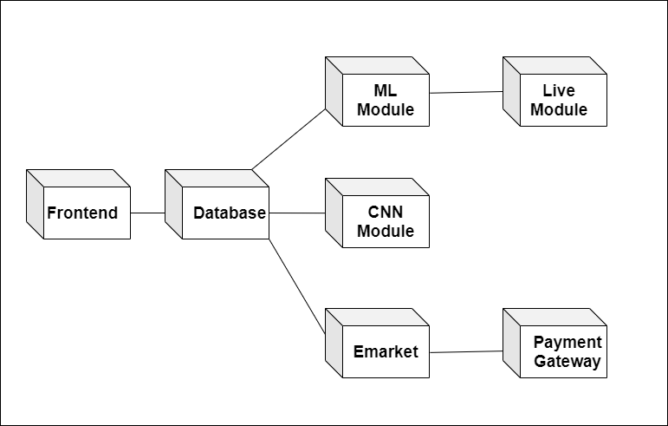



**6.1Code Snippet**



**6.2 Screen shots & Results**

1. **Home Page:**



**ii. E-Market:**

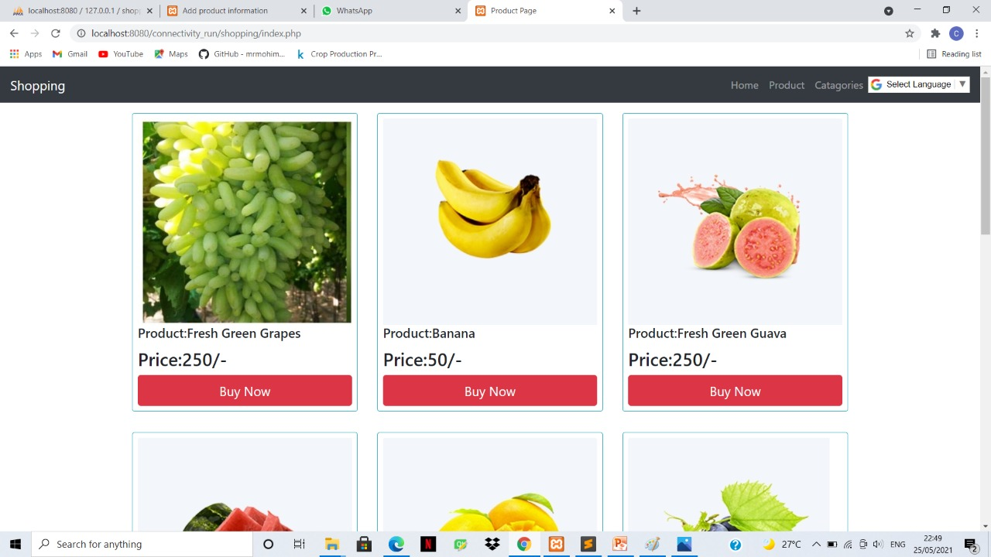

**7.1 Data flow diagrams**

**7.2 Sequential UML Diagrams**





Each and every sector in this digital world is undergoing a drastic change due to the Influence of Machine learning. But today, not much work has been done in the agricultural sector. “**Intelligent Farmers E-Marketplace with Prediction of Crop Risk Factors**”is a responsive web application. It helps farmers in crop selection for cultivation with most minimum risks and also alerts farmers about possible pest/insect/disease outbreak on farmers’ registered crops which in turn reduces crop losses. It is a multilingual web application.This model is divided into two parts,one is *E-marketing* platform,second is *Leaf disease detection system* which is the biggest advantage over existing systems in the market*.*This web application is very easy to use and can be accessed through any device.

The disease detections can be improved if more attributes are considered but lack of data reduces the parameters of the ML model. This can be further improved by improving the data set with more number of attributes in the prediction model.

In conclusion, we can say that if proper and optimized suggestions and predictions are given to farmers it will definitely help in building the economical status of agricultural production dependent countries. As developers, we learned a lot of new technologies through tutorials, online articles and with the help of our guide. Apart from this, we have learned to work as a team.



<References i.e. citations should be in APA format minimum 10 references>

* **This information can be provided by reference to an appendix or to another document.**

1. <https://data.gov.in/>
2. <https://www.kaggle.com/emmarex/plantdisease>
3. Subhadra Mishra, Debahuti Mishra, Gour Hari Santra. Applications of Machine Learning Techniques in Agriculture Crop Production: A Review Paper, Oct 2016.
4. P.Priya, U.Muthaiah, M.Balamurugan. Predicting yield of the crop using Machine Learning Algorithms.
5. M. Hunter, R. Smith, M.  Schipanski, L. Atwood and D.  Mortensen, "Agriculture  in  2050:  Recalibrating  Targets  for  Sustainable Intensification", BioScience,  vol.  67,  no.  4,  pp.  386-391,  2017. Available: 10.1093/biosci/bix010. Fig. 10. Confusion matrix –  validation dataset  Fig. 11. Top losses plotted – validation dataset  Fig. 12. Confusion matrix – test dataset
6. "PlantVillage",  Plantvillage.psu.edu,  2020.  [Online].  Available: https://plantvillage.psu.edu/. [Accessed: 31- Jan- 2020].
7. D. Klauser, "Challenges in monitoring and managing plant diseases in developing countries", Journal of  Plant Diseases and  Protection, vol. 125, no. 3, pp. 235-237, 2018. Available: 10.1007/s41348-018-0145-9.