IPV4 Static routing: Router 1
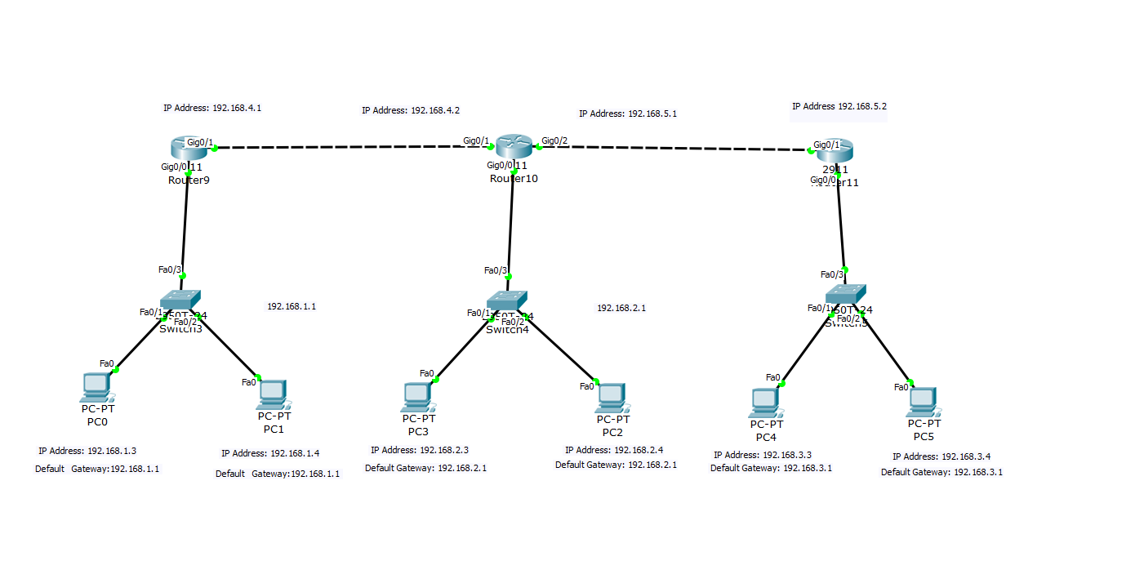
enable
configure terminal
hostname AyushaAdhikari
interface GigabitEthernet 0/0
ip address 192.168.1.1 255.255.255.0
no shutdown
exit
interface GigabitEthernet 0/1
ip address 192.168.4.1 255.255.255.0
no shutdown
exit
ip route 192.168.2.0 255.255.255.0 192.168.4.2
ip route 192.168.3.0 255.255.255.0 192.168.4.2
Router 2:
enable
configure terminal
interface GigabitEthernet 0/0
ip address 192.168.2.1 255.255.255.0
no shutdown
exit
interface GigabitEthernet 0/1
ip address 192.168.4.2 255.255.255.0
no shutdown
exit
interface GigabitEthernet 0/2
ip address 192.168.5.1 255.255.255.0
no shutdown
exit
ip route 192.168.1.0 255.255.255.0 192.168.4.1
ip route 192.168.3.0 255.255.255.0 192.168.5.2
Router 3
enable
configure terminal
interface GigabitEthernet 0/0
ip address 192.168.3.1 255.255.255.0
no shutdown
exit
interface GigabitEthernet 0/1
ip address 192.168.5.2 255.255.255.0
no shutdown
exit
ip route 192.168.1.0 255.255.255.0 192.168.5.1
ip route 192.168.2.0 255.255.255.0 192.168.5.1

ipv4 dynamic routing:
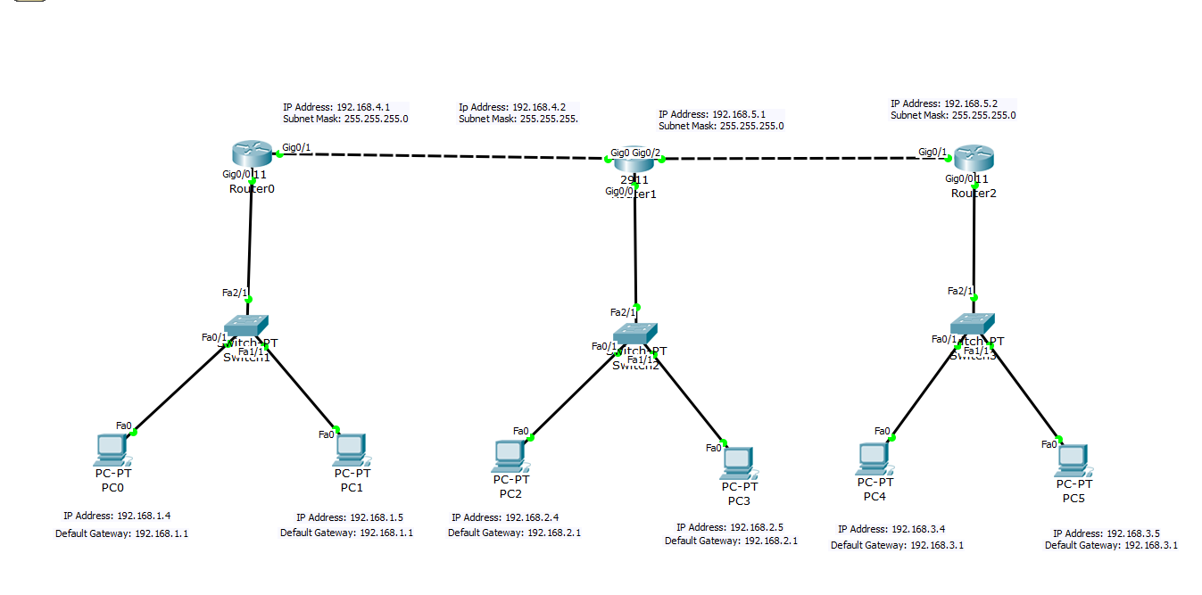
Router 0:
enable
configure terminal
hostname AyushaAdhikari
interface GigabitEthernet 0/0
ip address 192.168.1.1 255.255.255.0
no shutdown
exit
interface GigabitEthernet 0/1
ip address 192.168.4.1 255.255.255.0
no shutdown
exit
router rip
network 192.168.1.0
network 192.168.4.0
Router 1:
enable
configure terminal
hostname AyushaAdhikari
interface GigabitEthernet 0/0
ip address 192.168.2.1 255.255.255.0
no shutdown
exit
interface GigabitEthernet 0/1
ip address 192.168.4.2 255.255.255.0
no shutdown
exit
interface GigabitEthernet 0/2
ip address 192.168.5.1 255.255.255.0
no shutdown
exit
router rip
network 192.168.2.0
network 192.168.4.0
network 192.168.5.0

Router 2:
enable
configure terminal
hostname AyushaAdhikari
interface GigabitEthernet 0/0
ip address 192.168.3.1 255.255.255.0
no shutdown
exit
interface GigabitEthernet 0/1
ip address 192.168.5.2 255.255.255.0
no shutdown
exit
router rip
network 192.168.3.0
network 192.168.5.0
Lab to conduct IPv6 Auto Configuration
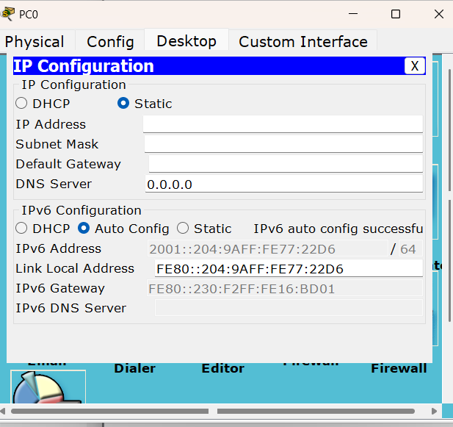
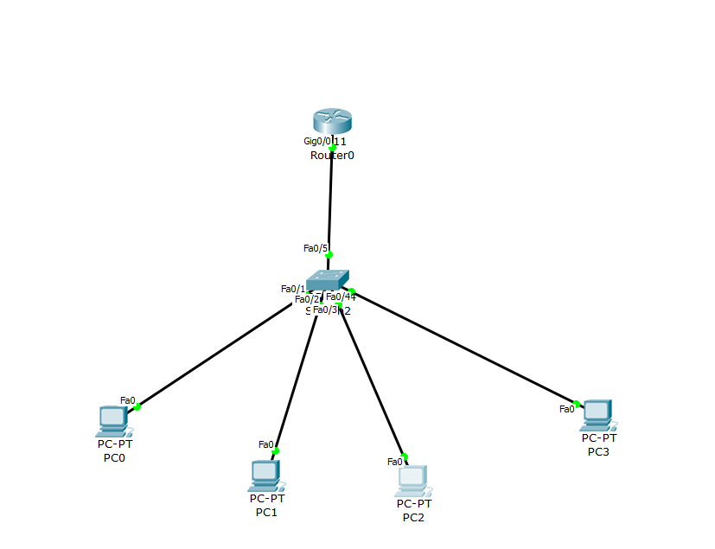
enable
configure terminal
hostname AyushaAdhikari
ipv6 unicast-routing
interface GigabitEthernet 0/0
ipv6 enable
ipv6 address 2001::/64 eui-64
no shutdown
exit

Lab to conduct IPV6 Static Routing

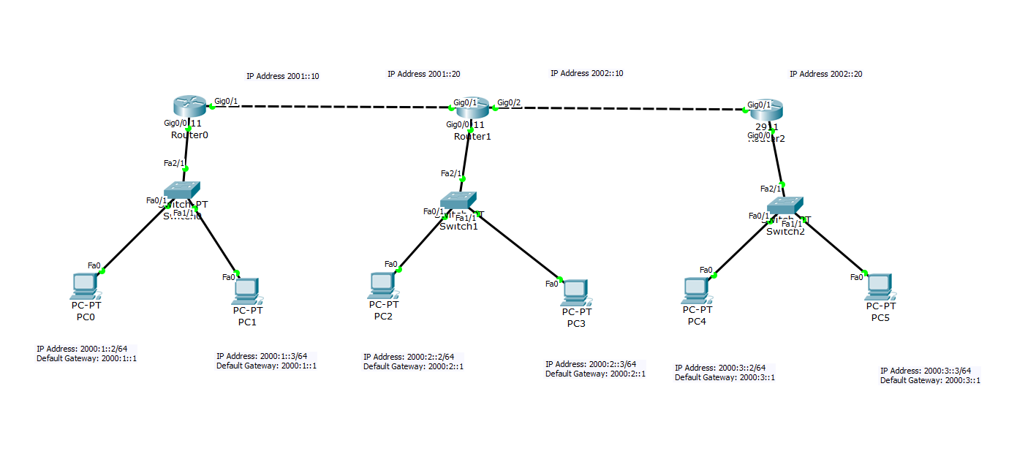

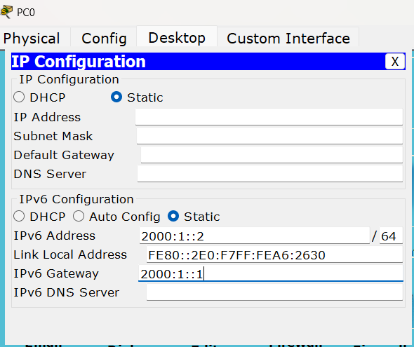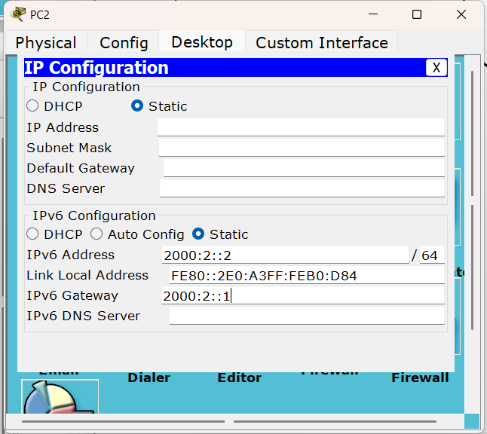

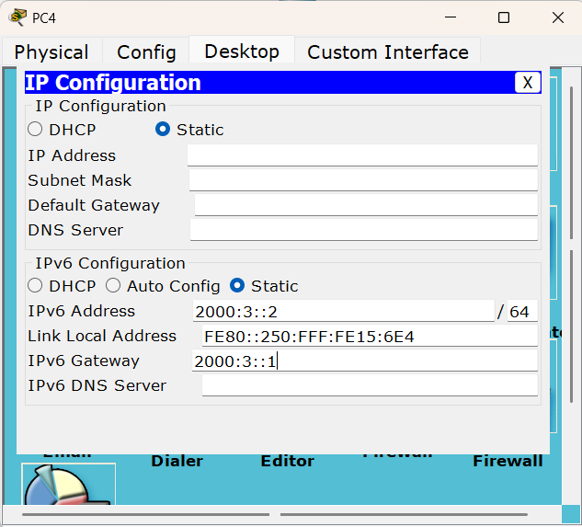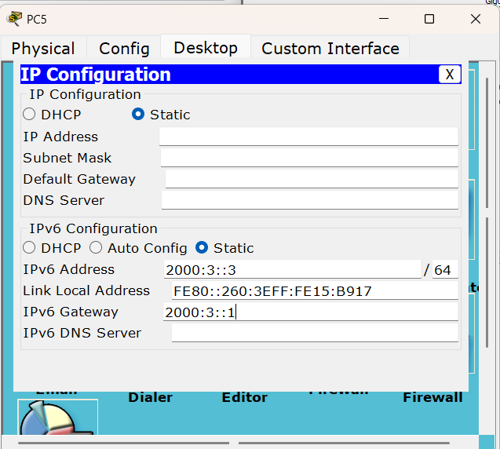
Router0 (Left) — Clean Commandsenable
configure terminal
hostname AyushaAdhikari
ipv6 unicast-routing
interface GigabitEthernet 0/0
ipv6 enable
ipv6 address 2000:1::1/64
no shutdown
exit
interface GigabitEthernet 0/1
ipv6 enable
ipv6 address 2001::19/64
no shutdown
exit
ipv6 route 2000:2::/64 2001::20
ipv6 route 2000:3::/64 2001::20

Router1 (Middle) — Clean Commandsenable
configure terminal
hostname AyushaAdhikari
ipv6 unicast-routing
interface GigabitEthernet 0/0
ipv6 enable
ipv6 address 2000:2::1/64
no shutdown
exit
interface GigabitEthernet 0/1
ipv6 enable
ipv6 address 2001::10/64
no shutdown
exit
interface GigabitEthernet 0/2
ipv6 enable
ipv6 address 2002::10/64
no shutdown
exit
ipv6 route 2000:1::/64 2001::10
ipv6 route 2000:3::/64 2002::20
Router2 (Right) — Clean Commandsenable
configure terminal
hostname AyushaAdhikari
ipv6 unicast-routing
interface GigabitEthernet 0/0
ipv6 enable
ipv6 address 2000:3::1/64
no shutdown
exit
interface GigabitEthernet 0/1
ipv6 enable
ipv6 address 2002::20/64
no shutdown
exit
ipv6 route 2000:1::/64 2002::10
ipv6 route 2000:2::/64 2002::10

Lab to conduct IPv6 Dynamic Routing
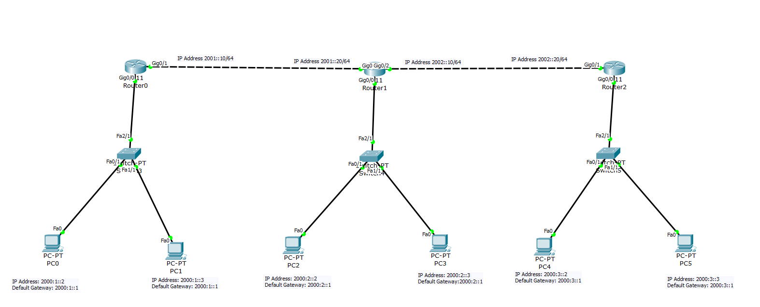
IPV6 Dynamic IP Configuration:
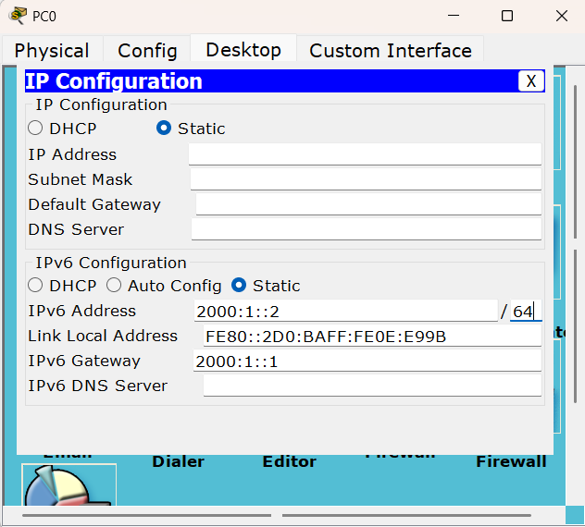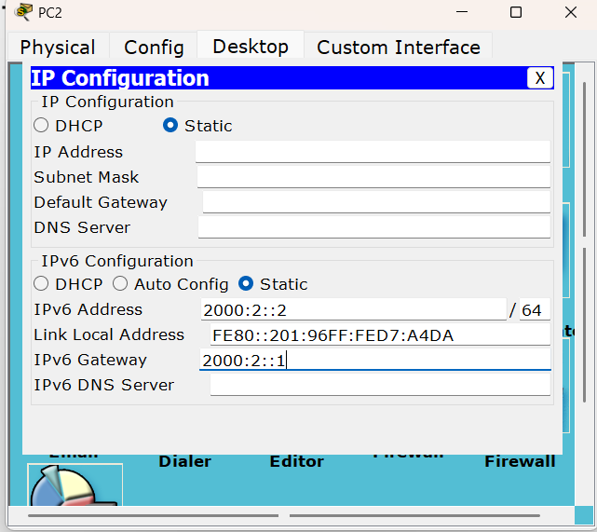

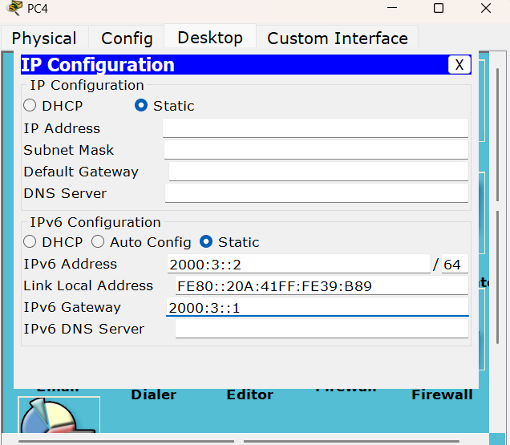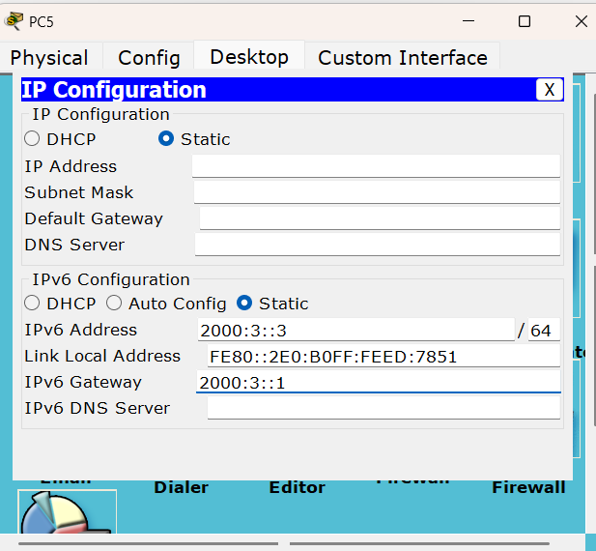

Router0 (Left) — Clean Commands
enable
configure terminal
hostname AyushaAdhikari
ipv6 unicast-routing
interface GigabitEthernet 0/0
ipv6 enable
ipv6 address 2000:1::1/64
no shutdown
exit
interface GigabitEthernet 0/1
ipv6 enable
ipv6 address 2001::10/64
no shutdown
exit
ipv6 unicast-routing
interface GigabitEthernet 0/0
ipv6 rip net1 enable
exit
interface GigabitEthernet 0/1
ipv6 rip net1 enable
exit

Router1 (Middle) — Clean Commands
enable
configure terminal
hostname AyushaAdhikari
ipv6 unicast-routing
interface GigabitEthernet 0/0
ipv6 enable
ipv6 address 2000:2::1/64
no shutdown
exit
interface GigabitEthernet 0/1
ipv6 enable
ipv6 address 2001::20/64
no shutdown
exit
interface GigabitEthernet 0/2
ipv6 enable
ipv6 address 2002::10/64
no shutdown
exit
interface GigabitEthernet 0/0
ipv6 rip net1 enable
exit
interface GigabitEthernet 0/1
ipv6 rip net1 enable
exit
interface GigabitEthernet 0/2
ipv6 rip net1 enable
exit

Router2 (Right) — Clean Commands
enable
configure terminal
hostname AyushaAdhikari
ipv6 unicast-routing
interface GigabitEthernet 0/0
ipv6 enable
ipv6 address 2000:3::1/64
no shutdown
exit
interface GigabitEthernet 0/1
ipv6 enable
ipv6 address 2002::20/64
no shutdown
exit
interface GigabitEthernet 0/0
ipv6 rip net1 enable
exit
interface GigabitEthernet 0/1
ipv6 rip net1 enable
exit

