MATERIALS REQUIREDS
1. Motor
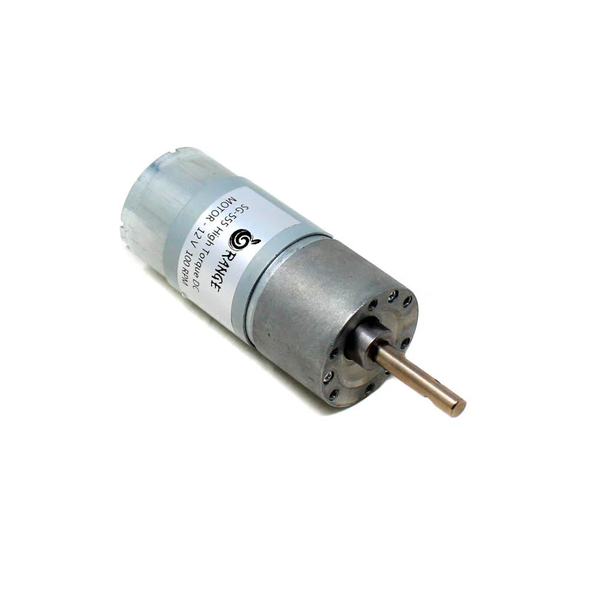
We need: - two 12v DC high power gearbox motors.
What we got: -https://robu.in/product/orange-12v-og555-100rpm-dc-motor-for-diy-projects-grade-a-quality/?gclid=Cj0KCQjwhY-aBhCUARIsALNIC05r4Stl5JwS27rjBmJ8oHP5HeDhCyd3PJ7U8pIIb-JDgTuXaJPVltgaAq6oEALw_wcB
Features:-
Current(mA)<=4134
Torque(N.cm)= 173.6
Speed(RPM)=100
Shaft Length=27mm
Shaft Diameter=8mm
Price = 500/- x 2= 1000/-
2.Battery
We need: - 12v 7Ah battery.
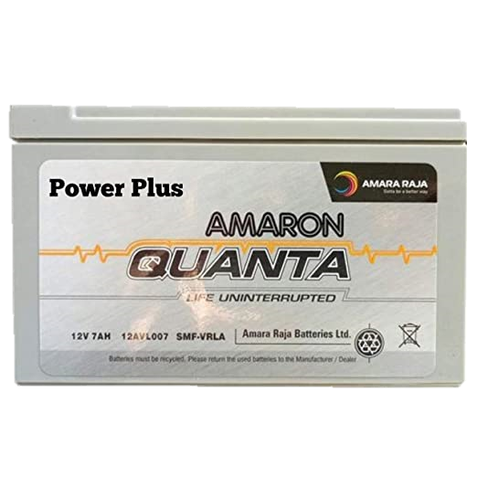
What we got: - https://www.amazon.in/dp/B08CVD2H13?tag=opr-mkt-opr-in-21&ascsubtag=1ba00-01000-ubp00-win10-other-nomod-in000-pcomp-feature-scomp-feature-scomp&ref=aa_scomp#customerReviews

Features: - Voltage=12v Capacity=7Ah
Price = 1500/-

3.Pump
We need: - A 12v high power pump.
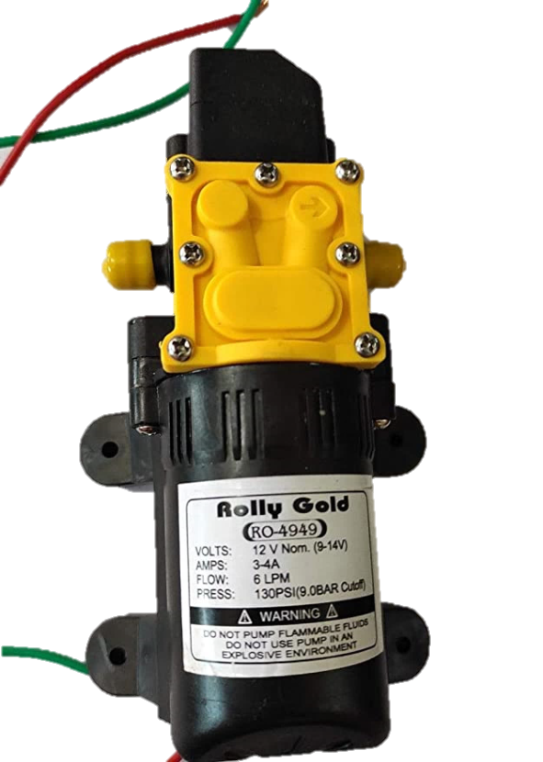
What we got: - https://www.amazon.in/ROLLY-GOLD-Electric-Diaphragm-Pressure/dp/B07ZM2NXPY/ref=asc_df_B07ZM2NXPY/?tag=googleshopdes-21&linkCode=df0&hvadid=397079215334&hvpos=&hvnetw=g&hvrand=17027238303173731194&hvpone=&hvptwo=&hvqmt=&hvdev=c&hvdvcmdl=&hvlocint=&hvlocphy=1007799&hvtargid=pla-844741024750&psc=1&ext_vrnc=hi
Features: -
Pressure = 130PSI
Flow = 6 litres/min
Voltage = 12v
Current = 3-4 A
Price = 500/-

4. Nozzeles
What we need: - Few high-pressure nozzles capable of spraying pesticides like actual product.
What we got: - https://www.amazon.in/Generic-Adjustable-Sprayer-Watering-Irrigation/dp/B019C58XSY/ref=pd_rhf_cr_s_pd_sbs_rvi_sccl_2_2/259-3892714-2856833?pd_rd_w=PZLC0&pf_rd_p=dc04bec4-fa1d-4db1-84b4-6f2b15be4d08&pf_rd_r=3BEYSEJDKKAN2AS09CED&pd_rd_r=640b8362-49de-4f1d-afea-4da7c6ea922f&pd_rd_wg=5q1bt&pd_rd_i=B019C58XSY&psc=1#customerReviews

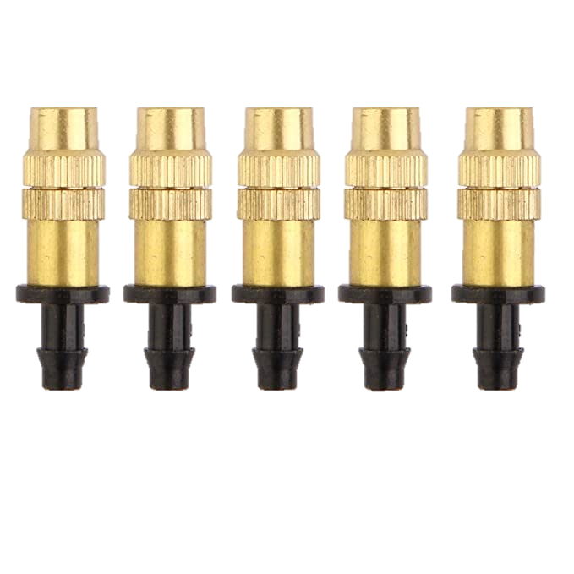
Features: -
Metal = Brass 8cm x 5cm x 1cm
Price = 375/- × 2 = 750

5. The motor controler
What we need: - A circuit which can control speed and direction of the motors.
What we got: -
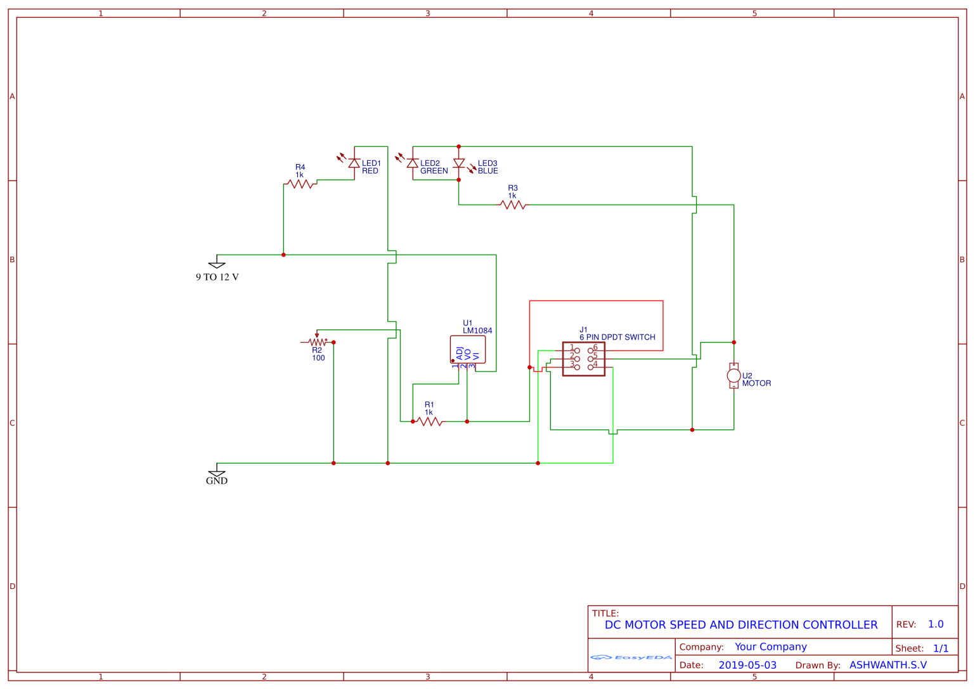
LM1084: LM1084IT-5.0/NOPB Texas Instruments | Integrated Circuits (ICs) | DigiKey
250/- × 2 – 500/-

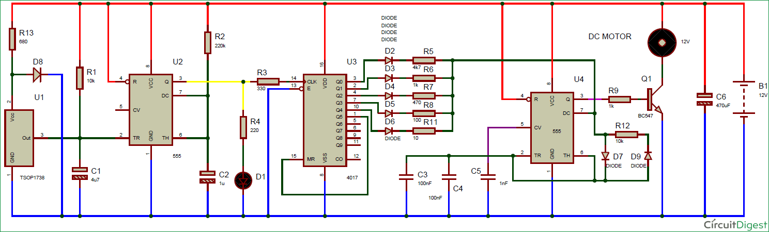

The above circuit is for controlling speed of only motor, can be duplicated for the pump.

6. The signal transmitter and receiver
What we need: - A circuit which can transmit and receive signals for motor speed, pump pressure and control directions.
What we got: - Buy 433MHz 100 meter STX882 ASK Transmitter w/ SRX882 Receiver (robu.in)
220/- × 2 – 440/-

(1) How to make simple wireless using RF module : Tutorial 28 - YouTube
Tutorial

7. BMS
What we need: - A circuit which can show battery levels, charge the battery and auto cut off when done.
What we got: -
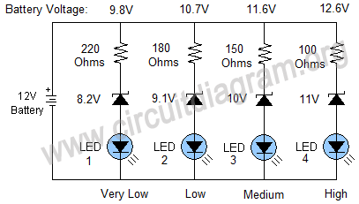

Auto cut off - Tutorial
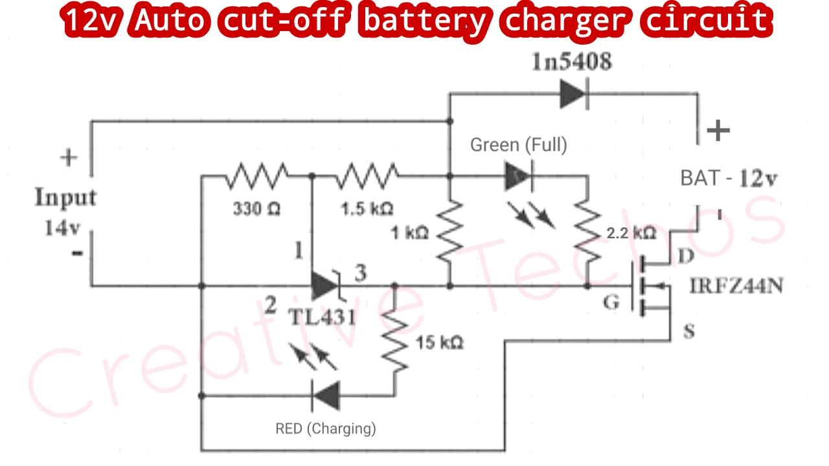

220v AC to 14v DC 2 A -

8. The main circuit
What we need: - A circuit which can receive signals, control speed and direction of the motors and pressure of pump.
What we got: -

Other small components like wire, capacitors, LEDs, switches etc. will cost less than 100/-.

Expected Expenditures
SL | Name | Price | Quantity | Total
1. | Motor | 500 | 2 | 1000
2. | Pump | 500 | 1 | 500
3. | Battery | 1500 | 1 | 1500
4. | Motor Driver Module | 615 | 1 | 615
5. | Nozzles | 375 | 10 | 750
6.
7.
8.
9.
10.
11. | Others | 200 | Many | 200
TOTAL

