COMPUTER SYSTEM ORGANIZATION

*Introduction:*

System is a set of detailed methods , procedures and routines created to carry out a specific activity , perform a duty ,or solve a problem. It is a set of various functional components of a computer that are interconnected in some fashion to achieve the basic function of the computer , that is to execute programs. It consists of I/O components , memory and CPU with one or more modules of each type. It takes a set of inputs , process them and create a set of outputs. A computer system function effectively only when all these components perform their assigned task. The failure of any one component of the system leads to the failure of whole system.

*Input device:*

Input is any data or instructions you enter into the memory of a computer . Once input is in memory , the CPU access it and process the input into output . Four types of input are data , programs , command and user responses. The device that takes in data and program instructions and converts them into digital form is called input device.  
Input device perform the following basic function:

* It accept data from user.
* It convert data into binary code that is understandable to the computer
* It send data in binary form to the computer for further processing

Keyboard , mouse , joystick , light pen , scanner and touch screen are some of the popular input device.

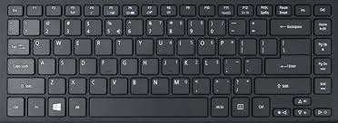

*Central Processing Unit:*

Central Processing Unit(CPU) is the main information processor in a digital computer capable of executing a program. CPU also referred to as a central processor unit , is the hardware within a computer that is also responsible for carrying out the processing job. It is a brain of the computer. It is where all the searching , sorting , calculating and decision making takes place. It guides , directs and controls a computer's performance. The processing capability of a PC is measured in terms of the amount of data processed by its CPU in one operation. The speed of the CPU is measured in MegaHertz(MHz). The various type of CPU chips are Pentium IV , Intel Cerelon , Cyrix and AMD Duron . It has 2 component:

1. Arithmetic Logic Unit(ALU)
2. Control Unit(CU)

*Arithmetic Logic Unit(ALU):*

The ALU of the CPU is the place where the actual execution of instruction take place during the processing operation. It is a multi operational digital circuit performing the arithmetic operations on integer(whole number) and real (with a decimal point) operands. It can also perform simple logical tests for equality , greater than and less than between operands. It contains the accumulator , the temporary register ,logical and arithmetic and logical circuit.

*Control Unit(CU):*

The CU is the logical hub of the CPU. It directs and coordinates the activities of the entire computer. It consists of registers (which are memory locations similar to primary memory ,but located in CPU) to hold address of the current instruction being executed , the current instruction itself and circuitry to decode the current instruction and take necessary action. The CU consists of several registers like address register , instruction register , sequence register and decoder. When a program is executed a number of steps are to be followed by computer system.

* The instruction selected by the sequence register and set to the instruction register.
* The operation part of the instruction is sent to the decoder and address part is sent to the address register.
* The CU issues order to extract the contents from the address and transfer them to ALU . Also the instruction like multiply or divide also goes to ALU
* The sequence register moves onto the next instruction. The process of fetching the instruction and sending its parts to appropriate registers constitutes the fetch cycle. The calculation of the result after performing the required arithmetic or logic operation is called execution cycle

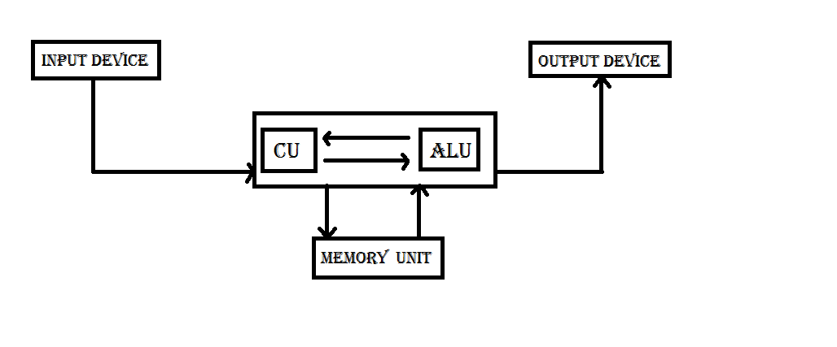

*Primary memory:*

Primary memory is computer memory that a processor or computer accesses first or directly. It allows a processor to access running execution applications and services that are temporarily stored in a specific memory location. Primary memory is also known as primary storage or main memory. It is divided into 2 parts:

1. Random Access Memory(RAM)
2. Read Only Memory(ROM)

*Random Access Memory(RAM):*

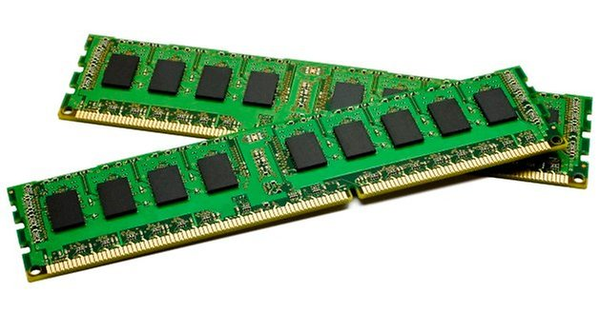

RAM is the most important form of memory whose bytes or memory locations are open and accessible to the user. It is called random access memory because of its ability to access memory because of its ability to access each byte of data directly. The purpose of RAM is to hold a copy of operating system , currently executing programs and data. The capacity of the RAM is usually measured in MegaBytes(MB).

* Static Random Access Memory
* Dynamic Random Access Memory

**Static Random Access Memory:**

SRAM is a fast memory technology that requires power to hold its content. It is used for high speed register , caches and relatively small memory banks such as frame buffer on a display adapter. SRAM has a low bit density , high power consumption and is more expensive. SRAM chips have access times ranging from 10 to 30 nanosecond.

**Dynamic Random Access Memory:**

DRAM is a read write random access memory whose storage cells are based on transistor-capacitor combinations , in which the digital information is represented by charges that are stored on the capacitors and must be repeatedly refresed in order to retain the information. The DRAM is cheaper but its access time is slower than that of RAM. Most DRAM technology support access times of around 60 nanoseconds.

*Read Only Memory(ROM):*

ROM is a permanent memory containing special instructions called the ROM BIOS(Basic Input/Output System) for detailed computer operations. These instructions tell the computer how to access the hard disk , find the operating system, load it into RAM . It is housed in a single integrated circuit which is plugged into the motherboard . It is read only memory which means that the CPU can read or retrieve , the programs written on the ROM chip. However , the user cannot write or change the information or instruction in ROM . The contents of the ROM are written into at manufacturing time. It is non-volatile in nature ,meaning that its contents are not lost when power supply is switched off. There are 3 types of Rom . They are:

**PROM(Programmable Read Only Memory):**

PROM(Programmable Read Only Memory) is a read only memory that can be modified once by the user . PROM is a way of allowing a user to tailor a microcode program using a special machine called PROM programmer. This machine supplies an electric current to specific cells in the ROM that effectively blows a fuse in them. The process is known as burning the PROM.

**EPROM(Erasable Programmable Read Only Memory):**

EPROM(Erasable Programmable Read Only Memory) is a programmable read only memory that can be erased and reused. Eraser is caused by shining an intense ultraviolet light through a window that is designed into the memory chip.

**EEPROM(Electrically Erasable Programmable Read Only Memory) :**

EEPROM(Electrically Erasable Programmable Read Only Memory) is a user modifiable read only memory that can be erased and reprogrammed repeatedly through the application of higher than normal electrical voltage. Unlike EEPROM chips , EEPROMs do not need to be removed from the computer to be modified. However an EEPROM chip has to be erased and reprogrammed in its entirety , not selectively. It also has a limited life - that is the number of times it can be reprogrammed is limited to tens or hundreds of thousands of times.

*Cache Memory:*

Cache Memory is extremely fast memory that is built into a computer's CPU or located next to it on a seperate chip. The CPU uses cache memory to store instruction that are repeatedly required to run programs , improving the overall system speed . The advantage of cache memory is that the CPU does not have to use the motherboard's system bus for data transfer. Whenever data must be passed through the system bus ,the data transfer speed slows to the motherboard's capability. The CPU can process data much faster by avoiding the bottleneck created by the system bus.

*Secondary Memory:*

Secondary Memory is a long term memory used to store programs and data for the future reference. It supplements the limited storage capacity and volatile characteristics of primary memory. This is because secondary memory is much cheaper than primary storage and the data or programs stored in secondary memory will not be lost when electrical power is switched off. It is also known as backing storage or external memory . The 2 main types are magnetic disk and optical disk.

*Output devices:*

Any information that has been processed and comes from a computer or computer device is considered output . It might be in the form of the words , numbers , graphics , sounds , videos and animation. The device that converts the binary coded data into human acceptable form and presents it to the user in the desired form is called output device. It performs following functions:

* It accepts result produced by the computer in binary form
* It converts the binary coded data into human acceptable form.
* It supplies converted results to the user

The monitor , printer and graphic plotter are some of the popular output device.