COMPUTER HARDWARE CONCEPT

*Introduction:*

A computer is a electronic device that processes data by following set of instruction. A computer system is a set of physical parts including computer itself ,that work together perform tasks. The physical parts that make up the entire computer system is called computer hardware. Such physical parts may be optical , electronic and mechanical. Hardware helps to enter raw data , process data , store data and finally display output on screen or printer.It is one of the important aspect of computer. A typical personal computer consist of following physical parts:input device , output device , microprocessor , computer memory , system board , expansion port , slots and cards and computer power supply.

*Input unit:*

The input unit is responsible for accepting input i.e. data and instruction from user. This work is accomplished with the help of input devices.Input device are the vital part of machine's functionally. Without these there would no way for a user to communicate with the computer. Modern machines can handle several different input device in use at one time. Most of the input device are attached to the computer either through a standard serial port connection or USB connection.

*Computer keyboard:*

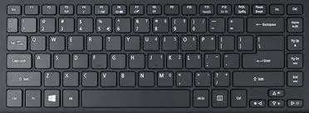

A computer keyboard is a typewriter-style device which uses an arrangement of buttons or keys to act as a mechanical lever or electronic switch. It is one of the primary input devices. It allow you to input letters, numbers, and other symbols into a computer that can serve as commands or be used to type text.A keyboard contains many mechanical switches or push-buttons called "keys". There are 103 to 106 keys in keyboard. More modern devices carry extra buttons that provide the user with features like volume control , instant email acess and tools to control computer's media player.

*Mouse:*

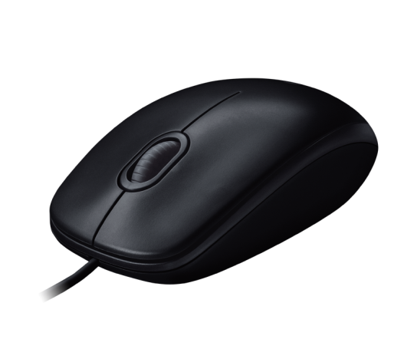

A computer mouse is an input device that is most often used with a personal computer. It has 2 or 3 buttons on the top with either a rotating ball or optical sensor at bottom. It moves on a soft rubber base called mouse pad. Moving a mouse along a flat surface can move the on-screen cursor to different items on the screen. Items can be moved or selected by pressing the mouse buttons.Similarly we can also draw shapes or make a choice from menu with the help of mouse.

*Joystick:*

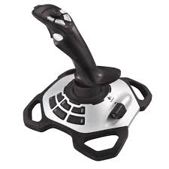

A joystick is an input device consisting of a stick that pivots on a base and reports its angle or direction to the device it is controlling. Joysticks are often used to playing video games and for CAD/CAM system.A joystick has a square or rectangular plastic base to which is attached a vertical stem. It has a spherical ball at lower end as well as upper end .The lower speherical ball moves in a socket. The joystick can moved omnidirectionally to control movement of an object in screen. The movement re sensed by potentiometer.

*Trackball:*

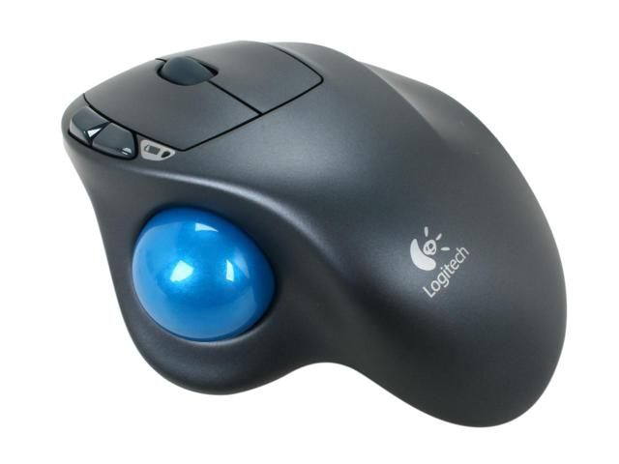

a trackball is a pointing input device. It consists of a ball held by a socket containing sensors to detect a rotation of the ball about two axes. It is like an upside-down mouse with a ball that sticks out. The user rolls the ball with the thumb, fingers or the palm of the hand to move a cursor. The trackball is held stationary while the ball is manually rotated by hand in any diection. The major advantage of trackball is that it takes little desktop surface.It is normally used in laptop personal computer.

*Touchpad:*



Touchpad is an input device found on the majority of portable computers that allows you to move mouse cursor without the need of an external mouse. It is operated by using your finger and dragging it across a flat surface , the mouse cursor will move in the same direction and it also has 2 buttons below the touch surface that enables you to click like a standard mouse.It must keep clean and static free because build up of dust and oil can affect a trackpad performance making it less sensitive to the touch.

*Graphics tablet:*

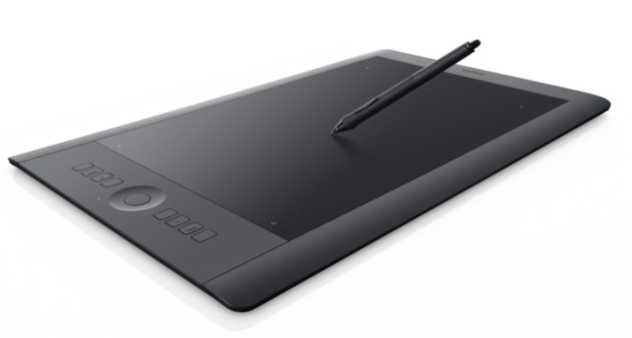

A graphics tablet is a hardware input device that enables an artist to draw or sketch digitally using a pen or stylus. They are helpful because they provide a more natural and precise feel than a standard computer mouse.When the pointing device is moved on the surface of the tablet , the location of device is translated to a specific o screen cursor position. It is used in engineering and design application as well as illustration work.

*Scanner:*

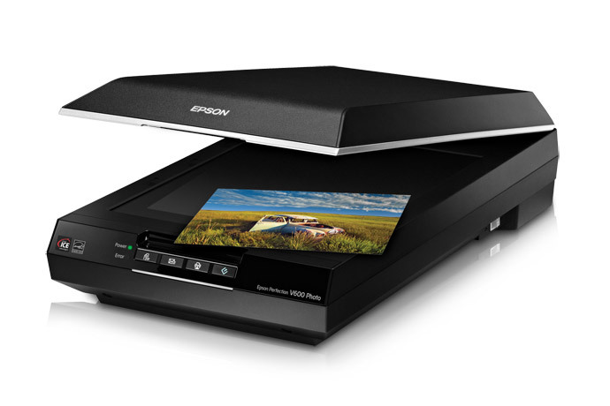

A scanner is an input device that scans documents such as photographs and pages of text. When a document is scanned, it is converted into a digital format.A scanner work by dihitizing an image --dividing it into a grid of boxes and representing each box with 0 or 1, depending on whwther the box is filled in. The resulting matrix of bits , called bit map can then be stored in a file,displayed in screen and manipulated by programs.

*Webcam:*

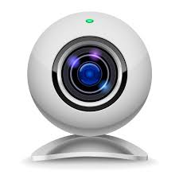

A webcam – short for ‘web camera’ – is a digital camera that’s connected to a computer. It can send live pictures from wherever it’s sited to another location by means of the internet. Many desktop computer screens and laptops come with a built-in camera and microphone, but if yours doesn’t, you can add a separate webcam at any time. There are various types. Some are plugged into computers through USB ports, but others are wireless (wifi).

*Microphone:*



Computer microphone gives the user the ability to transmit his voice through his computer. They are most commonly included as part of a headset apparatus that people can use to speak and listen to order computer users via the Internet.

*Light pen:*

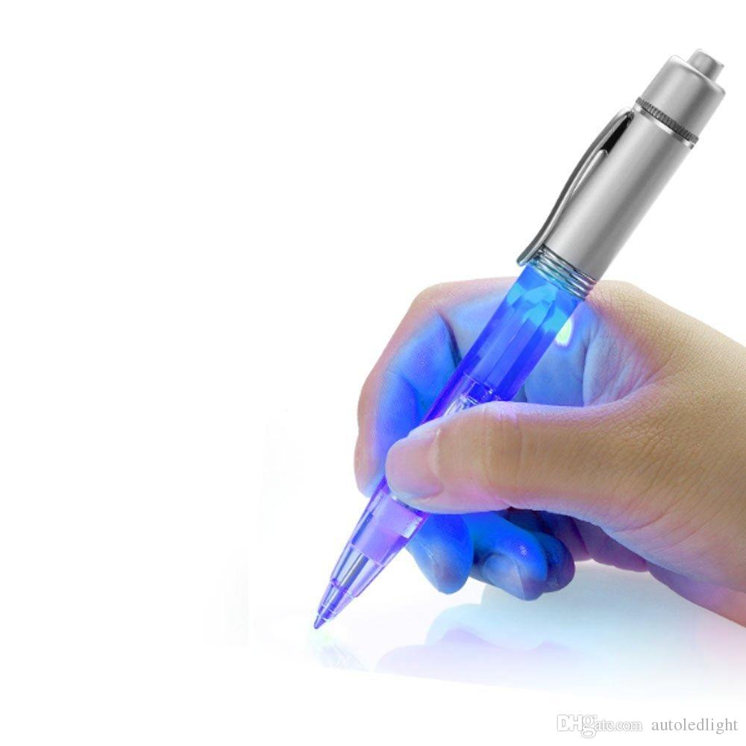

A light pen is a computer input device in the form of a light-sensitive wand used in conjunction with a computer's CRT display. It has a light sensor fixed at the end of a pen shaped tube and is capable of sensing a position an the screen when its tip touches the screen. It allows the user to point to displayed objects or write words or draw on the screen in a similar way to a touch screen but with greater positional accuracy.

*Barcode reader:*



A barcode reader or scanner also known as point of scale(POS) scanner is a hardware device capable of reading a barcode and printing out the details of the product or logging that product into database. The scanner converts light energy into electrical energy which is then converted into data by the decoder and forwarded to a computer . A perfect example of barcode reader is a supermarket barcode scanner that reads and logs the price of product.

*3D scanner:*

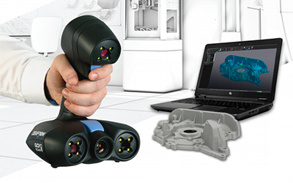

A 3-D scanner is an imaging device that collects distance point measurements from a real-world object and translates them into a virtual 3-D object. 3-D scanners are used for creating life-like images and animation in movies and video games. Other applications of 3-D scanning include reverse engineering, prototyping, architectural and industrial modeling, medical imaging and medical device modeling. 3-D printers can use data from 3-D scans to create physical objects. Optical 3-D scanners use photographic, stereoscopic cameras, lasers or structured or modulated light. Optical scanning often requires many angles or sweeps. Commercial desktop and hand held 3-D scanners vendors include Digitizer, NextEngine , Go!SCAN and Fuel3-D. Most products use a combination of the techniques to make a faster and more accurate device that can capture color as well as form.

*Output unit:*

Output unit is a responsible for displaying output . It receives information from the computer and translates it from machine language to a form that human can understand. There are 2 board classes of output device. They are:

* Soft copy output
* Hard copy output

*Soft copy output:*

It refers to the output displayed on the screen. The output on the screen is lost when the computer is turned off . The most commonly used soft copy output device is a monitor.

*Computer monitor*

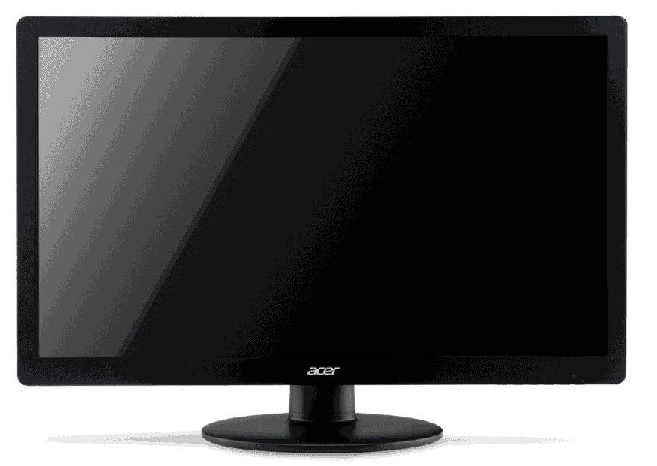

Monitor is most common form of output in a computer. It is a television like screen that display result of work done by computer. It provides a temporary display of meaning information . The output display in the screen often referred as soft copy. The basic types of monitors are: Cathode Ray Tube(CRT) monitors and Liquid Crystal Display (LCD) monitors. The CRT monitors look like television and are used with non-portable computer system. LCD monitors are flat and occupy less space.

*Hard copy output:*

It refers to recording letters , graphics or pictures on a permanent medium such as paper or film. The principal of hard copy output devices are printers and graphic plotters.

*Printer:*

Printer is a device that accepts text and graphics output from a computer and transfers the information to the paper usually to standard size sheets of paper. The output generated by a printer is often related as hard copy. Computer printers are commonly divided into 2 general classes according to the way they produce image on paper. They are:

**Impact printer**

Impact printer uses the electromechanical mechanism , that is physically striking the hammers to strike a character against an inked ribbon. Each hammer is embossed with the shape of alphanumeric character and is transferred through the inked ribbon onto the paper , resulting in a printed character . They are relatively slow , noisy and inexpensive.

1. Dot matrix printer

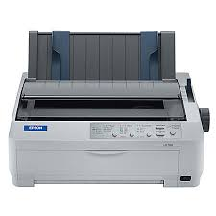

It is the most popular impact printer. The print head contains a vertical array of pins. As the print head moves across the paper , selected pins fire against the ribbon to form pattern in the paper Dot-matrix printers are noisy, inexpensive, and they can print through multipart forms, creating several copies of a page at the same time,

1. Daisy wheel printer

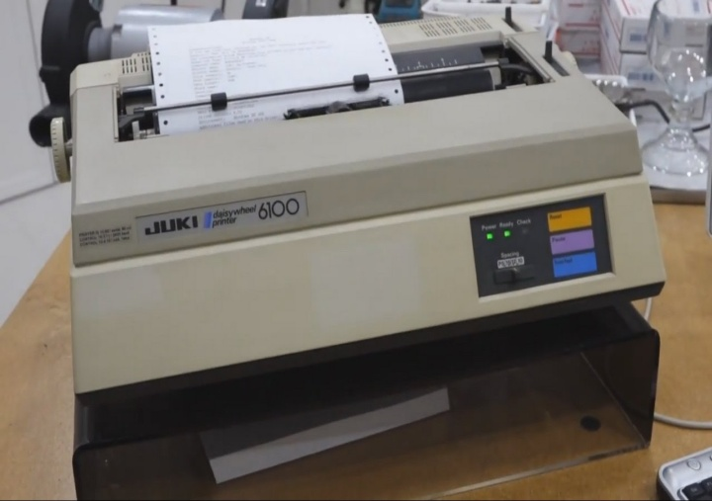

It is a type of impact printer that has raised letters and numbers arranged on the wheel. The daisy wheel turns around until the correct letter is in position for a hammer to strike it against an inked ribbon. It is noisy and quiet slow. However, daisy-wheel printers cannot print graphics.

**Non-Impact printer**

Non impact printer is a printer in which printing is done with ink jet ,electrostatic , chemical , laser beam and thermal technology. The quality of printing is very high. It is less noisy , faster , and produce high quality graphics

1. Ink jet printer

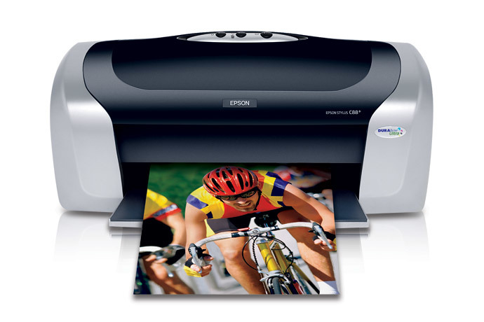

It uses a continuous stream of ink drops to print characters on paper. It does not make a noise and can produce a good printout of both graphics and text. Ink-jet printers spray small, electrically charged droplets of ink from four nozzles through holes in a matrix at high speed onto paper.

1. Laser printer

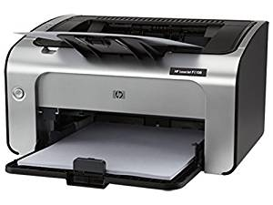

It use a light beam to form images on the paper , using toner ink as the medium. The output image is written on a copier drum with the help of the light beam. It is quiet and produce high quality output but it is very expensive.

*Speakers:*

Speakers are the output device that are used to give the sound output. They are used to listen music and other sounds being played by the computer. Computer speakers range widely in quality and in price. The computer speakers typically packaged with computer systems are small , plastic and have moderate sound quality.

*Secondary storage:*

A secondary storage device refers to any volatile storage device that is internal or external to the computer. It can be any storage device beyond the primary storage that enables permanent data storage. A secondary storage device is also known as an auxiliary storage device or external storage.

*Magnetic tape:*



A sequential storage medium used for data collection, backup and archiving. Like videotape, computer tape is made of flexible plastic with one side coated with a ferromagnetic material. The major drawback of tape is its sequential format. Locating a specific record requires reading every record in front of it or searching for markers that identify predefined partitions. Although most tapes are used for archiving rather than routine updating, some drives allow rewriting in place if the byte count does not change. Otherwise, updating requires copying files from the original tape to a blank tape (scratch tape) and adding the new data in between.

*Magnetic disk:*

Magnetic disk is a thin , circular plate/platter made of metal or plastic , which is usually coated on both sides with a magnetizable recording material , such as iron oxide. Data are recorded on the tracks of a spinning disk surface , read from the surface by one or more read/write heads . These heads are fastened to an arm in a disk storage device so that they can be moved quickly and directly to any disk location to store or retrieve data. It offers high storage capacity , reliability and the capacity to directly access stored data.

*Hard disk:*

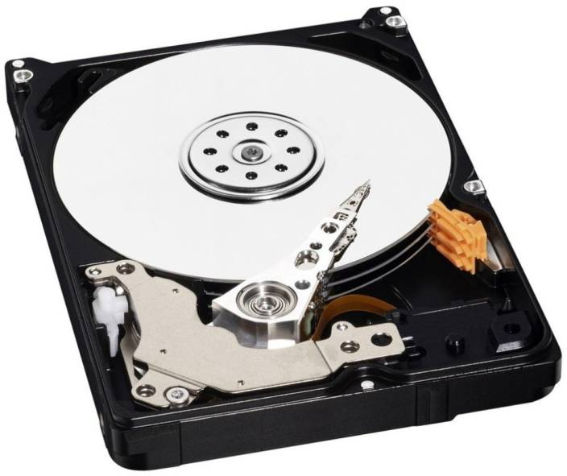

A hard disk is a storage device that stores data magnetically in platters. It contains a circuit board that translates information to the bus of a computer to be used and it is in a protective case so that the platters won't be affected by outside magnetism and acquire dust. It consists of one or more platters. Each platter is a thin , circular metal plate coated on both sides with a magnetic material. This platter is connected to a spindle. The spindle rotates the disk platter with different speed. There is an access arm having 2 read/write heads for each recording surface of the platter to read/write the data as the disk spins.

*Floppy disk:*

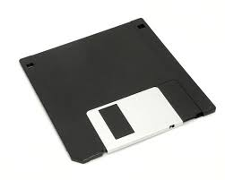

Floppy disk is a circular piece of thin plastic material with magnetic coating on one or both sides. The plastic disk coated with magnetic material are permanently sealed in square jacket to protect them from dust and scratches. It is called floppy because it flops if you wave it. Floppy disks are portable , because you can remove them from a disk drive. Disk drives for floppy disks are called floppy drive. Floppy disk is inserted in a Floppy disk drive until by pushing it through a slot. Once inside the disk drive , the disk spins within its cover at 300 revolution per minute, and data is read and recorded by a read/write head. Floppy disk has a write protect notch to protect it against being written on or to enable it to write. Floppies come in 3 basic sizes:

**8-inch:**The first floppy disk design invented by IBM in the late 1960s and used in early 1970s as first a read only format and then as a read write format.

**5-inch:**The common size for PCs made before 1987 and the predecessor to the 8- inch floppy disk . This type of floppy is generally capable of storing between 100K AND 1.2MB of data. The most common sizes are 360K and 1.2MB.

**3-inch:**The most common sizes for PCs are 720K and 1.44MB. Macintoshes support disks of 400K , 800K , and 1.2MB.

*Floppy disk capacities:*

Floppies can be found in different sizes with varying storage capacities. They must be formatted before they can be store information. Commonly used diskettes are referred to as either double density or high density.

|  |  |  |  |  |
| --- | --- | --- | --- | --- |
| **Size(inches)** | **5.25** | **5.25** | **3.5** | **3.5** |
| Type | Double density | High density | Double density | High density |
| Capacity | 360K | 1.2M | 720K | 1.44M |
| Tracks | 40 | 80 | 80 | 80 |
| Sectors/Tracks | 9 | 15 | 9 | 18 |
| Heads | 2 | 2 | 2 | 2 |
| Rotations/min | 300 | 360 | 300 | 300 |
| Data rate(kbps) | 250 | 500 | 250 | 500 |
| Bytes/sector | 512 | 512 | 512 | 512 |

The disk capacity can be calculated by using the following formula:  
Storage capacity = No. of bytes per sector x No. of sectors per track x No. of tracks x No. of sides

1. Calculate the storage capacity of a 5.25" double sided double density disk.

Solution  
Storage capacity :  
= No. of bytes per sector x No. of sectors per track x No. of tracks x No. of sides  
=512x9x40x2  
=368640 bytes  
=360KB

1. Calculate the storage capacity of a 5.25" double sided high density disk

Solution  
Storage capacity :  
= No. of bytes per sector x No. of sectors per track x No. of tracks x No. of sides  
=512x15x80x2  
=1228800 bytes  
=1200KB  
=1.2MB

1. Calculate the storage capacity of a 3.5" double sided double density disk.

Solution  
Storage capacity :  
= No. of bytes per sector x No. of sectors per track x No. of tracks x No. of sides  
=512x9x80x2  
=737280 bytes  
=720KB

1. Calculate the storage capacity of a 3.5" double sided high density disk

Solution  
Storage capacity :  
= No. of bytes per sector x No. of sectors per track x No. of tracks x No. of sides  
=512x18x80x2  
=1474560 bytes  
=1440KB  
=1.44MB

*Handling floppy disk:*

Floppies can be found in different sizes with varying storage capacities. They must be formatted before they can be used to store information. Commonly used diskettes are referred to as either double density or high density.

* Always hold disk by the label
* Always keep the disk in its envelope when you are not using it.
* Do not bend or crease the disk
* Always write the label before sticking it onto the disk
* Keep disk away from dust and liquids.
* Never touch the surface of the disk

*Optical disk:*

An optical disk is an electronic data storage medium that can be written to and read using a low-powered laser beam. Optical disc offers a number of advantages over magnetic storage media. An optical disc holds much more data. Storage capacity increases with each new generation of optical media. Emerging standards, such as Blu-ray, offer up to 27 gigabytes (GB) on a single-sided 12-centimeter disk. Optical discs are inexpensive to manufacture and data stored on them is relatively impervious to most environmental threats, such as power surges, or magnetic disturbances. The most widely used type of optical storage medium are CD-ROM , CD Rewritable ,CD-Recordable and DVD.

**CD-ROM**

CD -ROM disk is a rigid plastic disk covered with a layer of reflecting material such as aluminum . It stores a large amount of data through the use of laser optics technology and are popular for storing databases and multimedia materials. The most common format of CD-ROM holds approximately 700 megabyte of data.

**DVD-ROM**

DVD-ROM is an optical storage medium capable of storing computer data and a full length movie on single disk. It provides better graphics , greater resolution and increased storage capacity. A standard single layer , single sided DVD can store 4.7GB of data. DVD-ROM uses include interactive games , video file storage and photographic storage.

**Blue-ray disk**

Blue-ray is an optical disk format such as CD and DVD. It was developed for recording and playing high definition(HD) video for storing large amounts of data. While a CD can hold 700MB of data and a basic DVD can hold 4.7GB of data , a single Blu-ray disc can hold up to 25GB of data . Even a double sided dual layer DVD can only hold 17GB of data. Dual layer blu-ray discs will be able to store 50GB of data. This is equivalent to 4 hours of HDTV.

*Motherboard:*

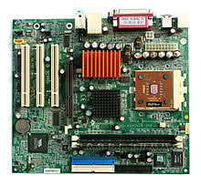

The motherboard is the main circuit board in a computer that connects the different parts of computer together. It contains the primary components of computer system and provides the main computing capability. All the components such as the processor , graphics card , memory modules and so on , connect to the motherboard . An important feature of motherboard is the socket used to house the CPU. The motherboard is also called Printed Circuit Board(PCB).

*Expansion slots:*

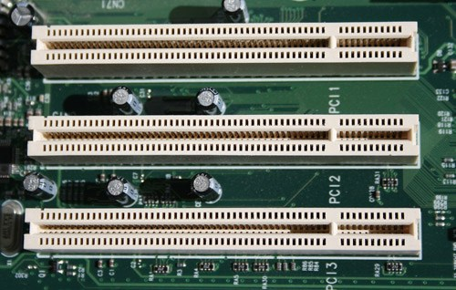

Expansion slots is a slot or socket where a circuit board can be inserted into the motherboard. Most personal computers have form 3 to 8 expansion slots. Expansion slots provide a means of adding new devices or capabilities to the computer such as higher quality sound device , a modem or graphic capabilities. There are 4 types of expansion slots found in the most of the today's computer-a video card , a modem card , a sound card and a networking card.

*Ports:*

External devices such as keyboard , monitor , printer , mouse and microphone are often attached by a cable to the system unit. The interface or point of attachment to the system unit is called ports. Ports are located at the back of system unit . Serial ports transmit one bit of data at a time and is used on IBM PC and compatibles to connect devices such as keyboard , modem and mouse. Parallel ports transmit a byte of data at a time on parallel paths and reserved for printers and some types of external storages devices. A video port is used to connect monitor. Universal Serial Bus is a new type of port that can connect upto 127 different devices with a single connector.