# COMPUTER SOFTWARE CONCEPT

*Introduction:*

Sometimes abbreviated as SW and S/W, software is a collection of instructions that enable the user to interact with a computer, its hardware, or perform tasks. Without software, most computers would be useless. For example, without your Internet browser software, you could not surf the Internet or read this page and without an operating system, the browser could not run on your computer. The picture to the right shows a Microsoft Excel box, an example of a spreadsheet software program. There are 2 types of software. They are:  
1)System software  
2)Application software

*Chart on types of computer:*

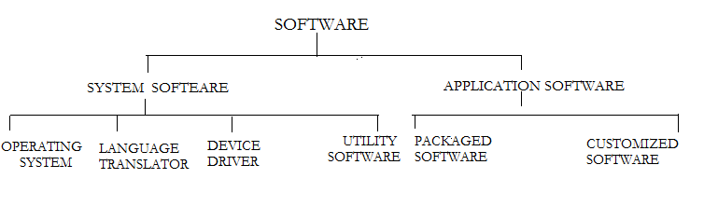

*System software:*

System software refers to the files and programs that make up your computer's operating system. System files include libraries of functions, system services, drivers for printers and other hardware, system preferences, and other configuration files. The programs that are part of the system software include assemblers, compilers, file management tools, system utilites, and debuggers. Since system software runs at the most basic level of your computer, it is called "low-level" software. It generates the user interface and allows the operating system to interact with the hardware. It can further be classified into following categories:  
1) Operating system  
2) Language processor  
3) Device drivers  
4) Utility software

*Operating system :*

An operating system, or "OS," is software that communicates with the hardware and allows other programs to run. It is comprised of system software, or the fundamental files your computer needs to boot up and function. Every desktop computer, tablet, and smart phone includes an operating system that provides basic functionality for the device. From the largest mainframe and supercomputers to small personal computers almost all computer systems run under OS control. The general goal of OS is to operate computer with a minimum of idle time and execute the user programs in the most efficient and economical way.  
An operating system has three main functions:   
1) manage the computer's resources, such as the central processing unit, memory, disk drives, and printers,   
(2) establish a user interface, and   
(3) execute and provide services for applications software. For example  
Operating systems such as MS-DOS and OS/2 are generally used for microcomputer system. CICS,CMS,DOS AND MVS are used for mainframe system.

*Language translator :*

A language translator is a computer program that translates a program that translates a program written in a given programming language into a functionally equivalent program into different languge. Depending on the translator this may involve changing or simplifying the program flow, without losing the essence of the program therby producing a functionally equivalent program . There are 3 types of language translator. They are:   
**1) Assembler**  
An assembler is a program that converts assembly language into machine code. It takes the basic commands and operations from assembly code and converts them into binary code that can be recognized by a specific type of processor.   
**2) Compiler**  
A compiler is a software program that compiles program source code files into an executable program. The compiler takes source code files that are written in a high-level language, and compiles the code into a low-level language, such as machine code. It reports all the errors of the program along with line number.   
**3) Intepreter**  
Interpreter is a language translator that converts high level language into machine language. It translates a program line-by-line (statement-by-statement) and carries out the specified actions in sequence.

*Device drivers:*

Device driver, is a software program that enables a specific hardware device to work with a computer's operating system. Device drivers may be required for internal components, such as video cards and optical media drives, as well as external peripherals, such as printers and monitors.For example sound card drivers tell your software exactly how to translate data into audio signals that the card can output to set of computer>

*Utility software :*

Utility software is system software designed to help analyze, configure, optimize or maintain a computer. It is used to support the computer infrastructure in contrast to application software, which is aimed at directly performing tasks that benefit ordinary users. System profilers,disk defragmenters,network managers and virus scanner.

*Application software:*

Application software is a complete ,self contained program that perfors a specific function directly for the user.It helps the user to work faster,more effiently and more productively. Application software may be written by a large software house which distributes its produts widely and addresses a general class of problems or may be written by an individual and addresses a particular problem.   
Application software is of 2 types.They are:   
1) Customized software   
2) Packaged software

*Customized software:*

Customized software(also known as bespoke software or tailor-made software) is software that is specially developed for some specific organization or other user It is software that is made just for an individual or business that performs tasks specific to their needs. For example, if you had a home business, you may hire someone to create a custom software program to help print and view invoices.

*Packaged software:*

Packaged software, also called a software package, is software that is often used together, performs similar functions, or includes similar features, and is bundled together as a set of software programs. For example, Microsoft Office is packaged software, including multiple software programs used in a home or office, such as Microsoft Excel, Microsoft Word, and Microsoft Powerpoint. Video and audio editing software may be available as packaged software as well, as they may be used together for editing music and video files used in a movie.   
Software programs included in packaged software may be available for purchase individually. However, purchasing the packaged software is often cheaper than purchasing each software program separately. They are user friendly too.

*Popular Packaged software:*

Some of the popular packaged software are discussed below:

**Word processing packages**  
It is a package software that provides extensive tools for creating , editing, storing and printing all kinds of text base documents. It also enables you to add images to document. It can also create document for publishing on the WWW with hyperlinked text and graphics. Examples-microsoft word , page maker and amipro

**Electronic spreadsheet packages**  
It is a special computer program for entering , calculating , manipulating and analyzing sets of number. It also supports graphic features that enable you to produce charts and graphs from data. Example- lotus 1-2-3 and MS-Excel  
**Database Management System(DBMS)**  
It is a complex set of program that control te organization , storage and retrieval of data for many users. It is extensively used in business environment.A database management system must control the security of database. example-oracle , sybase ,dBASE and MS-SQL Server

**Engineering Design packages**  
It refers to the use of computers to help all phases of engineering design work. It also involves conceptual and analytical design step. Example-CAD , AutoCAD

**Presentation graphics packages**   
It provide powerful design tools that make it easy for anyone to outline , create ,edit , arrange and display complex slide presentation. It also enables you to import data from a spreadsheet application to create charts and graphs. Example-microsoft powerpoint , harvard presentation graphics