Table Description

1. Admin
2. User
3. Packages
4. Booking

ADMIN:-

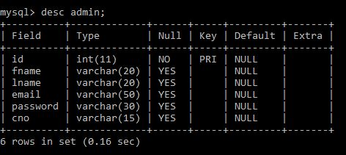

USER:-

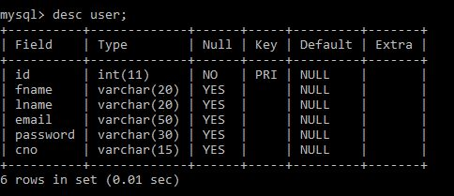

PACKAGES:-



BOOKING:-

