Design Patterns and Principles (Mandatory Hands On)
Exercise 1: Implementing the Singleton Pattern
Logger.cs
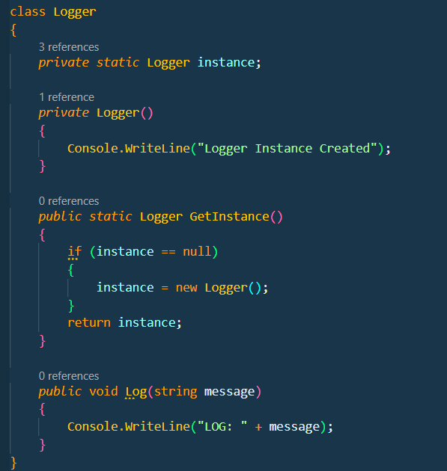
Program.cs
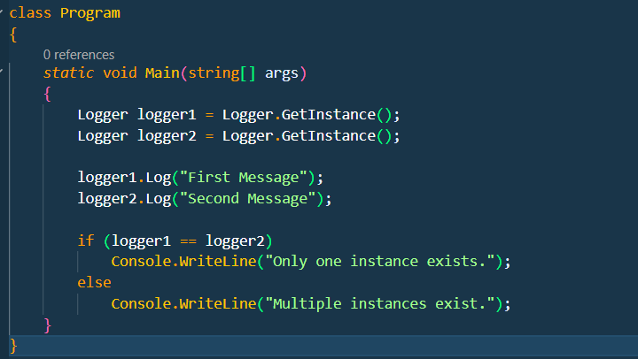

Output:
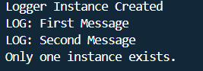

Exercise 2: Implementing the Factory Method Pattern
IDocument.cs
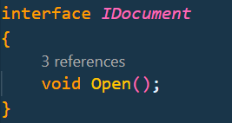
DocumentFactory.cs
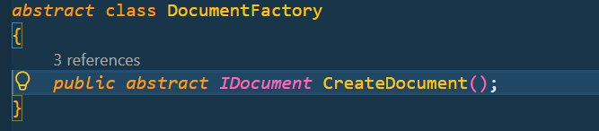
WordDocumnet.cs
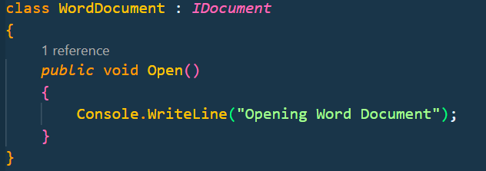
PdfDocument.cs
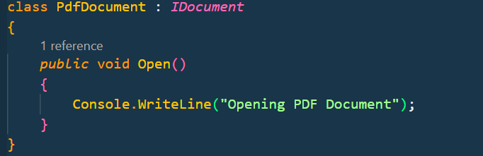
ExcelDocument.cs
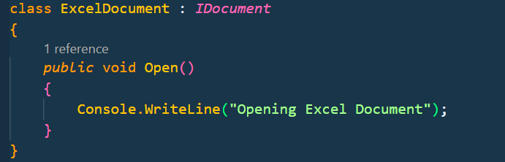
WordFactory.cs
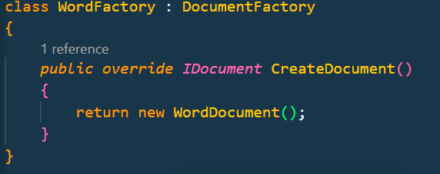

PdfFactory.java
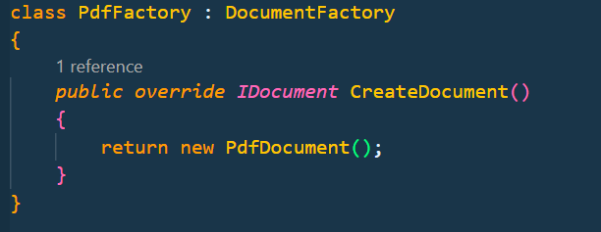
ExcelFactory.cs
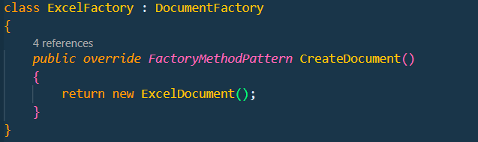
Program.cs
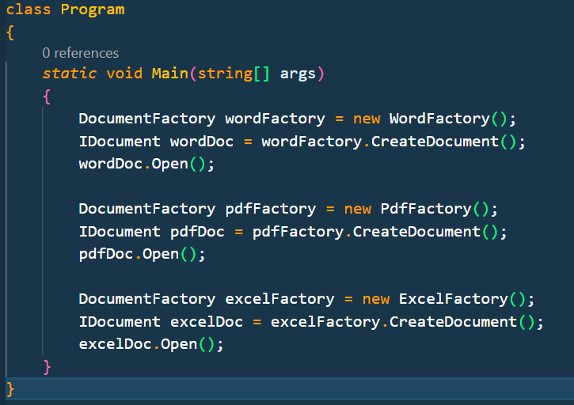

Output:


