Data Structures and Algorithms (Mandatory Hands on)

Exercise 2: E-commerce Platform Search Function
Product.java
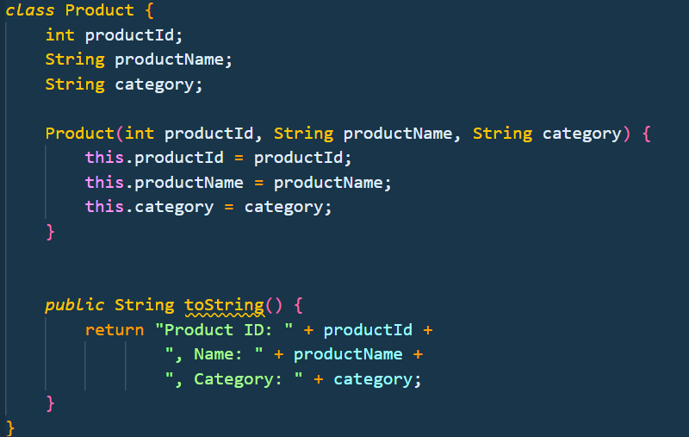
EcommerceSearch.java // Binary Search Implementation
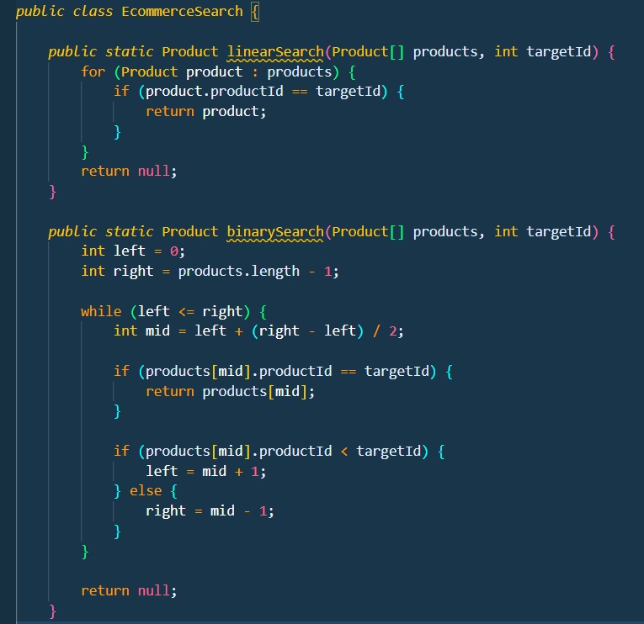
Main file
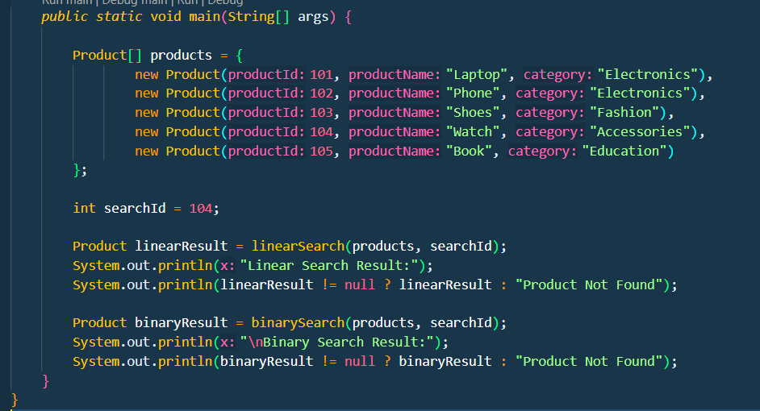
Output:

Exercise 7: Financial Forecasting
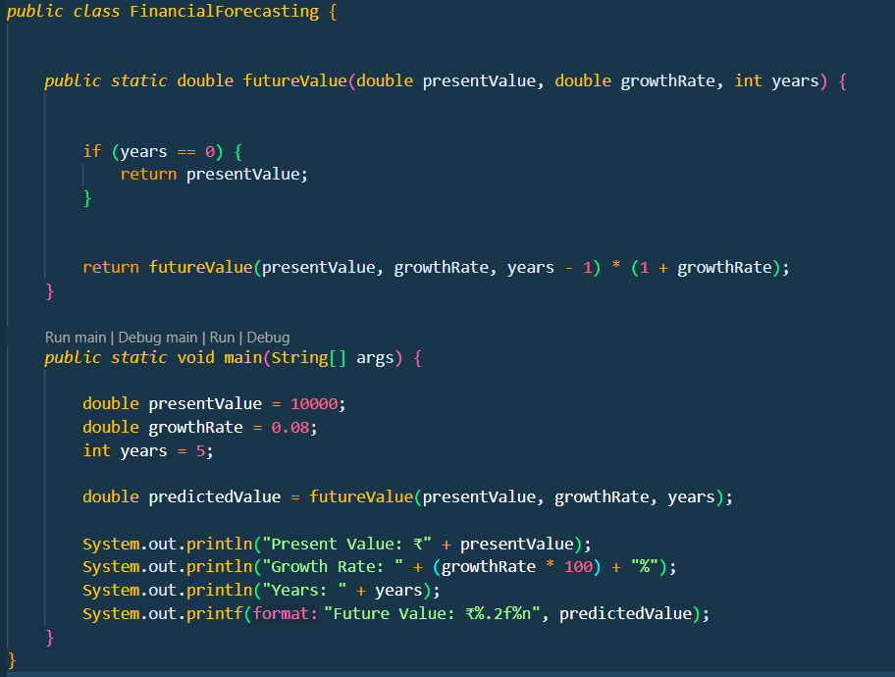
Output:


