Advance SQL Server(Mandatory + Additional HandsOn)
Ranking and Window Function
Scenario 1:
Using ROW_NUMBER () (Top 3 products per category)
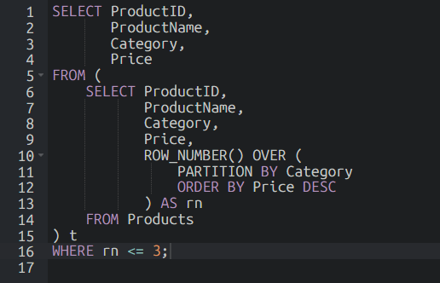
Using RANK () (Handles ties with gaps)
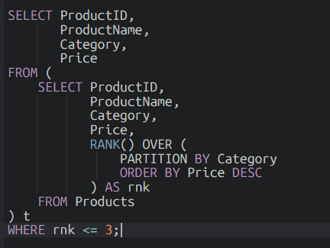
Using DENSE_RANK ()
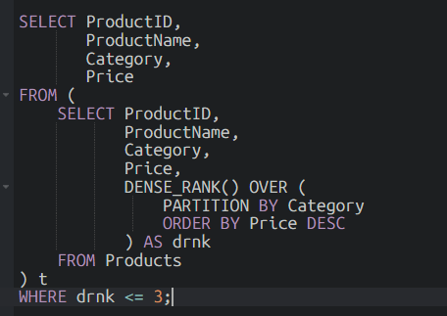
Exercise 1 : Create a Stored Procedure

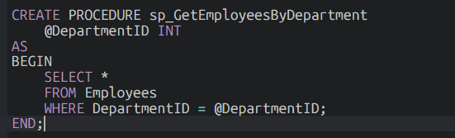
Sample Output:
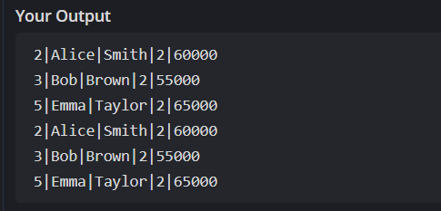
Exercise 5 : Return Data From Stored Procedure
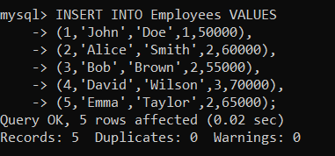
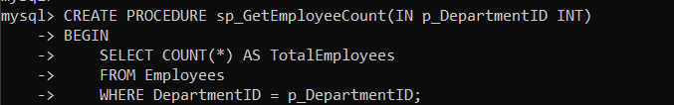
Output:
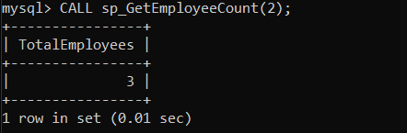

SQL Exercise Index:
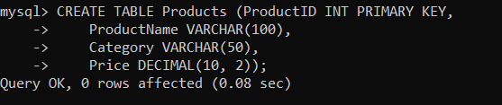
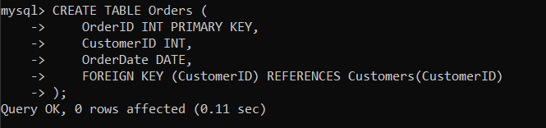
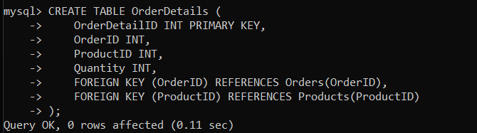
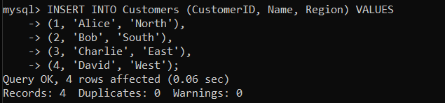
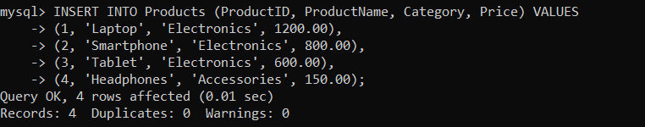
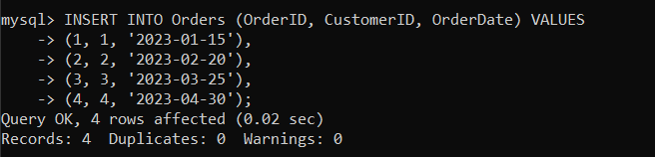
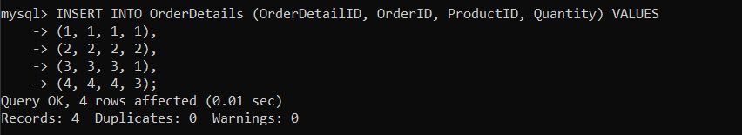
Exercise 1: Creating a Non-Clustered Index
Goal: Create a non-clustered index on the ProductName column in the Products table and compare query execution time before and after index creation.
Step 1:
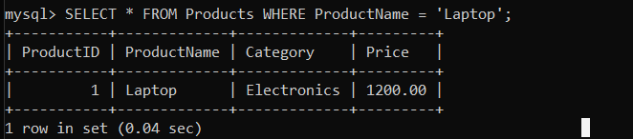
Step 2: Create a non-clustered index
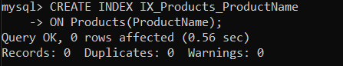
Step 3:
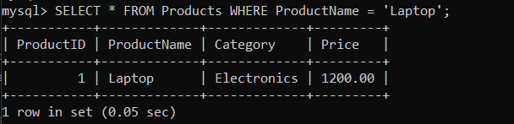

Exercise 2: Creating a Clustered Index
Goal: Create a clustered index on the OrderDate column in the Orders table and compare query execution time before and after index creation.

Step 1: Query to fetch orders before index creation
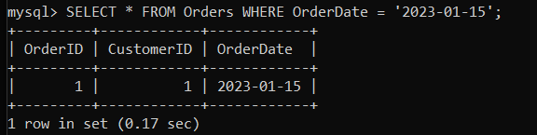
Step 2: Create a clustered index on OrderDate
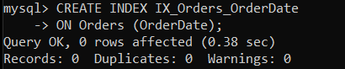
Step 3: Query to fetch orders after index creation
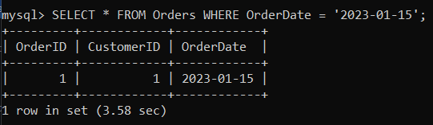

Exercise 3: Creating a Composite Index
Goal: Create a composite index on the CustomerID and OrderDate columns in the Orders table and compare query execution time before and after index creation.
Step 1: Query to fetch orders before index creation
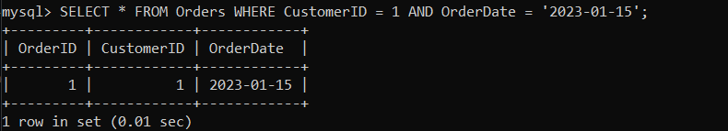
Step 2: Create a composite index on CustomerID and OrderDate
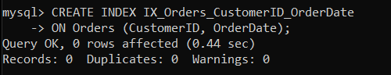
Step 3: Query to fetch orders after index creation
