Design

Introduction

Design refers for architecture or base of application being developed where different diagram displays the application functions, flow of data from one class to another, one frame to another frame. It defines the application. In the case of maintenance or update or for new version, the design and all models are again used. Designing is the most harder in software development process. The application without any design is believed as a non-engineered application. Design refers engineering of any application.

Structural modelling:

Structural modelling is general solution of application to be developed. It gives solution for the visibility of data being passed. It specifies memory requirement and debugging functions. It declares data, variable, method and their label of privacy like privatize or public or secured protection.

Class Diagram

The class diagram is architectural flow cart where classes of application are arranged in relational form. They show relation between classes. The class diagram reflects abstraction, interface dependency, encapsulation inheritance and in general explanation all the coding in diagrammatic form. All methods and process, operations, variables are declaimed before. The application will undergo as the class diagram is constructed. It is the base architecture of application which will be used from starting the project to re-maintenance or update. The class diagram of the application being developed is as next.

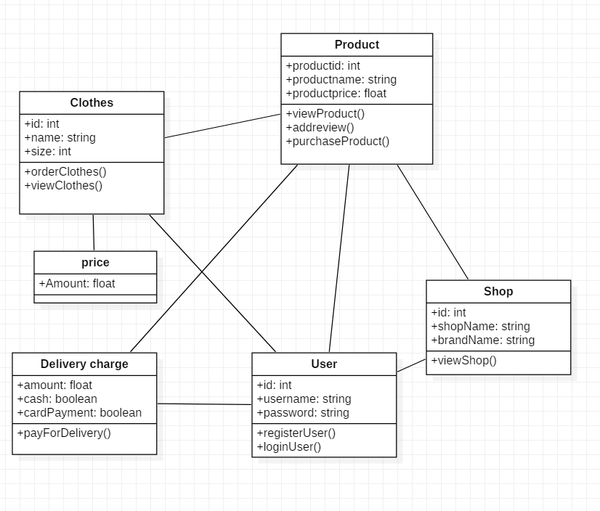

Since Class diagram is the main architectural diagram displaying the internal coding structure it is required in every software development. The main importance of class diagram is that it is the main diagram in time of maintenance or in case any other developer try to effect on code.

Flow chart:

A flowchart is a type of diagram that represents a workflow or process. A flowchart can also be defined as a diagrammatic representation of an algorithm, a step-by-step approach to solving a task. The flowchart shows the steps as boxes of various kinds, and their order by connecting the boxes with arrows. This diagrammatic representation illustrates a solution model to a given problem. Flowcharts are used in analyzing, designing, documenting or managing a process or program in various fields.

Flow char justification:

Behavioral modelling

Behavioral Modelling is the modelling which deals with functionality of entire entity of system. All statements of the system are drafted sequentially with process statement and defines all responses of system.

Activity

Activity diagram is a UML dynamic flowchart which represent flow of one activity to another activity as operation inside the system. It is particular operation of system. So, it is used to construct executable system by using forward and reverse engineering. Though, it doesn’t show message flow, it visualizes the system. It plays specific role in designing the system as explaining the system. The activity of my system is as next. (Tutorials Point, n.d.).

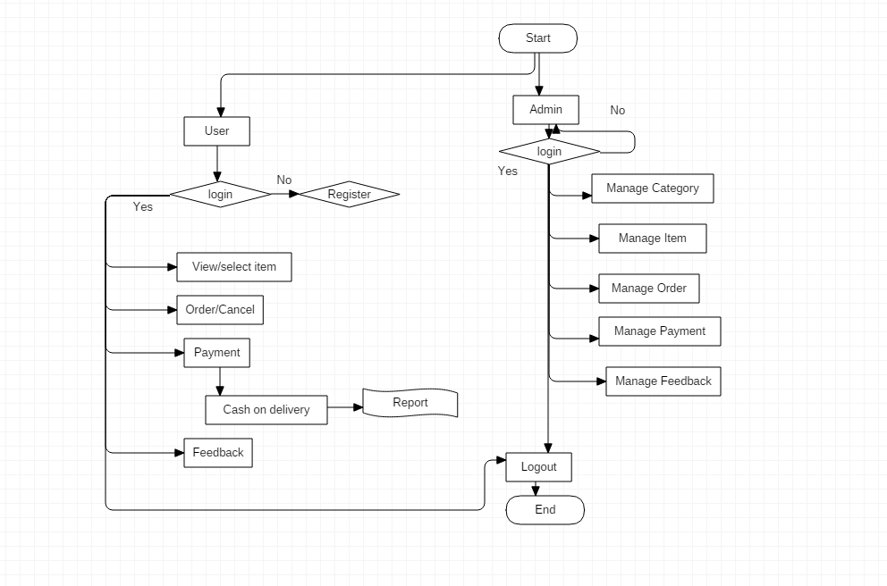

Justification:

There is two swim lane representing user and server. Starting from initial it ends on logout following different step. The process and step relating to server and similarly client are easily displayed. It is displaying all required flows.

Sequence Diagram

Sequence Diagram is UML representation of object collaboration whereas it displays event sequence and interaction between object for provable outcome. Sequence diagram is held as timing diagram and event diagram as per system design specification. Two sequence diagram required is shown below

Justification:

Database Design:

The data is most valuable object in the current context of world. Since the big companies sells their user data for money, data is being misused. Sometimes the database we performing is not secure enough. In the case of my system, most things are done real-time i.e. using server less. Though, for message, user information, group details and contact purposes or for function of application, database should take action. MySQL database will be implemented since being easiness. Use of google login method and holding their register data will be an easier way in my data work. No any call will be saved, image and text would be saved temporarily. So MySQL database will be enough to handle my system’s data.

Data Dictionary

Data dictionary is record of object of database and their relationships to be implemented. Database administrator interact with data dictionary i.e. no any person would be able to view it while it is crucial component of database and its security. It contains all name of data, data type, constraints and null or not null. The constructed database for my database are as below.