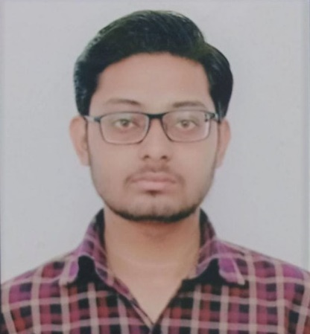

**STRENGTH**

* Analysing every angle of the project before working on it.
* Self-Confident and Great Patience.

**CONTACT**

Mobile: 8707326161 (Call & WhatsApp)

Email: ayushgupta208019@gmail.com

**SKILLS**

* HTML, CSS
* BOOTSTRAP
* PYTHON, DJANGO
* MYSQL

**INTEREST**

* Cooking
* Traveling
* Coding

**LANGUAGE**

* English (Intermediate)
* Hindi

**EDUCATION**

**GOVERNMENT POLYTECHNIC KANPUR**

THREE YEAR DIPLOMA IN IT (2022- CURRENT)

**JAI NARAYAN VIDYA MANDIR INTER COLLEGE, KANPUR**

HIGHSCHOOL (2017) – 78.5 %

**JAI NARAYAN VIDYA MANDIR INTER COLLEGE, KANPUR**

INTERMEDIATE (2019) – 77.2 %

**INTERNSHIP**

**RAMAVI PRIVATE LIMITED**

Time Duration: 6 Months

PYTHON: DJANGO DEVELOPER

**STRENGTHS**

**AYUSH GUPTA**

**PYTHON DEVELOPER**

**Hi, I'm Ayush. I'm completed our BCom from Swami Vivekananda Subharti University Meerut from distance learning and currently I am pursuing Three Year Diploma in Information Technology from Government Polytechnic Kanpur Nagar. I'm passionate about coding and use HTML, CSS, Bootstrap, Python and Django for web development. I'm also familiar with MySQL. I'm an Intermediate level English speaker and I also enjoy cooking, reading, and coding in my free time. I'm looking forward to gain more knowledge and experience in the field of computer.**