Synopsis

on

**Gesture Control Advancements**

Submitted by

**Group No.-**

**Srishty Singh --** 2100290140136

**Raj Pratap Singh --** 2100290140109

under supervision of

**Mr. Prashant Agrawal**



Submitted to

**Department of Computer Applications,**

**KIET Group of Institutions,**

**Delhi-NCR, Ghaziabad**

**ABSTRACT**

The project introduces an application using computer vision for ‘Hand Gesture Recognition’. A camera takes live video stream, and palm detection is applied. Then hand landmarks are generated on the input feed. After that the gesture is recognized.

Previous systems have used data gloves or markers for input in the system. I have no such constraints for using the system. The user can give hand gestures in view of the camera naturally. A completely robust hand gesture recognition system is still under heavy research and development; the implemented system serves as an extensible foundation for future work.

**Table of Contents**

1. Introduction
2. Libraries Used
3. Software Requirement
4. Hardware Requirement
5. Applications
6. Gantt Chart
7. Conclusion

**INTRODUCTION**

Gesture recognition is the mathematical interpretation of a human motion by a computing device.

Gesture recognition is a type of perceptual computing user interface that allows computers to capture and interpret human gestures as commands. The general definition of gesture recognition is the ability of a computer to understand gestures and execute commands based on those gestures.

.

**LIBRARIES USED**

The libraries used for developing this project are:

* Open-CV
* Google Mediapipe
* Tkinter Python Module

**SOFTWARE REQUIREMENTS**

The software environment used for developing the application is:

* Operating System - Windows 10/11 or Ubuntu 18.04
* Code editor – Pycharm

**HARDWARE REQUIREMENTS**

There are no minimum requirements to use this application. However, the preferred hardware requirements are:-

* Processor – Intel i3 5th generation or higher.
* RAM – 4 GB or more.
* A Good Quality Webcam.
* Minimum 8 GB of disk space.

**APPLICATIONS**

**OF GESTURE RECOGNITION**

1. Sign language recognition
2. Media controls
3. Virtual keyboard with gesture inputs
4. Gaming gestures
5. Home automation
6. Robot management

**GANTT CHART**

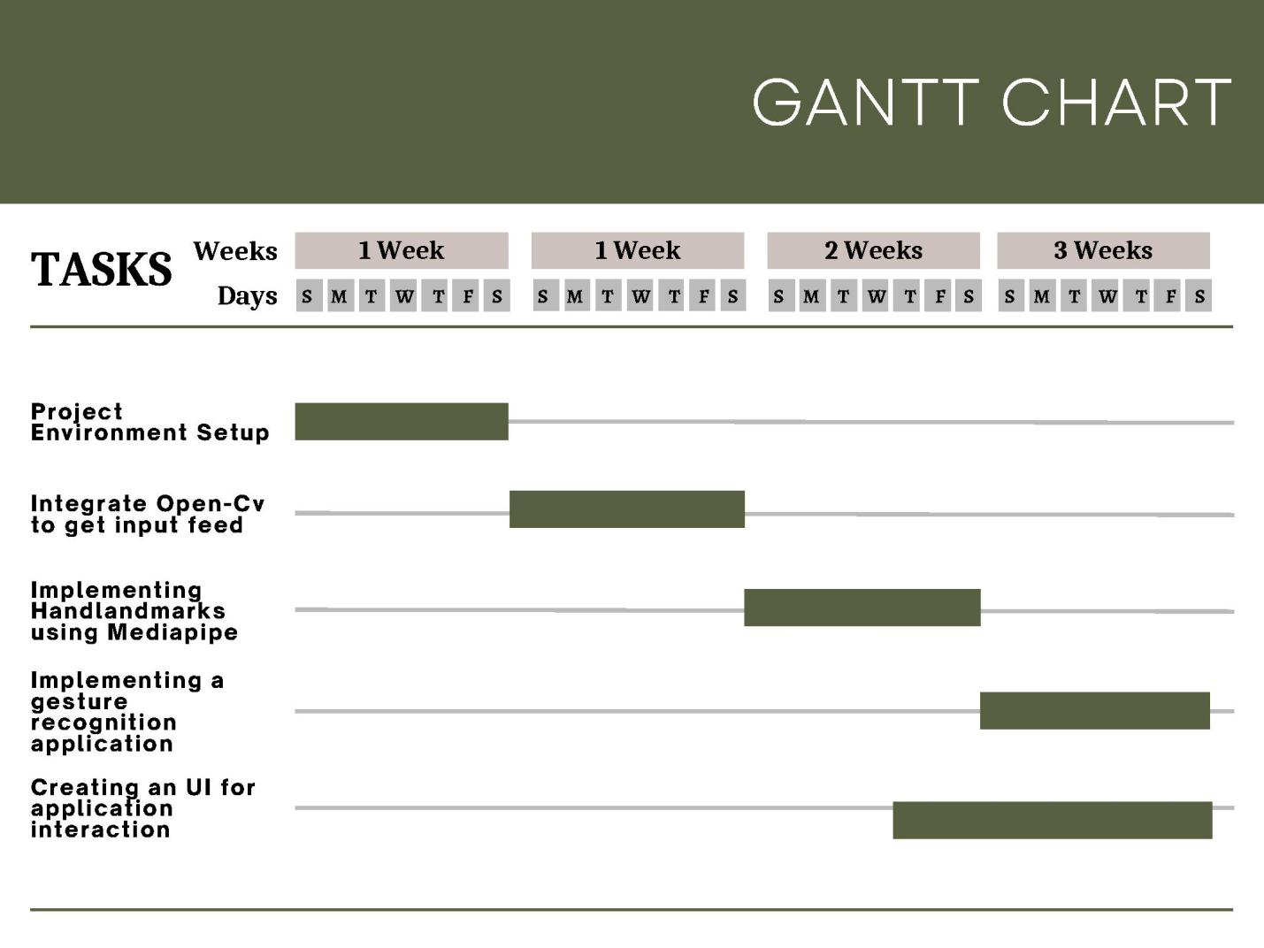

**CONCLUSION**

Gesture recognition technology is the turning point primarily in the world of VR/AR development. It can allow seamless non-touchable control of computerized devices to create a highly interactive, yet fully immersive and flexible hybrid reality.  
The inclusion of this technology in multiple applications across various sectors is further revolutionizing human-computer communication. That said, gesture recognition is no novice’s game.