**PROJECT TITLE**

**A PROJECT REPORT**

**Submitted By**

**Vishal Chaturvedi**

**(2100290140150)**

**Shagun**

**(2100290140150)**

**Vishal Rajput**

**(2100290140151)**

**Submitted in partial fulfilment of the**

**Requirements for the Degree of**

**MASTER OF COMPUTER APPLICATION**

**Under the Supervision of**

**Dr. Sangeeta Arora**

### Assistant Professor



**Submitted to**

**Department Of Computer Applications**

**KIET Group of Institutions, Ghaziabad**

**Uttar Pradesh-201206**

**(June 2023)**

**CERTIFICATE**

Certified that **Vishal Chaturvedi 210029140150168, Shagun 2100290150150** has/ have carried out the project work having “**Face Detection**” for Master of Computer Applications from Dr. A.P.J. Abdul Kalam Technical University (AKTU**)** (formerly UPTU), Technical University, Lucknow under my supervision. The project report embodies original work, and studies are carried out by the student himself / herself and the contents of the project report do not form the basis for the award of any other degree to the candidate or to anybody else from this or any other University/Institution.

**Date:**

**Vishal Chaturvedi (2100290140150)**

**Shagun (2100290140150)**

**Vishal Rajput (2100290140150)**

…………………

…………………….

This is to certify that the above statement made by the candidate is correct to the best of my knowledge.

Date:

**Dr. Sangeeta Arora**

**Assistant Professor**

**Department of Computer Applications**

**KIET Group of Institutions, Ghaziabad**

**Signature of Internal Examiner Signature of External Examiner**

**Dr. Arun Tripathi**

**Head, Department of Computer Applications**

**KIET Group of Institutions, Ghaziabad**

**ABSTRACT**

Face detection, as a fundamental task in computer vision, has garnered significant attention due to its wide-ranging applications in various fields. This paper presents a comprehensive review of face detection techniques, highlighting their algorithms, applications, and associated challenges. The aim is to provide researchers and practitioners with a consolidated understanding of the current state-of-the-art in face detection.

The paper begins by introducing the importance of face detection and its significance in real-world scenarios. It then delves into an overview of different face detection algorithms, covering both traditional approaches and recent advancements driven by deep learning. The traditional algorithms include methods based on Haar-like features, Viola-Jones framework, and cascade classifiers, while deep learning techniques encompass Convolutional Neural Networks (CNNs), Region-based Convolutional Neural Networks (R-CNNs), and Single Shot MultiBox Detectors (SSDs), among others.

Next, the paper explores the diverse applications of face detection across multiple domains. These applications encompass face recognition, emotion analysis, age and gender estimation, facial expression recognition, biometric authentication, surveillance systems, and human-computer interaction, to name a few. The discussion emphasizes how face detection serves as a critical precursor for various higher-level facial analysis tasks.

Furthermore, the paper sheds light on the challenges faced in face detection, including variations in illumination, occlusions, pose variations, facial expressions, and scale variations. It also addresses ethical considerations such as privacy concerns and potential biases associated with face detection algorithms.

To conclude, this review paper provides a comprehensive analysis of face detection techniques, their applications, and the challenges they encounter. It offers valuable insights for researchers, developers, and practitioners working in computer vision and related fields, facilitating further advancements in face detection technology and its integration into real-world applications.

**ACKNOWLEDGEMENTS**

Success in life is never attained single handedly. My deepest gratitude goes to my thesis supervisor, **Dr. Sangeeta Arora** for his guidance, help and encouragement throughout my research work. Their enlightening ideas, comments, and suggestions.

Words are not enough to express my gratitude to Dr. Ajay Kumar Shrivastava, Professor and Head, Department of Computer Applications, for his insightful comments and administrative help at various occasions.

Fortunately, I have many understanding friends, who have helped me a lot on many critical conditions.

Finally, my sincere thanks go to my family members and all those who have directly and indirectly provided me moral support and other kind of help. Without their support, completion of this work would not have been possible in time. They keep my life filled with enjoyment and happiness.

**Vishal Chaturvedi**

**Shagun**

**Vishal Rajput**

**CHAPTER 1 – INTRODUCTION**

**1.1 PROJECT DESCRIPTION**

The project aims to develop an online attendance system using face detection technology. The system will automate the attendance process by capturing and analyzing the facial features of individuals, eliminating the need for manual attendance tracking. This project description provides an overview of the key features and functionality of the system.

Objective:

Develop a reliable and accurate face detection application to identify individuals in real-time.

Capture facial images and extract relevant features for attendance tracking.

Integrate the face detection algorithm with a user-friendly web application for seamless interaction.

Implement a secure database to store attendance records and relevant user information.

Generate comprehensive attendance reports for administrators and users.

System Architecture:

The online attendance system will consist of the following components:

Face Detection Algorithm: A robust algorithm that can detect and recognize human faces accurately.

Image Capture Module: A camera or webcam device to capture facial images for attendance tracking.

Web Application: A user-friendly interface for administrators and users to interact with the system.

Database: A secure database to store attendance records, user profiles, and relevant information.

System Functionality:

Face Enrollment: Users will be required to enroll their facial data during registration, which will be used for future attendance tracking.

Attendance Tracking: The system will capture facial images during specified attendance periods and compare them with enrolled faces to mark attendance.

Real-time Face Detection: The system will employ real-time face detection to identify individuals accurately, ensuring efficient attendance tracking.

Security and Privacy:

Data Encryption: Implement robust encryption techniques to protect sensitive user data and prevent unauthorized access.

Privacy Considerations: Ensure compliance with privacy regulations and obtain necessary consent from users for storing and processing their facial data.

Access Controls: Implement role-based access controls to restrict system functionalities to authorized personnel only.

Technology Stack:

Face detection and recognition: OpenCV or similar libraries/frameworks.

Database: used firebase for database, where data can be stored and fetched in real time.

Expected Outcomes:

Accurate and automated attendance tracking system using face detection technology.

Improved efficiency and reduced administrative burden in managing attendance records.

Enhanced security through biometric-based authentication.

Detailed attendance reports and analytics for administrators.

User-friendly interface for easy system interaction.

**1.2 LITERATURE REVIEW**

The primary purpose of this paper review is to find the solutions provided by others author and consider the imperfection of the system proposed by them, give the best solutions. In [18] Kawaguchi introduced a lecture attendance system with a new method called continuous monitoring, and the student’s attendance marked automatically by the camera which captures the photo of a student in the class. The architecture of the system is simple since two cameras equipped with the wall of the class. The first one is a capturing camera used to capture the image student in the class and the second camera is sensor camera is used to getting the seat of a student inside the class and the camera capturing will snap the image of the student. The system compares the picture taking from a camera capturing images and faces in the database done much time to perfect the attendance. Other paper proposed by [2] introduced a real-time computer vision algorithm in automatic attendance management system. The system installed the camera with non-intrusive, which can snap images in the classroom and compared the extracted face from the image of the camera capturing with faces inside the system.

**1.2 PROJECT SCOPE**

Problem Definition:

Clearly define the purpose of the face detection system.

Determine the context in which face detection will be used (e.g., security, biometrics, photography, video analysis).

System Requirements:

Identify the technical requirements for the face detection system, such as accuracy, speed, scalability, and compatibility with different platforms or devices.

Determine the environmental requirements, such as lighting conditions and camera specifications.

Data Collection and Preparation:

Identify the data sources for training and testing the face detection algorithm, which may include image databases or video recordings.

Develop strategies for collecting and annotating the data to create a labeled dataset for training the face detection model.

Preprocess and clean the data to remove any irrelevant or noisy information.

Algorithm Selection:

Research and evaluate different face detection algorithms, such as Viola-Jones, Histogram of Oriented Gradients (HOG), or deep learning-based approaches like Convolutional Neural Networks (CNNs).

Select the most suitable algorithm based on the project requirements and constraints, considering factors such as accuracy, speed, and computational resources.

Model Training and Optimization:

Train the selected face detection model using the labeled dataset.

Fine-tune the model parameters to improve accuracy and performance.

Perform rigorous testing and validation to ensure the model meets the desired performance metrics.

Integration and Deployment:

Integrate the trained face detection model into the target system or application.

Develop an interface or API for interacting with the face detection system.

Test the integrated system for functionality, reliability, and performance.

Evaluation and Iteration:

Evaluate the performance of the face detection system against predefined metrics and criteria.

Collect user feedback and make necessary improvements or refinements based on the evaluation results.

Iterate on the system, incorporating additional features or addressing any identified limitations.

Documentation and Maintenance:

Prepare comprehensive documentation that includes system architecture, algorithms used, training methodologies, and deployment instructions.

Establish a maintenance plan to address future updates, bug fixes, and potential scalability requirements.

**1.3 HARDWARE / SOFTWARE USED IN PROJECT**

**1.3.1 SOFTWARE REQUIREMENTS**

* Operating System – Windows 10/11 or Ubuntu 18.04 or above.
* Code Editor –Pycharm
* Flutter: for designing UI
* Dart: for programming language
* Firebase Fire store: for online database

**1.3.2 HARDWARE REQUIREMENTS**

* Processor – Intel i5 7th generation or higher
* RAM – Minimum 4 GB, recommended 8 GB
* Disk Space – Minimum 10 GB of free disk space

**CHAPTER 2 – FEASIBILITY STUDY**

**2.1 TECHNICAL FEASIBILITY**

The technical feasibility of the Project Allotment System (PAS) assesses the system's ability to be developed, implemented, and operated successfully within the organization's technical infrastructure. It evaluates factors such as technology requirements, compatibility, scalability, and integration capabilities. The technical feasibility of the PAS is as follows:

* Technology Requirements: a. Development Framework: The PAS will require a suitable development framework that supports the required functionalities, such as web development frameworks like Django, Ruby on Rails, or ASP.NET. b. Database Management System: A database management system, such as MySQL, PostgreSQL, or MongoDB, will be necessary to store and manage project data, user profiles, and assignments. c. Server Infrastructure: Adequate server infrastructure, including hardware and software, will be required to host and deploy the PAS. Considerations like server capacity, security, and performance must be addressed. d. Web-Based Interface: The PAS will be developed as a web-based application, necessitating compatibility with modern web browsers and responsive design to ensure accessibility across various devices.
* Compatibility and Integration: a. Integration with Existing Systems: The PAS may need to integrate with other existing systems, such as project management tools, HR databases, or authentication systems. Compatibility and data exchange requirements must be assessed and addressed. b. System Interoperability: The PAS should support standard data formats and protocols to facilitate interoperability with external systems and enable data sharing.
* Scalability: a. User and Project Scaling: The PAS should be designed to handle the expected number of users and projects within the organization. Considerations for scaling the system, such as database optimization, load balancing, and server capacity, must be incorporated into the design.
* Security: a. Data Security: The PAS should employ robust security measures to protect sensitive project and user data. This includes encryption, secure authentication mechanisms, and access control to prevent unauthorized access. b. System Vulnerability Assessment: Regular vulnerability assessments and security audits should be conducted to identify and address potential system vulnerabilities.
* Technical Expertise: a. Development Team: The availability of skilled developers with expertise in the chosen development framework, database management system, and web technologies is essential for the successful implementation of the PAS. b. IT Infrastructure Support: Adequate IT support and resources must be available to ensure the smooth operation, maintenance, and troubleshooting of the PAS.
* Budget and Timeline: a. Adequate budget and timeline should be allocated to meet the technical requirements, perform necessary integrations, conduct testing, and address any unforeseen technical challenges.

Evaluating the technical feasibility of the Project Allotment System is crucial to ensure that the required technology infrastructure, resources, and expertise are available to develop, implement, and operate the system effectively within the organization. Addressing technical considerations in the early stages of the project minimizes risks, supports a smooth implementation process, and enables the successful deployment of the PAS.

**2.2 OPERATIONAL FEASIBILITY**

The operational feasibility of the Project Allotment System (PAS) evaluates its practicality and effectiveness in day-to-day operations within the organization. It assesses the system's impact on existing workflows, user acceptance, training requirements, and overall operational efficiency. The operational feasibility of the PAS is as follows:

* User Acceptance: a. Stakeholder Analysis: Identify the key stakeholders and user groups who will interact with the PAS, such as project managers, team members, and administrators. Understand their needs, preferences, and potential resistance to change. b. User Involvement: Involve users in the development and implementation process through feedback sessions, pilot testing, and training programs. Their input and engagement are crucial for user acceptance and successful adoption of the PAS. c. User Interface and Experience: Ensure that the PAS provides a user-friendly interface and intuitive navigation. Design the system to accommodate varying levels of technical expertise among users, minimizing the learning curve and promoting user acceptance.
* Workflow Integration: a. Workflow Analysis: Evaluate the existing project assignment and resource allocation processes within the organization. Identify potential bottlenecks, inefficiencies, and pain points that the PAS can address and streamline. b. System Customization: Assess the PAS's ability to adapt to the organization's specific requirements and workflows. Customization options should be available to align the system with existing processes and terminology. c. Integration with Existing Systems: Determine the PAS's ability to integrate with other existing systems, such as project management tools or HR databases, to ensure smooth data exchange and minimize duplication of efforts.
* Training and Support: a. Training Needs Assessment: Identify the training requirements for different user groups to effectively use the PAS. Develop training materials, conduct training sessions, and provide ongoing support to ensure users are proficient in utilizing the system. b. Help and Support Mechanisms: Implement a robust help desk or support system to address user queries, provide troubleshooting assistance, and resolve issues promptly. This helps users feel supported and confident in utilizing the PAS.
* Organizational Impact: a. Change Management: Develop a change management strategy to address any resistance to change and promote organizational buy-in. Clearly communicate the benefits of the PAS to stakeholders and create a supportive environment for system adoption. b. Organizational Readiness: Evaluate the organization's readiness for adopting the PAS, considering factors such as resource availability, infrastructure requirements, and cultural acceptance of technological advancements.
* Performance Measurement: a. Key Performance Indicators (KPIs): Define relevant KPIs to measure the effectiveness and impact of the PAS on resource allocation, project performance, and overall operational efficiency. Monitor these KPIs to track the system's benefits and identify areas for improvement.

Assessing the operational feasibility of the Project Allotment System is essential to ensure that the system integrates seamlessly into existing workflows, gains user acceptance, and enhances operational efficiency. By considering user needs, workflow integration, training requirements, and organizational impact, organizations can identify potential challenges and develop strategies to overcome them. The goal is to achieve smooth system implementation, user satisfaction, and improved project management practices within the organization.

**2.3 BEHAVIORAL FEASIBILITY**

Behavioral feasibility assesses the willingness and ability of individuals within an organization to adopt and effectively utilize the Project Allotment System (PAS). It considers the human factors, such as attitudes, perceptions, and behavioral patterns, that may impact the system's successful implementation. The behavioral feasibility of the PAS is as follows:

* User Acceptance: a. User Needs Assessment: Understand the needs, preferences, and pain points of potential system users, such as project managers, team members, and administrators. Conduct surveys or interviews to gather feedback on the current project assignment processes and identify areas for improvement. b. User Involvement: Involve users in the design and development stages of the PAS to ensure their needs and expectations are considered. Engage them in providing feedback, testing the system, and participating in decision-making processes. c. Change Management: Develop a comprehensive change management strategy to address any resistance to the system. Communicate the benefits and value of the PAS to users, emphasizing how it will simplify their tasks, improve resource allocation, and enhance overall project management practices.
* Training and Education: a. Training Programs: Offer training programs to users to enhance their understanding of the PAS, its functionalities, and best practices for efficient utilization. Provide hands-on training, user guides, and tutorials to help users become proficient in using the system. b. User Support: Establish a support system to address user inquiries, troubleshoot issues, and provide ongoing assistance. Offer resources such as FAQs, help desks, or dedicated support personnel to ensure users can access timely support when needed.
* User-Friendly Interface: a. Intuitive Design: Design the PAS with a user-friendly interface, considering user experience and ease of navigation. Ensure that the system is intuitive and requires minimal training to perform common tasks. b. Clear and Consistent Terminology: Use terminology and language that aligns with the organization's existing project management practices. Avoid complex jargon or ambiguous terms that may confuse or alienate users.
* Perceived Value and Benefits: a. Communication of Benefits: Clearly communicate the benefits and advantages of the PAS to users. Emphasize how the system will streamline project assignment, optimize resource allocation, and enhance overall project performance. b. Demonstrations and Success Stories: Conduct system demonstrations and share success stories from early adopters or pilot projects to showcase the positive impact of the PAS. Seeing practical examples of the system's benefits can increase user confidence and acceptance.
* Continuous Improvement: a. Feedback Mechanisms: Establish feedback mechanisms to allow users to provide input, suggest improvements, and report any issues or concerns related to the PAS. Actively listen to user feedback and consider incorporating valuable suggestions into system enhancements. b. Iterative Development: Adopt an iterative development approach, regularly releasing updates and improvements based on user feedback and changing organizational needs. This demonstrates a commitment to continuous improvement and keeps users engaged.

By considering behavioral factors and addressing user acceptance, training, and communication of system benefits, organizations can enhance the behavioral feasibility of the Project Allotment System. Engaging users, providing necessary support, and fostering a positive perception of the system increases the likelihood of successful adoption and utilization. Ultimately, user acceptance and satisfaction are crucial for the system's long-term success within the organiza **2.4 ECONOMICAL FEASIBILITY**

The economic feasibility of the Project Allotment System (PAS) assesses the financial viability and cost-effectiveness of implementing and operating the system within an organization. It involves evaluating the costs associated with development, implementation, maintenance, and potential cost savings or benefits derived from the system. The economic feasibility of the PAS is as follows:

* Cost Analysis: a. Development Costs: Evaluate the expenses related to developing the PAS, including software development, system design, and customization. b. Hardware and Infrastructure Costs: Assess the need for hardware upgrades or additional infrastructure to support the PAS. Consider factors such as servers, network infrastructure, and storage requirements. c. Integration Costs: Determine the costs associated with integrating the PAS with existing systems, such as project management tools, HR databases, or authentication systems. d. Training Costs: Consider the expenses for user training programs, documentation, and ongoing support to ensure users are proficient in utilizing the PAS. e. Maintenance and Support Costs: Estimate the ongoing costs for system maintenance, updates, bug fixes, and user support.
* Cost Savings and Benefits: a. Resource Optimization: Identify potential cost savings resulting from improved resource allocation and utilization. The PAS can help minimize idle time, reduce overallocation, and optimize project assignments, leading to increased productivity and efficiency. b. Project Delays and Rework Reduction: Assess the potential reduction in project delays and rework resulting from improved project assignment and resource allocation processes. This can lead to cost savings by avoiding additional project costs and penalties. c. Improved Decision Making: Consider the value of enhanced decision-making capabilities resulting from the PAS's reporting and analytics features. The ability to analyze resource allocation data can lead to better resource planning and cost-effective project management. d. Scalability and Growth: Evaluate the potential for cost savings and scalability as the organization grows. The PAS should be capable of accommodating increased project volumes and resource requirements without significant additional costs.
* Return on Investment (ROI): a. Calculate the return on investment by comparing the total costs incurred against the projected benefits and cost savings over a specific period. This helps determine the financial feasibility of implementing the PAS. b. Consider the payback period, which indicates how long it will take for the organization to recover the initial investment in the PAS.
* Risk Analysis: a. Assess potential financial risks and uncertainties associated with the PAS implementation, such as cost overruns, unexpected expenses, or changes in technology or market conditions. Develop risk mitigation strategies to minimize the impact of these risks.

The economical feasibility study of the Project Allotment System provides insights into the costs, potential savings, and benefits associated with the system's implementation and operation. It helps decision-makers evaluate the financial viability of investing in the PAS and determine if the expected benefits outweigh the costs. By conducting a thorough economic analysis, organizations can make informed decisions and allocate resources effectively to maximize the return on investment.

**CHAPTER 3 – DATABASE DESIGN**

**2.1 WATERFALL MODEL**

The waterfall model is a well-known structured methodology for software development. The whole process of system development is divided into distinct phases. The model has been introduced in 1970s. Every phase has a unique output. It was the first SDLC model to be used widely. So that, sometimes it is referred to Waterfall by SDLC. The waterfall model is used when the system requirements are well known, technology is understood, and the system is a new version of an existing. Product (Dennis, Wixom and Roth, 2012).

Mainly there are six phases in Waterfall model. If there is a problem faced in any phase of cycle, the system goes to the previous phase. The phases of Waterfall method are.

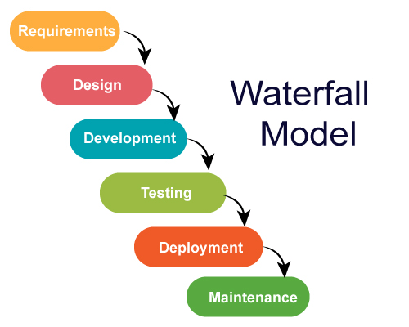

Figure 1: Waterfall Model

**2.2 ER DIAGRAM**

An Entity-Relationship (ER) diagram can be utilized in the development of a chatting app to visualize the relationships between various entities and their attributes. Here's how an ER diagram can be applied.

* **User Entity:** The ER diagram can include a "User" entity, representing the users of the chatting app. It can have attributes such as UserID, Username, Password, Email, and Profile Picture. This entity captures the basic information related to the app's users.
* **Chat Entity:** The "Chat" entity can be included to represent individual conversations or group chats. It may have attributes such as ChatID, Title, and CreationDate. This entity helps establish the relationship between users and their conversations.
* **Message Entity:** The "Message" entity can be used to capture the messages exchanged within a chat. It can have attributes such as MessageID, Content, SenderID, and Timestamp. This entity establishes the relationship between chats and the messages exchanged within them.
* **Group Entity:** If the app includes group chatting functionality, a "Group" entity can be added. It can have attributes such as GroupID, Name, Description, and CreationDate. This entity helps represent and manage the groups within the app.
* **Media Entity:** If multimedia sharing is a feature of the app, a "Media" entity can be included. It may have attributes like MediaID, Type, Filename, and UploadDate. This entity enables the management and tracking of shared multimedia content.
* **Relationships:** Establish relationships between entities using appropriate cardinalities. For example, a user can participate in multiple chats, so the relationship between User and Chat would be one-to-many. Similarly, messages belong to a specific chat, indicating a one-to-many relationship between Chat and Message.

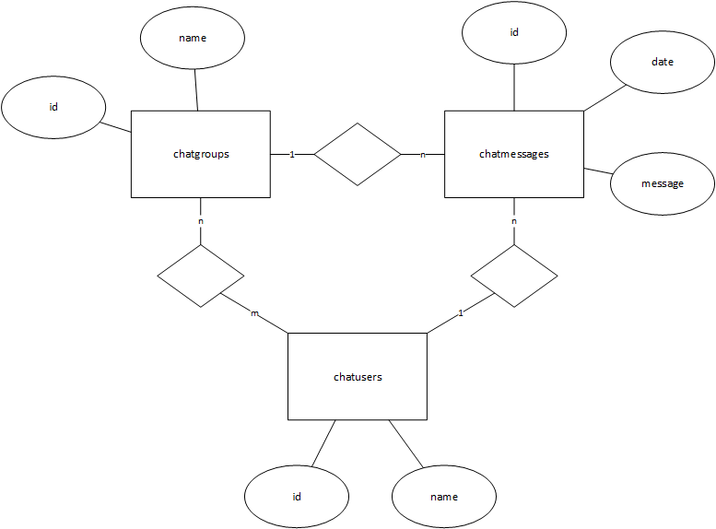

Figure 2: ER Diagram

**2.3 USE CASE DIAGRAM**

Use-case diagrams model the behavior of a system and help to capture the requirements of the system. Use-case diagrams describe the high-level functions and scope of a system. These diagrams also identify the interactions between the system and its actors.

A use case diagram is used to represent the dynamic behavior of a system. It encapsulates the system's functionality by incorporating use cases, actors, and their relationships. It models the tasks, services, and functions required by a system/subsystem of an application. It depicts the high-level functionality of a system and also tells how the user handles a system.

Purposes of a use case diagram given below:

* It gathers the system's needs.
* It depicts the external view of the system.
* It recognizes the internal as well as external factors that influence the system.
* It represents the interaction between the actors

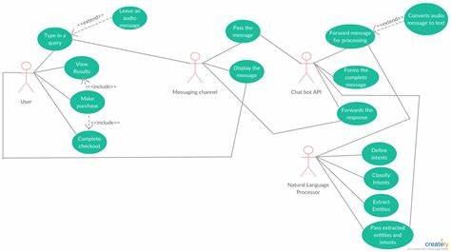

Figure 3: ER Diagram

**2.4 ACTIVITY DIAGRAM**

An Activity Diagram can be used in the development of a chatting app to depict the flow of activities and behaviors within the system. Here's how an Activity Diagram can be applied.

* **User Registration:** The Activity Diagram can start with the "User Registration" activity, depicting the process of a user creating an account. It would include activities such as entering registration details, validating input, and creating a new user profile.
* **Login and Authentication:** The diagram can show the activities related to user login and authentication. This would involve activities like entering login credentials, validating them, and granting access to the app upon successful authentication.
* **Chatting Activities:** The core activities of the chatting app can be represented, including creating a new chat, joining an existing chat, and sending messages. These activities can be visualized as separate swimlanes or branches, showing the interaction between multiple users or participants within the chat.
* **Multimedia Sharing:** If the app supports multimedia sharing, the diagram can depict the activities involved in uploading and sharing photos, videos, or other media files. It would include activities like selecting a file, uploading it, and notifying other participants of the shared media.
* **Group Management:** If the app includes group chatting functionality, the Activity Diagram can illustrate activities related to group creation, management, and member invitations. It would involve activities like creating a new group, adding or removing members, and moderating group conversations.
* **Notification System:** The diagram can show activities related to the notification system, including activities like sending push notifications for new messages or updates, and displaying notifications to the users.
* **Logout and Session Management:** The diagram should include activities related to user logout and session management, ensuring that users can securely end their session and handle scenarios such as session timeouts.

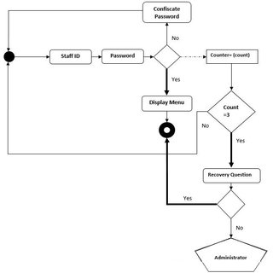

Figure 4: ER Diagram

**2.5 SEQUENCE DIAGRAM**

A Sequence Diagram can be useful in the development of a chatting app to illustrate the chronological sequence of interactions between different entities or components within the system. Here's how a Sequence Diagram can be applied:

* **User Registration:** The Sequence Diagram can depict the sequence of interactions between the user interface and the backend components during the user registration process. It would show the steps involved, such as the user entering registration details, the system validating the input, and the creation of a new user profile.
* **Login and Authentication:** The diagram can illustrate the sequence of interactions between the user, the login interface, and the authentication system. It would show how the user enters login credentials, the system verifies them, and grants access to the app upon successful authentication.
* **One-to-One Chat:** The Sequence Diagram can represent the sequence of interactions between two users engaging in a one-to-one chat. It would show the exchange of messages between the sender and receiver, indicating the order and timing of message delivery.
* **Group Chat:** If the app supports group chatting, the diagram can depict the interactions between multiple users within a group chat. It would show how messages are sent, received, and distributed to all members of the group.
* **Multimedia Sharing:** The Sequence Diagram can illustrate the interactions involved in sharing multimedia content, such as photos or videos. It would show the steps of selecting a file, uploading it to the server, and notifying other users about the shared media.
* **Notification System:** The diagram can represent the interactions between the app and the notification system. It would show how the app sends notifications to users when new messages or updates are received, and how users interact with those notifications.
* **Error Handling:** The Sequence Diagram can depict the interactions related to error handling and exception scenarios. It would show how errors or exceptions are detected, reported, and handled within the app, including displaying error messages to users.
* **Logout and Session Management:** The diagram can illustrate the sequence of interactions involved in user logout and session management. It would show the steps taken to securely end the user session and perform any necessary cleanup or session-related tasks.

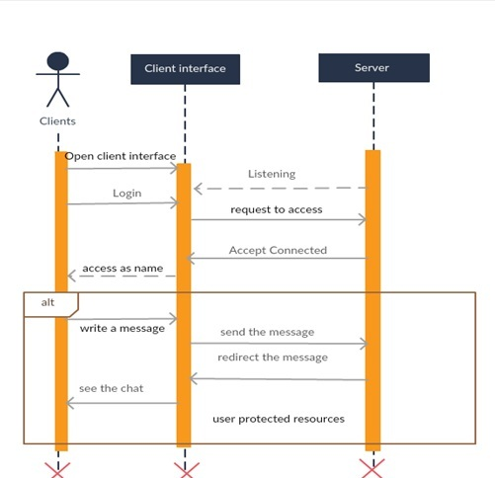

Figure 5: Sequential Diagram

**2.6 COLLABORATION DIAGRAM**

A Collaboration Diagram is useful in the development of a chatting app for several reasons:

* **Visualizing Interactions:** A Collaboration Diagram provides a visual representation of how different objects or entities in the system collaborate and interact with each other. It helps developers understand the flow of information and the sequence of interactions between components, making it easier to identify potential issues or bottlenecks.
* **Clarifying Object Relationships**: The diagram illustrates the relationships and dependencies between objects or entities in the app. It helps in understanding how objects communicate and cooperate to accomplish specific tasks. This clarity assists in designing and implementing the app's architecture and ensures that the interactions between components are properly defined.
* **Identifying Communication Channels:** The Collaboration Diagram helps in identifying the communication channels between different objects or entities. It shows how messages or data are passed between components, clarifying the interfaces and API calls required for successful communication. This information is vital for developers when implementing the app's functionality.
* **Analyzing System Behavior:** By visualizing the interactions and collaborations between objects, the diagram enables developers to analyze the behavior of the system. It helps in identifying potential issues such as concurrency problems, race conditions, or communication conflicts. This analysis can lead to improvements in the app's performance and reliability.
* **Communication and Collaboration:** The Collaboration Diagram serves as a communication tool among developers, designers, and stakeholders. It provides a shared understanding of how different components work together, facilitating effective discussions and decision-making during the development process. It helps in aligning the development team's understanding of the app's architecture and functionality.
* **Test Case Generation:** The Collaboration Diagram can aid in generating test cases for the app. By examining the interactions between components, developers can identify the critical paths and scenarios that need to be tested. It helps in designing comprehensive test cases that cover all the necessary interactions and ensure the app functions as intended.

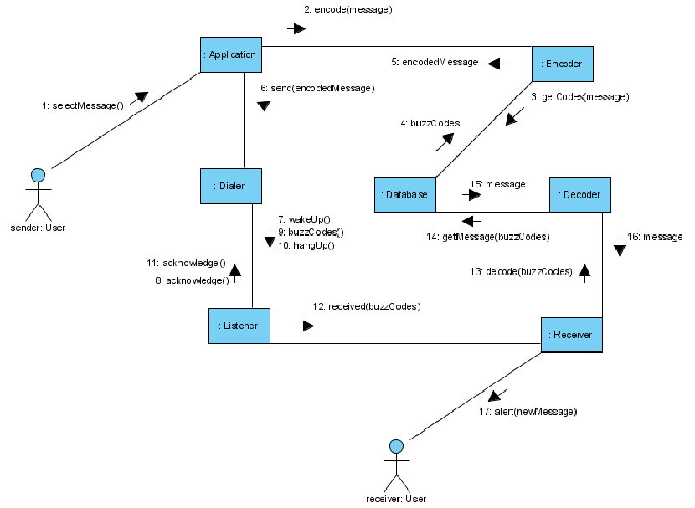

Figure 6: Sequential Diagram

**2.7 COMPONENT DIAGRAM**

A Component Diagram is useful in the development of a chatting app to depict the high-level structure and organization of the system, highlighting the various components and their interdependencies. Here's how a Component Diagram can be applied:

* **User Interface Component:** The Component Diagram can include the User Interface component, representing the front-end or client-side of the chatting app. It encompasses the graphical user interface (GUI), screens, forms, and user interaction elements.
* **Application Server Component:** The diagram can depict the Application Server component, representing the server-side logic of the chatting app. This component handles business logic, authentication, message routing, and other core functionalities.
* **Database Component:** The Component Diagram can include the Database component, representing the storage and retrieval of data in the app. It illustrates the database management system (DBMS) or data storage technology used, and the tables or collections storing user profiles, chats, messages, and other relevant data.
* **Messaging Service Component:** If the app includes real-time messaging capabilities, the diagram can show the Messaging Service component. This component manages the communication and exchange of messages between users, ensuring reliable and efficient message delivery.
* **Media Storage Component:** If multimedia sharing is supported, the Component Diagram can include the Media Storage component. It represents the storage infrastructure or cloud service used to store and retrieve media files, such as images or videos.
* **External Services or APIs:** The diagram can illustrate external services or APIs used by the app, such as authentication services (OAuth, OpenID), notification services (Push Notifications), or media processing services (image compression, video transcoding). These components depict the integration points with external systems.
* **Dependency Relationships:** The Component Diagram highlights the dependencies between components, indicating the required interfaces, dependencies, or communication channels between them. For example, the User Interface component may depend on the Application Server component for user authentication or message retrieval.
* **Deployment Environment:** The Component Diagram can also depict the deployment environment, illustrating the physical or virtual infrastructure where the components are deployed. This may include servers, cloud platforms, or other hosting environments.

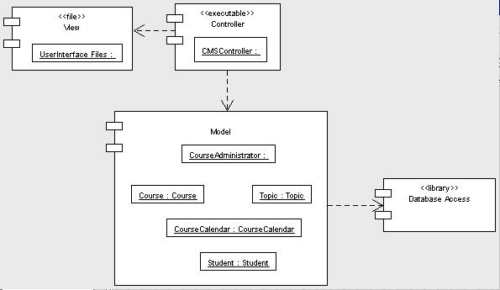

Figure 6: Component Diagram

**CHAPTER 4 – FORM DESIGN**

**4.1 SCREENSHOTS**

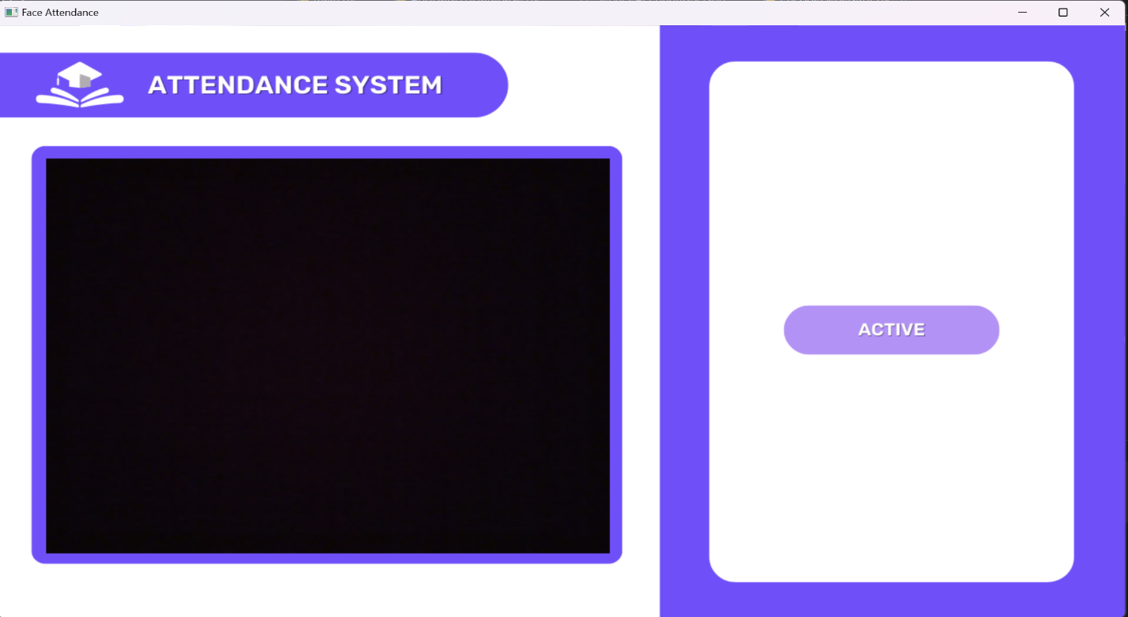

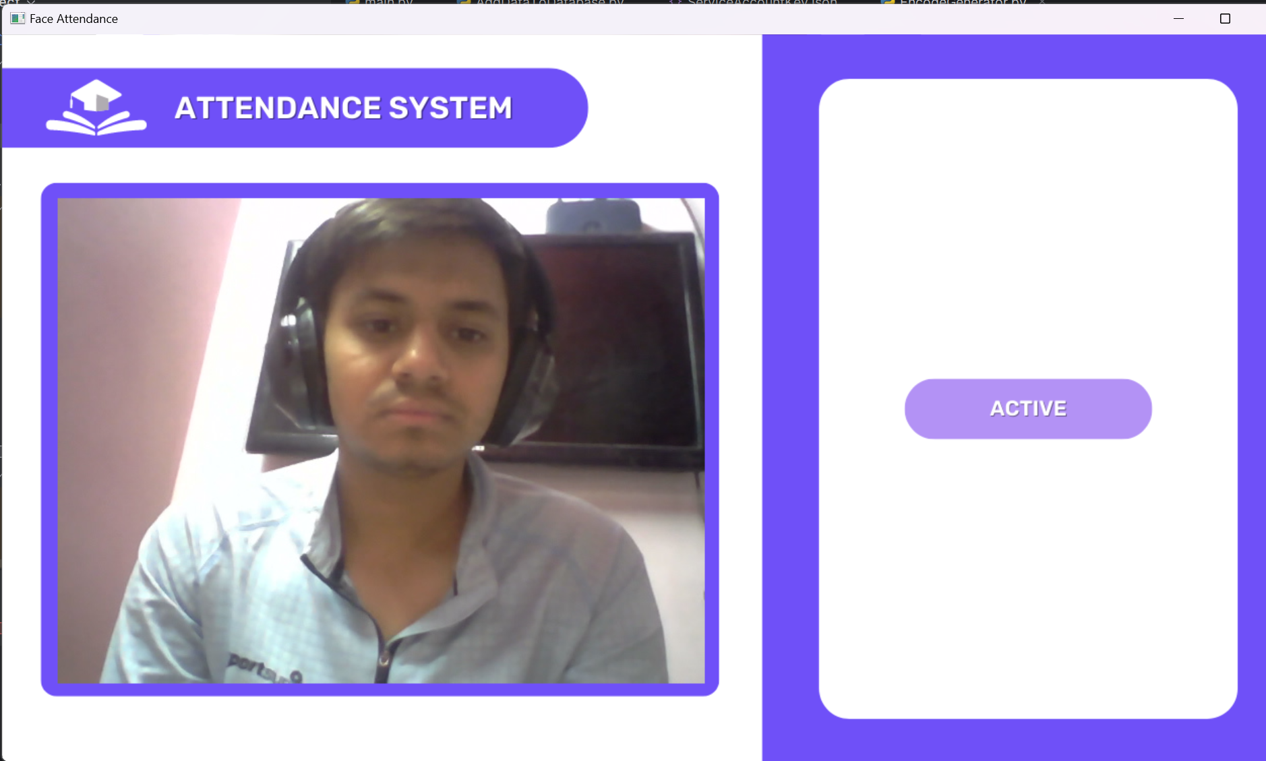

**CHAPTER 6 – TESTING**

**6.1 Functional Testing**

Functional testing is highly valuable in the development of a chatting app as it ensures that the app's features and functionalities work correctly and meet the intended requirements. Here's how functional testing can be useful, along with examples of test cases:

1. **User Registration:**

* **Test Case 1:** Verify that a new user can successfully register by entering valid registration details, such as a unique username, email address, and password.
* **Test Case 2:** Validate that the app displays an error message when attempting to register with invalid or duplicate information.
* **Test Case 3:** Ensure that the user's registration information is stored correctly in the database and can be retrieved for future logins.

1. **User Authentication and Login:**

* **Test Case 1:** Confirm that users can log in with valid credentials and are granted access to the app's features and functionalities.
* **Test Case 2:** Verify that the app displays appropriate error messages when users enter incorrect login credentials or forget their password.
* **Test Case 3:** Test the "Remember Me" functionality, ensuring that users can stay logged in across app sessions when the option is selected.

1. **One-to-One Chat:**

* **Test Case 1:** Validate that users can start a one-to-one chat by selecting a contact and sending messages back and forth.
* **Test Case 2:** Ensure that messages are delivered and displayed accurately and in the correct order to both the sender and receiver.
* **Test Case 3:** Test the app's ability to handle multimedia content within one-to-one chats, such as sending and receiving photos or videos.

1. **Group Chat:**

* **Test Case 1:** Verify that users can create a group chat and invite other users to join the group.
* **Test Case 2:** Validate that messages sent in a group chat are received by all members of the group and displayed correctly.
* **Test Case 3:** Test the functionality of adding or removing participants from a group chat, ensuring that updates are reflected accurately.

1. **Multimedia Sharing:**

* **Test Case 1:** Ensure that users can upload and share multimedia content, such as photos or videos, within chats or groups.
* **Test Case 2:** Validate that shared media files are displayed correctly to the recipients and can be downloaded or viewed as intended.
* **Test Case 3:** Test the app's ability to handle different file formats and sizes when sharing multimedia content.

1. **Notifications:**

* **Test Case 1:** Validate that users receive push notifications for new messages or updates, even when the app is in the background or the device is asleep.
* **Test Case 2:** Verify that notifications are delivered accurately and in a timely manner without any delay or loss.
* **Test Case 3:** Test the behavior of notifications when the user is actively using the app, ensuring they don't disrupt the user experience.
  1. **NON-FUNCTIONCAL TESTING**

Non-functional testing is essential in the development of a chatting app as it focuses on evaluating aspects of the app beyond its specific features. It assesses the app's performance, usability, security, and other non-functional aspects. Here's how non-functional testing can be useful, along with examples of test cases:

1. **Performance Testing:**

* **Test Case 1:** Evaluate the app's response time for common operations such as sending messages, loading chats, or retrieving user profiles.
* **Test Case 2:** Measure the app's scalability by simulating a high number of concurrent users and monitoring its performance under load.
* **Test Case 3:** Verify the app's ability to handle a large volume of messages, ensuring that it doesn't degrade in performance.

1. **Usability Testing:**

* **Test Case 1:** Assess the app's ease of use and intuitiveness by observing users' interactions with the user interface and gathering feedback.
* **Test Case 2:** Validate that the app adheres to user interface design guidelines, including consistent layout, clear labeling, and intuitive navigation.
* **Test Case 3:** Test the app's accessibility features, ensuring compatibility with screen readers, font size adjustments, and color contrast options.

1. **Security Testing:**

* **Test Case 1:** Assess the app's resistance to common security vulnerabilities, such as SQL injection, cross-site scripting (XSS), or session hijacking.
* **Test Case 2:** Validate the effectiveness of encryption mechanisms for sensitive data transmission, such as user credentials or media files.
* **Test Case 3:** Verify that user authentication and authorization mechanisms prevent unauthorized access to chats or user information.

1. **Compatibility Testing:**

* **Test Case 1:** Validate the app's compatibility with different operating systems, such as iOS and Android, and different versions of each platform.
* **Test Case 2:** Test the app's compatibility with various web browsers, ensuring consistent functionality and appearance across different browsers and versions.
* **Test Case 3:** Verify the app's compatibility with different screen resolutions and device sizes to ensure a consistent user experience.

1. **Reliability Testing:**

* **Test Case 1:** Verify the app's stability by conducting prolonged testing sessions and monitoring for crashes or unexpected behavior.
* **Test Case 2:** Validate the app's ability to recover from unexpected events, such as network interruptions or server failures, without data loss or corruption.
* **Test Case 3:** Test the app's behavior under low or unstable network conditions, ensuring it handles connectivity issues gracefully.

1. **Load Testing:**

* **Test Case 1:** Assess the app's performance and stability under heavy loads by simulating a large number of users and monitoring response times and resource usage.
* **Test Case 2:** Validate that the app's infrastructure, including servers and databases, can handle the expected load without performance degradation.
* **Test Case 3:** Test the app's behavior when multiple users perform simultaneous actions, such as sending messages or sharing media.

**REFERANCES**

1. Bharti, P., Yadav, S., & Rathi, S. (2017). Resource Allocation in Software Project Management: A Comprehensive Review. International Journal of Computer Applications, 171(4), 13-18.
2. Chokshi, N., & Chokshi, A. (2018). Project Resource Allocation using Genetic Algorithm. International Journal of Computer Applications, 179(3), 29-35.
3. Fernandes, A. J., Rodrigues, R. M., & Neves, J. (2016). Project Scheduling and Resource Allocation: A Survey of Current Models and Techniques. European Journal of Operational Research, 248(3), 749-774.
4. Jiang, J., Sun, C., Zeng, H., & Fan, J. (2019). An Overview of Resource Allocation and Scheduling in Project Management. Future Generation Computer Systems, 92, 899-910.
5. Maheshwari, P., Suman, A., Kumar, A., & Poonia, R. C. (2016). Resource Allocation Techniques in Cloud Computing: A Comprehensive Review. International Journal of Computer Applications, 148(4), 20-25.