

**SOEN 6841**

**Software Project Management**

**Winter 2024**

**Topic 29: Emergency Response Coordination System**

| **Group Members** | **Student Id** |
| --- | --- |
| Harsh Tank | 40269370 |
| Ayush Patel | 40272388 |
| Zeel Divawala | 40272584 |
| Ankush desai | 40271170 |
| Mihir Gediya | 40272399 |

**Professor: Dr. Joumana Dargham**

**INTRODUCTION**

This project and report focus on addressing a critical gap by seizing the opportunity to develop and commercialize a system that enhances communication and coordination during emergencies. The system will connect first responders, authorities, and the broader community, aiming to serve a diverse range of users not only emergency departments but also residents across Canada.This system will leverage these efforts by offering a modern, scalable solution designed to streamline emergency response across multiple levels of users.

**PROBLEM AND OPPORTUNITY STATEMENT**

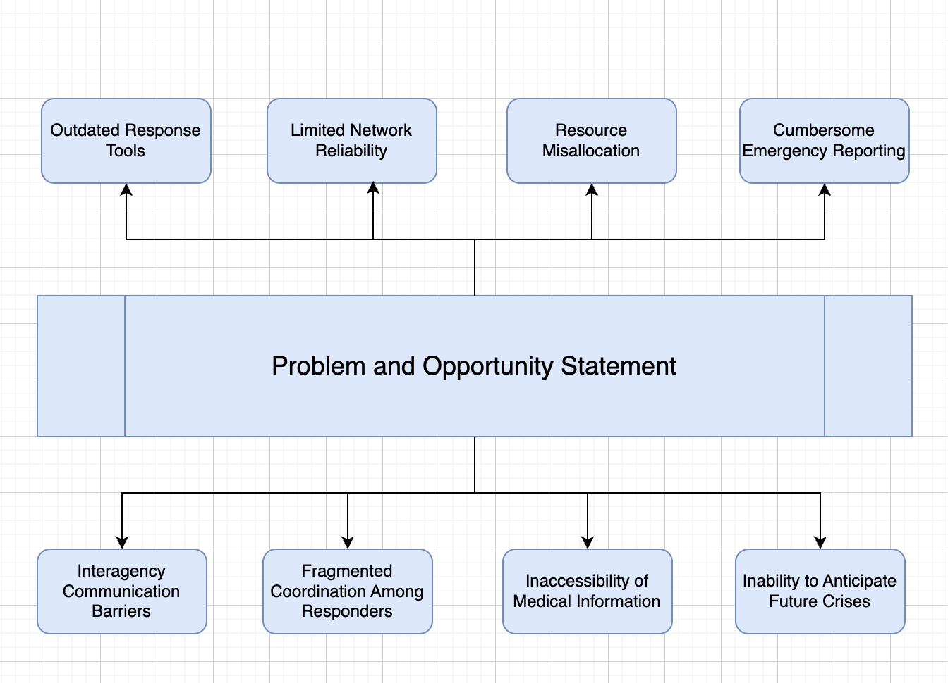

**1. Cross-Department Compatibility**

**Problems:** Cooperation and information sharing are hampered by the disparate emergency response teams' usage of incompatible communication platforms. During large-scale emergencies, it is challenging for teams from different regions to collaborate seamlessly due to the absence of a uniform platform.

**Opportunity:** This divide can be closed with a powerful, unified system that combines information from several departments. Instead of starting from scratch, the solution can involve integrating current systems and adding new functionality to them.

**2. Limitations in Real-Time Information for Responders**

**Problems:** Inadequate or antiquated technology hinders emergency teams' ability to obtain precise real-time information, which slows down decision-making in emergency situations.

**Opportunity:** Creating a mobile app and real-time dashboard for responders will guarantee that they have access to the most recent data and improve their ability to make decisions quickly.

**3. Difficulty in Reporting Emergencies**

**Problems**: The public's current means of reporting emergencies are frequently convoluted, which causes delays in response times that can be fatal.

**Opportunity**: A public-facing, easy-to-use software with a straightforward UI will enable locals to report emergencies promptly and effectively, while also providing more sophisticated functions for individuals who require them.

**4. Network Dependability and Infrastructure Limitations**

**Problems**: The system's performance is largely dependent on the network infrastructure, which might be unstable in rural or underdeveloped locations.

**Opportunity**: The application will provide various means of connectivity, such as cellular internet, Wi-Fi, GPS, GIS, texting, and phone calls. Considering the urgency of the issue, it will intelligently choose the best available network.

**5. Wastage of Time and Resources**

**Problems:** Ineffective resource management during crises results in unneeded expenditures and delays, which reduces the efficacy of response operations.

**Opportunity:** The system's ability to streamline resource use and optimize time management will cut expenses, minimize delays, and improve response effectiveness.

**6. Lack of Coordination Among Responders**

**Problems:**  In emergency situations, a lack of coordination between responding agencies causes confusion, duplication of effort, and delays.

**Opportunity:** Responders will be able to collaborate more efficiently and rapidly with each other if they have access to a system that allows for real-time communication across various departments and provides the option to escalate difficulties.

**7. Lack of Immediate Access to Medical Information**

**Problems**: In medical emergencies, responders frequently do not have instant access to vital patient information, which can postpone treatment and put lives at danger.

**Opportunity**: During an emergency, rescuers can access medical data entered by users into the public app, including blood type and emergency contacts, which will speed up and enhance the quality of care provided.

**8. Limited Capability to Predict Emergencies**

**Problems**: Planning for readiness and response is hampered by the current systems' poor capacity to forecast the possibility and intensity of future emergencies.

**Opportunity**: The system can use machine learning to enhance prediction capabilities by gathering pertinent and anonymised emergency data. This will enable authorities to better plan for future catastrophes.

**STAKEHOLDER ANALYSIS**

Several important stakeholders are involved in the creation and implementation of an Emergency Response Coordination System (ERCS) because they are either impacted by current issues or have an opportunity to gain from better emergency response coordination. For successful system deployment and effective stakeholder involvement, it is essential to comprehend their interests and concerns.

### **1. Government Agencies**

* **Interests**: Improving interagency cooperation, guaranteeing public safety, and bolstering catastrophe preparedness.
* **Concerns**: The difficulties of coordinating several agencies, bureaucratic inertia, and resource limitations are possible obstacles.

### **2. First Responders (Firefighters, Police, EMS)**

* **Interests**: Making sure one is safe while operating, getting real-time information, and allocating resources effectively.
* **Concerns**: Dangers brought on by poor communication, a wait for assistance, and the psychological and physical effects of emergency circumstances.

### **3. Healthcare Organizations**

* **Interests**: Delivering prompt medical attention, effectively handling the influx of patients, and upholding the standard of healthcare services.
* **Concerns**: Overburdened facilities, resource shortages, and ensuring the safety of healthcare personnel.

### **4. Non-Governmental Organizations (NGOs)**

* **Interests**: Providing humanitarian aid, helping populations in need, and working with other organizations to coordinate efficient relief operations.
* **Concerns**: Concerns include navigating logistical obstacles, obtaining enough financing, and guaranteeing assistance workers' safety.

### **5. Media**

* **Interests**: Providing the public with timely and accurate information, encouraging transparency, and promoting public safety via efficient communication.
* **Concerns**: Concerns include preventing the dissemination of false information, protecting journalists in risky situations, and striking a balance between accuracy and speed of reporting.

### **6. Logistics Companies**

* **Interests**: Encouraging the effective flow of commodities, particularly vital ones during crises, and assisting relief efforts by ensuring prompt delivery.
* **Concerns**: Issues to be concerned about include infrastructure damage, security threats in war areas, and crisis coordination with other authorities and groups.

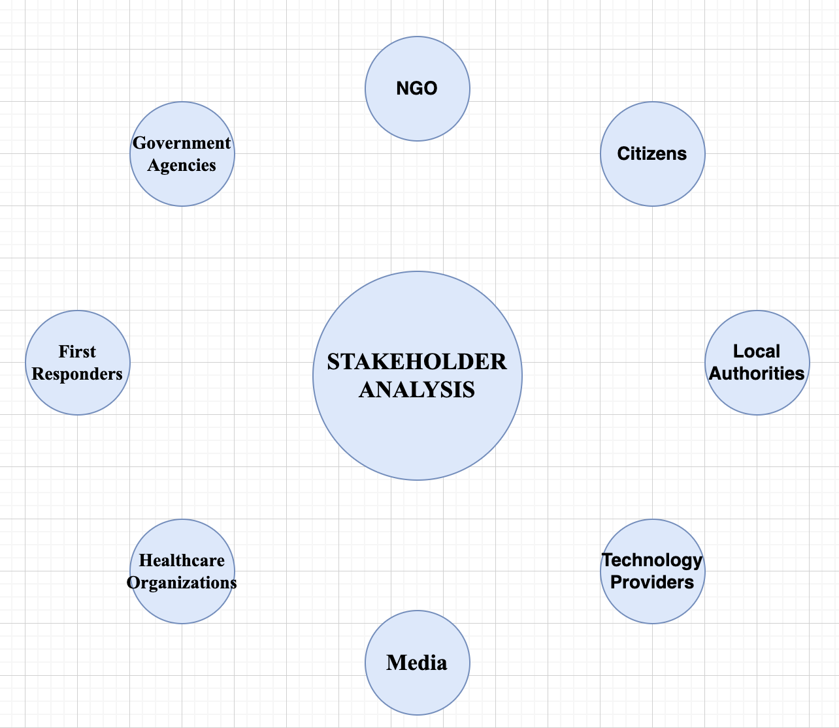

### **Relevance to Software Solution**

**Comprehensive Data Integration**Responders are given a comprehensive picture of the emergency situation by the program, which maintains and integrates many data sources. The effectiveness of responses can be improved by making well-informed decisions based on accurate and up-to-date information thanks to this integrated data management.

**Enhanced Communication**The software facilitates seamless, instantaneous communication amongst emergency responders, enabling them to synchronize their operations with efficiency. During emergencies, the instantaneous transmission of vital information facilitates faster response times and better results.

**Secure Information Storage**The program guarantees the safekeeping of crucial user information, maintaining secrecy and privacy while yet offering the data required for making emergency decisions. This protects private information from possible misuse and unwanted access.

**Alert System**The software's alert system is a crucial feature that promptly notifies impacted family members and responders about situations. This timely warning aids in the quick mobilization of aid, which may save lives and lessen the overall impact of emergencies.

**Live Situation Monitoring**The software makes it easier to track emergencies in real time, giving responders the ability to see developments as they happen. Their ability to make prompt judgments and necessary modifications is enhanced by this real-time awareness, which in turn improves their overall reactivity during times of crisis.

**Integration of AI and Machine Learning**The program improves its capacity to assess and forecast emergencies by integrating AI and machine learning features. Responders are more equipped to foresee possible threats thanks to this proactive strategy, which also increases response efforts' efficacy.

**Initial Thoughts on the Scope of the Emergency Response Coordination System (ERCS) Software Solution**

#### **1. Core Functionalities**

* Real-Time Communication:
* Incident Reporting and Management:
* Resource Allocation:
* Data Integration:
* Notifications and Alerts

#### **2. Advanced Features**

* AI and Machine Learning:
* Live Monitoring Dashboards:
* Post-Event Analysis Tools:

#### **3. User Roles and Permissions**

* Customizable User Roles:

#### **4. Training and Support**

* User Training Programs:
* Ongoing Support and Maintenance:

**REFERENCES**

## An Emergency Management Plan: <https://research.com/software/best-emergency-management-software#1>

Safety Culture:

<https://safetyculture.com/app/emergency-management-software/>

StackHolder’s Framework

<https://www.ontario.ca/document/emergency-management-framework-ontario/stakeholders>