Name= abhishek tomar

Course= BSc IT 2B

Student ID = 20051085

Q.1 Write a c program to implement FCFS CPU Scheduling Algorithm

Source code:

#include<stdio.h>

struct PCB{

int pid, arrival, burst, turnaround;

};

void pline (int x);

void main()

{

int i, num, j;

float avg=0.0, sum =0.0;

struct PCB p[10], temp;

printf ("Enter the total number of Processes: ");

scanf("%d", &num);

for (i = 0; i < num; i++)

{

printf ("Enter Arrival time and Burst time for Process %d: \n", i+1);

scanf("%d %d", &p[i] .arrival, &p[i]. burst);

p[i]. pid= i+1;

}

for(i=0; i<num-1; i++)

{

for(j=0; j<num-i-1;j++)

{

if(p[j]. arrival > p[j+1] . arrival)

{

temp=p[j];

p[j]=p[j+1];

p[j+1]=temp;

}

}

}

for(i=0; i<num; i++)

{

sum = sum +p[i] .burst;

p[i].turnaround =sum;

}

sum =0;

pline (44);

printf("PID\tArrival\tBurst\tTurnaround\n");

pline(44);

for(i= 0; i< num; i++)

{

printf("%d\t%d\t%d\t%d\n",p[i].pid,p[i].arrival,p[i].burst,p[i].turnaround);

sum+=p[i].turnaround;

}

pline (44);

avg = sum /(float)num;

printf("\nTotal Turnaround Time : %f.", sum);

printf("\nAverage Turnaround Time : %.3f.", avg);

}

void pline(int x)

{

int i;

for(i =0; i<x;i++)

{

printf("-");

}

printf("\n");

}

Output :

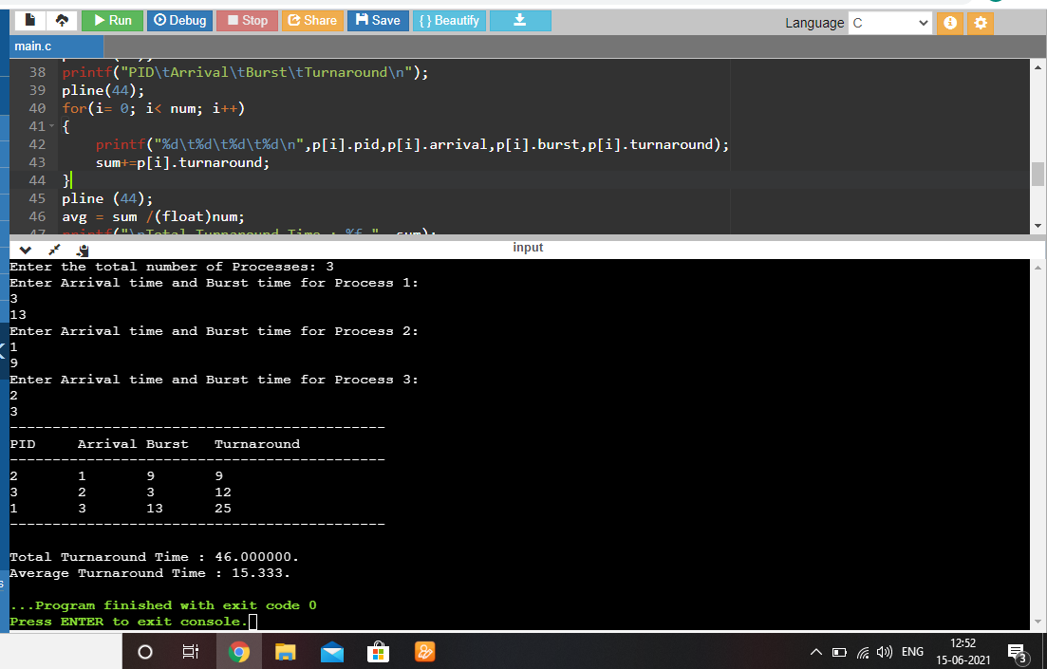

Q.2 Write a c program to implement SJF CPU Scheduling Algorithm.

Source code:

#include <stdio.h>

struct PCB{

int burst, pid, wait, turnaround;

};

void pline(int);

void main ()

{

struct PCB p[10], temp;

int i, n, j=1, sum=0,w_total=0, t_total =0;

float w_avg=0.0, t_avg=0.0;

printf("SJF Algorithm\n");

printf("Enter the total number of processes :");

scanf("%d", &n);

for (i=0;i<n;i++)

{

printf("Enter the Burst Time of process %d :\n",i+1);

scanf("%d", &p[i] .burst);

p[i].pid = i+1;

}

for(i=0;i<n;i++)

{

for(j=0;j<n-i-1;j++)

{

if(p[j].burst>p[j+1].burst)

{

temp = p[j];

p[j] = p[j+1];

p[j+1] = temp;

}

}

}

for(i=0;i<n;i++)

{

p[i].wait = sum;

sum = sum + p[i] .burst;

p[i] . turnaround = sum;

}

pline (35);

printf("OID\tBurst\tWait\tTurnaround");

pline (35)

;

for(i=0;i<n;i++)

{

printf("%d\t%d\t%d\t%d\n", p[i] .pid,p[i].burst, p[i].wait,p[i].turnaround);

w_total += p[i].wait;

t_total +=p[i].turnaround;

}

w_avg = w_total/(float)n;

t_avg = t_total/(float)n;

printf("\nTotal Waiting Time : %d ",w_total);

printf("\nAverage Waiting Time : %.3f",w_avg);

printf("\nTotal Turnaround Time : %.3f",t_avg);

}

void pline (int x)

{

int i;

for(i=0;i<x;i++)

{

printf("-");

}

printf("\n");

}

Output :