How did I get the formula?

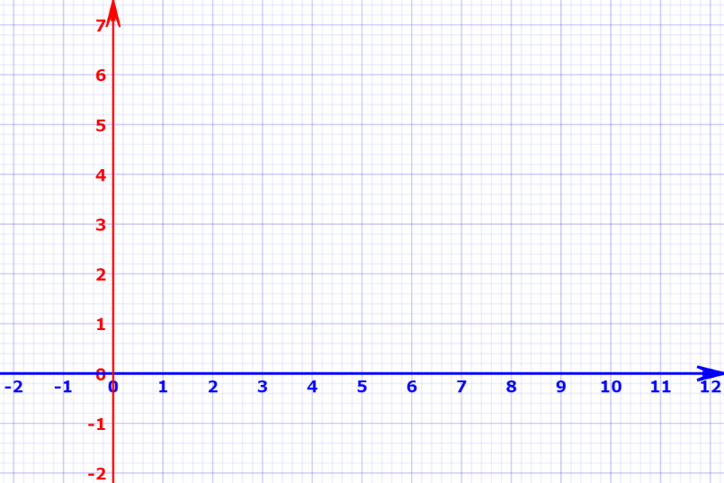

Sol. Let (a,b) be the chef and (c,d) be the girl and

\* (c, d )

\* (a,b )

(0,x) be the mirror.

Line joining chef and mirror = L1

Line joining girl and mirror = L2

Slope of line L1 = m1 = $\frac{b-0}{a-x}$ = $\frac{b}{a-x}$

(x, 0 )

Slope of line L2 = m2 = $\frac{d-0}{c-x}$ = $\frac{d}{c-x}$

Angle between L1 and x-axis = α

Angle between L1 and x-axis = β

Now, L1 is incident ray and L2 is reflected ay, so by the law of reflection α = β.

Now, angle between lL1 and x-axis = tan α = $\left|\frac{m1-m2}{1+m1m2}\right|$ = $\left|\frac{\frac{b}{a-x}-0}{1+\frac{b}{a-x}* 0}\right|$ = $\left|\frac{b}{a-x}\right|$

Now, angle between lL1 and x-axis = tan α = $\left|\frac{m1-m2}{1+m1m2}\right|$ = $\left|\frac{\frac{d}{c-x}-0}{1+\frac{d}{c-x}* 0}\right|$ = $\left|\frac{d}{c-x}\right|$

Therefore, α = β $→$ tan α = tan β $→$ $\left|\frac{b}{a-x}\right|$ = $\left|\frac{d}{c-x}\right|$

Solving these we get x = $\frac{bc-ad}{b-c}$ or $\frac{bc+ad}{b+c}$