Exploratory Data Analysis and Preprocessing
Dataset Overview
The ILPD (Indian Liver Patient Dataset) contains records of 416 patients diagnosed with liver disease and 167 patients without liver disease. This information is contained in the class label named 'Selector'. There are 10 variables per patient: age, gender, total Bilirubin, direct Bilirubin, total proteins, albumin, A/G ratio, SGPT, SGOT and Alkphos. Of the 583 patient records, 441 are male, and 142 are female.
The current dataset has been used to study
- differences in patients across US and Indian patients that suffer from liver diseases.
- gender-based disparities in predicting liver disease, as previous studies have found that biochemical markers do not have the same effectiveness for male and female patients.
Preprocessing Methodology
- Dataset Loading and Initial Inspection
The dataset was loaded using the Pandas library. Since the CSV file did not contain column headers, appropriate feature names were manually assigned based on the dataset documentation. The dataset structure was then inspected by checking its shape and displaying the first few rows.
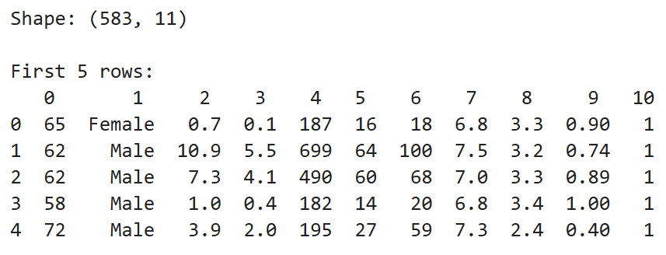
- Data Type Verification
The data types of each column were examined to ensure that all features were correctly interpreted as numerical or categorical variables.

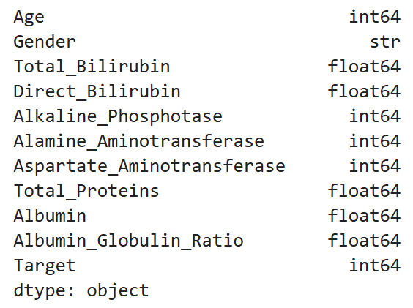
This step confirms that numerical attributes such as bilirubin levels, enzyme measurements, and protein levels are stored in numeric format. The Gender column is identified as a categorical feature and will require encoding before analysis.
- Missing Value Detection and Handling
The dataset was checked for missing values using a column-wise null value analysis.
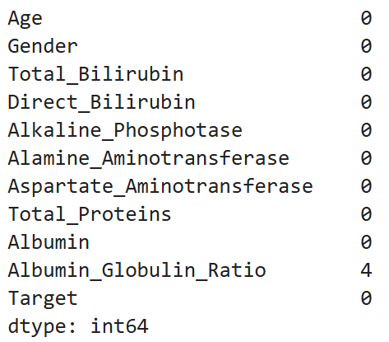
The analysis showed that most columns were complete, but the Albumin_Globulin_Ratio feature contained a small number of missing values. So, the subsequent rows were removed from the dataset to ensure that subsequent statistical computations could be performed without errors.
Since the number of missing values was very small compared to the total dataset size, removing these rows did not significantly affect the dataset. This approach simplifies preprocessing while maintaining data integrity.
- Encoding Categorical Variables
The Gender column was converted into a numerical format using binary encoding:
- Male → 1
- Female → 0
Machine learning algorithms require numerical inputs. Converting categorical variables into numeric representations allows the model to process this information during training.
- Detecting Infinite and Invalid Values
Invalid values in a dataset can lead to incorrect analysis and unreliable model predictions. These may occur due to data entry errors, incorrect measurements, or inconsistencies in the dataset.
The dataset was examined for values falling outside expected ranges, such as negative ages, unrealistically high ages, and negative values for bilirubin, protein, and albumin levels. Checks were also performed for infinite values (∞ or −∞) that may arise during calculations. Since the dataset contains both numeric and non-numeric columns, only the numeric columns were selected before applying the infinity check, to avoid type errors during numerical operations.
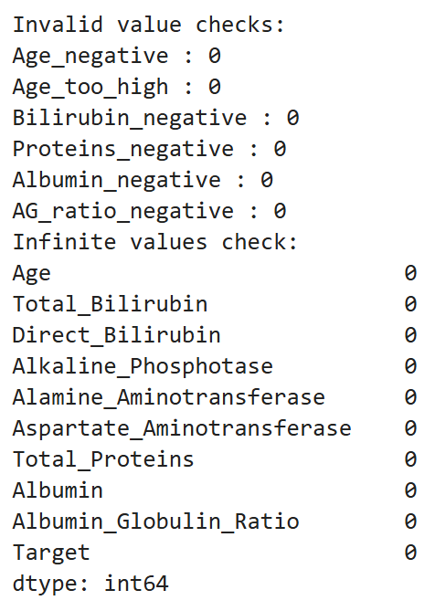
- Duplicate Record Detection and Removal
The dataset was examined for duplicate rows using duplicate detection functions, and any duplicates identified were removed.
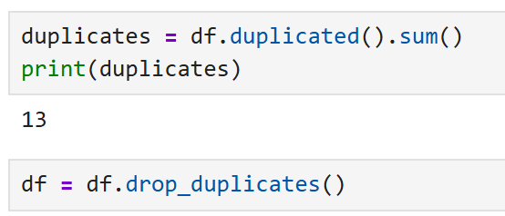
Removing duplicate records ensures that each patient observation contributes uniquely to the dataset. This prevents bias that could occur if identical records are counted multiple times.
- Feature and Target Separation
The dataset was divided into two components:
- Feature matrix (X) containing all predictor variables
- Target variable (y) containing the liver disease classification label
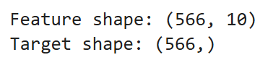
Separating features from the target variable is necessary for supervised machine learning tasks. The model will learn patterns in the features to predict the target class.
- Target Variable Distribution
The distribution of the target variable was analysed using frequency counts and a visualization plot.
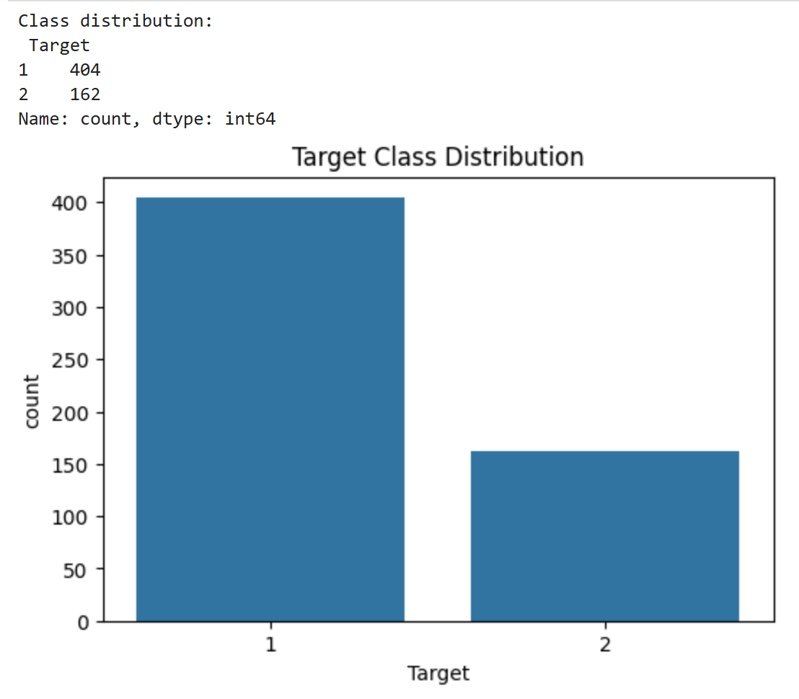
The dataset shows a class imbalance, with significantly more instances belonging to Class 1 than Class 2.
- Feature Scaling
Feature scaling is an important preprocessing step that ensures all numerical features contribute equally to the model by bringing them onto a similar scale. Two scaling techniques were applied to the feature matrix:
Standard Scaling (StandardScaler): StandardScaler standardizes features so that they have a mean of 0 and a standard deviation of 1. The transformation is defined as Z = (X − μ) / σ, where X is the original value, μ is the feature mean, and σ is the standard deviation. This technique is suitable for data that follows approximately normal distributions.
Robust Scaling (RobustScaler): RobustScaler is designed to be resistant to the influence of outliers. Instead of using the mean and standard deviation, it scales features using the median and interquartile range (IQR): X_{scaled} = (X − Median) / IQR. Because it relies on median and IQR rather than mean and standard deviation, it performs better when the dataset contains extreme values, which is the case for several biochemical markers in this dataset. Both scaled versions of the feature matrix were saved for downstream modeling tasks.
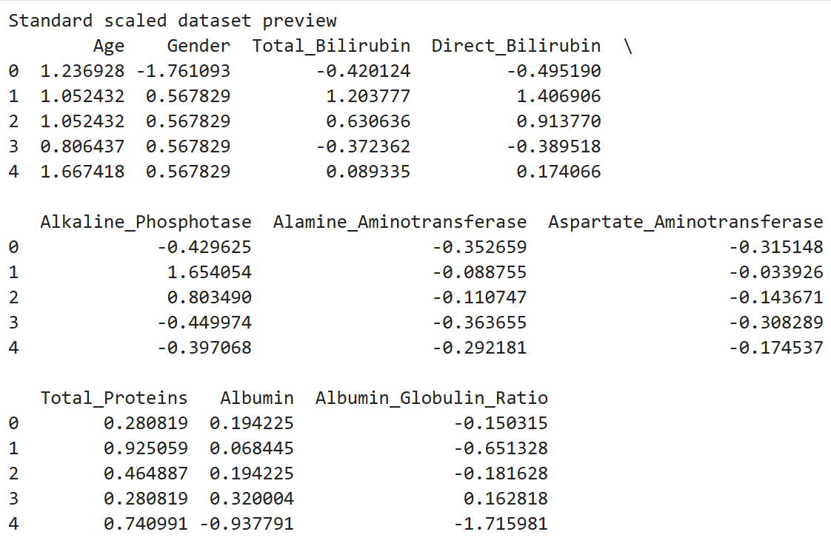
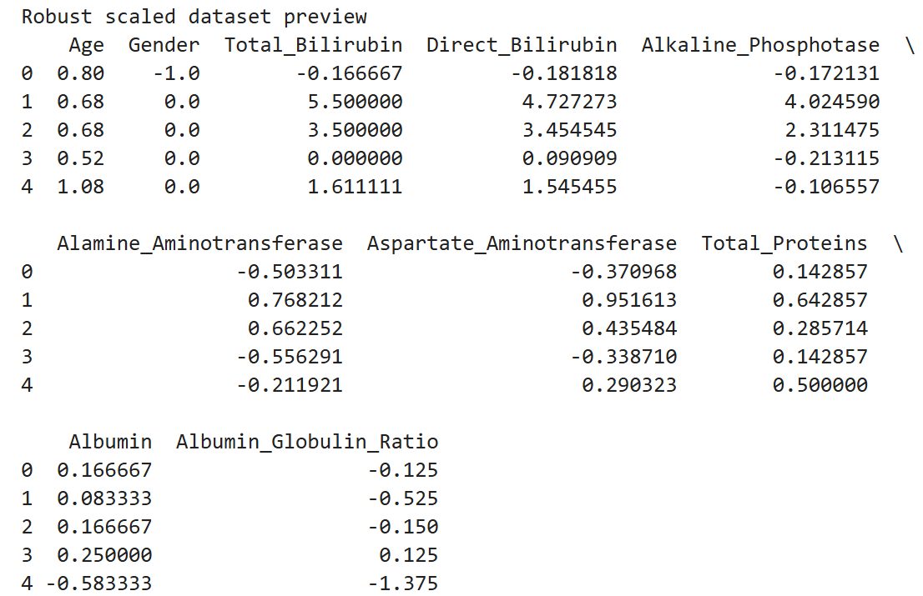
- Statistical Summary of Features
Measures of central tendency were calculated for each feature:
- Mean
- Median
- Mode
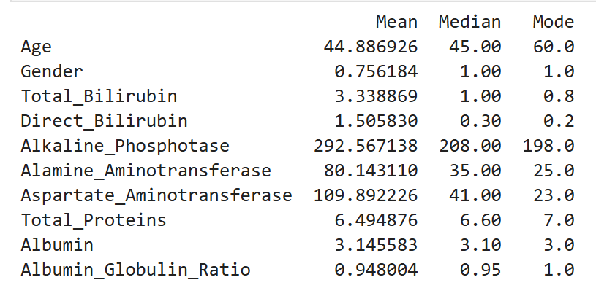
Several biochemical features such as Total Bilirubin, Alamine_Aminotransferase, and Aspartate_Aminotransferase show a significant difference between their mean and median values. This suggests that these variables are positively skewed, meaning that a small number of patients exhibit very high enzyme or bilirubin levels compared to the majority of patients.
- Distribution Analysis (Skewness and Kurtosis)
Statistical measures of distribution shape were computed:
- Skewness to measure asymmetry
- Kurtosis to measure tail heaviness
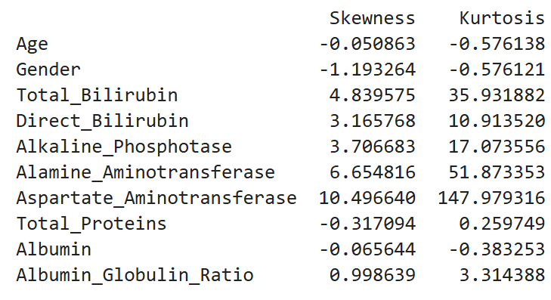
Most biochemical markers exhibit strong positive skewness, indicating that while most patients have relatively normal values, a subset of patients show extremely high measurements associated with liver dysfunction.
The Aspartate_Aminotransferase feature shows the highest skewness, suggesting the presence of extreme values that may correspond to severe liver disease cases.
Several features also exhibit very high kurtosis values, indicating heavy-tailed distributions with extreme outliers.
- Feature Distribution Visualization
Histograms were generated for each feature to visually analyse their distribution patterns.
- Total_Bilirubin
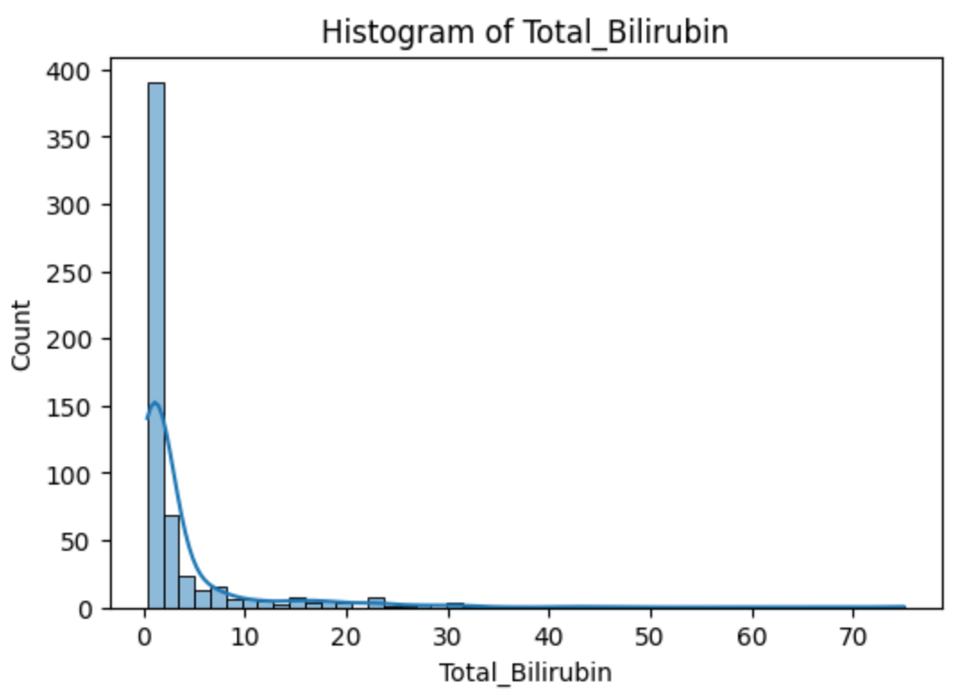
The histogram shows a strong right-skewed distribution. Most patients have relatively low bilirubin levels, while a smaller number of patients exhibit very high values, which are often associated with liver dysfunction.
- Aspartate_Aminotransferase (AST)
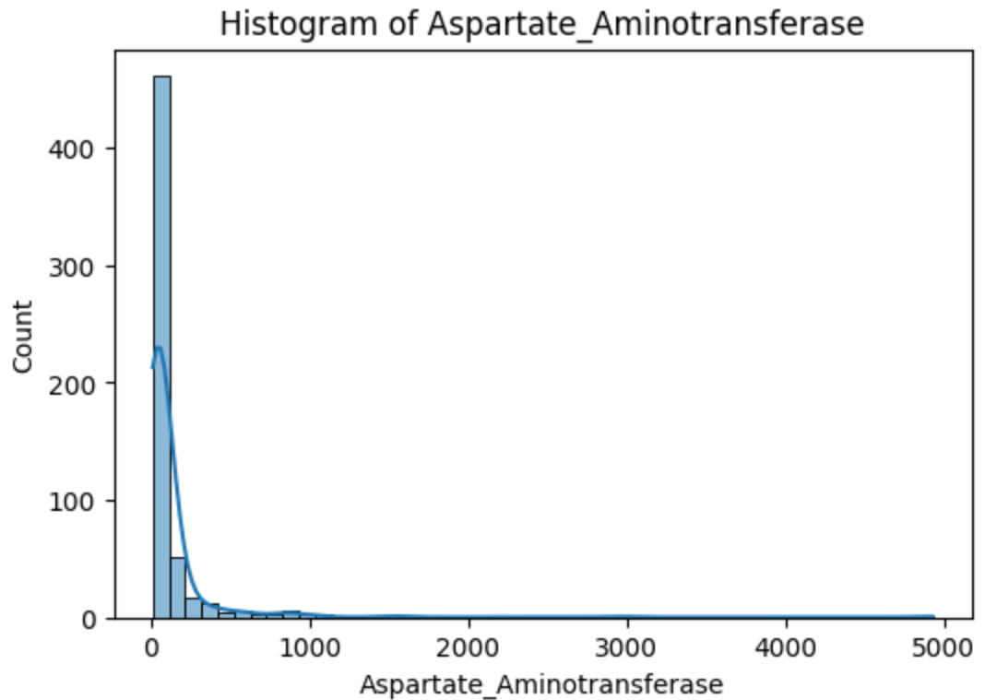
AST values are highly right-skewed with several extreme values. Elevated AST levels are commonly observed in patients with liver damage, explaining the presence of high-value outliers.
- Alamine_Aminotransferase (ALT)
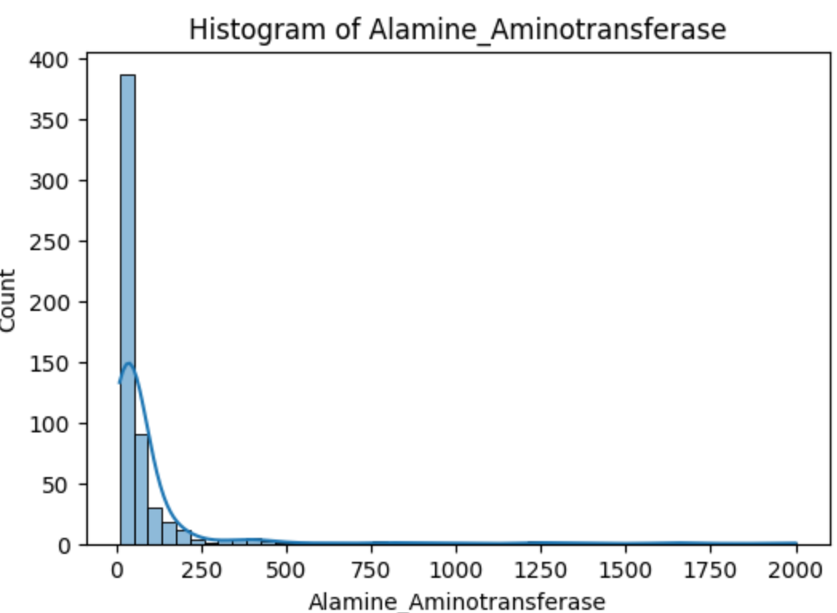
The ALT distribution shows a similar pattern to AST, where the majority of observations are concentrated at lower values while a small number of patients exhibit significantly higher enzyme levels.
- Age
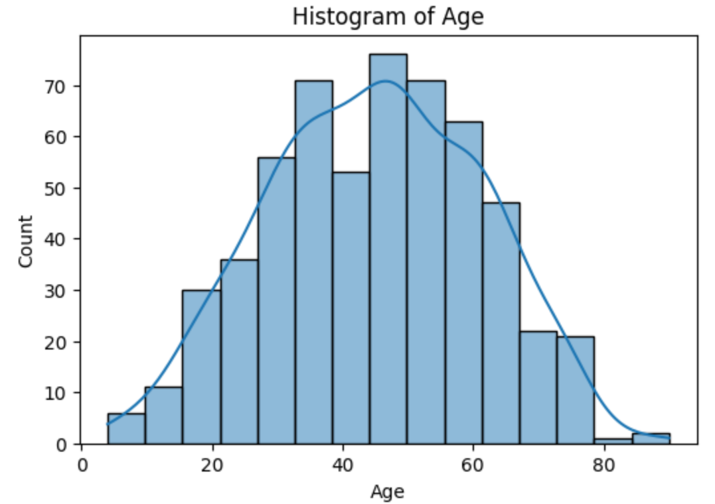
The age distribution appears relatively balanced across adult age groups, indicating that the dataset contains patients from a broad age range.
- Albumin_Globulin_Ratio
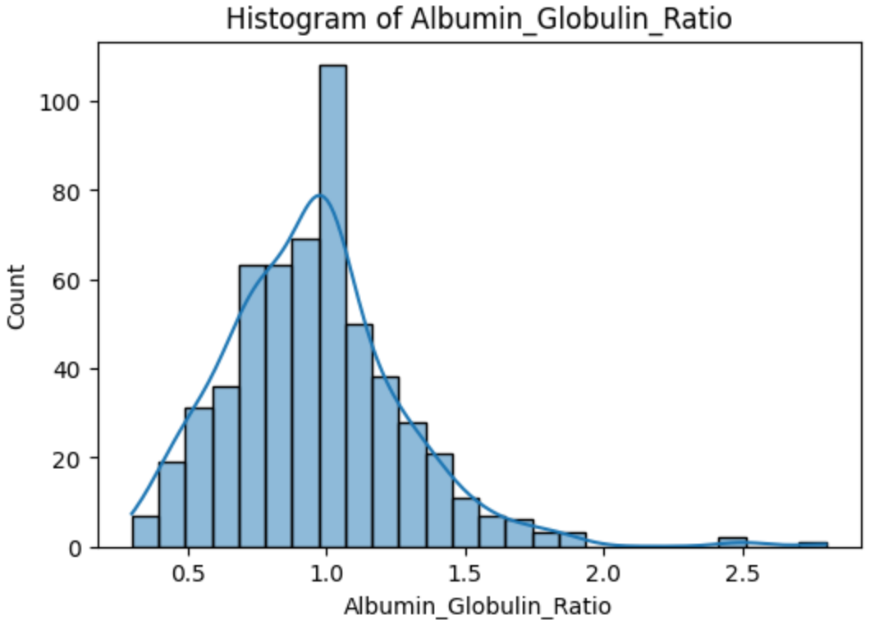
The Albumin–Globulin ratio shows a moderately skewed distribution, reflecting variability in protein balance among patients with different liver conditions.
- Outlier Detection
Boxplots were created for each feature to identify potential outliers.
- AST
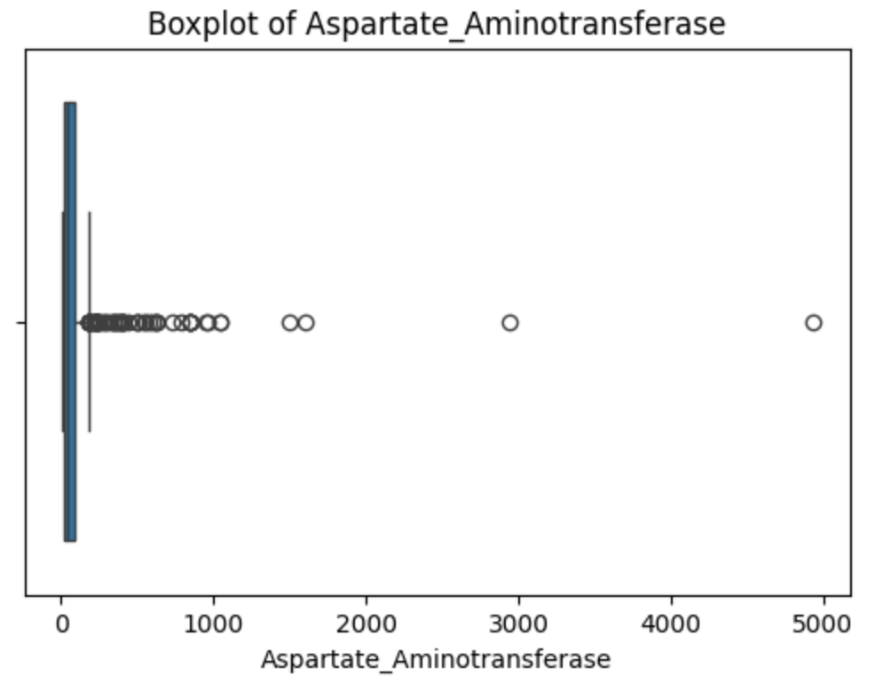
The boxplot reveals several extreme outliers in AST levels, indicating that some patients exhibit significantly elevated enzyme levels compared to the general population.
- ALT
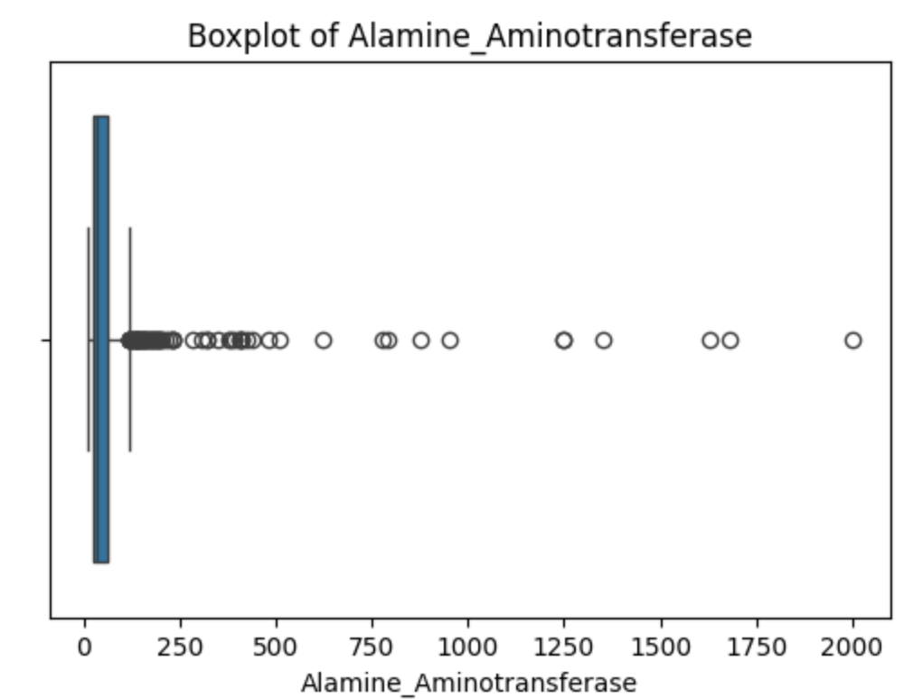
Similar to AST, the ALT boxplot highlights multiple outliers, reflecting abnormal enzyme concentrations associated with liver dysfunction.
- Total Bilirubin
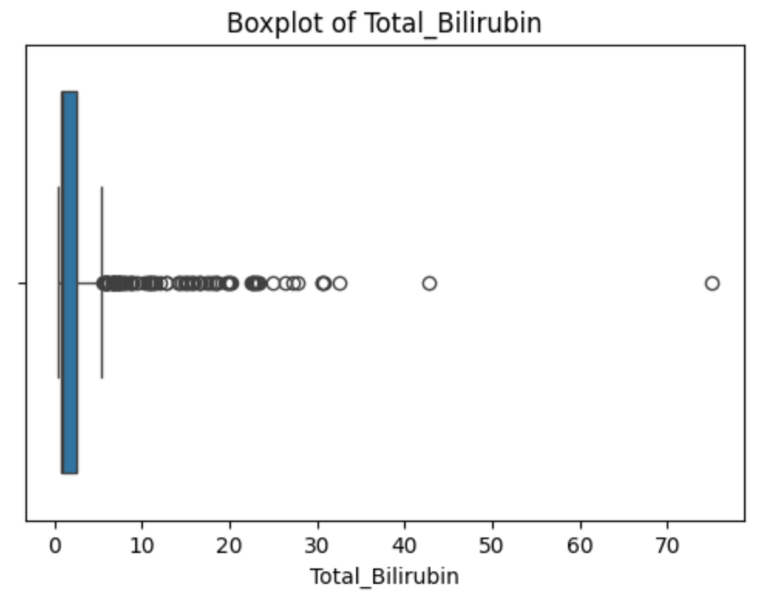
The boxplot shows a concentration of values near the lower range with several high-value outliers, indicating abnormal bilirubin levels in certain patients.
- Albumin
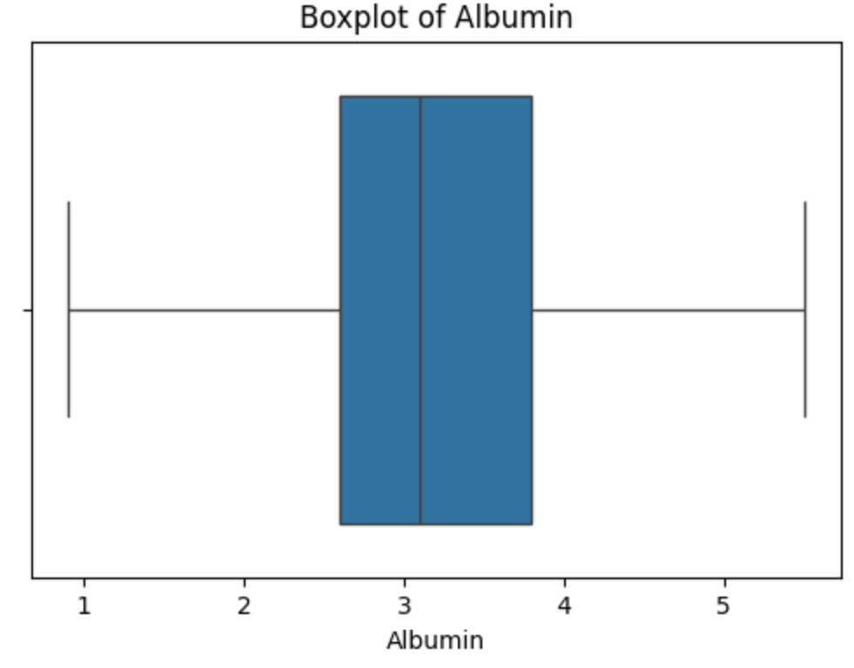
The albumin distribution appears relatively stable with fewer extreme values, suggesting that protein levels are less variable than enzyme measurements.
- Correlation Analysis
A correlation matrix was generated and visualized using a heatmap to study relationships between features.
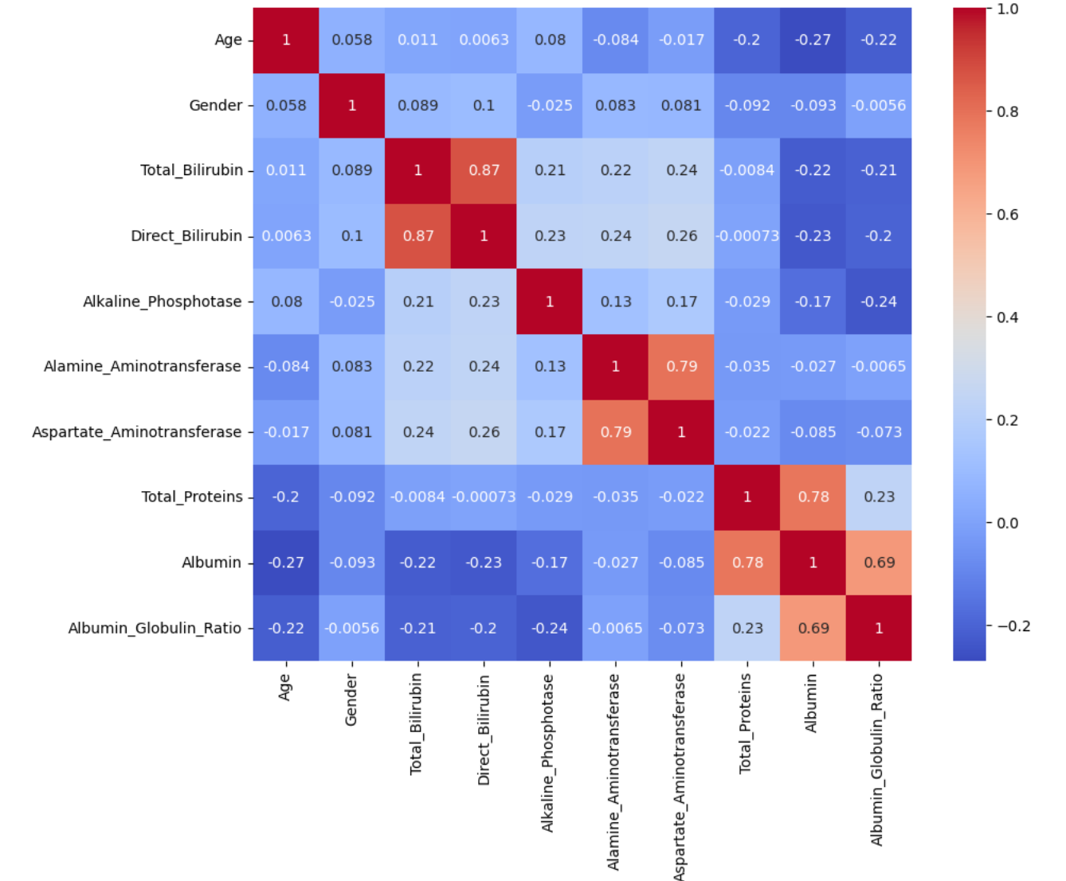
The correlation matrix highlights relationships between biochemical attributes. Enzyme-related features such as ALT and AST tend to show stronger correlations, as they both reflect liver enzyme activity.
Conclusion
Overall, the preprocessing steps provided valuable insights into the dataset’s structure, distribution characteristics, and potential anomalies. These insights help in selecting appropriate modeling techniques and ensuring that the dataset is suitable for multivariate classification tasks related to liver disease prediction.

