# **Tasks**

**Objective Questions**:

1. What is the total no. of attributes present in the data?

**Ans:** Here I’ve considered column as an attribute, so I have **10** attributes in table **Tickets** and **6** attributes in table **IT Agents.** Therefore, we have **15** in total because **Agent ID** is common.

1. Which columns have inconsistent or missing values, and what is the count of such values?

**Ans:** I corrected **29,410** misspellings of "Unassigned," identified **15,845** "Medium" values in **Priority**, **356** "Unclassified" and **4,836** "Major" values in **Severity**, and made **two** column header corrections (**ID** and **Date**).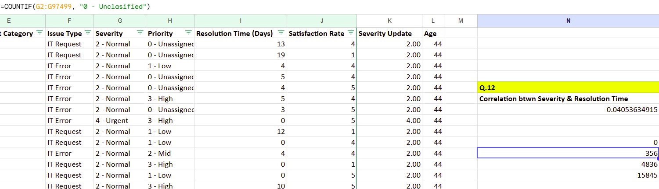

1. What is the average daily ticket volume over time?

**Ans:** **53.36508,** I got this by first fetching unique dates from Fecha i.e. Date column then took count of it and then at the last took average of that value. Also got the same output using pivot which is included in the sheet (**Objective Pivot**).

1. What is the distribution of ticket categories (e.g., Login Access, System, Software)?

**Ans:** Count of ticket categories using pivot.

|  |  |
| --- | --- |
| *Request Category* | COUNTA of ID |
| Hardware | 9733 |
| Login Access | 29193 |
| Software | 19570 |
| System | 39002 |
| **Grand Total** | **97498** |

1. How many tickets has each agent handled?

**Ans.** Tickets handled by each agent are listed below using pivot.

|  |  |
| --- | --- |
| *Agent ID* | COUNTA of ID |
| 1 | 1969 |
| 2 | 1968 |
| 3 | 2021 |
| 4 | 1988 |
| 5 | 2000 |
| 6 | 1949 |
| 7 | 1935 |
| 8 | 1960 |
| 9 | 1949 |
| 10 | 1974 |
| 11 | 1956 |
| 12 | 1897 |
| 13 | 1856 |
| 14 | 1942 |
| 15 | 1991 |
| 16 | 1926 |
| 17 | 1961 |
| 18 | 1892 |
| 19 | 1984 |
| 20 | 1920 |
| 21 | 1889 |
| 22 | 1966 |
| 23 | 1915 |
| 24 | 2003 |
| 25 | 1906 |
| 26 | 1963 |
| 27 | 1968 |
| 28 | 1946 |
| 29 | 1931 |
| 30 | 1963 |
| 31 | 1987 |
| 32 | 1974 |
| 33 | 1958 |
| 34 | 1927 |
| 35 | 2007 |
| 36 | 1913 |
| 37 | 1931 |
| 38 | 1938 |
| 39 | 2026 |
| 40 | 1920 |
| 41 | 1966 |
| 42 | 1945 |
| 43 | 1897 |
| 44 | 1943 |
| 45 | 1929 |
| 46 | 1950 |
| 47 | 1933 |
| 48 | 2027 |
| 49 | 1890 |
| 50 | 1949 |
| **Grand Total** | **97498** |

1. How can you extract the domain from the email addresses in the IT Agents sheet?

**Ans:** We can extract the domain from email addresses using a combination of string functions and the Text-to-Columns feature. First, I used the formula **=RIGHT(C2, LEN(C2) - FIND("@", C2))** to isolate the text after "@". After removing hyperlink formatting, I applied Text-to-Columns to extract the domain while excluding the ".com" suffix. For example, this resulted in **"fp20analytics"** as the domain.  
  
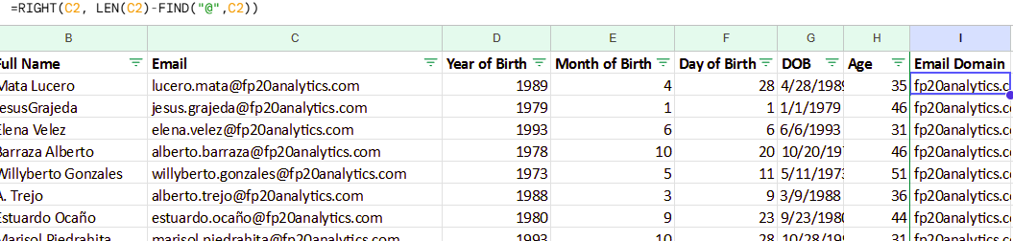

1. How can you find the full name of an agent given their Agent ID?

**Ans:** Using **VLOOKUP** I’ve fetched the full name of the respective Agents by their Agent ID. And used the formula: **=VLOOKUP(A2, $A$2:$B$51, 2, 0)**  
  
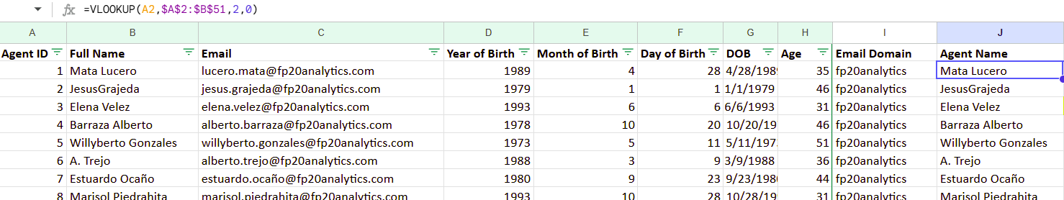

1. What is the count of each issue type (e.g., IT Error, IT Request)?

**Ans:** Count of each issue type.

|  |  |
| --- | --- |
| *Issue Type* | COUNTA of ID |
| IT Error | 24278 |
| IT Request | 73220 |
| **Grand Total** | **97498** |

1. What is the daily average resolution time for tickets?

**Ans:** **5,** found it by first creating pivot table with **Date** and **Average Resolution Time.** Then, I calculated the overall average resolution time across unique dates from the pivot.(Refer to the **Objective Pivot** sheet for details.)

1. How has the volume of tickets changed over time?

**Ans:** Here, I’ve created a pivot of date column & grouped it by Year-Quarter and then have taken the count of tickets for each Year-Quarter. Also, prepared the chart using the same pivot to understand it better. (Refer **Objective Pivot** sheet to check the full pivot value)

|  |  |
| --- | --- |
| *Date - Year-Quarter* | COUNTA of ID |
| 2016-Q1 | 3276 |
| 2016-Q2 | 3265 |
| 2016-Q3 | 3252 |
| 2016-Q4 | 3258 |
| 2017-Q1 | 3559 |
| 2017-Q2 | 3834 |
| 2017-Q3 | 3717 |
| 2017-Q4 | 3805 |
| 2018-Q1 | 4266 |
| 2018-Q2 | 4936 |
| 2018-Q3 | 4927 |
| 2018-Q4 | 4825 |

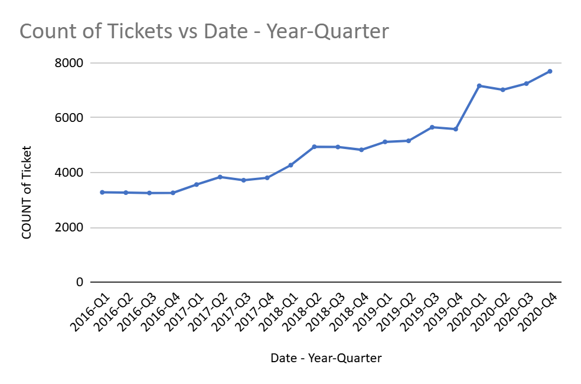

1. What is the average age of the IT agents?

**Ans:** **39.46,** got it by finding **dates (DOB)** from the given column in the **IT Agents** table then by using **DATEDIF()** got the **age** in years for each agent and then calculated the average of them.  
  
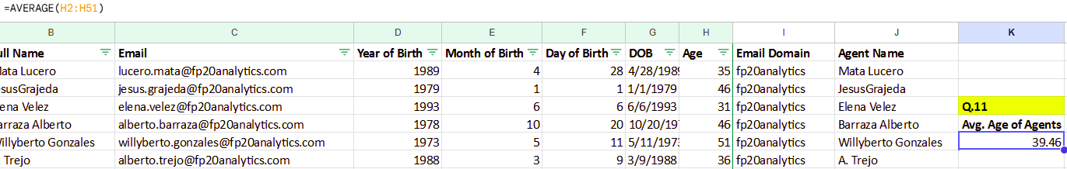

1. Is there a correlation between the severity of issues and the resolution time?

**Ans:** **-0.04053634915** got it using **CORREL().** This indicates there is a very weak negative correlation between the severity of issues and the resolution time which is almost negligible (Refer sheet **Tickets** for the finding).

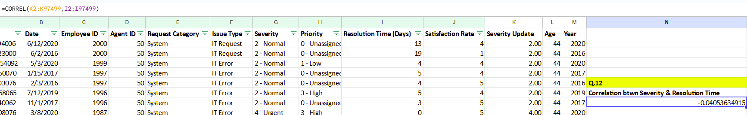

1. How many categorical columns are there in the data? [Search about categorical and continuous data, and try to answer this question]

**Ans:** According to my understanding there are **4** categorical columns and they are- **Request Category, Issue Type, Severity, Priority** located in Tickets table.

**Subjective Question:**

1. If there is an investment, should it be used to hire more IT agents, improve training programs, or upgrade ticket management software?

Analysis: Perform a cost-benefit analysis using ticket resolution and satisfaction metrics.

**Approach:** Here, I have gathered the **Ticket** data and found out the-

* Average performance metrics and count of tickets handled by each agent.
* The ratio of average Satisfaction Rate with the Resolution Time of the entire agents.
* And collectively checked the performance metric (count of tickets, resolution time & satisfaction rate) for each issue type and also, it’s impact on the severity & priority of the tickets.

**(1) To Hire More IT Agents:**

|  |  |  |  |
| --- | --- | --- | --- |
| ***Agent ID*** | **AVERAGE of Satisfaction Rate** | **AVERAGE of Resolution Time (Days)** | **COUNTA of ID** |
| **1** | **4.34** | **5.45** | **1969** |
| **2** | **4.47** | **3.60** | **1968** |
| **3** | **3.62** | **5.38** | **2021** |
| **4** | **4.19** | **5.24** | **1988** |
| **5** | **4.38** | **4.26** | **2000** |
| **6** | **3.59** | **5.32** | **1949** |
| **7** | **3.98** | **5.52** | **1935** |
| **8** | **4.44** | **3.83** | **1960** |

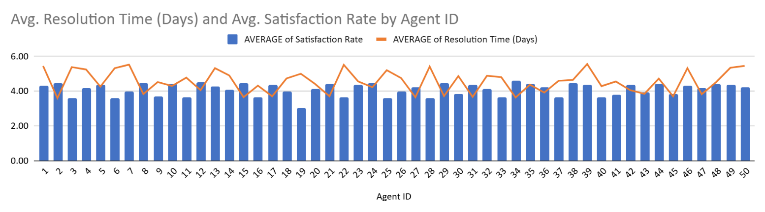

**(2) Improve training programs:**

Ratio of Satisfaction Rate with Resolution Time = **0.6716925623**

**(3) Upgrade ticket management software:**

|  |  |  |  |
| --- | --- | --- | --- |
| **Issue Type** | **COUNTA of ID** | **AVERAGE of Resolution Time (Days)** | **AVERAGE of Satisfaction Rate** |
| **IT Error** | **24278** | **3** | **4.098772551** |
| **IT Request** | **73220** | **5** | **4.101270145** |
| **Grand Total** | **97498** | **5** | **4.100648218** |

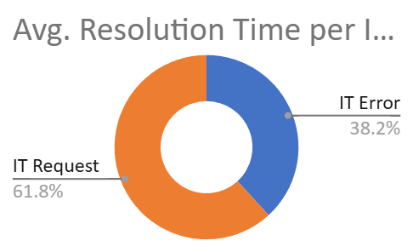

|  |  |  |  |
| --- | --- | --- | --- |
| ***Severity*** | **AVERAGE of Resolution Time (Days)** | **AVERAGE of Satisfaction Rate** | **COUNTA of ID** |
| **0 - Unclasified** | **2.88** | **4.168539326** | **356** |
| **1 – Minor** | **3.44** | **4.072187777** | **2258** |
| **2 – Normal** | **4.66** | **4.099846598** | **88656** |
| **3 – Mayor** | **3.91** | **4.11827957** | **4836** |
| **4 – Urgent** | **2.00** | **4.119252874** | **1392** |
| **Grand Total** | **4.55** | **4.100648218** | **97498** |

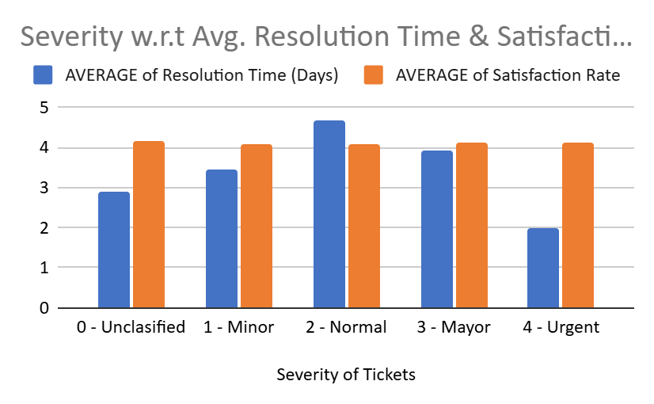

|  |  |  |  |
| --- | --- | --- | --- |
| ***Priority*** | **AVERAGE of Resolution Time (Days)** | **AVERAGE of Satisfaction Rate** | **COUNTA of ID** |
| **0 - Unassigned** | **5** | **4.091805508** | **29410** |
| **1 – Low** | **6** | **4.128968492** | **16694** |
| **2 – Mid** | **4** | **4.101167561** | **15845** |
| **3 – High** | **3** | **4.094433036** | **35549** |
| **Grand Total** | **5** | **4.100648218** | **97498** |

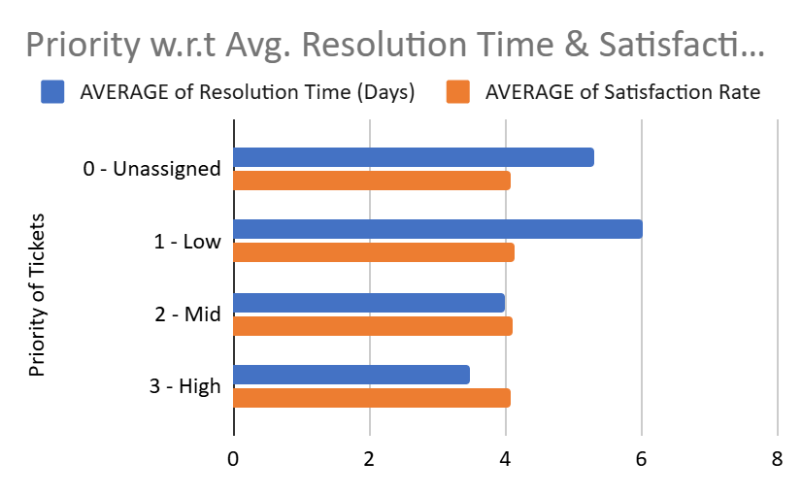

**Insight:** Based on analysing all the factors, we can conclude this-

* **Hiring More IT Agents:** Faster ticket resolution leads to higher satisfaction, but hiring alone won’t improve efficiency without better training and software.
* **Improving Training Programs:** Training can help agents perform better, especially those with lower satisfaction or slower resolution times.
* **Upgrading Ticket Management Software:** Better software can speed up resolutions, handle large ticket volumes, and improve efficiency across all types of tasks.

**Recommendation:** Prioritize upgrading ticket management software, invest in training for underperforming agents, and consider hiring only if workloads remain excessive after these measures.

1. Which agents need additional training based on their performance metrics?

Analysis: Identify agents with the lowest satisfaction ratings and longest resolution times.

**Approach**: Here, I created the pivot and included average performance metrics of each agent. Then filtered the highest resolution time and sorted the satisfaction rate in ascending order to understand the agents who need additional training.

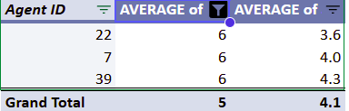

**Insight:** As per our analysis we can clearly see, Agent ID 22, needs additional training as it has the lowest performance metrics.

**Recommendation:** Agent ID 22 requires focused training to enhance resolution efficiency and customer satisfaction. Post-training performance should be monitored to track improvements.

1. Do certain categories of requests have longer resolution times?

Analysis: Analyse the resolution times by request category.

**Approach**: Analysed resolution times across different request categories using a pivot table and chart to identify trends.

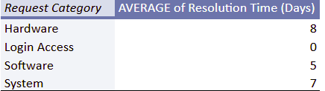

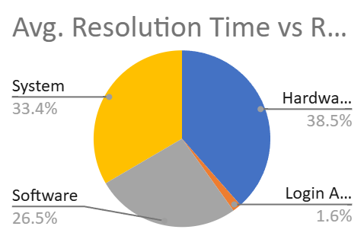

**Insight**: As we can see from the table & chart that the **Hardware & System** categories have the longest resolution times.

**Recommendation:**

* Simplify processes for Hardware and System requests to resolve them faster.
* Provide specialized training for agents handling these categories.
* Ensure sufficient resources, like tools and spare parts, to improve resolution times.

1. How effective are the current software tools in managing IT tickets?

Analysis: Evaluate performance metrics before and after the implementation of new tools.

**Approach**: Review ticket trends by priority and severity, check if the software handles urgent tickets effectively.

|  |  |  |  |  |
| --- | --- | --- | --- | --- |
| ***COUNTA of ID*** | ***Priority*** |  |  |  |
| ***Severity*** | **0 - Unassigned** | **1 - Low** | **2 - Mid** | **3 - High** |
| **0 - Unclasified** | **115** | **80** | **55** | **106** |
| **1 - Minor** | **626** | **549** | **407** | **676** |
| **2 - Normal** | **26826** | **15282** | **14468** | **32080** |
| **3 - Mayor** | **1434** | **614** | **713** | **2075** |
| **4 - Urgent** | **409** | **169** | **202** | **612** |

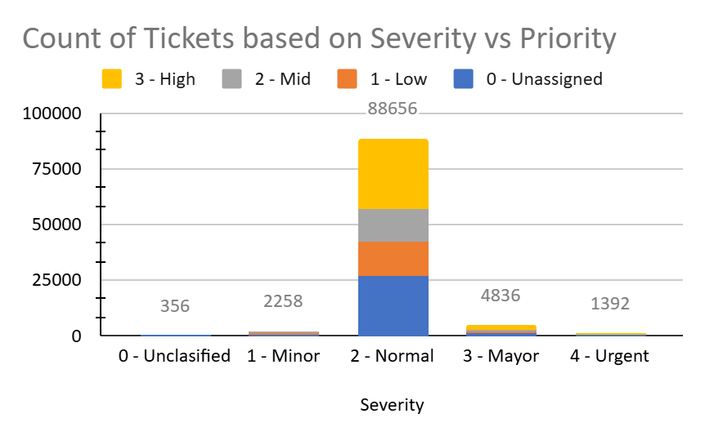

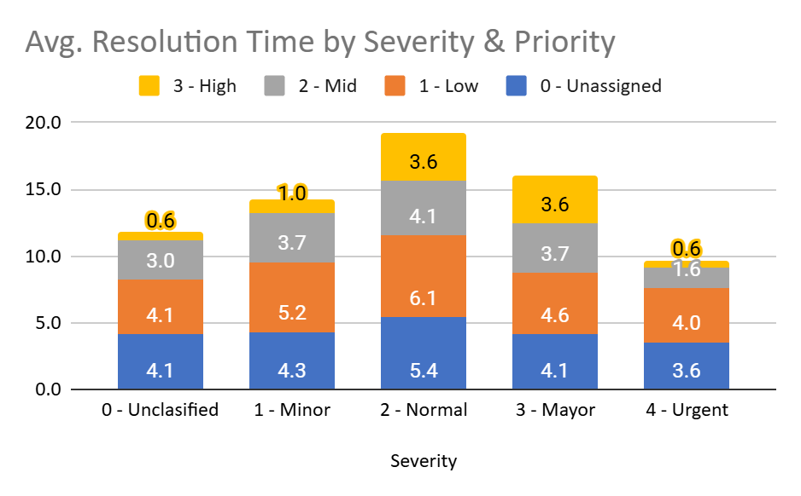

**Insight:** Urgent tickets are resolved but need to be handled faster. Many tickets are unclassified, which shows some inefficiencies. Most tickets are Normal Severity and Mid/High Priority, so they need better management.

**Recommendation**: Improve how tickets are prioritized, automate the categorization process, make handling high-volume tickets smoother, and regularly check how well the system is performing.

1. How has the performance of the IT support team changed over time (e.g., monthly or quarterly)?

Analysis: Trend analysis using time series charts.

**Approach:** Performed a trend analysis using time series charts to evaluate how the resolution time and satisfaction rate have changed over time (quarterly analysis) through pivot.

|  |  |  |
| --- | --- | --- |
| ***Date - Year-Quarter*** | **AVERAGE of Resolution Time (Days)** | **AVERAGE of Satisfaction Rate** |
| **2016-Q1** | **4.55** | **3.95** |
| **2016-Q2** | **4.62** | **3.97** |
| **2016-Q3** | **4.54** | **3.98** |
| **2016-Q4** | **4.50** | **4.02** |

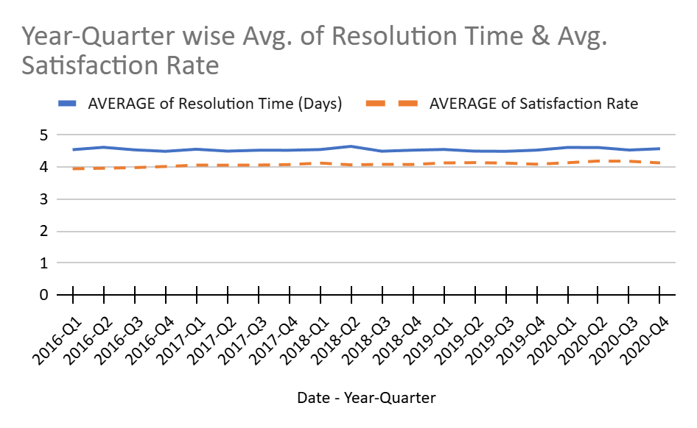

**Insight:**

* Resolution times have remained relatively stable, with minor fluctuations across the quarters.
* Satisfaction rates have shown a slight increase over time, particularly in the last quarter of 2016, indicating some improvement in customer experience.

**Recommendation**:

* Continue to monitor both resolution times and satisfaction rates regularly to identify patterns or areas needing improvement.
* Investigate strategies to further reduce resolution times while maintaining or improving satisfaction levels.

1. If we invest more on tech (Hardware, software, etc), do you think it will improve the ticket resolution times and employee satisfaction?

Analysis: Use historical data to project potential improvements.

**Approach:** Analysed historical data to see how different types of requests perform in terms of resolution time and satisfaction rate, and predicted how investing in tech could improve these areas.

|  |  |  |  |
| --- | --- | --- | --- |
| ***Request Category*** | **AVERAGE of Satisfaction Rate** | **AVERAGE of Resolution Time (Days)** | **COUNTA of ID** |
| **Hardware** | **4.100996609** | **7.63** | **9733** |
| **Login Access** | **4.094508958** | **0.31** | **29193** |
| **Software** | **4.106336229** | **5.24** | **19570** |
| **System** | **4.102302446** | **6.62** | **39002** |
| **Grand Total** | **4.100648218** | **4.55** | **97498** |

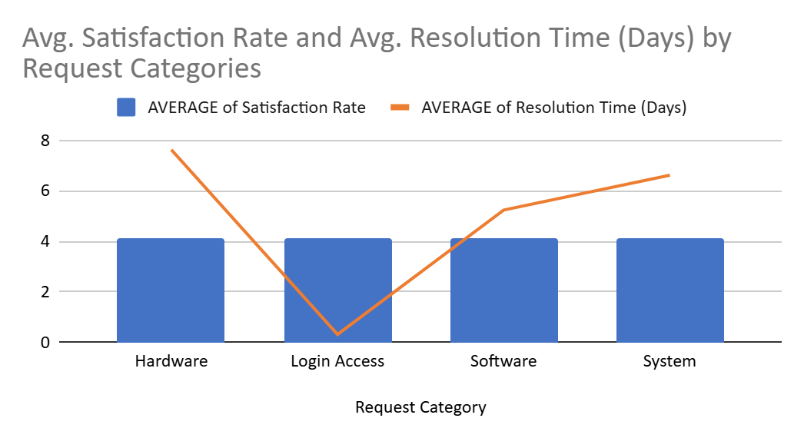

**Insight:** Hardware issues take the longest to resolve, while login access is resolved quickly. Improving tech for **hardware** and **system** problems could help speed up resolutions and increase satisfaction.

**Recommendation:**

* Invest in Hardware and System Improvements: Focus on upgrading hardware and system infrastructure to reduce resolution times in these categories.
* Enhance Ticket Management Tools: Consider software tools that streamline issue resolution, particularly for more time-consuming categories like hardware and system issues.
* Monitor Impact: Track improvements in resolution times and satisfaction after the tech investment to assess its effectiveness.

1. What are the key performance metrics for IT agents, and how can they be improved, do we need to fire any agents?

Analysis: Define and analyse metrics such as average handling time, satisfaction scores, and number of tickets resolved.

**Approach**: Focused on key performance metrics—satisfaction rate, resolution time, and the number of tickets resolved—then identified agents with low satisfaction and high-resolution times for further analysis.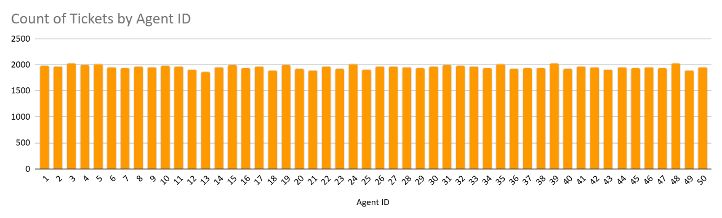

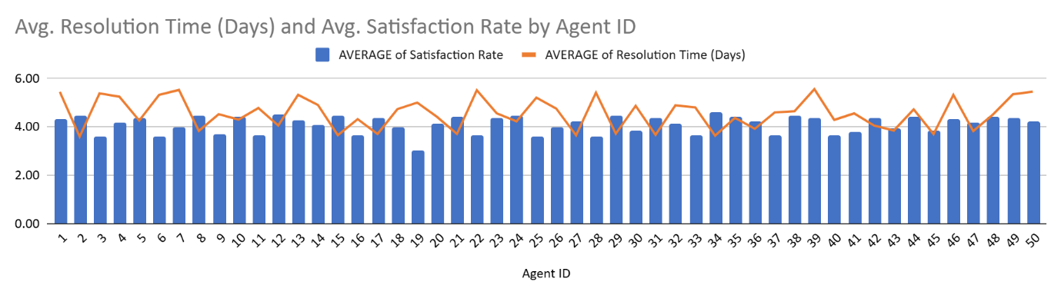

**Insight:**

* Agents with low satisfaction and long resolution times (e.g., Agent IDs 6, 7, 19, 22) need improvement.
* High-performing agents (e.g., Agent IDs 2, 8, 12) should be recognized.
* Higher resolution time doesn't always mean lower satisfaction.

**Recommendation:**

* Provide training to agents with low satisfaction and high-resolution times.
* Review ticket complexity to help agents improve efficiency.
* Offer ongoing support before considering termination.
* Recognize top performers and share their strategies.
* Set clear performance targets and review regularly.

1. How do employee demographics (e.g., department, seniority) impact satisfaction and ticket outcomes?

Analysis: Segment analysis using filters and pivot tables.

**Approach:**

* Segmented the data by age groups to analyse how demographics impact satisfaction rate and resolution times.
* Focused on average resolution time and satisfaction rate across these segments to identify trends.

|  |  |  |  |
| --- | --- | --- | --- |
| *Grouped Age* | COUNTA of ID | AVERAGE of Resolution Time (Days) | AVERAGE of Satisfaction Rate |
| 20 - 29 | 15541 | 4.49 | 4.2129 |
| 30 - 39 | 29299 | 4.69 | 4.1249 |
| 40 - 49 | 38952 | 4.62 | 4.0175 |
| 50 - 60 | 13706 | 4.12 | 4.1580 |

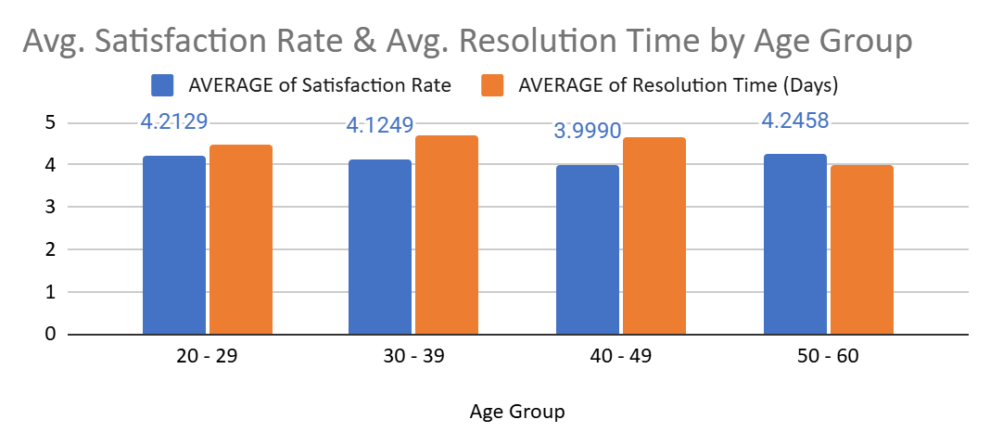

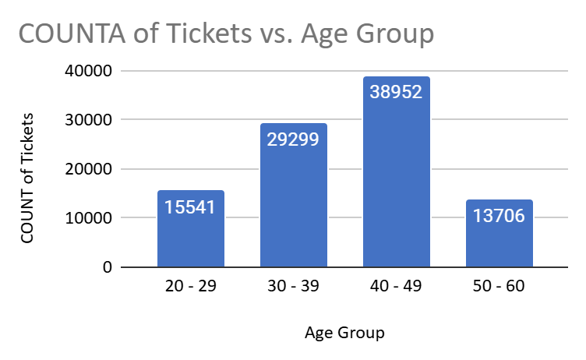

**Insight:**

* 20 - 29 years: Highest satisfaction (4.21) and fast resolution times (4.49 days).
* 30 - 39 years: Slightly low satisfaction (4.12) and lowest resolution times (4.69 days).
* 40 - 49 years: Lowest satisfaction (4.02) with stable resolution times (4.62).
* 50 - 60 years: High satisfaction (4.16) and quickest resolution times (4.12), indicating efficiency but a need for improved customer engagement.

**Recommendation:**

* Provide targeted training for older age groups (40 - 60) to improve satisfaction.
* Set up mentorship programs between older and younger employees to share modern customer service techniques.
* Monitor expectations and offer more support to older employees to align satisfaction with resolution efficiency.
* Distribute work evenly across all age groups to make the most of everyone's strengths.

1. Identify the trends for IT support operations based on ticket volumes and satisfaction, and mention the peak and stable times.

Analysis: Use pivot tables and charts to identify peak and off-peak hours.

**Approach:**

* Analysed ticket volumes and satisfaction trends by issue type over time.
* Identified peak and stable periods to understand demand fluctuations.

|  |  |  |  |
| --- | --- | --- | --- |
| ***Issue Type*** | **COUNTA of ID** | **AVERAGE of Resolution Time (Days)** | **AVERAGE of Satisfaction Rate** |
| **IT Error** | **24278** | **3.11** | **4.0988** |
| **IT Request** | **73220** | **5.03** | **4.1013** |
| **Grand Total** | **97498** | **4.55** | **4.1006** |

|  |  |  |
| --- | --- | --- |
| ***COUNTA of ID*** | ***Issue Type*** |  |
| ***Date - Year*** | **IT Error** | **IT Request** |
| **2016** | **3294** | **9757** |
| **2017** | **3680** | **11235** |
| **2018** | **4653** | **14301** |
| **2019** | **5344** | **16146** |
| **2020** | **7307** | **21781** |
| **Grand Total** | **24278** | **73220** |

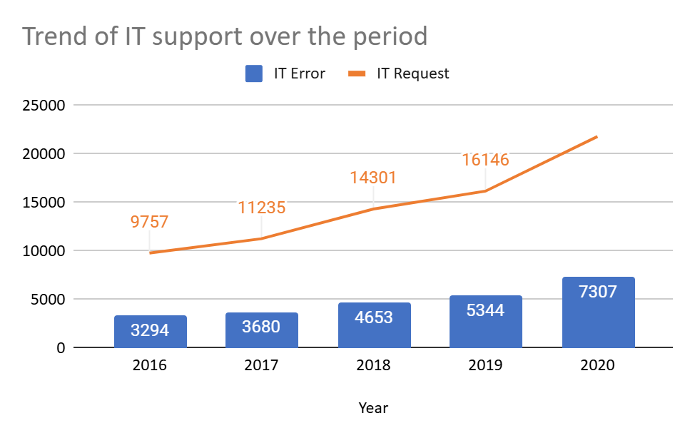

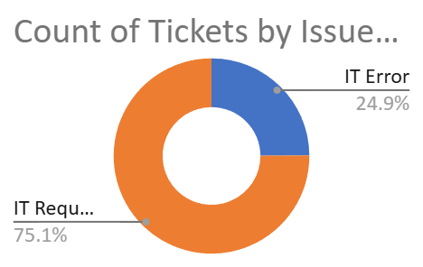

**Insight:**

* Peak Period: 2020 had the highest ticket volumes, likely due to IT challenges during the pandemic.
* Stable Period: Ticket volumes grew gradually from 2016 to 2019, with satisfaction mostly stable.
* Ticket Types: **IT Requests** make up a larger share of tickets, with satisfaction rates similar to **IT Errors**.

**Recommendation:**

* Allocate more resources during peak periods (like 2020) to manage high ticket volumes effectively.
* Focus on resolving recurring IT Errors to reduce future issues.
* Prepare for high-volume periods proactively, ensuring consistent satisfaction.
* Monitor trends regularly to adapt to changing ticket volumes and customer needs.

1. What metrics should be included in the final dashboard to provide a comprehensive view of call centre performance and guide investment decisions?

**Approach:**

* Ticket Volume Metrics: Track the total number of tickets, issue types, and priority levels.
* Resolution Metrics: Measure average resolution times and break them down by severity and priority.
* Satisfaction Metrics: Track average satisfaction rates by ticket type and resolution time.
* Agent Performance: Monitor resolution times, satisfaction scores, and ticket volumes per agent.
* Demographics & Time Trends: Analyse performance by age group or department and monitor trends over time.

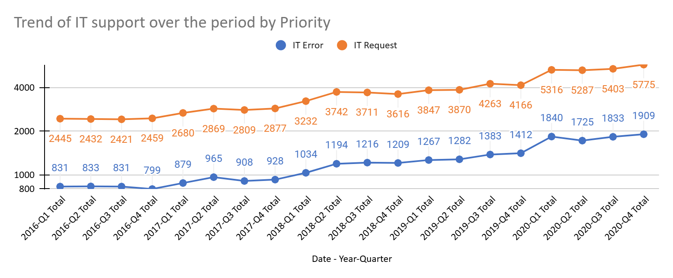

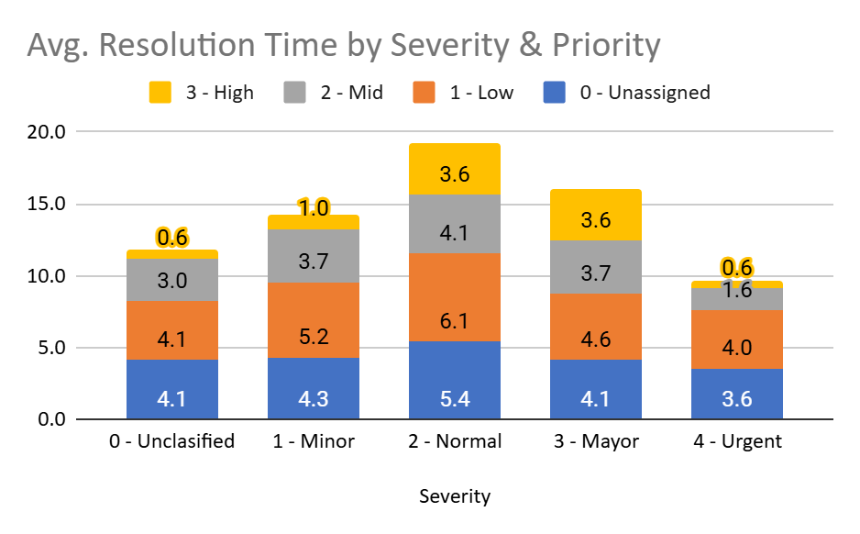

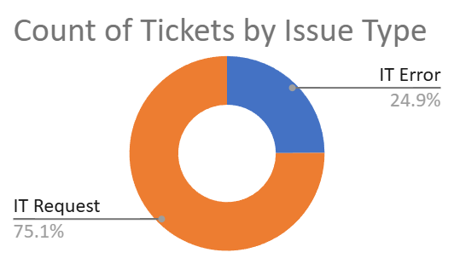 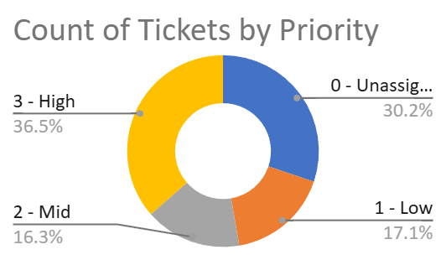

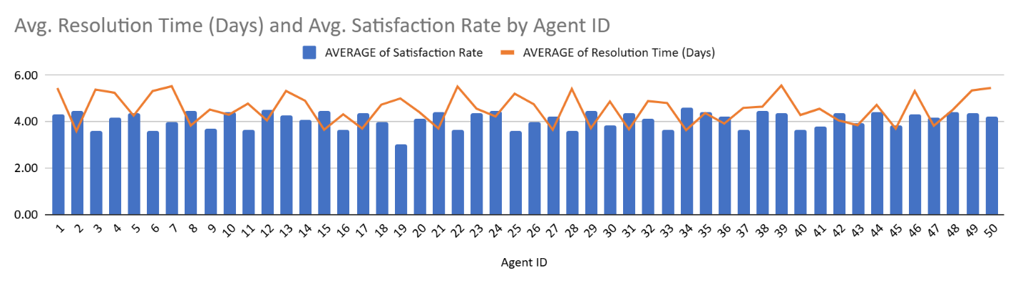

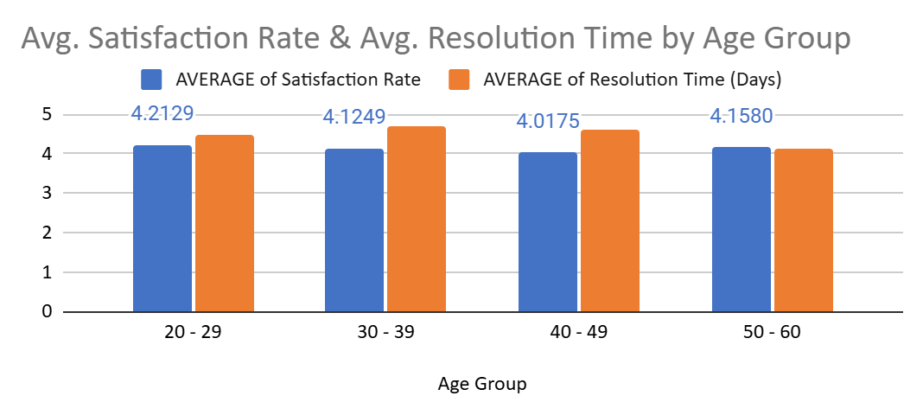



**Insight:**

* Ticket volumes fluctuate (e.g., 2020), showing the need for scalable resources during busy times.
* Faster resolution tends to increase satisfaction, but balancing speed and quality is key.
* Monitoring individual agent performance helps identify training needs.
* Different age groups or departments may require tailored support to improve performance.

**Recommendation:**

* Invest in scalable tools to handle peak ticket volumes.
* Identify underperforming agents and provide training or support.
* Focus on customer engagement to maintain high satisfaction while resolving issues quickly.
* Address recurring IT issues to reduce ticket volume.
* Continuously track metrics and adjust strategies to maintain high performance.