Assignment 06
- create database company;

- use company;

- create table employee(emp_id int primary key, emp_name varchar(50), dept_id int, salary int);

- insert into employee(emp_id, emp_name, dept_id, salary) values
- (1,"John",101,50000),
- (2,"Emma",101,65000),
- (3,"Raj",102,45000),
- (4,"Meera",103,70000),
- (5,"Ravi",102,48000),
- (6,"Naina",103,52000),
- (7,"Alex",101,58000);

- select * from employees;
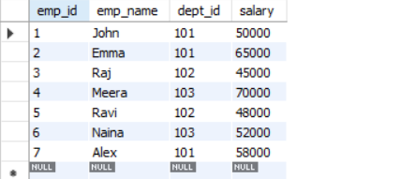

- create table departments(dept_id int, dept_name varchar(50));

- insert into departments(dept_id, dept_name) values

- (101,"Sales"),
- (102,"Marketing"),
- (103,"Finance"),
- (104,"HR");

- select * from departments;


Q1. Display employee name with their department name.
- select e.emp_name, d.dept_name from employees e
inner join departments d
on e.dept_id = d.dept_id;

Q2. List all employees including those with no matching department.
- select e.emp_name,d.dept_name
from employees e
left join departments d
on e.dept_id = d.dept_id;

Q3. List all departments even if no employees.
- select e.emp_name,d.dept_name
from employees e
right join departments d
on e.dept_id = d.dept_id;

Q4. Show employees from sales department.
- select e.emp_name,d.dept_name
from employees e
inner join departments d
on d.dept_id = e.dept_id
where d.dept_name = "Sales";

Q5. Find top 3 highest paid employees.
- select emp_name,salary
from employees
order by salary desc
limit 3;
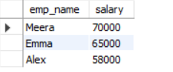
Q6. Find employees earning more than 50,000 from Marketing.
- select e.emp_name,e.salary,d.dept_name
from employees e
inner join departments d
on d.dept_id = e.dept_id
where salary > 50000 and d.dept_name = "Marketing";

Q7. Count employees in each department.
- select count(e.emp_id),d.dept_name
from employees e
right join departments d
on e.dept_id = d.dept_id
group by d.dept_name;
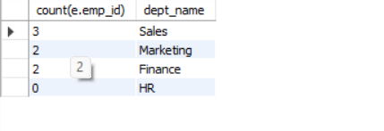
Q8. Show departments having more than 2 employees.
- select d.dept_name,count(e.emp_id)
from employees e
right join departments d
on d.dept_id = e.dept_id
group by d.dept_name
having count(e.emp_id) > 2;

Q9. Show highest salary in each department.
- select d.dept_name,max(e.salary)
from employees e
right join departments d
on e.dept_id= d.dept_id
group by d.dept_name;
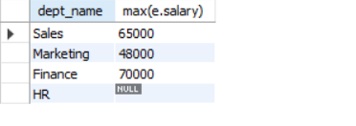
Q10. Show employees whose salary is above department average.
- select e.emp_name,d.dept_name,salary
from employees e
inner join departments d
on d.dept_id = e.dept_id
where salary > (select avg(salary) from employees);
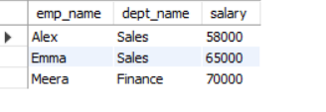
Q11. Show employees and their departments sorted by department name.
- select e.emp_name,d.dept_name
from employees e
inner join departments d
on e.dept_id = d.dept_id
order by d.dept_name;
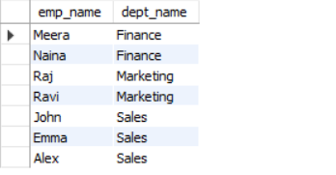
Q12. List the 2 lowest-paid employees with department names.
- select e.emp_name,d.dept_name,e.salary
from employees e
inner join departments d
on e.dept_id = d.dept_id
order by salary
limit 2;
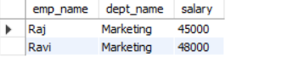
Q13. Show total salary expenditure per department.
- select d.dept_name,sum(salary)
from employees e
inner join departments d
on e.dept_id = d.dept_id
group by d.dept_name;
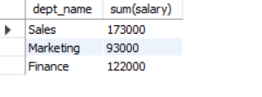
Q14. Show departments where total salary spent is more than 150,000.
- select d.dept_name,sum(salary)
from employees e
inner join departments d
on e.dept_id = d.dept_id
group by d.dept_name
having sum(salary) > 150000;

Q15. Show employees who belong to departments starting with 'S'.
- select e.emp_name,d.dept_name
from employees e
inner join departments d
on e.dept_id = d.dept_id
where d.dept_name like "s%";

Q16. Find employees whose salary is the highest in their department.
- select e.emp_name, d.dept_name, e.salary
from employees e
inner join departments d
on e.dept_id = d.dept_id
where e.salary = (select MAX(e2.salary)from employees e2
where e2.dept_id = e.dept_id );
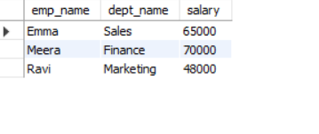
Q17. Show employees and department sorted by salary descending.
- select e.emp_name,d.dept_name,e.salary
from employees einner join departments d
on d.dept_id = e.dept_id
order by e.salary desc;
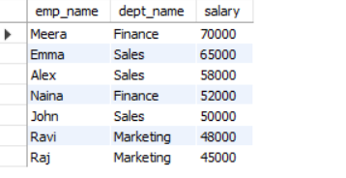
Q18. Count how many employees earn above 50,000 per department.
- select count(e.emp_id), d.dept_name
from employees e
inner join departments d
on d.dept_id = e.dept_id
where salary > 50000
group by d.dept_name;
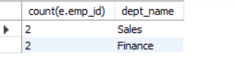

Q19. Show employee name, department, and salary for employees between 45,000 and 60,000.
- select e.emp_name,e.salary,d.dept_name
from employee e
left join department d on e.dept_id=d.dept_id
where e.salary between 45000 and 60000;
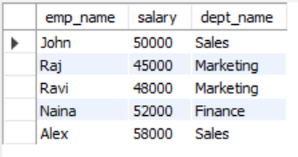

Q20. Find departments with no employees.
- SELECT d.dept_name
FROM Department d
LEFT JOIN Employee e ON d.dept_id = e.dept_id
GROUP BY d.dept_name
HAVING COUNT(e.emp_id) = 0;

