Tags

**HTML <option> Tag**

The HTML <option> tag is a versatile tool that enhances user interaction by creating selectable options within a dropdown list. This tag can be used with or without any attributes, and the selected value can be sent to the server.

This elements must be inside <select> tag, <optgroup>, or <datalist> tags. It represents an individual option within a <select> dropdown, allowing users to choose among multiple choices.

Syntax:

<option> Contents... </option>

Global and Event Attributes

Each <option> tag can include text or numeric values, which will be presented to the user. The <option> tag also supports the Global Attributes and Event Attributes in HTML.

Examples of HTML option Tag

<!DOCTYPE html>

<html>

<body>

<h1>GeeksforGeeks</h1>

<h2>HTML option Tag</h2>

<select>

<!-- option tag starts -->

<option>Choose an option</option>

<option value="html">HTML</option>

<option value="java">JAVA</option>

<option value="C++">C++</option>

<option value="php">PHP</option>

<option value="perl">PERL</option>

<!-- option tag ends -->

</select>

</body>

</html>

Output

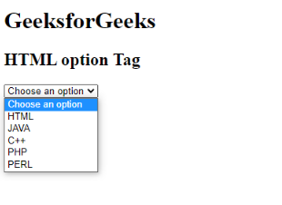

**Checkbox**

The <input type="checkbox"> defines a checkbox. The checkbox is shown as a square box that is ticked (checked) when activated. Checkboxes are used to let a user select one or more options of a limited number of choices.

Syntax

<input type="checkbox">

Example of HTML Checkbox tag

<!DOCTYPE html>

<html>

<head>

<title>

HTML Input Type Checkbox

</title>

<style>

h2 {

text-align: center;

}

fieldset {

width: 250px;

margin: auto;

}

</style>

</head>

<body>

<h2>HTML &lt;input type="checkbox"&gt;</h2>

<form action="#">

<fieldset>

<legend>Select Your Subjects:</legend>

<input type="checkbox"

name="check"

id="checkbox1"

value="html" checked>

<label for="checkbox1">HTML</label>

<br>

<input type="checkbox"

name="check"

id="checkbox2"

value="css">

<label for="checkbox2">CSS</label>

<br>

<input type="checkbox"

name="check"

id="checkbox3"

value="javascript">

<label for="checkbox3">JavaScript</label>

</fieldset>

</form>

</body>

</html>

Output

