ASSIGNMENT 1
Task 1: Create a Git repository named as your enrollment number. Create 2 folders in your repository named as Assignment_1 and Assignment_2.
Step 1 : First Login to Github Using Your Account.
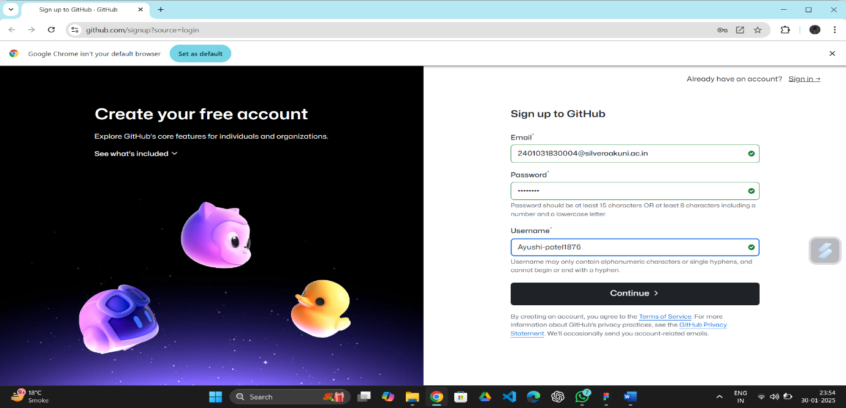
Step 2 : This Screen will appear after login now click on create repository to create your repository.
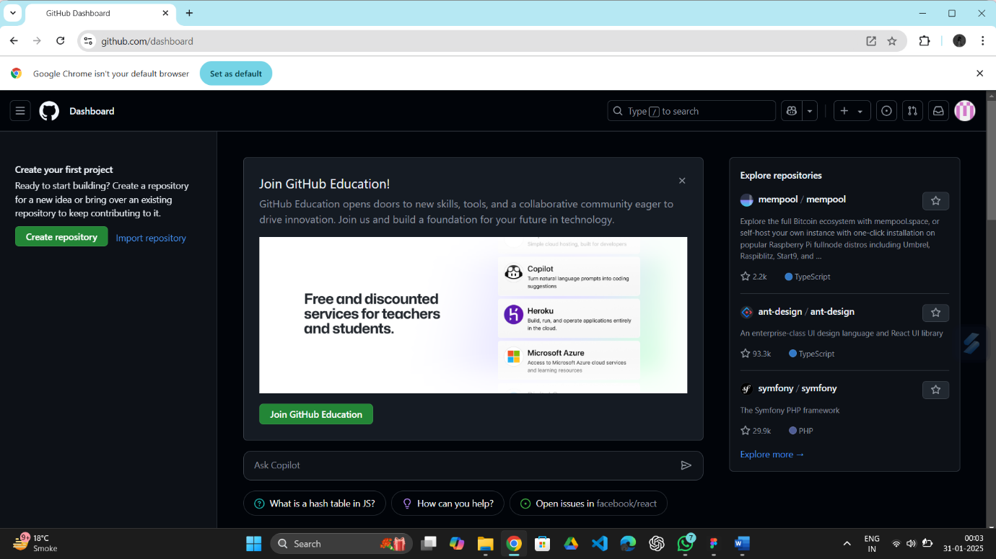
Step 3 : Create a Repository as per your Enrollment No.
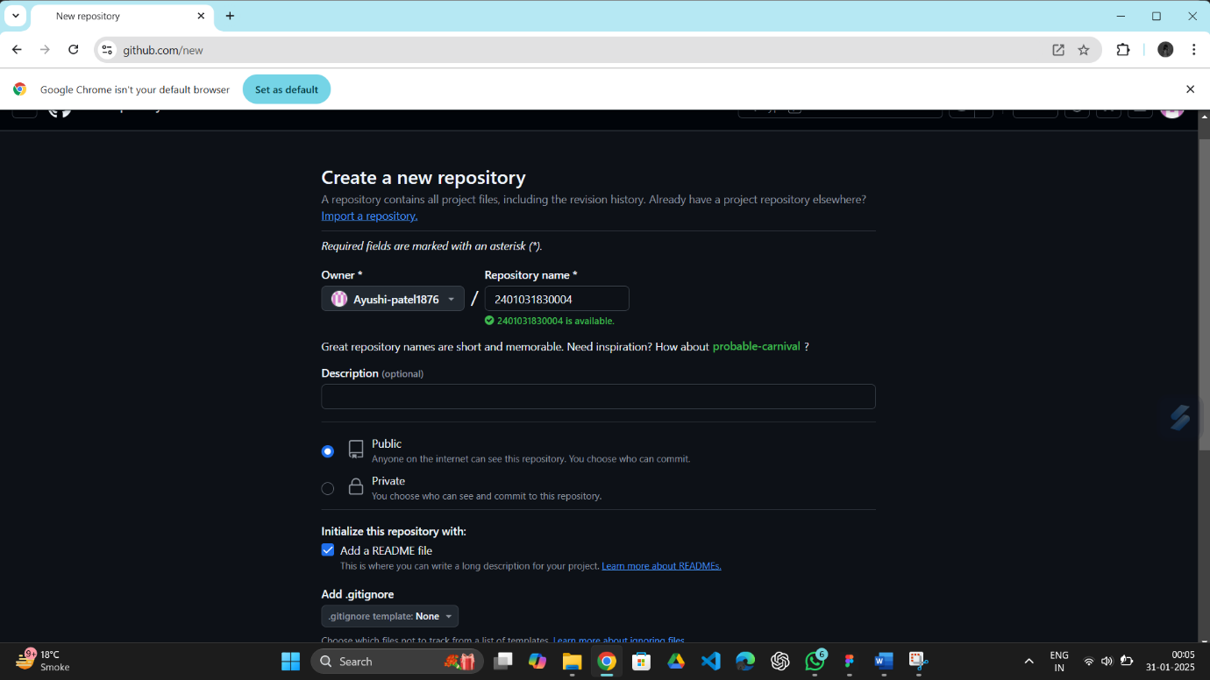

Step 4 : Create First folder named as Assignment_1 .
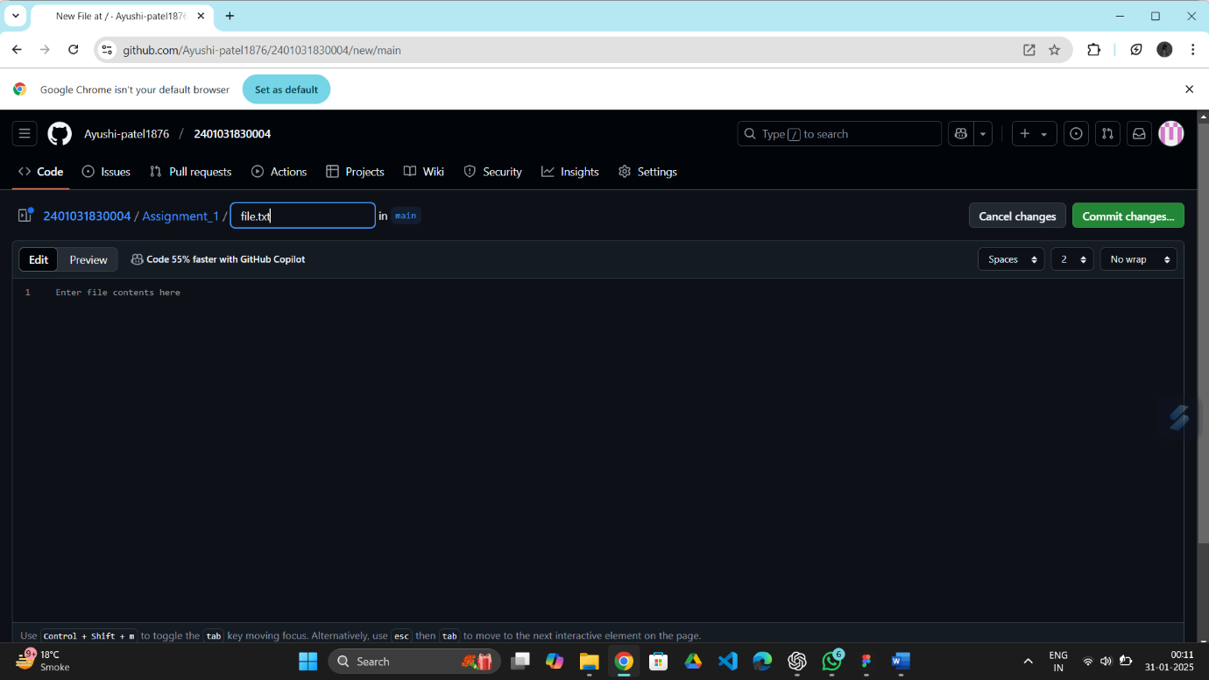

Step 5 : Create Second folder named as Assignment_2 .
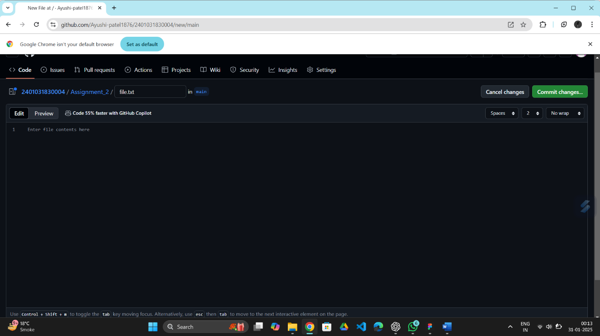

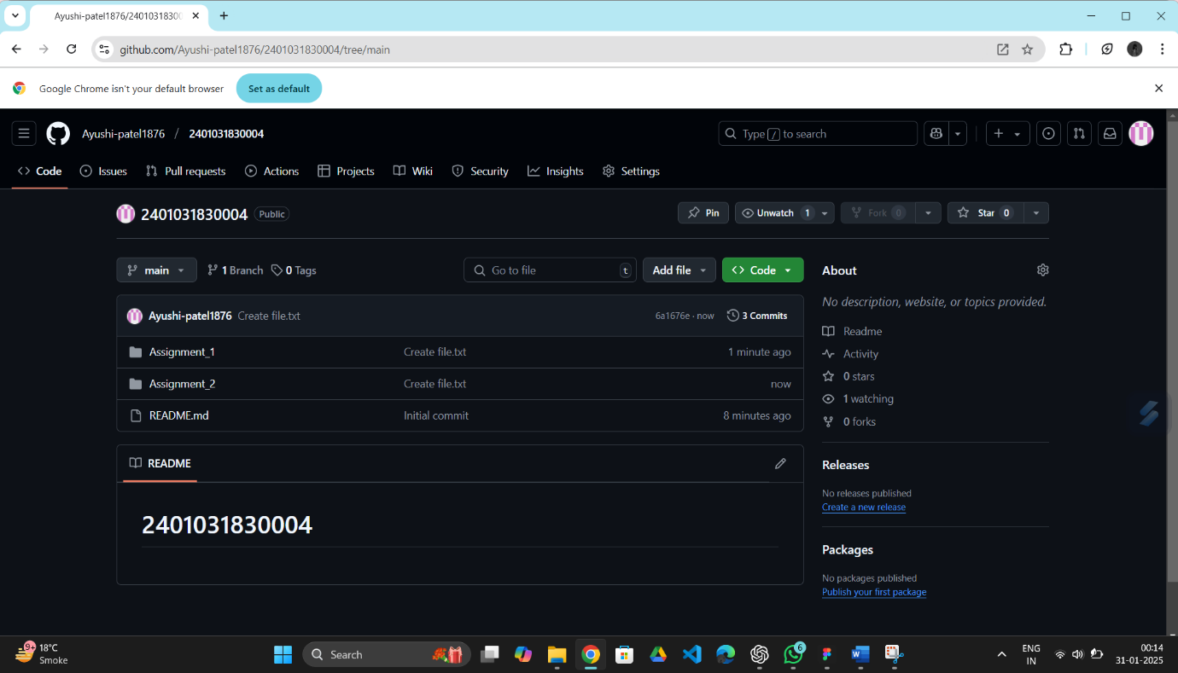
Step 6 : Below is the View After Successfully creating All folders.

