iCloudEMS Support Engineer (AI) Assignment
Prepared by: Aje Shukla | Analysis database: SQLite | Source export: 2,767 rows
Scope note: The ZIP contains the re-evaluation sheet as CSV (41 rows), although the assignment brief describes it as XLSX. Analysis was performed on the supplied CSV. No live ERP/database changes were made.

Task 1 — Ticket triage: EX-20481
1. Client need: The COE needs the Exam-Wise Report to show component-wise marks again so it can identify pending examination work and process results. They are asking for investigation and restoration of the report, not simply a new report.
2. Initial hypothesis: More likely a marks-data / exam-scheme configuration or processing issue than a report-code bug. The report may be correctly reflecting missing marks or unmatched schemes; Task 2 validates this.
3. Priority: High is justified. Missing or misleading marks visibility can delay result verification and publication, create avoidable student queries, and affect examination-calendar deadlines. A published status alongside missing marks also needs urgent reconciliation.
4. Questions: (a) Which exact filters/session/department/semester were selected? (b) When did the report last show marks, and was there a deployment or configuration change since? (c) Does the issue affect all courses or selected courses/components? (d) Were marks uploaded and then transferred from the temporary table; what failure reasons were shown? (e) Were marks frozen or results processed/published recently?
5. First response (within 30 minutes; 67 words):
“Thank you for reporting this. We have taken ownership of EX-20481 as a high-priority examination issue and are checking the supplied export against marks-entry and exam-scheme statuses. Please confirm the report filters used and the last date/time it displayed marks, and let us know whether all departments/courses are affected. We will share an evidence-based update and next steps within 2 hours; no marks will be changed without COE approval.”

Task 2 — Investigation of exam_wise_report_export.csv

2.1 Summary numbers
Measure | Finding
Total rows | 2,767
Unique students (Admno) | 875
Unique courses (Code) | 208
Rows where marks are present | 104
Rows with Marks Entry Status = Not Done | 1,638
Rows with Exam Name = Scheme Not Found | 1,025
Published rows where marks are not present | 1,849

2.2 Why the report shows no marks
Only 104 of 2767 rows contain a numeric Marks Obtained value. There are 1638 rows explicitly marked Not Done and 1025 rows whose Exam Name is Scheme Not Found; together these account for all 2,663 rows with missing marks. The missing-scheme rows also lack marks-entry and freeze status. The report therefore appears to be exposing missing/unmatched source data rather than proving a report-rendering defect. However, 1849 rows are labelled Published despite having no marks, so the university and developers must reconcile result status against the live marks records before relying on the report.

2.3 Data anomalies found
Anomaly | Column(s) | Rows | Example Sr. | Why it matters / action
Marks not entered | Marks Entry Status, Marks Obtained | 1,638 | Sr. 2 | Marks are blank and entry is Not Done; faculty/COE must complete or confirm the component.
Exam scheme not found | Exam Name, Marks Entry Status, Max Marks | 1,025 | Sr. 7 | Scheme mapping/master data is missing; marks cannot be reliably matched/transferred.
Published but no marks | Result Publish, Marks Obtained | 1,849 | Sr. 5 | Published status conflicts with absent marks; reconcile before result reliance.
Duplicate business keys | Admno, Code, Exam Name | 716 rows in 356 groups (360 excess rows) | Sr. 214/219 | May double-count or create ambiguous mark updates; deduplicate only after confirming intended component rows.
Negative marks | Marks Obtained | 10 | Sr. 222 | Values of -100 are outside a 0–100 range and may be sentinel/absence values; confirm coding before processing.
Scaled marks mismatch | Marks Obtained, Max Marks, Scaled Marks, Scaled MaxMarks | 9 | Sr. 222 | 9 rows have equal original/scaled maximums but different marks; verify scaling logic. These overlap with negative marks.
Semester spelling/case variants | Semester | 140 rows | Sr. 1 (case variant); Sr. 2767 (Sem 9) | 139 rows use inconsistent casing; one uses 'Sem 9'. Standardise known case variants; confirm 'Sem 9' with registrar.
Junk/test row | Admno, Rollno, Student, Code, Type, Course | 1 | Sr. 2767 | Values are '1' and Course is blank; exclude from processing and confirm source contamination.
Registered but unfreezed | Register Status, Freeze/Unfreeze Status | 48 | Sr. 85 | If registration is meant to be final before marks freeze, this requires workflow review.
Processed but not published | Result Process, Result Publish | 32 | Sr. 1304 | May be a legitimate approval/publishing queue; confirm expected workflow and pending action.
Additional data-quality note: Max Marks, Scaled Marks and Scaled MaxMarks are blank on 2,663 rows, matching the 2,663 rows without Marks Obtained. Marks Entry Status and Freeze/Unfreeze Status are blank on the 1,025 Scheme Not Found rows. Type has one invalid value ('1') on the junk row.

2.4 Where to start
Five courses with the most Not Done rows:
Code | Course | Not Done rows
E1UA202T | Probability And Statistics | 258
R1UC601B | Advanced Algorithmic Problem Solving | 164
C1UC323T | Linear Algebra | 138
C1UC121B | Multi Variable Calculus | 75
C1UC322T | Probability And Statistics | 70
Department + semester combinations with the most Scheme Not Found rows:
Department | Semester | Scheme Not Found rows
Bachelor of Computer Applications | Sem II | 101
Bachelor of Technology in Computer Science and Engineering | Sem VI | 92
Bachelor of Computer Applications | Sem IV | 85
Bachelor of Technology in Computer Science and Engineering | Sem III | 79
Bachelor of Technology in Computer Science and Engineering | Sem II | 72

2.5 Chart
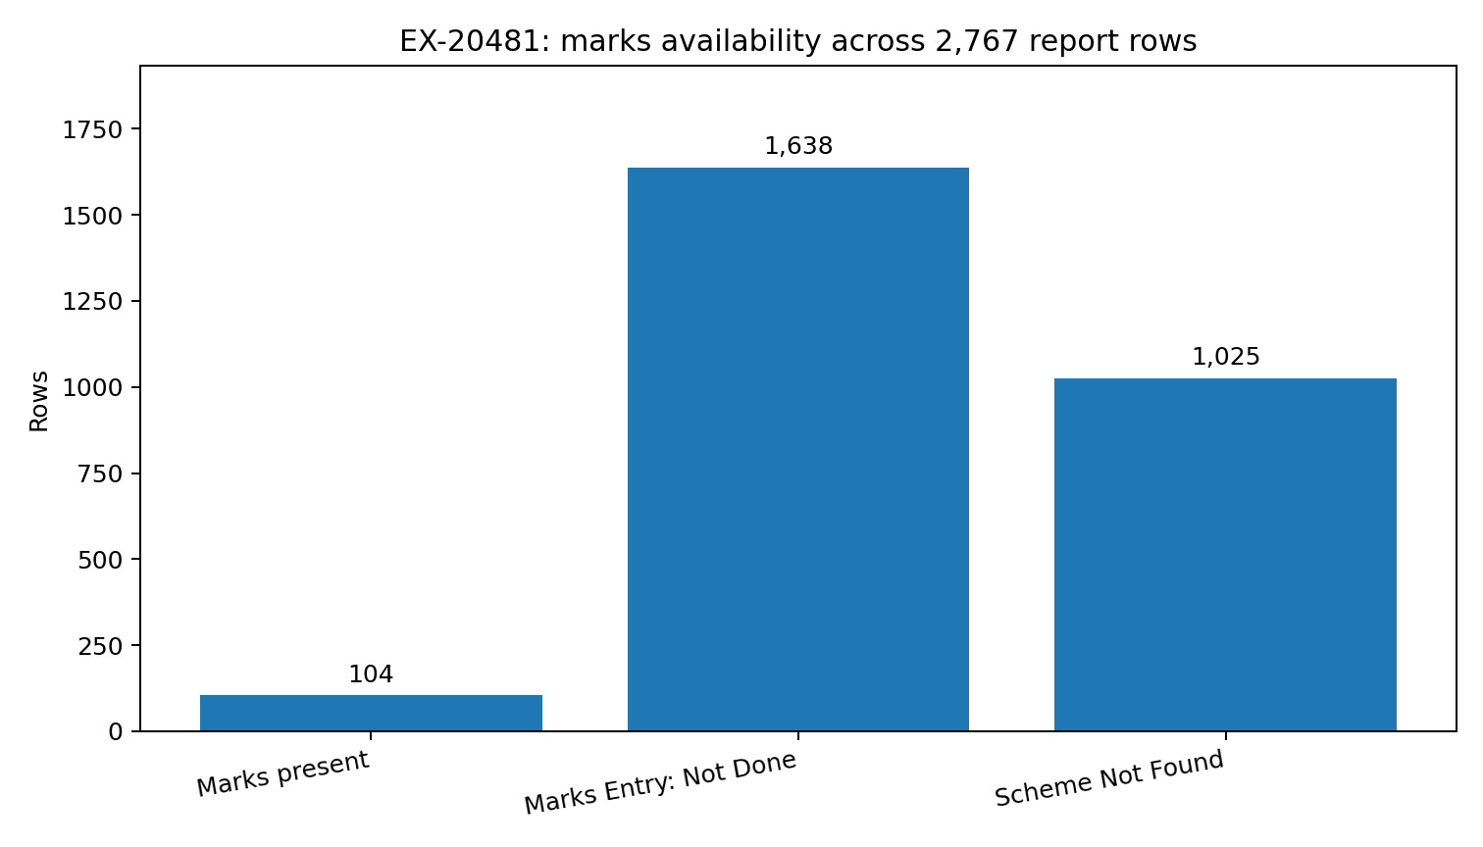
Caption: Only 104 of 2,767 rows (3.8%) contain marks; 1,638 are Not Done and 1,025 have no matching exam scheme.

Task 3 — SQL
SQLite was selected. The complete CREATE TABLE and requested queries, with expected result-row counts in comments, are supplied in the separate queries.sql file. The SQL uses the supplied 26 report columns renamed to snake_case.
Expected outputs: query 1 = 5 grouped rows; query 2 = 1,849 rows; query 3 = 356 duplicate-key groups; query 4 = 10 rows; query 5 preview = 17 distinct semester values; query 5 safe case-normalisation update = 139 rows; query 6 = 273 distinct missing-scheme combinations. 'Sem 9' is intentionally excluded from automatic normalisation.
Safety: create and verify exam_wise_report_backup before the UPDATE; run the UPDATE in a transaction in a controlled environment, compare affected rows to the preview, and retain rollback capability. The supplied export is evidence only; no production update is authorised.

Task 4 — Re-evaluation upload: GU-16432

4.1 Validation and exceptions
The supplied re-evaluation file has 41 rows. 33 rows are prepared in the upload CSV; 8 rows are held in the exception workbook. The 8 held rows are not silently corrected.
S.No | Student / key | Issue | Action
4 | Varun Iyer / 22SCSE2475390 / R1UC401T | Revised marks 112 exceed maximum 100. | Hold; ask COE to verify the approved revised score and correct source record.
12 | Dev Arora / 22SCSE99999999 / K1UC426T | Enrollment number 22SCSE99999999 has no matching student/course row in the report export. | Hold; ask COE to confirm the enrollment number and student identity.
16 | Ayush Saxena / 21SCSE6422395 / E2UC502T | Revised value is AB, not a numeric mark; remark says 'Absent in rechecking?'. | Hold; COE/exam authority must decide the correct absence code and its result treatment.
20 | Myra Mehta / 22SCSE7045594 / R1UC601B | Revised Marks is blank. | Hold; ask COE for the approved revised mark or explicit status.
23 | Myra Nair / 23SCSE8385138 / C1UC125T | Revised marks 41 are lower than old marks 47. | Hold; obtain written confirmation/approval from COE. Do not overwrite or reject based on direction alone.
28 | Ananya Chauhan / 21SCSE5105821 / E2UC501T | Duplicate student + paper key also appears at S.No. 41 with a conflicting revised mark (28 vs 31). | Hold both duplicate rows; COE must confirm the single authoritative value.
32 | Wrong Name Typed / 22SCSE9017090 / R1UC601B | Student name 'Wrong Name Typed' conflicts with report name 'Kavya Singh' for this enrollment and paper. | Hold; ask COE to correct/confirm the student identity. Do not silently replace the name.
41 | Ananya Chauhan / 21SCSE5105821 / E2UC501T | Duplicate student + paper key also appears at S.No. 28 with a conflicting revised mark (31 vs 28). | Hold both duplicate rows; COE must confirm the single authoritative value.
Cross-check limitation: the report export is for Special Exam Form Sep 2025-2026, while the upload ticket is Winter 2025-26. Student and paper-code matches were used as a validation aid, but the export does not provide a same-session authoritative old-mark comparison; marks in the matching ETE-1 rows are blank. COE must confirm the old marks against the Winter 2025-26 live record.

4.2 Mapping and assumptions
Source / rule | Template column(s) / treatment
Enrollment No | admno
Roll No | rollno
Student Name | studentName
Paper Code | subCode; uppercase normalisation only
Paper Name | subName
Report Type | ssType; matched ETE-1 row (PP for included rows)
Fixed | examName=ETE-1; sequenceNo=1; questionNo=1
Revised Marks | marks and totalMarks
Max Marks | maxMarks and totalMaxMarks
Fixed | acadYear=2025-2026; examSession=Revaluation Re Check Form Winter 2025-2026
Blank by instruction | sessId, bloomsLevel, coMapping, coDifficulty, qLabel
Not provided | qType; no question-type field in source/template mapping instructions, so left blank
Assumptions: one question/component row is represented with questionNo=1 and sequenceNo=1 as instructed. totalMarks and totalMaxMarks are set equal to the revised mark and maximum for this single-row upload. No student mark is inferred, averaged, or changed. The valid rows have a corresponding ETE-1 record in the export and a report Type of PP.

4.3 Before/after upload checklist
- Confirm COE approval and the exact Winter 2025-26 session and ETE-1 scheme for every included student/course.
- Resolve all 8 exception rows and obtain written decisions for lower marks, AB, blank marks, duplicate conflicting values and identity mismatch.
- Back up the staging table and retain the original source sheet and generated CSV.
- Check the CSV header/order against the 21-column template; confirm 33 rows, no blank keys, numeric marks and marks not above maximum.
- Check enrollment + roll number + course code + exam component uniqueness; do not upload both conflicting duplicate rows.
- Upload first in the approved staging workflow and review every success/failure row before transfer; do not proceed if Scheme Not Found or identity mismatch occurs.
- After transfer, reconcile successful count to 33, verify sample student/course/component marks in the live marks screen, and confirm freeze/result processing only after COE verification.
If any row fails with Scheme Not Found again: stop that row, capture the failure reason, verify session/course/component scheme configuration with the exam master team, correct configuration through the authorised process, and retry only after revalidation. Do not force-map it or mark it successful manually.

4.4 Deliverables
GU-16432_upload_ready.csv contains 33 validated rows. GU-16432_exceptions.xlsx contains the 8 held rows plus a separate normalisation/assumptions sheet. No live upload was performed.

Task 5 — Communication

5.1 Client reply (EX-20481)
Thank you for raising this issue. We reviewed the supplied Exam-Wise Report export and found that the report is not simply blank because of a display problem. Of 2,767 course/component records, only 104 contain marks; 1,638 are marked “Not Done” and 1,025 show that the required exam scheme could not be found. We also found 1,849 records marked as published despite having no marks, which needs urgent verification before the university relies on those result statuses. We recommend that the exam cell first review the courses with the highest pending counts, beginning with Probability and Statistics (E1UA202T), Advanced Algorithmic Problem Solving (R1UC601B), and Linear Algebra (C1UC323T). The university should confirm the correct schemes, complete missing marks, and verify/freeze marks through its normal approval process. Our team will share the detailed affected-course list and coordinate with the product team to check the report and status logic. We will provide the next update within one working day. No marks will be changed without COE approval.

5.2 Internal developer escalation
- Ticket: EX-20481, High priority. Client reports Exam-Wise Report previously showed marks but now shows none; export is Special Exam Form Sep 2025-2026.
- Data checked: 2,767 rows; 875 unique Admno; 208 unique course codes; only 104 rows have Marks Obtained.
- Evidence: 1,638 rows Marks Entry Status=Not Done; 1,025 rows Exam Name=Scheme Not Found; 1,849 rows Result Publish=Published with Marks Obtained NULL.
- Examples: Sr. 2 is Not Done with blank marks; Sr. 7 is Scheme Not Found with blank marks/status; Sr. 2767 is a junk row with Admno/Rollno/Student/Code/Type='1' and blank Course.
- Other findings: duplicate key (Admno+Code+Exam Name) in 356 groups / 716 rows; 10 negative marks (-100), 9 scaled mismatches (overlap); 140 semester values are noncanonical (139 case variants + 'Sem 9'); 48 Registered + Unfreeze rows.
- Suspected root cause: missing/inconsistent exam-scheme configuration and incomplete marks entry/transfer are the main cause of absent marks. The report may be accurately reflecting missing live marks; separately, Published status appears inconsistent and requires investigation.
- Attachments: source export, chart, anomaly summary, queries.sql, missing-scheme list (273 distinct Department/Semester/Code/Course combinations).
- Developer actions requested: verify report query joins and component mapping; confirm why Scheme Not Found is emitted alongside ETE-1 for some same student/course keys; validate duplicate-row generation; reconcile Result Process/Result Publish against live marks; confirm whether -100 is a sentinel and correct scaling expectations. Return affected IDs and safe remediation steps; do not alter marks.

Task 6 — How AI was used
AI was used to help structure the investigation, draft SQL and support communications, and identify candidate data-quality rules. Python/pandas was used to calculate and independently verify all counts and create the upload files; AI suggestions were not treated as authoritative.

Three useful prompts
- “Inspect this report export and calculate total rows, unique students/courses, marks-present, Not Done, Scheme Not Found, and Published-without-marks counts. Show the exact pandas logic so I can verify it.” — Helped structure Task 2 metrics.
- “Find data-quality anomalies in this CSV, including duplicate business keys, impossible marks, inconsistent semester values, missing master data and contradictory status combinations. For every finding give row count and example Sr.” — Helped create the anomaly checklist.
- “Map these re-evaluation columns to the provided staging template. Do not change marks; flag invalid, blank, lower-than-old, AB, duplicate and identity-mismatch rows for human approval.” — Helped design a conservative upload and exception workflow.

Example of AI limitation and verification
An automated cleanup suggestion could treat “Sem 9” as “Sem IX” because both may mean ninth semester. That mapping is not proven by the supplied data, so it was not applied. The value is isolated for registrar confirmation. A second counting pitfall is confusing 356 duplicate key groups with 356 duplicate rows: the actual export has 356 groups containing 716 rows (360 excess rows). Counts were verified with pandas groupby/duplicated checks.

Possible AI-agent automation (human approval retained)
An AI support agent could validate incoming upload headers, required fields, numeric ranges, duplicate student-course keys, student identity, course codes and exam-scheme availability. It could compare the file with current ERP master data, generate a staging CSV, produce an exception workbook and draft the client/developer notes. It could flag published-without-marks and negative/sentinel values for daily monitoring. A human COE/support approver must approve mark changes, AB/lower-mark decisions, identity corrections, scheme changes, final staging transfer, freezing and result publication.

