What is Cloud Computing?
- Cloud Computing is a technology that allows you to store and access data and applications over the internet instead of using your computer’s hard drive or a local server.
Architecture Of Cloud Computing
- Cloud computing architecture refers to the components and sub-components required for cloud computing. These components typically refer to:
1. Front End ( User Interaction Enhancement )
The User Interface of Cloud Computing consists of 2 sections of clients. The Thin clients are the ones that use web browsers facilitating portable and lightweight accessibilities and others are known as Fat Clients that use many functionalities for offering a strong user experience.
2. Back-end Platforms ( Cloud Computing Engine )
The core of cloud computing is made at back-end platforms with several servers for storage and processing computing. Management of Applications logic is managed through servers and effective data handling is provided by storage. The combination of these platforms at the backend offers the processing power, and capacity to manage and store data behind the cloud.
3. Cloud-Based Delivery and Network
On-demand access to the computer and resources is provided over the Internet, Intranet, and Intercloud. The Internet comes with global accessibility, the Intranet helps in internal communications of the services within the organization and the Intercloud enables interoperability across various cloud services. This dynamic network connectivity ensures an essential component of cloud computing architecture on guaranteeing easy access and data transfer.
The 5 Core Characteristics of Cloud Computing
All cloud services share five fundamental characteristics that define them:
  - On-Demand Self-Service: Users can provision computing resources like servers and storage automatically, without requiring human intervention from the service provider.
  - Broad Network Access: Capabilities are available over the network and can be accessed through standard mechanisms by any device, such as laptops, tablets, and mobile phones.
  - Resource Pooling: The provider's computing resources are pooled to serve multiple customers using a multi-tenant model. Resources are dynamically assigned and reassigned according to demand.
  - Rapid Elasticity (Scalability): Resources can be scaled up or down quickly and, in some cases, automatically, to meet demand. This ensures you have enough power during traffic spikes and aren't paying for idle resources during quiet periods.
  - Measured Service (Pay-as-you-go Model): Cloud systems automatically control and optimize resource use. Usage is monitored, controlled, and reported, providing transparency for both the provider and the consumer. You only pay for what you use.
The Shared Responsibility Model
Security in the cloud is a partnership between the cloud provider and the customer. This is known as the Shared Responsibility Model.
  - The Cloud Provider (e.g., AWS, Azure, GCP) is responsible for the security OF the cloud. This includes the physical security of the data centres, the hardware, and the core networking infrastructure.
  - The Customer (You) is responsible for security IN the cloud. This includes managing who has access to your resources, encrypting your data, configuring firewalls (like Network Policies), and securing your applications.
The amount of responsibility you have depends on the service model you choose.
Types of Cloud Computing Services
The following are the types of Cloud Computing:
1. Infrastructure as a Service (IaaS )
Infrastructure as a Service (IaaS) is a type of cloud computing that gives people access to IT tools like virtual computers, storage, and networks through the internet. You don’t need to buy or manage physical hardware. Instead, you pay only for what you use.
2. Platform as a Service (PaaS )
Platform as a Service (PaaS) is a cloud computing model where a third-party provider offers the software and hardware tools needed to develop, test, and run applications. This allows users to focus on building their applications without worrying about managing servers or infrastructure.
3. Software as a Service (SaaS)
Software as a Service (SaaS) is a way of using software over the internet instead of installing it on your computer. The software is hosted by a company, and you can use it just by logging in through a web browser. You don’t need to worry about updates, maintenance, or storage the provider takes care of all that.
4. Function as a Service (FaaS)
Function as a service (FaaS) is a cloud-computing service that allows customers to run code in response to events, without managing the complex infrastructure. You just write the code, upload it and the cloud provider runs it only when it's needed. You pay only for the time your code runs.
Cloud Deployment Models
  - Private Cloud: The cloud infrastructure is operated solely for a single organization. It can be managed internally or by a third party and can exist on-premise or off-premises. It offers the highest level of security and control.
  - Public Cloud: The cloud infrastructure is owned and operated by a third-party cloud service provider (like AWS or Google) and is made available to the general public over the internet. It offers massive scalability and a pay-as-you-go model.
  - Hybrid Cloud: This model combines a private cloud with one or more public clouds, allowing data and applications to be shared between them. This offers flexibility, allowing companies to keep sensitive data on a private cloud while leveraging the scalable resources of a public cloud for other applications.
  - Multi-Cloud: A strategy where an organization uses a combination of clouds from two or more different public cloud providers. This helps avoid vendor lock-in and allows a company to use the "best-of-breed" service from each provider.
Cloud Security
Cloud security recommended to measures and practices designed to protect data, applications, and infrastructure in cloud computing environments. The following are some of the best practices of cloud security:
1. Data Encryption
Encryption is essential for securing data stored in the cloud. It ensures that data remains unreadable to unauthorized users even if it is intercepted.
2. Access Control
Implementing strict access controls and authentication mechanisms helps ensure that only authorized users can access sensitive data and resources in the cloud.
3. Multi-Factor Authentication (MFA)
MFA adds an extra layer of security by requiring users to provide multiple forms of verification, such as passwords, biometrics, or security tokens, before gaining access to cloud services.
Use Cases of Cloud Computing
Cloud computing is used across all industries for various applications:
  - Scalable Websites and Applications: Host applications that can handle millions of users.
  - Data Storage, Backup, and Recovery: Cost-effectively store vast amounts of data and ensure it can be recovered in case of a disaster.
  - Big Data Analytics: Process and derive insights from enormous datasets efficiently.
  - Software Development and Testing: Create and dismantle development environments quickly.
  - Artificial Intelligence and Machine Learning: Access powerful GPU resources to train complex AI models.

Advantages of Cloud Computing
- Cost Efficiency: No need for upfront hardware investment; pay-as-you-go pricing.
- Scalability: Easily scale resources up or down based on demand.
- Accessibility: Access services from anywhere with an internet connection.
- Reliability: High availability and disaster recovery options.
- Security: Advanced security features and compliance standards (though shared responsibility applies).
- Automatic Updates: Providers handle software and hardware updates.
- Innovation: Faster deployment of new technologies and services.

On-Prem Deployment vs Cloud Deployment
Aspect | On-Premises Deployment | Cloud Deployment
Infrastructure | Owned and managed by the organization | Managed by cloud provider
Cost | High upfront CAPEX for hardware and maintenance | OPEX model (pay-as-you-go)
Scalability | Limited; requires purchasing and installing hardware | Highly scalable; resources provisioned instantly
Maintenance | Organization responsible for updates and repairs | Provider handles maintenance and updates
Accessibility | Limited to internal network or VPN | Accessible globally via the internet
Deployment Speed | Slow; requires procurement and setup | Fast; resources provisioned in minutes
Security | Full control but requires internal expertise | Shared responsibility; provider offers advanced security
Disaster Recovery | Requires separate setup and cost | Built-in options with minimal effort

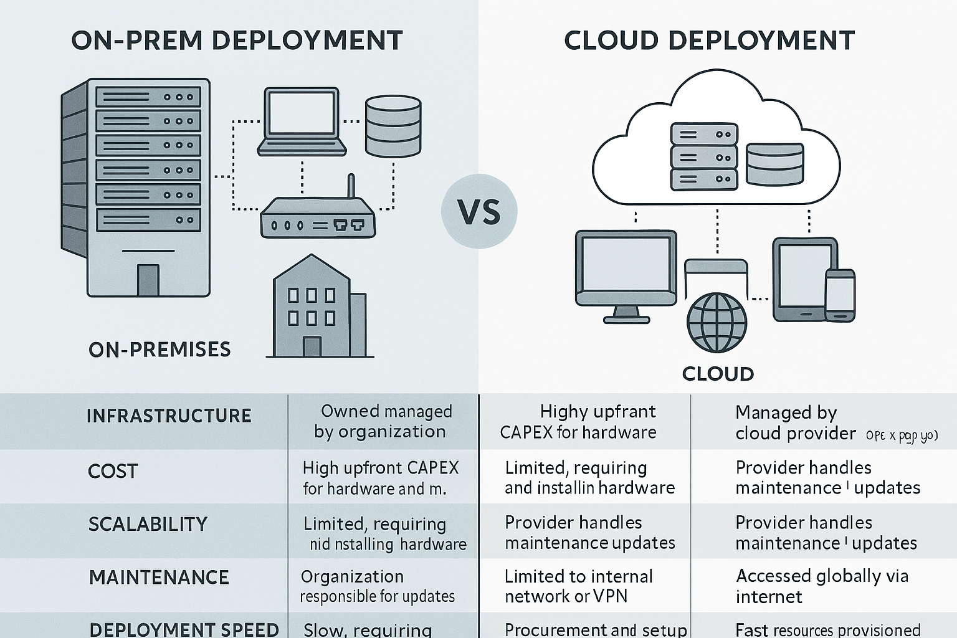

The Four V’s of Big Data (Detailed Analysis)
1. Volume
- Definition: Volume refers to the massive amount of data generated every second from various sources such as social media, IoT devices, sensors, transactions, and enterprise systems.
- Why It Matters: Traditional data processing tools cannot handle such large datasets efficiently. Big data technologies like Hadoop and distributed storage systems are designed to manage petabytes or even exabytes of data.
- Examples:
  - Facebook generates over 4 petabytes of data daily.
  - IoT devices in smart cities produce continuous streams of sensor data.
- Challenges:
  - Storage capacity.
  - Efficient retrieval and processing.
- Solutions:
  - Distributed file systems (HDFS).
  - Cloud storage solutions (AWS S3, Azure Blob Storage).

2. Velocity
- Definition: Velocity is the speed at which data is generated, collected, and processed. In today’s digital world, data flows in real-time from multiple sources.
- Why It Matters: Businesses need to process data quickly to make timely decisions. Delayed processing can lead to missed opportunities.
- Examples:
  - Stock market transactions occur in microseconds.
  - Real-time fraud detection in banking.
- Challenges:
  - Handling streaming data.
  - Maintaining low latency.
- Solutions:
  - Real-time processing frameworks like Apache Kafka, Apache Spark Streaming.
  - In-memory computing.

3. Variety
- Definition: Variety refers to the different types of data formats—structured, semi-structured, and unstructured.
- Types of Data:
  - Structured: Relational databases (tables, rows).
  - Semi-structured: XML, JSON.
  - Unstructured: Images, videos, audio, social media posts.
- Why It Matters: Traditional relational databases cannot handle unstructured data efficiently.
- Examples:
  - Tweets, Facebook posts, YouTube videos.
- Challenges:
  - Integrating diverse data sources.
  - Data normalization.
- Solutions:
  - NoSQL databases (MongoDB, Cassandra).
  - Data lakes for storing raw data.

4. Veracity
- Definition: Veracity refers to the trustworthiness, accuracy, and quality of data.
- Why It Matters: Poor-quality data leads to incorrect insights and decisions.
- Examples:
  - Social media posts may contain false information.
  - Sensor data might have noise or errors.
- Challenges:
  - Data cleansing.
  - Removing duplicates and inconsistencies.
- Solutions:
  - Data validation techniques.
  - Machine learning for anomaly detection.

Importance and Implications
The four Vs of Big Data hold profound implications for organizations across diverse sectors, offering both opportunities and challenges in leveraging data as a strategic asset:
Opportunities:
Harnessing insights: By leveraging the volume, velocity, and variety of data, organizations can uncover actionable insights, trends, and patterns that drive innovation, enhance customer experiences, and optimize business operations.
Real-time decision-making: The velocity of data enables organizations to make informed decisions in real-time, responding promptly to market trends, customer preferences, and emerging opportunities.
Innovation and agility: The variety of data fosters innovation and agility, empowering organizations to experiment with new data sources, models, and technologies to gain a competitive edge in the digital economy.
Challenges:
Scalability and infrastructure: Managing the volume and velocity of data requires scalable infrastructure, storage systems, and processing frameworks capable of handling massive datasets and real-time data streams.
Data integration and interoperability: The variety of data poses challenges in terms of data integration, interoperability, and governance, necessitating robust data management strategies and standards to ensure consistency and coherence across disparate data sources.
Data quality and trust: Ensuring the veracity of data is paramount, as inaccuracies, biases, and errors can undermine the integrity of insights and decisions derived from Big Data analytics.
Examples and Use Cases
The four Vs of Big Data find application across a myriad of domains and use cases, driving innovation and transformation in various industries:
Healthcare:
- Volume: Analysing large-scale genomic datasets to uncover genetic markers for disease susceptibility and personalized medicine.
- Velocity: Monitoring real-time patient vitals and sensor data to detect anomalies, predict medical emergencies, and enable proactive interventions.
- Variety: Integrating electronic health records, medical imaging data, and wearable device data to provide holistic patient insights and improve clinical outcomes.
- Veracity: Ensuring the accuracy and reliability of medical data to support clinical decision-making, drug discovery, and epidemiological research.
Finance:
- Volume: Analysing vast volumes of transaction data to detect fraudulent activities, identify patterns of financial fraud, and mitigate risks in real-time.
- Velocity: Processing high-frequency trading data and market feeds to execute algorithmic trading strategies and capitalize on market opportunities.
- Variety: Integrating diverse data sources, including market data, social media sentiment, and news feeds, to gain holistic insights into market trends and investor sentiment.
- Veracity: Validating the accuracy and reliability of financial data to ensure compliance with regulatory requirements, risk management standards, and financial reporting guidelines.
Retail:
- Volume: Analysing large-scale customer transaction data to segment customers, personalize marketing campaigns, and optimize product recommendations.
- Velocity: Monitoring real-time sales data and website traffic to dynamically adjust pricing, inventory levels, and promotional strategies.
- Variety: Integrating diverse data sources, including point-of-sale data, social media interactions, and customer reviews, to gain holistic insights into customer behaviour and preferences.
- Veracity: Ensuring the accuracy and reliability of customer data to enhance customer trust, loyalty, and satisfaction.
Conclusion
The four Vs of Big Data - Volume, Velocity, Variety, and Veracity - serve as the cornerstones of the data-driven revolution, shaping the contours of the digital landscape and redefining the possibilities of innovation, insights, and impact. As organizations grapple with the challenges and opportunities inherent in the Big Data ecosystem, embracing a holistic approach to data management, analytics, and governance becomes imperative. By harnessing the power of Big Data and navigating the complexities of the four Vs, organizations can unlock new frontiers of value creation, differentiation, and sustainable growth in the digital age.

