DBMS ASSIGNMENT 7

Name- Arpan Agarwal Course- Btech-CS

Section- C

Roll No. 14

Univ. Rollno.- 2215000343

Write SQL Queries for the following:

Q1. Create view WeakStudent on Student whose GPA is less than 3.7.

create view WeakStudent as select \* from student where gpa<3.7;

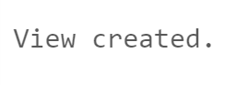

Q2. Create a view cView on college (containing all the columns) and rename the column cName as collegeName and enrollment as seats respectively.

create view cView as select cname "collegeName",state, enrollment "seats" from college;



Q3. Create view CSaccept having IDs and college of student who applied to CS major and their application is accepted.

create view CSaccept as select sid , cname from apply where decision='Y' and major='CS';



Q4. Create view CSberkeley having IDs, name, GPA, sizeHS of those student who are accepted in CS at Berkeley and comes from High School that is greater than 500. (Instruction: You are required to use view CSaccept in this query with Student table for joining)

create view CSberkeley as select student.sid, student.sname, student.GPA, student.sizeHS

from Student join CSaccept on student.sid = CSaccept.sid

where CSaccept.cname = 'Berkeley' and student.sizeHS > 500;



Q5. Display information about student in CSberk having GPA greater than 3.8.

select \* from csberkeley where gpa>3.8;

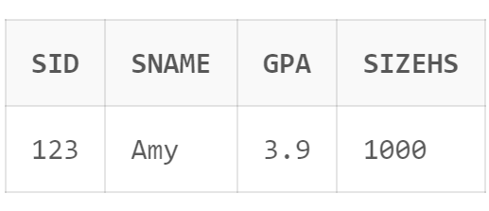

Q6. Drop view CSaccept.

drop view CSaccept;

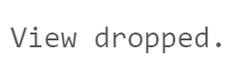

Q7. Display all student in CSberkeley.

select sname from CSberkeley;

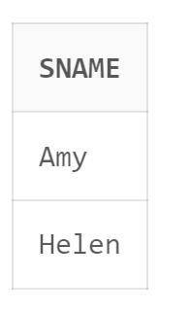

Q8. Update GPA by 0.8 of students in view WeakStudent who having high school size greater than 1000.

update WeakStudent set gpa=0.8+gpa where sizehs>1000;

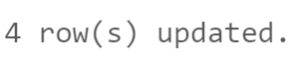

Q9. Create a view AppCount which contains sID of Student and number of applications they filed. Name the column sID and NoOfApp.

create view AppCount as select sid,count(sid) "NoOfApp" from apply group by sid;



Q10. Update NoOfApp so that sID 234 contains 4 applications.

update AppCount set NoOfApp=4 where sid=234;



Q11. Create a view StuName contain student name and their GPA. Is this View Updatable? If not specify why.

create view StuName as select sname,gpa from student;



Q12. Create view studentHS having details of student comes from High School of size more than 1000 using with check option.

create view studentHS as select \* from student where sizehs>1000 with check option;



Q13. Try insert detail of a new student Ram with sID 999 having GPA 9.9 and sizeHS 9999 to newly created view studentHS. (Comment is this view updatable?)

insert into studentHS(sid,sname,gpa,sizehs) values(999,'Ram',9.9,9999);

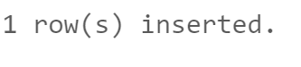

Q14. Clerk realize he wrongly type sizeHS of Ramu as 9999 it is actually 999. Can you help him to update the value of sizeHS of Ramu.

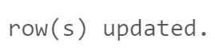update student set sizehs=999 where sizehs=9999;

Q15. Now, another boy registered to our system named Ramu with sID 998 having GPA 9.8 and sizeHS 989.

insert into student(sid,sname,gpa,sizehs) values(998,'Ramu',9.8,989);

