DBMS ASSIGNMENT 3

Name- Arpan Agarwal Course- Btech-CS

Section- C

Roll No. 14

Univ. Rollno.- 2215000343

Write SQL Queries for the following:

1. Produce a combine table in which each student is combine with every other application.

select * from student natural join apply;

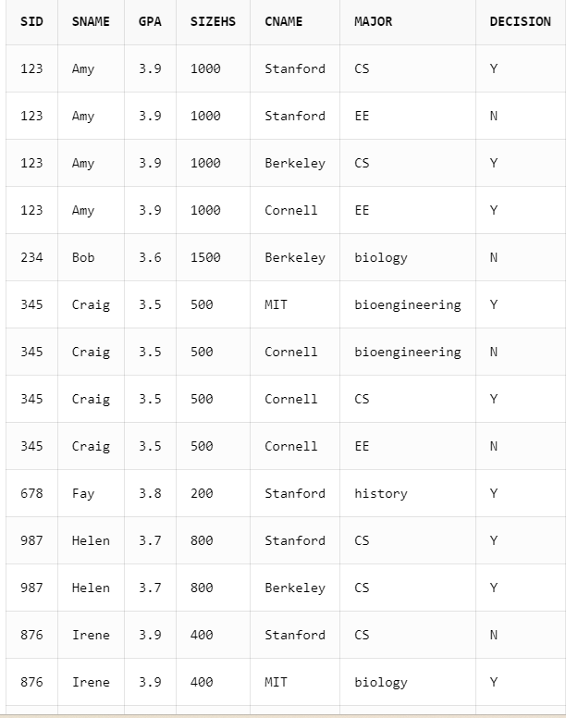

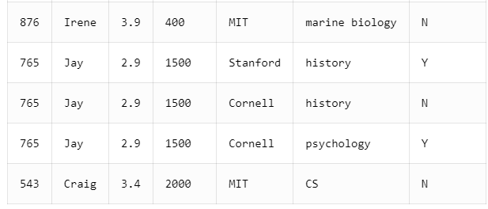

1. Give Student ID, name, GPA and name of college and major each student applied to

Select student.sid,student.sname,student.gpa,apply.cname, apply.major from student join apply on student.sid=apply.sid**;**

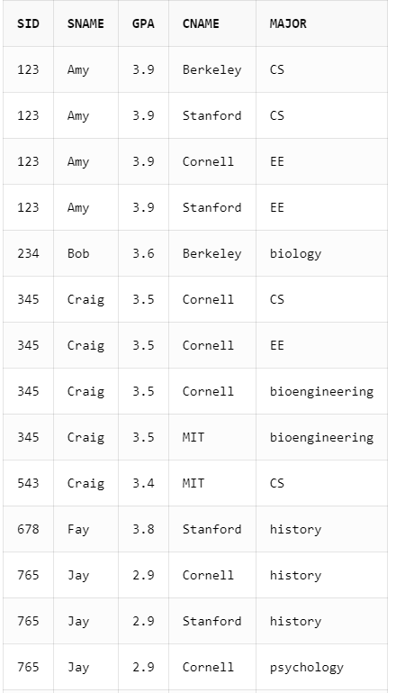

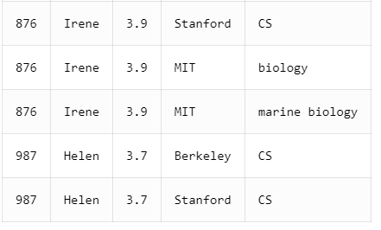

1. Find detail of applications who applied to California State.

Select apply.*From apply

Join college on apply.cname = college.cname

Where college.state = 'CA';

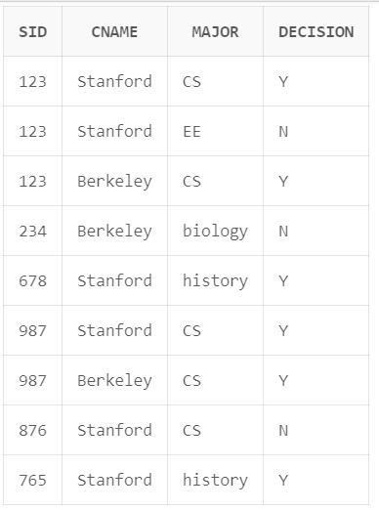

1. IDs, name, GPA of students and name of college with GPA > 3.7 applying to Stanford

select distinct student.sid,student.sname,student.gpa,apply.cname from student join apply on student.sid=apply.sid where gpa>3.7 and cname='Stanford';

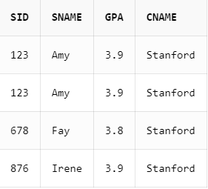

1. Find detail of Student who apply to CS major and their application are rejected.

select student.sid,student.sname,student.gpa,student.sizehs from student join apply on student.sid=apply.sid where decision='N' and major='CS'**;**

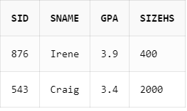

1. Find detail of student and application who applied to colleges at New York

Select student.sid,student.sname,student.gpa,student.sizehs,apply.cname,apply.major,apply.decision from student

join apply on student.sid=apply.sid

join college on college.cname=apply.cname

where state='NY';

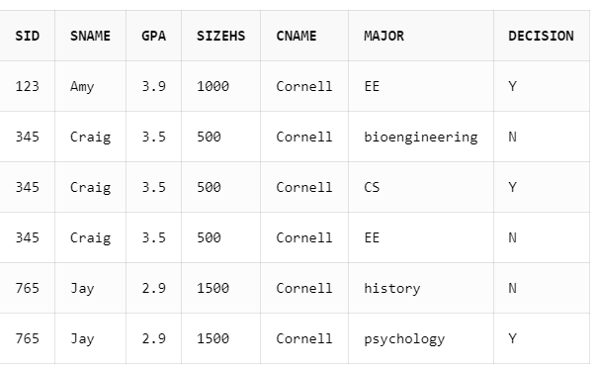

1. Find detail of student who have not applied to any of college.

select student.sid,student.sname,student.gpa,student.sizehs from student join apply on apply.sid=student.sid where apply.sid=null;

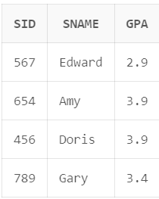

1. Find college where no student have applied

select college.cname from college join apply on apply.cname=college.cname where apply.cname=null;

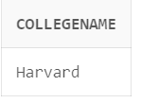

1. Find sID who have only one application.

select sid from apply group by sid having count(*)=1;

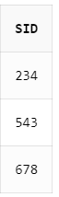

1. Find name and GPA of applicants who apply to any college whose enrollment is not more than 25000.

select student.sname,student.gpa from student

join apply on student.sid =apply.sid

join college on apply.cname=college.cname

where enrollment<=25000;

 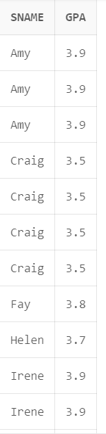

1. Find pair of students (sID) having same GPA. (each pair should occur just once in result).

select a.sname ,b.sname from student a join student b on a.gpa=b.gpa and a.sid<b.sid;

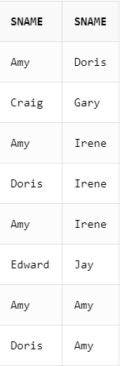

1. Find various majors student applied in at college in state MA.

select distinct apply.major,student.sid,student.sname from student

join apply on student.sid=apply.sid

join college on college.cname=apply.cname

where state='MA';

